Homework Policy

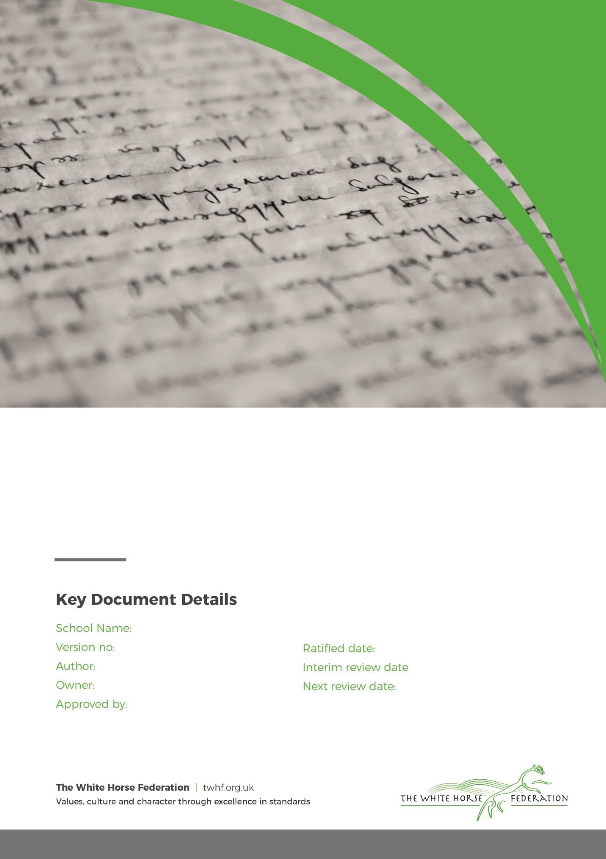Larkhill Primary 1

Simon Cowley C Harmer Governing Body

Sept 2023

Sept 24

September 2025

# Rationale

At Larkhill Primary, homework is seen as an opportunity to practice fundamental key skills. As a result, we limit what we ask pupil to do at home to reading and maths fluency practice. We recognise that homework has a variety of different purposes and benefits:

* Ensures progression towards independence and individual responsibility;
* Consolidates and reinforces skills and understanding;
* Provides opportunities for parents, children and school to work in partnership;
* Provides opportunities for parents and children to work together to enjoy learning

opportunities;

* Enable parents to be involved in the learning process and to have a better understanding of the work taking place at school;
* In Key Stage 2, to prepare children for secondary transfer.

# The Type and Amount of Homework

# All pupils are expected to read daily to an adult at home.

# Maths fluency and times table practice will be set on purple mash or doodle maths/English for years 2-6 for pupils to complete at home. The expectation is that pupil complete a fluency activity weekly at home.

# Responsibilities

For homework to be at its most effective, it is important that the child, the parent and the teacher is clear about their roles and responsibilities in the homework process. At Larkhill Primary this is how we regard each party’s responsibility.

# Children

The children are responsible for:

* Returning homework by the appointed day.
* Asking if they do not understand the homework task;
* Completing all activities to the best of their ability – keeping to the standard expected at School.

# Teacher

The teacher is responsible for:

* Setting tasks which match the ability of the child
* Explaining tasks clearly – giving the children the opportunity to check understanding.

Page **2** of **3**

# Parents

Parents are responsible for:

* Providing a conducive environment for children to work in
* Spending time talking to children about homework to support them
* Contacting the teacher if homework has become a challenge for any reason

Page **3** of **3**