Liverpool Archdiocese
Secondary Schools’ Partnership

Archbishop Beck Catholic College

Overview / Positive aspect of Sixth Form

Our assessment and monitoring tool allows individual student progress and attainment to be monitored as well as overall subject performance. A sixth form assessment calendar is issued with three key assessment periods highlighted. These assessments support formal reporting and internal subject based reporting on progress, accuracy of assessment and retention.

Purpose

The purpose of the monitoring and assessment calendar to ensure regular and rigorous A level standard assessment on all exam based courses. Data is recorded on our in-house tracking tool and forms the basis of the 3 written reports that students receive during the academic year. These reports offer realistic progress checks and facilitate intervention and support where needed.

What we did

- Agreed sixth form assessment and monitoring calendar
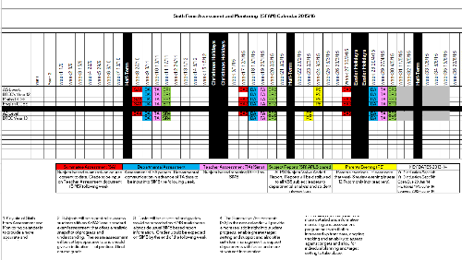

- Introduction of 3 formal mock exam assessments – run formally by exams team
- Exam questions must be from past papers and marked against appropriate mark scheme
- Results and overall student report completed after each set of assessments
- Individual student reports issued
- Internal in-house Alps report produced and distributed to subjects for analysis

- Subject’s complete analysis based on data received.

- Intervention scheduled incorporating subject leaders and sixth form management team

- Next steps improvement targets and review date agreed.

Outcome/Impact

- System allows for regular and rigorous assessment and monitoring of both student and subject performance.
- As well as outcomes against target, the report tracks accuracy of assessment and retention throughout the programme.
- Subjects are now more aware of the importance of retention and intervention and more importantly, the need for rigorous and accurate assessment.
- This allows positive progress to be acknowledged and shared, as well as informing focused intervention and support where needed.

Related documents and links:

