

Assessment, Recording and Reporting Policy

Schedule for Development, Monitoring and Review
Approved by governors on: | 18th March 2021
Implementation monitored by: | Jude Colver
Review arrangements: | Annually  All policies will be reviewed if there are any significant developments or changes to legislation
Reviewed:  The next review of this policy: | March 2022  March 2023

ASSESSMENT RECORDING AND REPORTING IS AN INTEGRAL PART OF THE TEACHING AND
LEARNING PROCESS.

The aim of this policy is to inform all stakeholders of the Assessment Recording and Reporting procedures that are in place within The Leicester Partnership School. This Policy ensures a consistent approach relating to the assessment of student progress, the accurate, detailed recording of that progress and the reporting of that progress to staff, students Parents/Carers, mainstream schools and colleagues from other support services, for example EPS, EWS. , LCI.

The Leicester Partnership School works in partnership with schools to enable students to reach their potential through a combination of school based, vocational and LPS based programmes.

ASSESSMENT AND TARGET SETTING

Promoting students’ learning is a principal aim of all educational establishments and assessment lies at the heart of this process. Assessment provides a framework in which objectives are set and student progress and achievement is tracked. It provides the basis for planning in response to students’ needs and forms part of the evaluation of learning outcomes.

Aims of Assessment

- To recognise and celebrate student achievement.
- To identify areas for development and plan appropriate support.
- To provide data to inform the setting of appropriate targets to raise performance.
- To enhance student learning and motivation.
- To provide summative reports on student achievement.
- To enable staff to plan appropriate work to match the needs of the student.
- To track student progress over time.
- To provide information for the students themselves, their Parents/Carers, LPS Staff, mainstream schools, external agencies, vocational providers and representatives from The Local Authority.

Effective Assessment

In order to raise the expectations of our students and to encourage them to fulfil their potential all staff should be aware of the importance of:

- Students with Special Educational Needs and Disabilities
- Students who are Looked After
- Gender, cultural and social background
- Prior attainment from mainstream schools
- Assessment matching learning objectives
- Target setting to improve student performance

ASSESSMENT

The LPS uses a range of initial assessment processes and procedures in order to determine a baseline level/grade for each student and in order to ensure that provision meets the needs of each student and that each student makes progress over time. This initial assessment is undertaken using our on-line ForSkills Testing Program in English, Maths and ICT and takes account of information provided by referring schools and work undertaken during the period of assessment.

TARGET SETTING

All work attempted and/or completed is rewarded with a positive comment explaining to the student why their work is good. It is followed by a target for improvement to enable a student to make further progress. The use of targets encourages students to take ownership of their learning and to recognise how they can improve to the next level/grade/REACH (B4L) status. Students are able to reflect on their targets and overall performance on a daily and weekly basis. Students are provided with Target Setting Rulers that enable them to identify their Expected, Better than Expected and Accelerated target levels. Refer to section below on Assessing Students Rate of Progress

LPS TARGETS

KS3: - It is expected that students will make 2 functional sub-levels of progress [or the equivalent] per academic year.

- 85% of students to demonstrate expected or better than expected progress in English, Maths and ICT against their Functional Skills Baseline Testing Level using ForSkills.
- 50%of students in KS3 make above expected or better then above expected progress in English, Maths and ICT.
- All Capable Learners will gain a Functional Skills qualification in their identified subject/s of English,Maths, ICT
- 50% will gain a Functional Skills qualificationat an above expected level.

KS4 – It is expected that any students attending LPS educational tuition for 3 or more academic terms will achieve a pass at their assessed functional or GCSE level.

- 80% or more will gain a Functional Skills qualification in all 3 Functional Skills areas
- All High Level Learners will gain a GCSE in English Maths and BTEC Science
- At least 20% of High Level Learners will gain a qualificationat and above expected levelin all 3 GCSEs

Overall Progress and achievement is based on ACTUAL QUALIFICATIONS achieved.

SEQUENCE OF ASSESSMENT, TARGET SETTING & PROGRESS TRACKING & MONITORING

Assessment / Tracking / Attainment Type | Frequency – Timescales |  |  | Purpose
Assessment / Tracking / Attainment Type | Initial | Intermediate | Final | Purpose
Baseline Testing & Re-testing

FORSKILLS IN ENGLISH, MATHS | On first day of their programme/during the first week of their programme | Every Term | Every Term or on exit | - To determine a student’s baseline Functional Skills level
FORSKILLS IN ICT | Within two weeks of the start of their programme | Every Term | Every Term or on exit | - To determine a student’s baseline Functional Skills level
SWRT | On first day of their programme/during the first week of their programme | During the course of the Learning Intervention Support Programme | On exit | - To determine the reading age of the student compared to their chronological age. This is for full time students only  - To assess the impact the Learning Intervention Support Programme has on the Reading progress of students
VERNON Spelling | On first day of their programme/during the first week of their programme | During the course of the Learning Intervention Support Programme | On exit | - To determine the spelling age of the student compared to their chronological age. This is for full time students only  - To assess the impact the Learning Intervention Support Programme has on the Spelling progress of students
PASS | On first day of their programme/during the first week of their programme | N/A | On exit | - To identify a student’s own attitude to themselves and school  - To assess the impact being at LPS has had on a student’s attitude to themselves and school
Sensory Screening | On first day of their programme/during the first week of their programme | N/A | N/A | - To identify any sensoey difficulties a student may have  - To inform staff of any sensoey difficulties a student may have which could affect their learning and behaviour  - To provide any supportive strategies
Progress / Achievement Tracking

Functional Skills Tracking in English, Maths and ICT (Using a combination of Teacher Assessment and/or Forskills re-testing) | N/A | Every half Term | On exit | - To determine level of progress & achievement over time
Functional Skills Progress in English, Maths and ICT (Using Forskills re-test) | N/A | Termly | On exit (unless exit co-incides with leaving at the end of a term) | - To determine student progress & achievement over time
GCSE Levels / Grades  [Using a combination of Teacher / Student Tracking] | Student provided with a level / grade within 2 weeks | Teacher tracking half termly | Grade achieved on exit | - To determine student progress & achievement over time
Functional Levels  [Using a combination of on-line & teacher assessment | Student provided with a working at level within 2 weeks | Teacher tracking half termly | Level achieved on exit | - To determine student progress & achievement over time
Vocational Progress | Determined by course criteria | On-going assessment & recording | Number of modules completed and / or qualification level completed | - To determine student progress & achievement over time

ASSESSING STUDENTS RATE OF PROGRESS

Because the vast majority of LPS students only receive educational provision on a part time and /or short duration basis the LPS uses a “Functional Progress Scale” and differentiated “Progress Rulers” to determine a student’s rate of progress and their overall expected level of progress if their time with the LPS were to be 3 terms. I.e. Enabling the LPS to access the speed of progress and the predicted likely level of progress if their speed of progress were to be maintained for a period of 3 terms. These progress Rulers are used to colour code students’ ForSkills [Functional] tracking scores according to their rate of progress [RED= Below Expected; AMBER = Expected Progress; GREEN = Above Expected progress; PURPLE = Accelerated Progress].

KS3 - STUDENT TARGET SETTING SLIDE RULE:

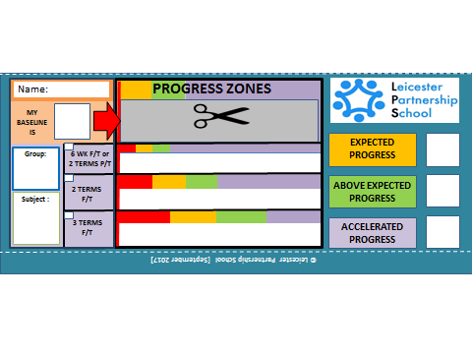
KS 4 – STUDENT TARGET SETTING SLIDE RULE [FUNCTIONAL SKILLS]

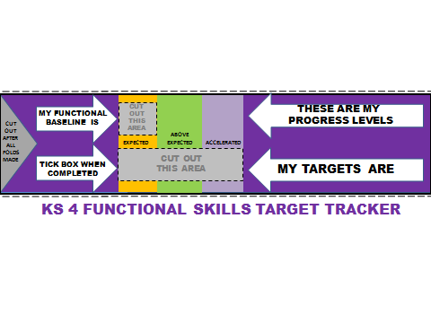

KS 4 – STUDENT TARGET SETTING SLIDE RULE [GCSE]

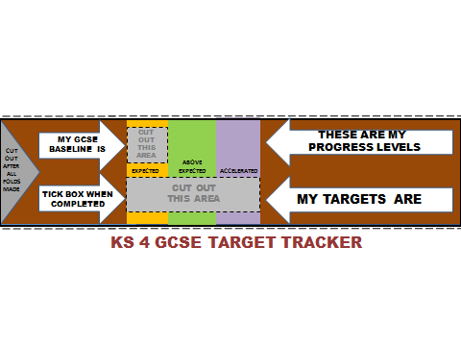

MARKING AND FEEDBACK

At the end of each module/ topic/piece of work a grade or level is awarded. For all pieces of work, targets for improvement are set. Quality marking provides positive feedback and promotes high expectations linked to the main learning objectives. Opportunities are given where possible to follow up after marking to ensure students understand and are able to respond in terms of improving their work and to achieve higher standards. The marking of work enables students to understand their achievements and to know what they need to do next to make progress. The use of the LPS Feedback Slip enables staff to identify strengths and areas for improvement within a piece of work/ a topic. Students are then able to respond to the comments made by staff and to the targets that have been set for them. The LPS uses the “WWW (What Worked Well)/EBI (Even Better If) approach when providing feedback to students

English Marking Codes:

CODE | Meaning
 | Work is correct
X | Work is incorrect
Sp | Spelling mistake  [Incorrect spelling will be underlined and the correct spelling will be provided in the margin]
Cp | Capital letter missing.  [Missing capital letter will be underlined]
P | Missing or in correct punctuation.  [In correct punctuation will be corrected and circled]
// | New paragraph needed  [The // symbol will be placed where the new paragraph is needed]
E1 | Effort Grade
GRADE | Achievement Grade
All work must be dated and signed

Maths Marking Codes

CODE | Meaning
 | Your work is correct
? | Your work is incorrect
o | Your method is correct but you have made an incorrect calculation.
Sp | Spelling mistake –[Incorrect spelling will be underlined and the correct spelling will be provided in the margin]
E1 | Effort Grade
GRADE | Achievement Grade
All work must be dated and signed

EFFORT GRADES

The Effort Grade system is set out as follows:

E1 = An excellent effort- You have completed all that is required of you.

E2 = A good effort- You have completed most of what is required of you.

E3 = A Satisfactory effort- You have completed some of what is required of you.

E4 = A Poor effort- You have completed very little of what is required of you.

LPS FEEDBACK SLIP

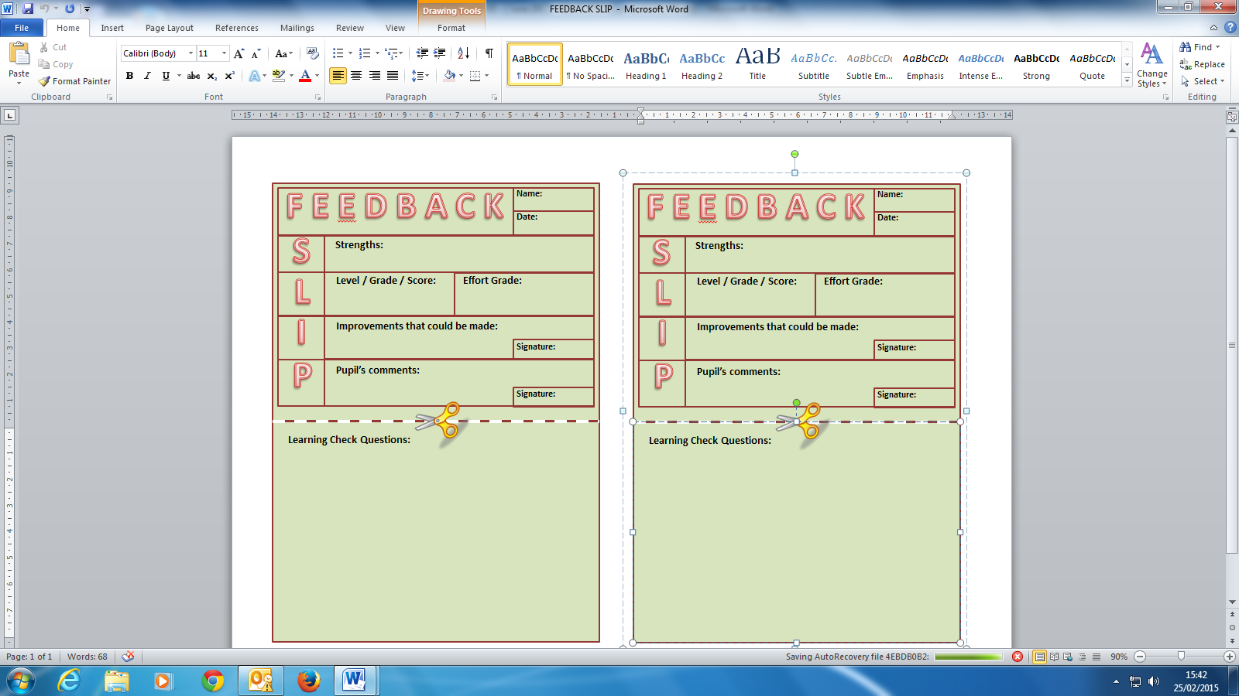

CURRICULUM SUBJECT ASSESSMENT

Full time students in KS3 are assessed on their Functional skills in English, Maths and ICT using the Forskills Assessment Programme and Teacher Assessments. For KS4 students, levels and grades are awarded based on whether students are studying Functional Skills or GCSE qualifications. Alternative qualifications are graded according to levels or assessment criteria associated with a particular course. However all pieces of work are marked and targets for improvement are set. All students are encouraged to take part in self-assessment, reflective learning and peer assessment. They are encouraged to reflect upon their own work, their achievements and future targets and supportively assess and discuss the work and progress of their peers.

BEHAVIOUR FOR LEARNING ASSESSMENT (REACH) (to be read in conjunction with The LPS Behaviour Policy)

The LPS uses the R (Ready) E (Engaged), A (Active) C (Creative), H (Heroic) scale to assess and track students’ Behaviour for Learning. Assessments take place during and at the end of each lesson and at the end of a piece of work/module/topic.

An example of the REACH Scale and some of the criteria applied to each level is provided below:-

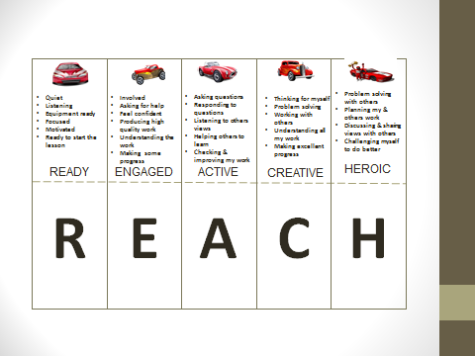

KS3-PERSONAL AND SOCIAL DEVELOPMENT ASSESSMENT

It would be inappropriate for assessment in PSHE education to be about grades, or about passing or failing. The model of assessment that is most meaningful in PSHE education is ipsative assessment.
It is important to carry out a baseline assessment before teaching anything new. As students’ learning in topics such as healthy eating, online safety, relationships and so on will come from a number of sources, we can only see whether they have made progress in their learning if we have established the knowledge, understanding, attributes, skills, strategies, beliefs and attitudes they had before any new teaching took place. The learning we wish to assess will relate to the students’ attributes and skills, as well as their knowledge and understanding related to the topic. (Please see below a brief description of the new PSHE assessment model)
- Baseline (thought shower) to be carried out at the beginning of each topic to assess current level of knowledge. (blue pen) (Appendix a)
- Feedback sheet to be completed at the end of the topic (Appendix B)
- Baseline to be revisited as an end point assessment (red pen)(Appendix a)
- Based on additional information provided students will be given a judgement. (No, partial, good or advanced knowledge gained.(Appendix C)
- Data to be added to the PSHE assessment tracked(Appendix D)

RECORDING

Each student in KS3 who receives support from The Leicester Partnership School has their progress recorded using a combination of a central electronic Assessment and Monitoring document and LPS Feedback Slips. Each student in KS4 who receives support from The Leicester Partnership School has their progress recorded using a combination of individual student tracking of progress documents and a central electronic assessment and monitoring document. In addition, Teachers and Lead Practitioners keep a written record of the progress a student is making in terms of marks/levels awarded. They also complete a Student Individual Needs Document, which details the appropriate support a student requires in order to make progress.

REPORTING

Upon arrival, full time students in KS3 undertake a Single Word Reading Test, a Vernon Spelling Test and a PASS (Pupils Attitude to Self and School) Survey and Sensory Screening . Alongside this, students complete Functional Skills baseline testing in English and Maths and ICT. . The LISP (Learning Intervention Support Programme) Team carry out this testing and then produce a One Page Profile, which is distributed to all staff.

The progress made by students is reported to them on a daily/weekly basis via the team of staff who work with them, during a tutorial time. During these sessions, students assess their performance, review their targets and set new ones.

The progress made is reported to Parents/Carers, mainstream schools and external agencies (if relevant) during regular telephone contact, review meetings and exit meetings.

The Leicester Partnership School staff share information with regard to student progress during staff meetings and Line Management Meetings. Should a student be underachieving or experiencing difficulties then a Parent/Carer interview is arranged to discuss progress and further appropriate support. If relevant, then external agencies and mainstream schools are invited to attend these meetings

MONITORING & EVALUATION

The following procedures are in place to monitor and evaluate this ARR Policy:

- Lesson Observations & Learning Walks
- Work Samples/Scrutiny
- Planning Scrutiny
- Student Interviews
- Line Management Meetings
- Staff Meetings
- Data Collection and Analysis
- Parent/Carer Meetings with external agencies and mainstream schools
- Progress Review Meetings
- Exit Meetings
- Student Profile Sheets
- Forskills tracking data
- Teacher Assessments

