

CCTV Policy
Version 13

Schedule for Development, Monitoring and Review
Approved by governors on: | 18th March 2021
Implementation monitored by: | Clive Francis
Review arrangements: | Annually  All policies will be reviewed if there are any significant developments or changes to legislation
Reviewed:  The next review of this policy: | May 2025  April 2026  April 2027

Table of Contents
Introduction 4
CCTV Centre Information 4
List of CCTV Camera Locations 5
What our CCTV system can be used for: 7
What our CCTV system cannot be used for: 7
Data Protection and UK GDPR 7
How we will operate and manage our CCTV systems 7
Camera Placement 7
Storing and Accessing CCTV Recordings 8
System Maintenance 9
Subject Access Requests (SARs) 9
Appendix 1 LPS - CCTV User Checklist used to maintain the system 10
Appendix 2 11
Processes for Requesting Access to CCTV Recordings 11
Need access to CCTV recordings onsite after an incident occurs (term time) 11
Need access to view CCTV recordings onsite after an incident occurs (school closure time) 11
Appendix 3 12
Electronic CCTV Form 12
Appendix 4 14
CCTV Access Request and Viewing Record (Paper version) 14
Appendix 5 15
CCTV Signage displayed on site 15

Introduction

Leicester Partnership School (LPS) fully recognises the contribution it can make to protect children, their parents/carers and visitors to its’ school. In order to comply with the law on the use of CCTV equipment, images recorded on the system may also be used for the purpose of crime prevention and detection and will be provided to the Police and/or social services if requested. For the reasons described above, the LPS operates CCTV equipment across the whole of the school site.

The aim of the policy is to explain the reasons and circumstances in which CCTV will be used to fulfil these functions.

CCTV Centre Information

CCTV cameras currently operate throughout the site both externally and internally.

The school’s entire CCTV system was updated during July and August in 2025. The new system has higher resolution cameras compared to the previous one and allows faster retrieval of recorded video when required. The total number of cameras is three more than the previous one, with some cameras viewing positions being altered to provide better coverage of some areas.

The system consists of a single CCTV server, linked to sixty-seven cameras across the school site. The majority of the cameras are the dome-style with infrared sensors and are capable of recording black and white video in the dark. Two of the external cameras are of the Pan-Tilt-Zoom (PTZ) type. None of the cameras on our system are currently capable of recording audio.

List of CCTV Camera Locations

Building | Cam Name | Internal | External | Fixed | PTZ
Double Mobile | NM - Classroom - Ground Left | ü |  | ü
Double Mobile | NM - Classroom - Ground Right | ü |  | ü
Double Mobile | NM - Corridor - First Left | ü |  | ü
Double Mobile | NM - Corridor - First Right | ü |  | ü
Double Mobile | NM - Corridor - Ground Left | ü |  | ü
Double Mobile | NM - Corridor - Ground Right | ü |  | ü
Double Mobile | NM - External Front |  | ü | ü
Double Mobile | NM - External Left |  | ü | ü
Double Mobile | NM - Heads office door | ü |  | ü
Double Mobile | NM - Rec Room Left | ü |  | ü
Double Mobile | NM - Rec Room Right | ü |  | ü
Double Mobile | NM - Reflection - Ground Front | ü |  | ü
Double Mobile | NM - Reflection - Ground Rear | ü |  | ü
Double Mobile | NM - Stairwell - First Left | ü |  | ü
Double Mobile | NM - Stairwell - First Right | ü |  | ü
Double Mobile | NM - Stairwell - Ground Left | ü |  | ü
Double Mobile | NM - Stairwell - Ground Right | ü |  | ü
Main Building | 1 to 1 Room | ü |  | ü
Main Building | Car Park - Bins |  | ü | ü
Main Building | Car Park - Disabled Space |  | ü | ü
Main Building | Car Park - Pick Up |  | ü | ü
Main Building | Car Park - Right |  | ü | ü
Main Building | Chestnut - Left | ü |  | ü
Main Building | Chestnut - Main | ü |  | ü
Main Building | Chestnut - Right | ü |  | ü
Main Building | Classroom - ADT | ü |  | ü
Main Building | Classroom - Ash | ü |  | ü
Main Building | Classroom - Cooking | ü |  | ü
Main Building | Classroom - Elm | ü |  | ü
Main Building | Classroom - ICT | ü |  | ü
Main Building | Classroom - Maple | ü |  | ü
Main Building | Classroom - Oak | ü |  | ü
Main Building | Classroom - Science Lab | ü |  | ü
Main Building | Classroom - Willow | ü |  | ü
Main Building | Cloakroom | ü |  | ü
Main Building | Cloakroom Door | ü |  | ü
Main Building | Corridor - Nr Server Room | ü |  | ü
Main Building | Corridor - Outside ADT | ü |  | ü
Main Building | Corridor - Outside Kiln Room | ü |  | ü
Main Building | Corridor - Outside Willow | ü |  | ü
Main Building | Corridor - Server Room Door | ü |  | ü
Main Building | Fire Exit - MUGA | ü |  | ü
Main Building | Fire Exit to Play Equip | ü |  | ü
Main Building | Hazel - Corridor | ü |  | ü
Main Building | Hazel - End Room | ü |  | ü
Main Building | Hazel - First Room | ü |  | ü
Main Building | Out - Old Mobile Front |  | ü | ü
Main Building | Out - Old Mobile View Right |  | ü | ü
Main Building | Out - Assault Course |  | ü | ü
Main Building | Out - Bike Rack |  | ü | ü
Main Building | Out - Wellbeing Garden |  | ü | ü
Main Building | Out - Cooking Room |  | ü | ü
Main Building | Out MUGA |  | ü | ü
Main Building | Out NM Exit Right |  | ü | ü
Main Building | Out PO Store Shed |  | ü | ü
Main Building | PTZ - Front |  | ü |  | ü
Main Building | Reception Doors | ü |  | ü
Main Building | Rewards Room | ü |  | ü
Main Building | Science Office | ü |  | ü
Main Building | Sports Hall - Inward | ü |  | ü
Main Building | Sports Hall - Outward | ü |  | ü
Main Building | Staff room - KS3 | ü |  | ü
Main Building | Student Entrance |  |  | ü
Main Building | Toilet - Boys nr Ash | ü |  | ü
Single Mobile | Single Mobile - Left Classroom | ü |  | ü
Single Mobile | Single Mobile - Right Classroom | ü |  | ü
Standalone | PTZ - Rear |  |  |  | ü

What our CCTV system can be used for:

Our CCTV systems will be used only for the following purposes:
- To help protect pupils, staff & visitors using our centres to ensure that they are safe and are not in danger of harm.
- To help protect our centres from criminal damage or acts caused by those using them or intruders.
- To help in the prevention of crime or with criminal investigations.

What our CCTV system cannot be used for:

Our CCTV systems will not be used for the following purposes:
- Covert surveillance or monitoring
- Tracking or monitoring of individuals without their knowledge
- Observation of employees for the purpose of performance management / assessment e.g. observing a lesson
- Recording sound – our CCTV system is technically not capable of doing so

Data Protection and UK GDPR

Our CCTV systems are registered with the Office of the Information Commissioner which oversees all data protection matters within the United Kingdom. Our system complies with the 2018 Data Protection Act and UK GDPR. Data Protection Registration documentation is stored at our site and provides details of the categories for usage under our registration. This registration is renewed annually. Information about data protection issues can be found on the Information Commissioner’s website which can be found at the following address https://ico.org.uk/

How we will operate and manage our CCTV systems

CCTV cameras have been located in and around our centres in order to help the Service to manage a safe environment for its pupils, staff and visitors. The quality of the images complies with legislation and are of sufficient quality to enable the Police to use them in order to investigate crimes.

The employees and pupils will be made aware of the purpose(s) for which the CCTV scheme has been established. Appropriate signage will be displayed in the Centre reception areas and around the site as deemed appropriate. This signage informs all staff, pupils and visitors that CCTV is in operation at our site. These signs are located on the front of all school buildings containing CCTV cameras and are visible on approach.

Camera Placement

All CCTV cameras installed across the site, will only be sited in such a way that it only monitors those spaces that are intended to be monitored by the cameras with the maximum effectiveness possible for those areas. However, it is not possible to guarantee that the placement of the cameras will detect and record all potential incidents.

Every effort will be made to ensure that the external CCTV cameras will be positioned so that their coverage is limited to the school premises only.

Storing and Accessing CCTV Recordings

Images taken by our CCTV system are stored on secure hard drives, located in a secure room onsite. These images are retrievable for a period of up to 30 days if not stored separately onto encrypted removeable media. Images can only be accessed on behalf of the Service’s Data Control Manager who is Julie Aquilina (Business Manager). The Data Control Manager strictly controls who has access to these images.

The following individuals have authorisation to access these images, in the absence of or with the permission of the Data Control Manager:

- Shaun Whittingham (Head Teacher)
- Nicola Anderson (Senior Leader – School Improvement)
- Denise Henderson (Deputy Head Teacher)
- Rebecca Edwards (Assistant Head of School – Safeguarding & Taskforce)
- Thomas Liney (Assistant Head – KS3)
- Andrew Barrett (Assistant Head – KS4)
- Toby Jeffery (APST DSL KS3 & KS4)

The following individuals are authorised to view the images but only with the permission of the above listed people:

- Hilroy Thomas (Senior Manager – Behaviour)
- Tanu Mistry (Senior Premises Officer)
- Trevor Brown (Premises Officer)
- Clive Francis (ICT Network Manager)
- Derren Bennet (Level 3 ICT Technician)

Any members staff who have been found to access the CCTV system and/or it’s recorded images, who are either not authorised to or do so or do not have permission to do so, will face disciplinary action.

Any images from the CCTV system will be made available to the Police involved in the prevention and detection of crime and not to any other third parties.

System Maintenance

All CCTV equipment is regularly checked by the ICT Team to ensure that it is operating properly:

- The cameras all functioning correctly with correctly set and unobscured views
- The recordings are of a consistent high quality
- The time and date is correctly set at all times
- The CCTV Server is kept updated with the latest critical and security software and OS updates
- The CCTV Server’s hardware is functioning as intended and undergoes annual cleaning maintenance

Subject Access Requests (SARs)

Under UK GDPR and the Data Protection Act 2018, individuals have the right to access and receive a copy of CCTV recordings relating to themselves – this is referred to as a Subject Access Request or SAR.

As per the Data Protection Act, all requests should be made verbally or in writing to the school with the following information:
- Specific Date/s and Time/s
- Proof of identity (if required)
- Description of yourself (if required)

The school will usually provide the recordings free of charge and within one month of receiving a valid request. The LPS reserves the right to refuse the request if it would:

- Put an ongoing criminal investigation at risk or
- Prejudice the legal rights of other individuals - for example if it is not possible to edit out other individuals in order to protect their identity

Appendix 1 LPS - CCTV User Checklist used to maintain the system
The CCTV equipment and images recorded by this system are controlled by Julie Aquilina (Data Control Manager) who is responsible for how the system is used and for notifying the Information Commissioner about the CCTV system and its purpose (This is a legal requirement of the Data Protection act 2018)
CCTV Statement: The above Data Control Manager has considered the need for using a CCTV system and has decided it is required for the prevention and detection of crime and for protecting the safety of staff, pupils and visitors to the centre. The CCTV system will not be used for other purposes.
The above Data Control Manager has authorised the following individuals to access images recorded on this system:

- Shaun Whittingham (Head Teacher)
- Nicola Anderson (Senior Leader – School Improvement)
- Denise Henderson (Deputy Head Teacher)
- Rebecca Edwards (Assistant Head of School – Safeguarding & Taskforce)
- Thomas Liney (Assistant Head – KS3)
- Andrew Barrett (Assistant Head – KS4)
- Toby Jeffery (APST DSL KS3 & KS4)

The above Data Control Manager has authorised the following additional individuals to access images recorded on this system, with permission from the above:

- Hilroy Thomas (Senior Manager – Behaviour)
- Tanu Mistry (Senior Premises Officer)
- Trevor Brown (Premises Officer)
- Clive Francis (ICT Network Manager)
- Derren Bennet (Level 3 ICT Technician)

Authorised staff must complete and sign the form (Appendix 3 or 4) when viewing recorded images.
Requirement | Check Frequency | Checked (Date) | By | Date of next review
Data Controller has notified the Information Commissioner that a CCTV system is being used on this site. This will be renewed annually | Annual | 27/05/2025 | J Aquilina | 27/05/2026
Cameras have been sited so that images are clear and suitable for the Police to use to investigate a crime. | Annual | 21/08/2025 | J Aquilina | 21/08/2026
Cameras have been positioned to avoid capturing the images of persons not visiting the Centre. | Annual | 21/08/2025 | J Aquilina | 21/08/2026
There are signs showing that a CCTV system is in operation and the Controllers contact details are displayed where it is not obvious who is responsible for operating the system. | 6 monthly | 21/02/2026 | C Francis | 21/08/2026
The recorded images from the CCTV system are securely stored and only a limited number of authorised persons have access to them. | Annual | 21/08/2025 | J Aquilina | 21/08/2026
The recorded images will be retained long enough for an incident to come to light (e.g. for a theft to be noticed) | N/A

Appendix 2

Processes for Requesting Access to CCTV Recordings

Need access to CCTV recordings onsite after an incident occurs (term time)

Incident Occurs involving staff / students / visitors during the school day
Request CCTV access from Assistant Head (AH) or Head Teacher (HT) if not available
AH or HT either accesses CCTV recordings or gives permission to another authorised member of staff* to access the recordings. The AH or HT then completes the form**
* = See Appendix 1 for list of authorised members of staff
** = See Appendix 3 for a copy of the form

Need access to view CCTV recordings onsite after an incident occurs (school closure time)

Incident Occurs involving staff / visitors / contractors during the day
Request CCTV access from Business Manager (BM) or Head Teacher (HT) / Assistant Head (AH) if not available
BM, HT or AH either accesses CCTV recordings or gives permission to another authorised member of staff* to access the recordings. The AH or H then completes the form**
* = See Appendix 1 for list of authorised members of staff
** = See Appendix 3 for a copy of the form

Appendix 3

Electronic CCTV Form
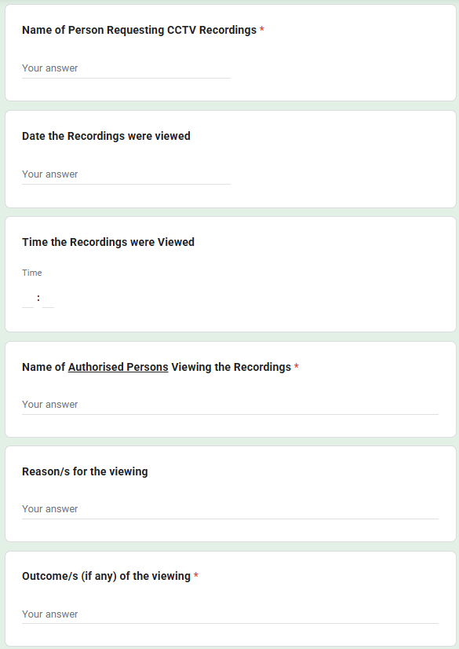
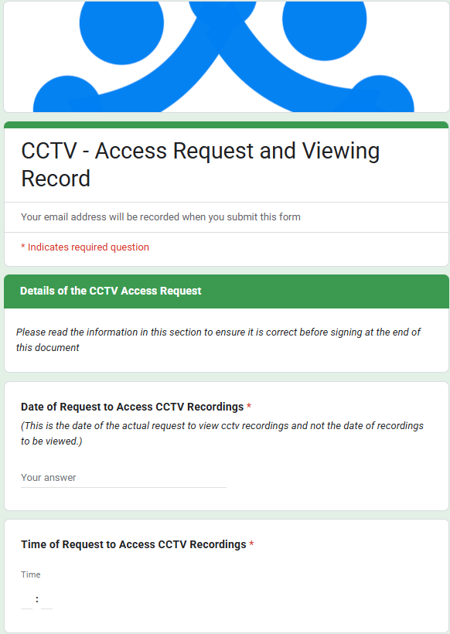

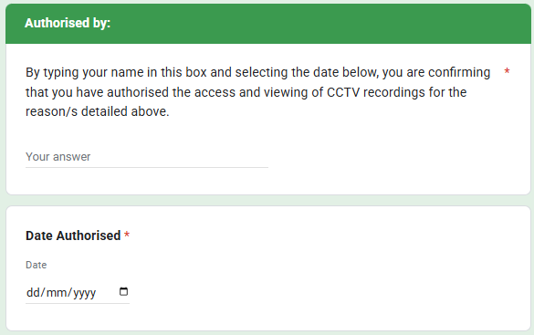

Appendix 4

CCTV Access Request and Viewing Record (Paper version)

Date and Time of Request: __/__/____ __ : __

Person Making request: ________________

Date and Time Recordings Viewed: __/__/____ __ : __

Name of Authorised Person/s Viewing the Recordings:
________________ ________________
________________ ________________
________________ ________________

Reason for the Viewing:

Outcome, if any, of the Viewing:

Authorised by: Date:

Appendix 5

CCTV Signage displayed on site

