Drugs, Alcohol, Substance Misuse and Smoking Policy

Schedule for Development, Monitoring and Review
Approved by governors on: | October 2019
Implementation monitored by: | Tom Liney
Review arrangements: | Annually  All policies will be reviewed if there are any significant developments or changes to legislation
Reviewed:  The next review of this policy: | October 2020  October 2021  October 2022  October 2023

Drug, Alcohol, Substance Misuse and Smoking Policy

Definition

The United Nations Office on Drugs and Crime defines a drug as: “A substance people take to change the way they feel, think or behave”

This definition has been adopted by the Home Office and is the definition that applies within this policy and which therefore covers:

- All illegal drugs (those controlled by the Misuse of Drugs Act 1971)
- All legal drugs, including alcohol and tobacco
- All legal medicinal drugs (including ‘over-the-counter’ and prescription medicines)

Aims of this policy
The purpose of this policy is to:

- Clarify the legal requirements and responsibilities of the school
- Reinforce and safeguard the health and safety of all staff, students, governors, parents/carers and external agencies.
- Clarify the school’s approach to drugs for all staff, students, governors, parents/carers and external agencies.
- Give guidance on developing, implementing and monitoring the drug education programme
- Enable staff to manage drugs, alcohol and illegal substances on the school premises, and any incidents involving such that may occur, with confidence and consistency, and in the best interests of those involved
- Ensure that the response to incidents involving drugs, alcohol and illegal substances compliments the overall approach to drug education and the values and ethos of the school
- Provide a basis for evaluating the effectiveness of the school’s drug education programme and the management of incidents involving illegal and other unauthorised drugs

Application

This policy applies to all persons using the school site; students, staff and visitors. It applies whilst students are travelling to and from school, during the school day (including break and lunch time), and during any additional times the school is legally responsible for the student.

Role of the Headteacher and Governors

The Governing Body have overall responsibility for the policy and its implementation. This responsibility is devolved to the Headteacher who is responsible for liaising with the governing body, parents/carers and appropriate outside agencies and for the appointment of those staff within the school, who have responsibility for handling the implementation of the policy. The Headteacher will ensure that all staff dealing with substance issues are adequately supported and trained.

Section 1

Drug, Alcohol and Substance Misuse education

Drug, Alcohol and Substance Misuse education is taught via the PSHE statutory curriculum for students up to Year 11 Health Education (PSHE) curriculum. Drug, Alcohol and Substance Misuse issues are addressed in PSHE lessons and throughout the school. We believe that if young people are not given accurate information about drug, alcohol and substance misuse in school, then they may obtain possibly dangerous misinformation from elsewhere.

- Learn about medicinal and reactional drugs
- Learn about the over-consumption of energy drinks
- Learn about the relationship between habit and dependence
- How to use over the counter and prescription medications safely
- How to assess the risks of alcohol, tobacco, nicotine and e-cigarettes
- How to manage influences in relation to substance use
- How to recognise and promote positive social norms and attitudes

The drug, alcohol and substance misuse education syllabus is revised from time to time, but always accords with the following principles, which all staff are required to follow:

- The legal context will be made clear, including prohibitions arnd maximum punishments
- The zero-tolerance stance of the school towards drug, alcohol and substance misuse while under the school’s jurisdiction will be emphasised
- Realistic information on the effects and potential effects of drugs and other restricted or illegal substances, physical, psychological and social, will be given information about how drugs and other restricted or illegal substances are obtained or used will not be given.

During the course of drug, alcohol and substance misuse education, students may be encouraged to research and debate issues, examining both sides of controversial questions, but staff, whatever their private opinions, will clearly uphold these principles.

Sanctions

The school’s jurisdiction covers students from the time they start from home to travel to school until they arrive home after school, and covers all school-related events and visits. When the welfare of other students and staff is compromised, this jurisdiction may also cover actions taken by students when they are not at school or a school related event.
While under the school’s jurisdiction, no student may at any time be in possession of a classified drug, alcohol, tobacco or other substance, which may be similarly abused.

Drugs

If a student is suspected of being under the influence of an illegal drug/legal high or is caught in possession of an illegal drug/legal high (or any form of drug paraphernalia) parents/carers will be informed at the earliest opportunity by the Headteacher (or designated member of staff). However, we reserve the right, in accordance with the current legal guidance, to exclude any student in possession of illegal drugs/legal highs, even for a first or one-off offence.

Students selling or supplying illegal drugs/legal highs will be given a fixed term exclusion. Lesser offences will be punished according to the guidelines decided from time to time by the governing body. Sanctions will range from internal isolation through to fixed term-exclusions. (See Exclusions Policy).

In all cases of illegal drug possession or the possession of drug paraphernalia, the police will be notified and criminal action may result.

We recognise that a student who is abusing drugs needs support. We would therefore hope that, in most circumstances, the school and parents/carers can work together to support the young person involved. Drug counselling, through the school nurse service will be offered, as appropriate, or a referral to other drug based organisations such as Turning Point.

Legal highs

These relate to all ‘psychoactive’ drugs, including ‘legal highs’, and can be described using three main categories: stimulants, ‘downers’ or sedatives, psychedelics or hallucinogens. They are substances that produce similar effects to illegal drugs but are not controlled under the Misuse of Drugs Act but is covered by the 2016 Psychoactive Substances Act, which means it’s illegal to give away or sell. Legal highs will be dealt with at Leicester Partnership School as a prohibited substance.

Cigarettes, E-Cigarettes, tobacco and matches

Students are forbidden to bring cigarettes, e- cigarettes, lighters or matches on to the school premises. Students are also forbidden to smoke on the way to or from school, or on school visits. If found smoking or found in the possession of cigarettes, e-cigarettes, tobacco or matches, students will have those items confiscated in the first instance and parents/carers will be contacted.

We recognise that any student who smokes, needs support. We would therefore hope that, in most circumstances, the school and parents/carers can work together to support the young person involved. The student will be referred to the school nurse for further intervention and to receive advice, support and guidance should they want to stop smoking.

Alcohol

Students are not allowed to bring alcohol on to the premises or to drink alcohol on the way to or from school. If a student is suspected of being under the influence of alcohol or is caught in possession of alcohol, the student’s parents/carers will be contacted. Depending on the severity of the incident, the student can expect to suffer a sanction such as a fixed-term exclusion.

We recognise that any student, who abuses alcohol, needs support. We would therefore hope that, in most circumstances, the school and parents/carers can work together to support the young person involved. The student will be referred to the school nurse for further intervention regarding alcohol abuse.

Medicines and Legal Medicinal Drugs

Students are forbidden to bring any harmful drugs into school unless they are for medication. In this case, a medical consent form must be completed and must be prescribed medicines that are in date, labelled, provided in the original container as dispensed by the pharmacist and include instructions for administration, their dosage and storage. Facilities exist for students to keep supplies of some medicines and other medical supplies in the first aid room. If a student needs to keep medicines in the first aid room, s/he should bring them to the medical room with a completed medical consent form. Where appropriate, students will always be expected to self-administer their medicine and are asked to take any medication within sight of a qualified first aider. Antibiotics should not need to be brought into school, except on the advice of a qualified medical practitioner.

We will only administer non-prescribed medicines that are in the original packaging with written consent on the “Medication Consent Form” e.g. eye drops, Feminax, Gaviscon, cough medicine. This will also only be on a short-term basis. Where the school have concerns, they will seek further guidance from their link. (School Nurse).

It is our policy to give age appropriate doses of paracetamol, ibuprofen and anti-histamine to students as described on the packet, if written consent from the parents has been received in advance of administration. This is usually through the medical consent, which can be obtained from school reception. We will check with the student and parent that they have not previously taken any medication containing paracetamol or ibuprofen within the preceding 4 hours.

We will never administer aspirin to any student under 16 years old unless prescribed by a doctor.

All other pain relief medicine will not be administered without first checking maximum dosages and when previously taken.

Searching and Confiscation

Under the Education and Inspections Act (2006) the Headteacher and authorised staff have a statutory power to search a student or students or their possessions, without consent, where we have reasonable grounds for suspecting that the student may have a prohibited item. Prohibited items are:

- Knives or weapons
- Alcohol
- Illegal drugs
- Stolen items
- Tobacco, e-cigarettes, cigarette papers and matches
- Fireworks
- Pornographic images
- Any article that the member of staff reasonably suspects has been, or is likely to be used:
  - To commit an offence
  - To cause personal injury to, or damage to the property of, any person (including the student)

The Headteacher and authorised staff can also search for any item banned by the school rules, which has been identified in the rules as an item which may be searched for.

At Leicester Partnership School, the rules also extend to:
- Legal highs
- Electronic cigarettes (also known as ‘e-cigarettes’)

Any student found to be in breach of any aspect of this policy will have the offending articles confiscated. In most cases, alcohol, tobacco and cigarette papers will be returned to the parent/carer (only) although depending on the seriousness of the offence, they may be surrendered to the police.

For regulations regarding searching and confiscation within schools, please refer to the DfE guidance at:
http://www.education.gov.uk/aboutdfe/advice/f0076897/screening-searching-and-confiscation as well as the schools’ behaviour policy.

This policy should be used in conjunction with Leicester Partnership School’s:

- Behaviour policy
- Exclusion policy
- Search Policy

Section 2: Medical Emergencies:
- Any medical emergencies will be dealt with as per Appendix A.

Section 3: Misuse of Supply of Drugs:
- In cases of substance use/misuse or supply on the premises, during the school day or during school visits etc., the matter will be dealt with as a ‘Safeguarding Matter’ and referred in the first instance to the school’s Responsible Officer for Safeguarding. The case will then be discussed with the young person and a written record taken (see Appendix C); parents/carers will be informed as soon as possible. The support of the Police and outside agencies will be sought as appropriate. Disciplinary action will be taken as appropriate
- Where appropriate the matter will be reported to the Police.
- The school will consider each incident individually and will employ a range of responses to deal with each incident. Specific cases will be managed as per Appendix B: staff, students, parents/carers will be informed of these issues.
- Leicester Partnership School will not knowingly allow its premises to be used for the production or supply of any controlled drug (e.g. the preparation of, or smoking of cannabis). Where it is suspected that substances are being sold on the premises, details regarding those involved, as well as much information as possible, will be passed to the police.
- Disciplinary action will be taken in all incidents of the misuse or supply of alcohol or drugs. The level and severity of the sanction will be at the discretion of the Headteacher based on the specific circumstances and any contingent factors. However, the head teacher will be expected by governors to consider whether permanent exclusion is the appropriate action in all cases.

All staff, parents/carers and young people will be reminded of this policy, and its procedures, on a regular basis.

APPENDIX A: Drug situation – medical emergencies

APPENDIX B: Situations involving drugs without medical authority

APPENDIX C: Recording of drug, alcohol, substance misuse and smoking incidents

Useful Policies to consider:

Keeping Children Safe in Education 2016
DfE and ACPO Drug Advice For Schools,
HYPERLINK "https://www.gov.uk/government/publications/searching-screening-and-confiscation" Searching, Screening and Confiscation, February 2014
Drug Wise Joining Forces
Education and Inspections Act (2006)
Drugs: Guidance for Police working with Schools and Colleges, 2004
Advice to schools and colleges on gangs and youth violence, 2013
Psychoactive Substances Act 2016

Enlisting Specialist Support:

Substance Misuse Treatment Services

Turning Point
Leicester, Leicestershire & Rutland’s Adult & Young People’s Drug & Alcohol Service
2 Eldon Street,
Leicester
LE1 3QL
0330 303 6000
http://wellbeing.turning-point.co.uk/leicestershire/hubs/leicester-city/

Appendix A: Drug situations – medical emergencies

The procedures for an emergency apply when a person is at immediate risk of harm. A person who is unconscious, having trouble breathing, seriously confused or disorientated or who has taken harmful toxic substance, should be responded to as an emergency. The main responsibility is for the student at immediate risk, but you also need to ensure the well-being and safety of others. Put into practice your school’s first aid procedures. If in any doubt, call medical help.

Always:
- Assess the situation
- Send for first aider
- If a medical emergency, send for medical help and ambulance.

Before assistance arrives

If the person is conscious:
- Ask them what has happened and to identify any drug used
- Collect any drug sample and vomit for medical analysis
- Do not induce vomiting
- Do not chase or over-excite them if intoxicated from inhaling a volatile substance
- Keep them under observation, warm and quiet.

If the person is unconscious:
- Ensure that they can breathe, place in the recovery position ,do not move them if a fall is likely to have led to spinal or other serious injury which may not be obvious
- Do not give them anything by mouth
- Do not attempt to make them sit or stand
- Do not leave them unattended or in charge of another student
- The admin team then will notify parents/carers (as with any emergency medical referral)

For needle stick (sharps) injuries:

- Encourage wound to bleed. Do not suck. Wash with soap and water. Dry and apply waterproof dressing.
- If used/dirty needle seek advice from a doctor.

When medical help arrives
- Pass on any information available, including vomit and any drug samples

Complete a medical record form as soon as you have dealt with the emergency.

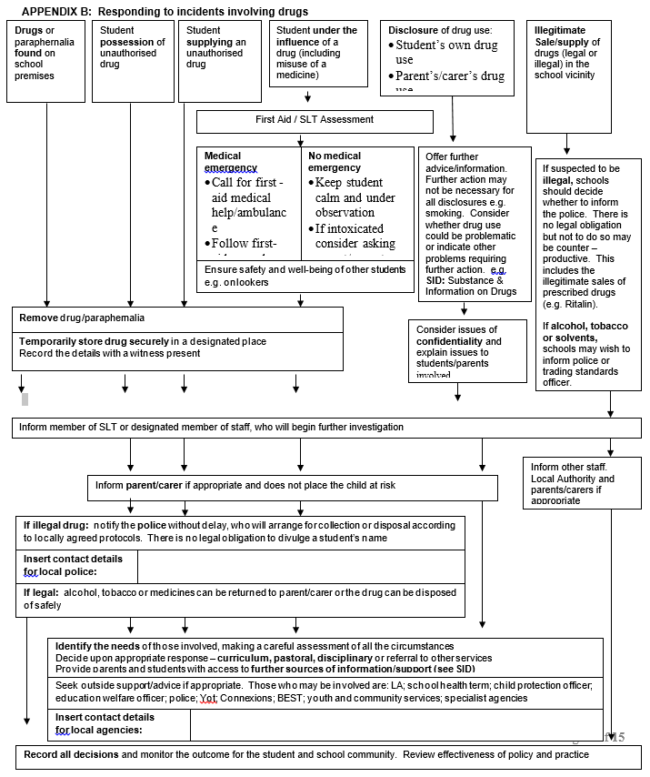

Appendix C: Recording of drug, alcohol, substance misuse and smoking incidents - CPOMS

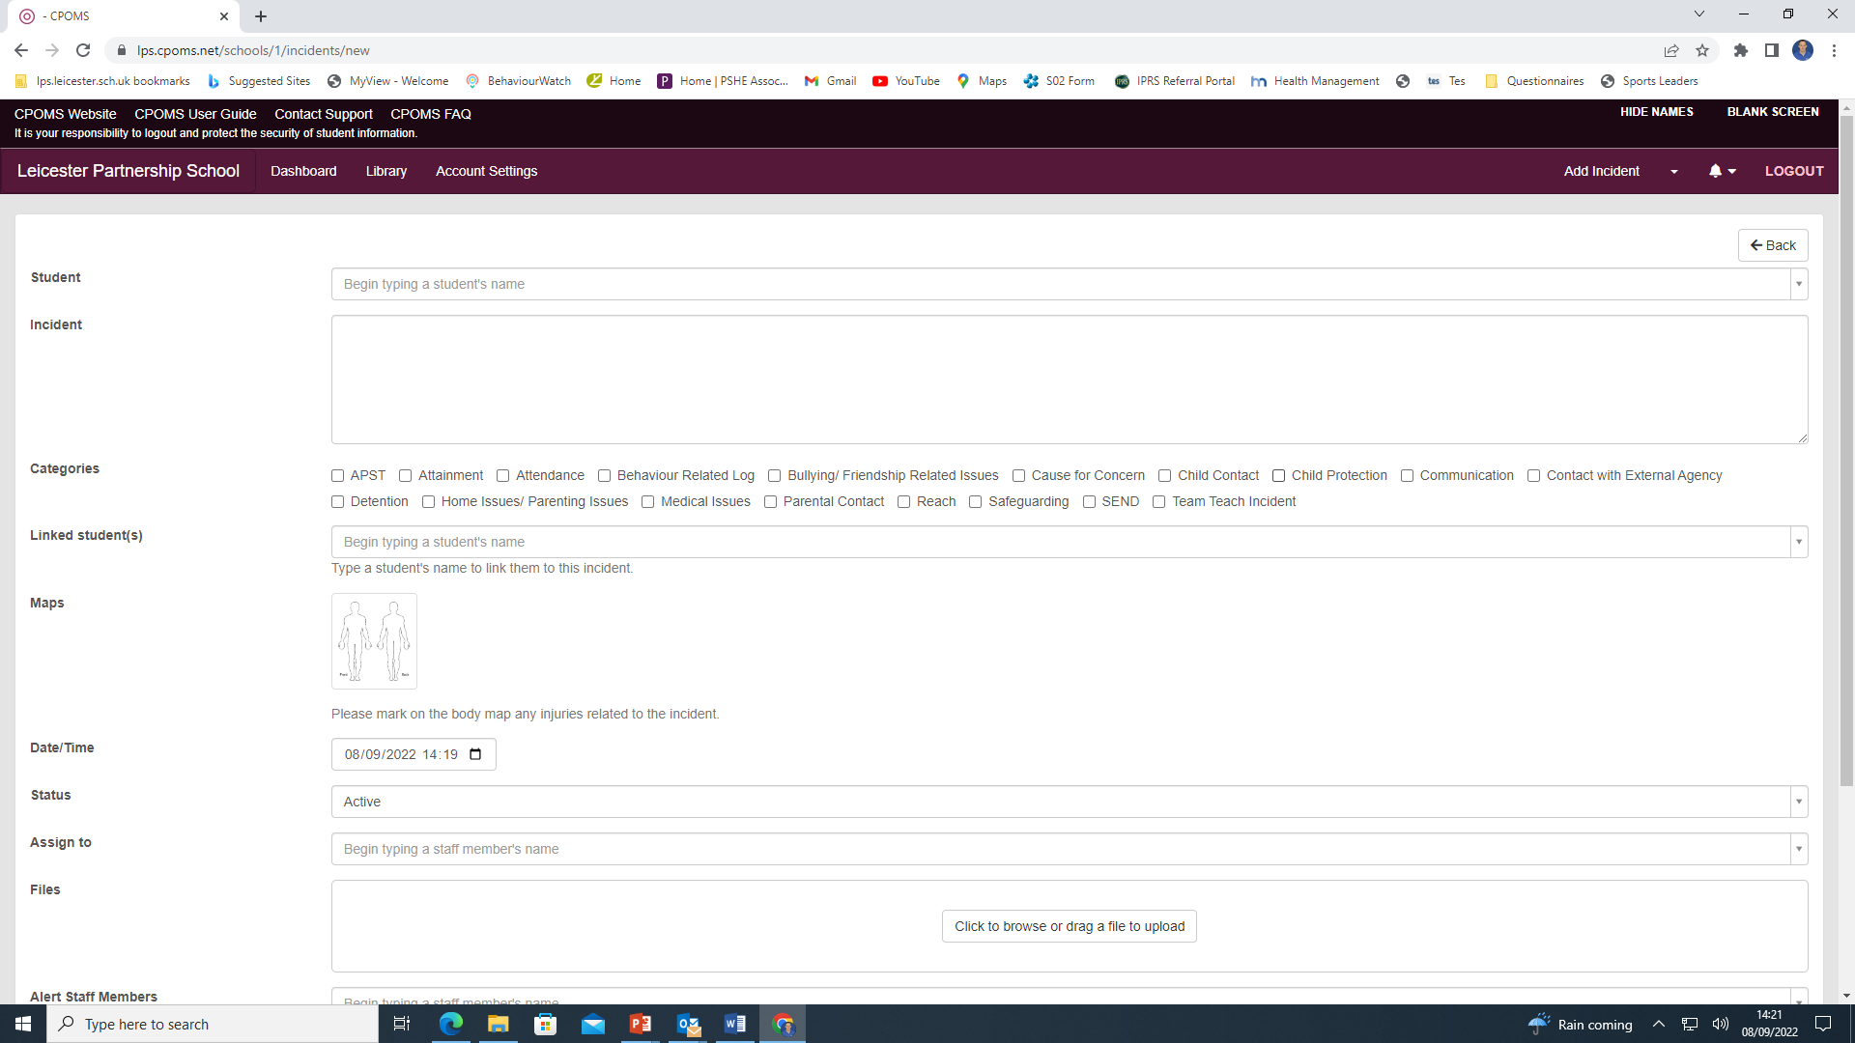

Smoking Policy

Staff and Students

Rationale
Smoking is a major cause of illness and early death, and affects non-smokers through passive smoking. The laws prohibiting smoking made under The Health Act 2006 require that enclosed or substantially enclosed public places and workplaces are smoke-free. In addition, since October 2007, it has been illegal to sell tobacco products to anyone under the age of 18 this also includes e-cigarettes.
Accordingly the school recognises its duty to discourage smoking and to encourage a healthy lifestyle.

Aims
- To apply the law prohibiting smoking made under The Health Act 2006 by providing a no-smoking environment.
- To make students aware of the health risks involved in smoking. To encourage students to cope with pressures on them to take up smoking and enable them to make informed, responsible choices.
- To support the national targets for reducing the proportion of smokers in all age groups.

Introduction

1.1 In line with the Health Act 2006 and subsequently, law since 1st July 2007,
Leicester Partnership School is a designated non-smoking site. This policy identifies how Leicester Partnership School will continue to maintain a smoke free environment within the school premises for the benefit of students, staff, visitors, parents and carers as well as members of the public.

1.2 Leicester Partnership School will continue to encourage and support students to stop smoking through the PSHE programme, the tutor programme, and the provision of the school in conjunction with the local authority which occurs outside of school hours.

1.3 The Health and Safety at Work Act etc (1974) requires that the school take reasonable measures to protect the health and safety of employees and members of the public visiting the school premises.

1.4 Passive smoking is a health and safety issue for all adults in the workplace, leading to increased costs to the school through sick pay, absenteeism, loss of productivity and potential litigation.

1.5 Children and young people are more susceptible than adults to the effects of passive smoking. 17,000 children under the age of five are admitted to hospital every year in the UK as a result of breathing second hand smoke. Associated illnesses include bronchitis, pneumonia, asthma and other respiratory problems.

Rationale for the Existence of School Smoking Policies

2.1 Everyone has the right to breathe clean air.

2.2 Smoking is the single most preventable cause of premature death and ill health in our society

2.3 85% of the adult population do not smoke.

2.4 Schools are in an ideal position to influence the health of the community they serve. The school environment, smoking education programme offered and the messages given about tobacco, have key roles to play in reducing smoking amongst young people, staff and visitors.

2.5 Where smoking is permitted on school sites this devalues the health education input students receive on smoking and provides contradictory messages to them. Schools have an important role in modelling non-smoking as the norm.

2.6 Children need to receive consistent messages and require non-smoking role models within the school.

Leicester Partnership School Rationale

3.1 Leicester Partnership School recognises and fully accepts those responsibilities placed upon it by health and safety legislation to provide a working and learning environment where health and safety of the staff, students, parents, carers and members of the public who visit the school premises are of paramount importance.

3.2 The purpose of the policy is to protect and improve health, safety and well-being of all staff, students, parents, carers and members of the public who visit the school premises.

3.3 Leicester Partnership School will place particular emphasis on raising awareness amongst students on the impact of smoking and second hand smoke, as part of the taught curriculum in PSHE.

Policy Strategy

4.1 The school is designated a no-smoking site and everyone involved with the school community is expected to adhere to the Smoking Policy. Those groups are:
- Employees
- Student Teachers
- Students
- Voluntary helpers
- Management Committee
- Visitors/Parents/Carers
- Contractors working on site

4.2 In accordance with the School’s Smoking Policy, the following will apply:

Students

- Students are not allowed to smoke at school or whilst engaged in any off-site activity representing the school
- Students should not be present when other students are smoking, or they will face the same consequences as those who are smoking

Staff

- Staff are recognised `role models` and as such are required not to smoke in sight of students. This will include visits, school excursions and include both teaching and non-teaching staff, near the school site.
- The spirit of this policy will also apply to employees whilst exercising direct responsibility for students on off-site activities, e.g. in the school mini-bus, school fixtures, school trips etc.

Visitors

- The Smoking Policy applies to all visitors to the school including suppliers, supply or temporary staff and contractors.

Parents and Carers

- It will be requested that Parents and Carers adhere to the Smoking Policy and refrain from smoking on the school grounds.

Events

- The school’s Smoking Policy applies to all social events

Students who are found contravening the school no smoking policy.

5.1 When a student is found smoking or with smokers in the vicinity of the school site.

- Parents will be notified by letter that their child has contravened the Smoking Policy and will be placed in isolation.
- Repeat offenders will face a fixed term exclusion from school and the school reserves’ the right to issue a £50 penalty in line with current legislation.

