

Emergency Procedures

Schedule for Development, Monitoring and Review
Approved by governors on: | October 2019
Implementation monitored by: | Julie Aquilina
Review arrangements: | Annually  All policies will be reviewed if there are any significant developments or changes to legislation
Reviewed:  The next review of this policy: | October 2020  October 2021  October 2022  October 2023  November 2024  November 2025

EMERGENCY PROCEDURES POLICY (+ COVID-19)

AIMS:

- To ensure the safety of all pupils, staff and visitors should an Evacuation/ Invacuation take place in any of the buildings of the Leicester Partnership School.

- To ensure that staff and pupils are aware of their roles and responsibilities on discovering a fire or when the fire alarm sounds as well clear procedures when an Invacuation is required.

EVACUATION: Occurs when persons leave the immediate area or school premises. Examples of this are Fire, Bomb Threat, and Gas explosion.

INVACUATION: Also known as a Lockdown occurs when circumstances dictate that the safety of staff, pupils and visitors is better ensured inside the building and behind locked doors. In the event of an Invacuation staff and students should remain out of site and away from doors and windows. All persons should seek cover behind furniture or solid walls. An example of this is a chemical spill or weapons crisis.

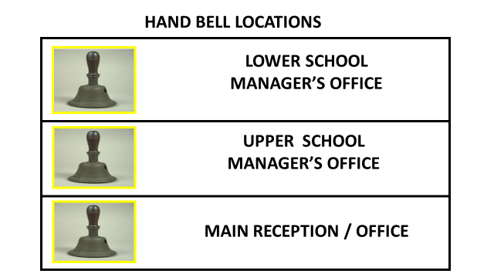

ASSEMBLY POINTS:

The assembly points for each ZONE are as described below:

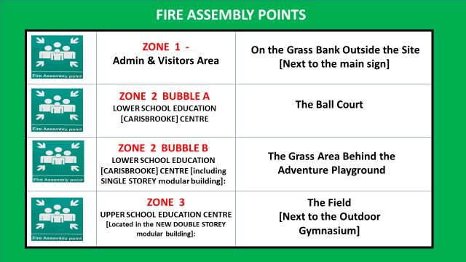

Actions – Discovering a Fire:

The LPS has smoke and heat detectors in all Centres although there is no automatic signalling to the emergency services in the case of a fire from the KS4 block.

Anyone discovering a fire or suspects there may be a fire MUST raise the appropriate alarm by immediately using the nearest call point (red break glass box).
If the alarm sounds at ANY time, the building MUST be evacuated immediately via the nearest designated Fire Exit.

Fire extinguishers and fire blankets are provided according to law and to European Safety Specification. No-one is to attempt to tackle any fire unless they have received suitable training. Fire safety equipment is inspected on an annual basis by a qualified contractor.

IF IN DOUBT – ALWAYS EVACUATE!!!

Actions – When an invacuation is required:-

Anyone who identifies the need for an invacuation must raise the alarm using their radio. If it is confirmed that an invacuation is required the Lead Manager [or Deputy Manager in their absence] will sound the alarm by ringing a hand bell. The hand bell must be rung until it is confirmed that all staff, students and visitors have heard the alarm. Hand bells are located in the following places:-

- UPPER SCHOOL MANAGER’S OFFICE
- LOWER SCHOOL MANAGER’S OFFICE
- LOWER SCHOOL MAIN RECEPTION OFFICE

ROLES & RESPONSIBILITIES:

ZONES 1 & 2

EVACUATION PROCEDURE:

LOWER SCHOOL EDUCATION [CARISBROOKE] CENTRE:
[Including the SINGLE STOREY MODULAR BUILDING]:

The Head Teacher has responsibility for all LPS premises, staff, students and visitors, and, as a consequence their welfare and security. The Head Teacher will nominate responsible persons to perform specific tasks to enable compliance with statutory requirements.

The nominated persons are detailed below:-

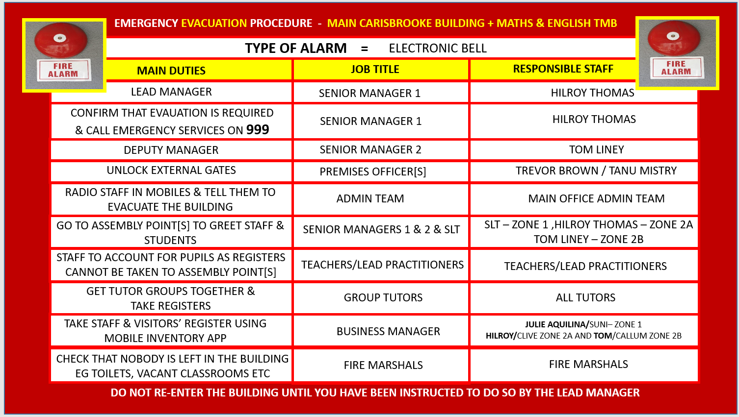

Any staff or pupils not in class at the time of the fire alarm and evacuation will leave the building by the nearest and safest exit and make their way to the Fire Assembly Point.

FIRE MARSHALS

The following staff are designated as “Fire Marshals” it is their responsibility to check an area of the building to make sure that nobody has been left in the building. Each Fire Marshal has an area of the building that they are responsible for checking. Fire Marshals and their areas of responsibility are detailed in the table below:-

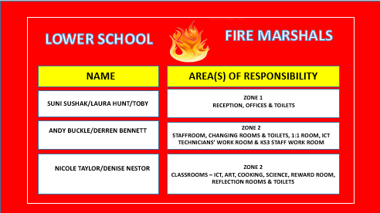

Trevor Brown/Tanu Mistry will meet the fire brigade as they arrive on site and inform them with as much information as to the location and situation of the fire and of any unaccounted people. They will give the fire brigade a plan of the building showing any hazards they may come across.

ZONES 1 & 2

INVACUATION PROCEDURE:
Upon notification of an Invacuation (Long continuous ringing of handbell and notification on staff radios)

General Guidance (To be applied when an invacuation is required)

- On hearing the bell everyone must stay in the building.
- The bell indicates that there is a potentially threatening situation somewhere on the site.
- Where possible close/lock all exterior doors and windows and ensure everyone is out of sight of the windows.
- Teacher/Class Lead to calm students and have them sit on the floor.
- All Teachers / Class Leads to undertake roll call of their class.
- Staff to check toilets / communal areas and escort students to nearest classroom.
- If students are not with a member of staff when the bell rings they should move to the nearest classroom where there is a member of staff present.
- Staff and Students remain in their location until staff radios confirm that all is clear.
- Then evacuation procedures will commence to ensure that everyone is present and accounted for at the assembly point (if deemed necessary to evacuate the site).

The nominated persons are as detailed below:-

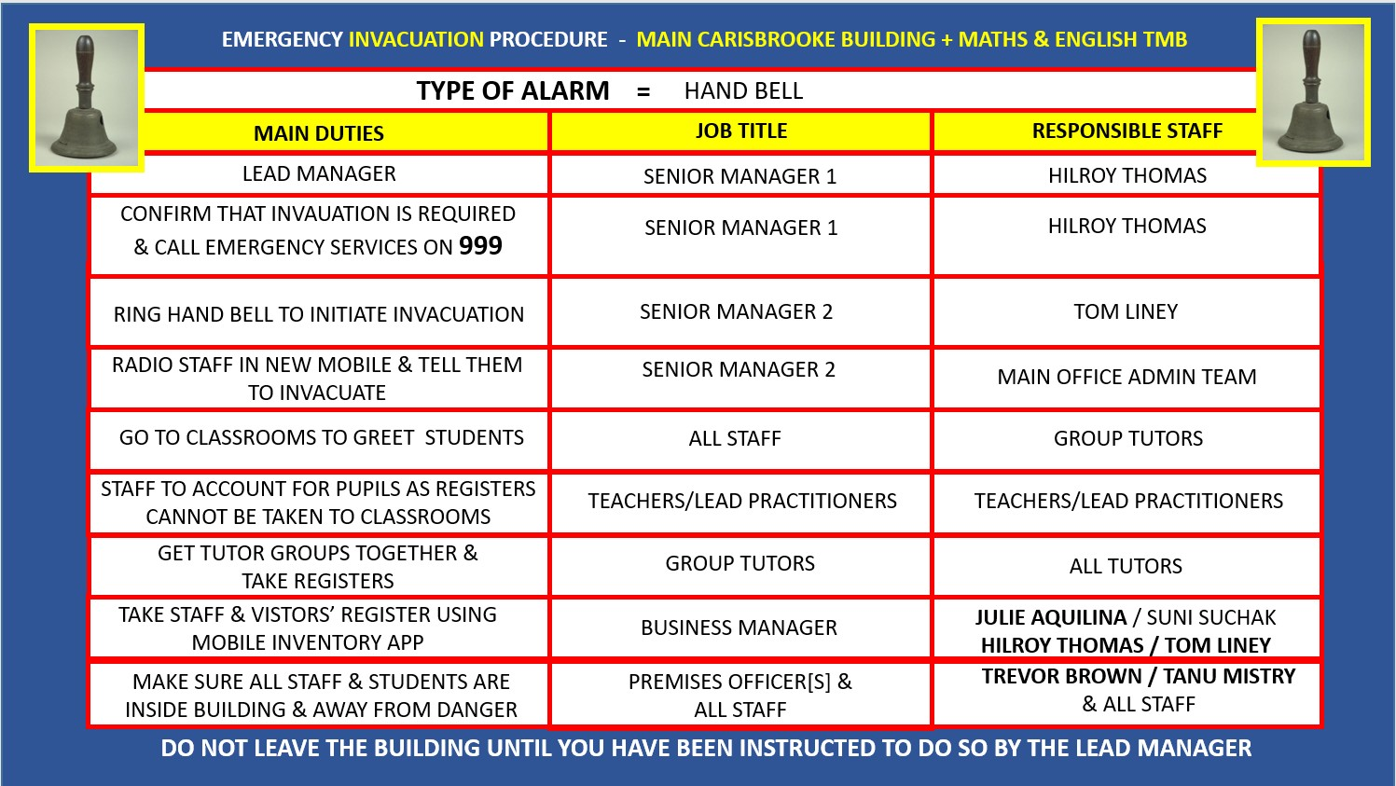

ZONE 3

UPPER SCHOOL EDUCATION CENTRE
[LOCATED IN THE NEW DOUBLE STOREY MODULAR BUILDING]:

The Head Teacher has responsibility for all LPS premises, staff, students and visitors, and, as a consequence their welfare and security. The Head Teacher will nominate responsible persons to perform specific tasks to enable compliance with statutory requirements. The nominated persons are detailed below:-

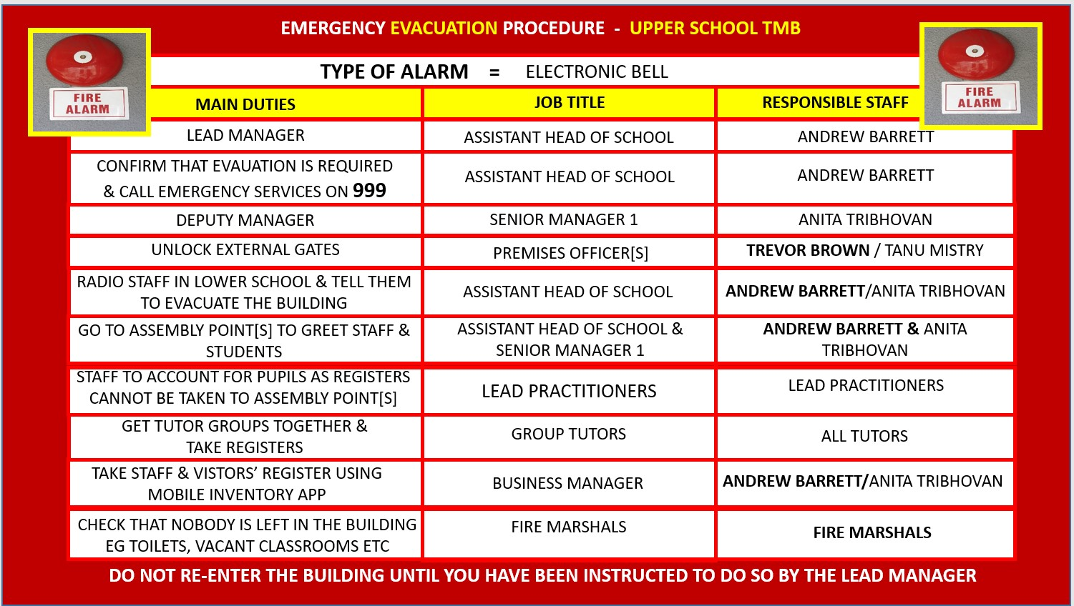

Any staff or pupils not in class at the time of the fire alarm and evacuation will leave the building by the nearest and safest exit and make their way to the Fire Assembly Point.

FIRE MARSHALS

The following staff are designated as “Fire Marshals” it is their responsibility to check an area of the building to make sure that nobody has been left in the building. Each Fire Marshal has an area of the building that they are responsible for checking. Fire Marshals and their areas of responsibility are detailed in the table below:-

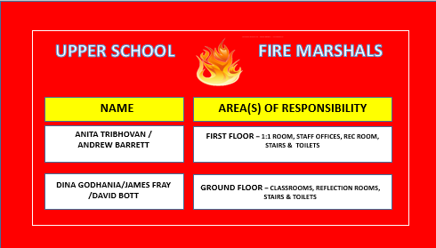

Trevor Brown / Tanu Mistry will meet the fire brigade as they arrive on site and inform them with as much information as to the location and situation of the fire and of any unaccounted people. They will give the fire brigade a plan of the building showing any hazards they may come across.

INVACUATION PROCEDURE:
Upon notification of an Invacuation (Long continuous ringing of hand bell and notification on staff radios)

Also:- Refer to general invacuation guidance (Page 3)

The nominated persons are detailed below:-

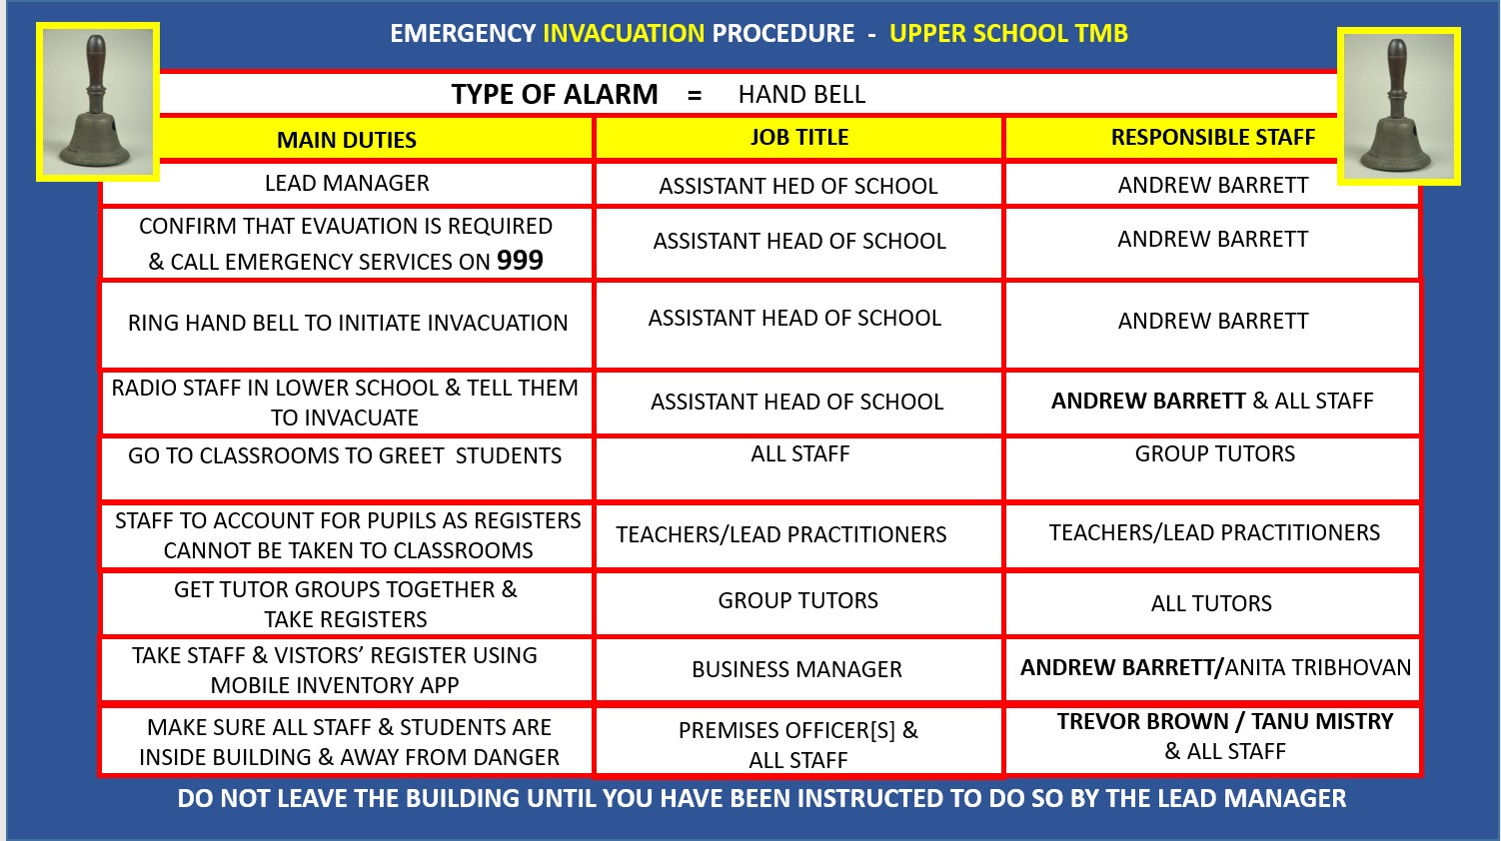

General Information:

In case of an evacuation, all users must leave the building via the CLOSEST AVAILABLE DESIGNATED FIRE EXIT. Personal belongings must be left in the building and no-one is to remain in the building or return to the building to collect personal affects or search for missing people.

Persons deemed as having a physical impairment or disability must be given priority to exit as well to be supported by a member of staff to ensure their exit from the building is safe and properly managed.

DO NOT RUN

All staff, students, visitors and contractors must comply with these instructions and are expected to follow all directives from the Site Manager and Senior staff.

All groups using the building must be made aware of the Emergency Procedures Plan as well as the location of all exit routes.

Fire Exits:

All the fire exits within the buildings that make up the LEICESTER PARTNERSHIP SCHOOL are clearly marked. AT NO TIME MUST THESE DOORS OR THE ACCESS AREAS AROUND THEM BE HINDERED BY ANY OBSTACLES

Classrooms:

Entrances into the classrooms must be kept clear of all obstructions. Classrooms must be kept tidy at ALL times. Flammable material must be kept away from all heaters and lighting. Litter is to be disposed of in the bins provided. It is the responsibility of the classroom Lead to ensure that bins are emptied as soon as possible.

Smoking/vaping is NOT permitted at any time on the school premises / grounds

Examination Procedures:

The Examination officer shall be responsible for the safe evacuation of students and staff in addition to maintaining the relevant procedures relating to the safety and security of examination papers and materials.

Out of term use:

All visitors / contractors to sign in and out when on site.

Premises officer responsible for contacting the fire brigade, taking out the contractors book and managing the fire evacuation.

