

Relationships and Behaviour Policy

Schedule for Development, Monitoring and Review
Approved by governors on: | 18th June 2025
Implementation monitored by: | Thomas Liney
Review arrangements: | Annually  All policies will be reviewed if there are any significant developments or changes to legislation
Reviewed:  The next review of this policy: | June 2025  June 2026
Relationship and Behaviour Policy

Contents

 | Page
- Introduction and ethos | 4
- Aims and objectives | 4
- Senior leaders and management | 5
- Implementation of the policy | 6
4.1. Rewards and consequences | 6
………..4.2. Person centred | 9
………..4.3. Encouraging positive behaviours | 10
4.4. Damage to property, theft and criminal damage | 11
4.5. Search, screen and confiscate | 11
4.6. Drugs, alcohol, substance misuse and smoking | 11
- Reflection spaces | 12
- Suspensions | 14
- Physical interventions | 15
- Monitoring and evaluation | 15
Appendix A – Evidence based approaches | 16
Appendix B – One page profiles and risk assessments | 19
Appendix C - Suspensions | 22

- Introduction and ethos

‘Always keep a student's experiences and perspectives in mind when they engage in challenging behaviour. Remember that they aren't giving you a hard time, they're having a hard time.’ Jen Alexander

Leicester Partnership School, based in Leicester City is a setting that is for students who are at risk of exclusion from their mainstream education or who have been permanently excluded. Our school is available to students who access education in the city. Our students seek help to address, overcome or manage social, emotional and mental health needs, which may have led to educational underachievement / barriers to learning. The school’s aim is to successfully support students into reintegration to their mainstream school or transition to an appropriate setting in their next steps. We work closely with students, parents and carers, mainstream schools and other agencies to support the students in the most effective way to ensure they have a positive future.

The ethos of the school is Trauma Informed to support students with SEMH and additional needs. Students are recognised for their achievements and rewarded for their positive behaviour. The school fosters a supportive environment by prioritising restorative language, such as reflections, instead of punitive measures like detentions. While there are still appropriate consequences for negative behaviour, the focus is on engaging in conversations that promote understanding and healing. This approach is designed to support long-term growth and resilience, creating a space where students can learn from their actions in a way that acknowledges and addresses their individual experiences and needs.

Please refer to Appendix A for Research based approaches.
This policy has been written in consultation with students, parents and carers, the staff team and the school governors.

N.B. The school uses CPOMS as a reporting and recording tool for staff to log behaviours, safeguarding, communication with parents / carers and other such information. This information is assigned to senior leaders to action.

- Aims and objectives

At LPS we endeavour to create a nurturing school community where students are given the opportunity to develop into young people with aspirations for the future. We aspire to create individuals who are able to have a sense of responsibility for themselves, in their future, their behaviour and their actions. The staff team at LPS, senior leaders and the wider school community aspire to create a sense of security for students to help them move on to their next placement, whether that be their own mainstream school or another setting. Student achievements are celebrated, however small their successes, which result in positive outcomes for students and staff at LPS.

Students at LPS are taught a broad and balanced curriculum, that provides learning opportunities for each child through personalised timetables to encourage growth within their learning. Staff and students work together to create an environment that is committed to mutual respect and trust. We encourage students to be the best they can be, and aim to provide high quality education that will help them towards being successful individuals.

The values that the LPS promote in the school community are as follows below (referred to as PIPE):

- Person centred approach – students are at the centre of everything we do at LPS. The history and needs of each individual are considered to ensure each young person has a bespoke approach to their school experience. The school community works as a team to ensure that each students behaviour is seen as communication, and provision can be made to meet their needs. The school is a safe place for students to be themselves.
- Inclusive – our student and staff recognise that all who attend LPS have differing needs ‘one size does not fit all’. By adopting this approach, student is enabled to access their learning, whilst addressing their own barriers to learning for their future beyond LPS. The LPS community is encouraged to be respectful towards each other.
- Positive school culture – the staff team promote positive attitudes towards students about their aspirations and achievements – no matter how small they are. The environment created allows students to learn in a calm, effective and positive space. Staff create positive relationships with students that are based upon mutual respect and trust. Students are avidly recognised for their positive behaviour, whilst fostering a ‘fresh start’ approach.
- Empowering young people – students are encouraged to reflect upon their behaviour. Students understand that their positive interactions will be recognised and negative interactions will be met with reflective practise to empower students to recognise appropriate behaviour.

LPS understands Trauma Informed Practice and implements the values detailed in this practice to provide an environment that is supportive towards student’s mental health and other needs.

- Senior leaders and management

It is the responsibility of all senior leaders and management to promote the fluidity of the implementation of this policy. To understand that each student comes with a complexity of need which requires consideration.
The senior leaders acknowledge the legal guidelines and operate within the following in mind:
- Education Act 1996 https://education-uk.org/documents/acts/1996-education-act.html
- Education Act 2011 https://www.legislation.gov.uk/ukpga/2011/21/contents
- Education and Training (Welfare of Children) Act 2021 https://www.legislation.gov.uk/en/ukpga/2021/16/enacted
- School Standards and Framework Act 1998 https://www.education-uk.org/documents/acts/1998-school-standards-framework-act.html
- Education Act 2002 https://www.legislation.gov.uk/ukpga/2002/32
- Education and Inspections Act 2006 https://www.legislation.gov.uk/ukpga/2006/40/contents
- School Information (England) Regulations 2008 https://www.legislation.gov.uk/uksi/2008/3093/contents/made
- Equality Act 2010 https://www.legislation.gov.uk/ukpga/2010/15/contents
- Keeping Children Safe in Education 2024 https://www.gov.uk/government/publications/keeping-children-safe-in-education--2

- Implementation of the policy

4.1 Rewards and consequences

At LPS we recognise the importance of rewards in everyday school life. We understand that rewards and consequences when used correctly, can have a profound impact upon the student’s regulation, self-awareness and the management of all behaviours.
The students at LPS are consulted each term about the rewards incentives that are offered. This ranges from snacks, drinks and reward trips. The consequences that are used at the school are supported by parents on the whole.

The LPS [Key stage] 3 reward programme (REACH) is designed to be adaptable and flexible. All students who attend the LPS have a range of different complex needs, therefore it is necessary and appropriate for the rewards programme to be child centred. A one size fits all approach will not work. The success criteria for one student will be different from one student to the next.

The KS4 LPS provision intends to reward positive behaviour and further develops the students understanding of taking responsibility for their own actions. This is manifested in the work they produce and the behavioural choices they make. There are reward systems in place for positive attendance and dedication to their bespoke learning pathways.

It is hoped that overtime our young people can think as independent learners and understand that rewards and consequences when appropriately and consistently applied on the site will enable them to become well rounded and balanced young citizens, that can positively contribute to the wider community.

Rewards and consequences are explained to parents/carers at the initial entry meeting. We make those key adults aware of their childs achievements and the rewards they receive through phone calls and text messages. Any consequences for negative behavioural choices such as the “Time Productivity”, are also communicated prior to and on the morning of the allocated atonement.
Students are scored out of 5 points in each lesson:
 | Score | Criteria
H eroic | 5 points | I am asking probing questions  I am completing extension work  I am teaching others
C reative | 4 points | I am solving problems  I am helping others to learn  I am producing high quality work
A ctive | 3 points | I am making progress in my lesson  I am asking questions relevant to the lesson  I am involved in discussions related to my learning
E ngaged | 2 points | I am asking for help when I need it  I am letting others learn  I am listening to instructions
R eady | 1 point | I am sat quietly and ready to learn  I arrived on time for my lesson  I am focussed and motivated
Did not achieve | 0 points | Absent without reason  Refused to attend the session  Refused to work

At the end of the week, each student’s weekly average Reach score will determine what level of reward they are awarded for the following week.

A student who achieves ‘creative’ (weekly 4.0 average score) status can choose one daily snack from the tuck shop and have access to one options period per week. The options period consists of a choice of cooking, sport, films, art and craft.

A student who achieves ‘heroic’ (weekly 4.6 average score) status can choose two items from the tuck shop and have access to the reward room at break time and lunch time. Heroic students also have an options period once a week, as above with the addition of the reward room, where they can use their mobile phones.
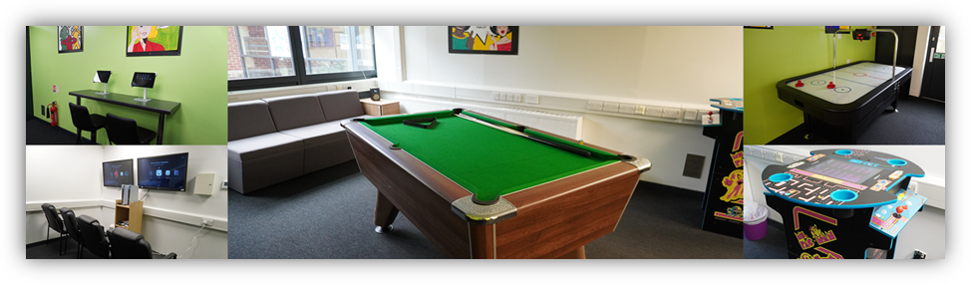
The reward room is a space that has been designed by students. It has a comfortable seating area, a variety of computer games, arcade games and a pool table.
At the end of each half term there is a reward trip for students who have consistently shown positive behaviours. The top eight students with the highest average reach score for the half term will be eligible to attend the half term reward trip.

For students who display challenging behaviour, there are consequences / sanctions for the choices they make. Alongside restorative conversations, students are issued with one or more of the following, dependent on the severity of their behaviour: -
- Low Reach scores for lesson
- Break/lunch/after school reflection time
- Phone calls home to parent / carers
- Agreed meeting with parent / carers
- Temporary / permanent removal of Reach reward (Creative / Heroic)
- Suspensions – which are kept to a minimum (research suggests this does not improve behaviour), see Appendix C for detailed procedures

From discussions between students and parents, the overall view is that rewards and consequences are supported and are dealt with extremely well. Both parents and students are appreciative that the approach towards students is tailored for each child, fully considering the needs of the student.

4.2 Person centred

The school is on the path to becoming a Trauma Informed school. The spaces around the school have considered the needs of our students, ensuring a safe and secure environment. All staff consider the wider environment when de-escalating behaviours. Staff ensure that they use the appropriate reflection spaces to support the individual. Communication between staff using a two-way radio, ensures that the spaces are available for students to access safely. Student risk assessments are updated regularly to ensure that the procedures put in place are there to support the student using the best approach. The staff team have CPD sessions to upskill their Trauma Informed approaches. Training includes:
- Trauma Informed Practice
- Understanding behaviour
- Attachment Theory
- Adverse Childhood experiences
- Restorative approaches

Staff have the restorative approaches on their lanyards as prompts to support students during dysregulated time.
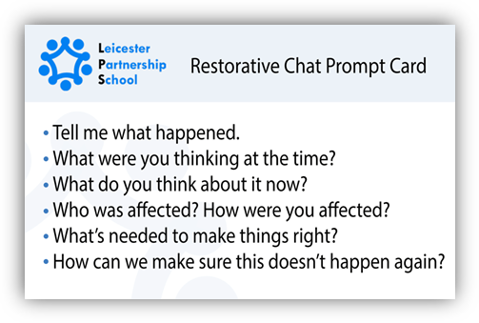
Staff are well aware of unacceptable behaviours such as child on child abuse, sexual harassment, discrimination alongside other behaviours which are detailed further in our Safeguarding Policy. The APST team are allocated students who require additional interventions.

Staff are familiar with each student’s profile who attend the school. A One Page Profile is available for each student alongside a Risk Assessment. Both documents provide staff with information on how to support students in their school experience at LPS. The documents both provide a picture of approaches that are suited to each student when they are dysregulated. Tutors keep both documents up to date for each student. Please refer to Appendix B for further information.

4.3 Encouraging positive behaviours

Through communicating high expectations for behaviour through the ethos of the school, policies and a committed team who encourage mutual respect and exemplary behaviour.

At LPS, students are expected to:
- Be respectful to themselves and others
- Listen to and follow instructions
- Show kindness, be polite and inclusive to others
- Exhibit safe behaviours
- Remain focused in lessons

These expectations are displayed around the building, including classrooms. Following these expectations, the REACH rewards in daily lessons recognises this behaviour.

Every individual at LPS is expected to be inclusive of others, feel safe and secure. Should any member of the school community feel threatened by aggression or violence, it is not accepted and will be challenged and dealt with accordingly. All incidents of bullying that are reported by staff or students will be dealt with promptly. Parents / carers will be informed if the student is the victim or the perpetrator. Please refer to the Anti-bullying policy for further details.

We aim to start each day with a positive start for all students. Students enter school and take part in breakfast time, where staff welcome students into the school. Students are encouraged to eat breakfast once they have handed in their belongings. Staff will engage in conversations with students, play games and provide a friendly environment.

4.4 Damage to property / theft and criminal damage

The school believes in fostering accountability through a restorative approach, helping students understand the impact of their actions and work towards making things right. If a student causes damage to property, they will have the opportunity to engage in restorative reparation work during their own time. However, we recognise that a student who is dysregulated may not be in the right frame of mind to engage in this process, and the damage may pose safety concerns to others. In such cases, a restorative conversation will take place to understand the situation and address the underlying causes of the behaviour. If a student continues to damage property, we will work with them and their family to discuss a fair contribution toward the repair or replacement of the item, always keeping the focus on growth, learning, and repairing harm.

Staff report any damage to the premises officers, Business Manager and record the damage on CPOMS with details of the incident. After evaluation of the damage, the Headteachers will make a decision whether the parents / carers will be requested to make a contribution. A letter explaining the damage and details of repair / replacement, with a full breakdown of cost will be provided to the parents / carers. If students are involved in any theft and serious damage to property, police will be contacted as well as parents / carers.

4.5 Search, screen and confiscation

The LPS takes care to ensure the safety of all the students who attend the school. Students are taken through a metal detection procedure to screen for items that are not allowed on site such as weapons, vapes, lighters. Should there be any concerns with the screen of the student using the metal detector, a low level, medium level or higher-level search will take place. Please refer to the Search Policy for further details.

4.6 Drugs, alcohol, substance misuse and smoking

Drugs, alcohol, legal highs, cigarettes, e-cigarettes and matches are not allowed on to the school premises. If students are found using any of these on the way to school or on school visits, or in possession of these items, students will have those items confiscated. For further information, please refer to the Drugs, alcohol, substance misuse and smoking policy.

Students are educated on the use of drugs, alcohol, substance misuse and smoking in the Personal Development lessons. Please refer to the Drugs, Alcohol, Substance Misuse and Smoking Policy for further details.

- Reflection spaces

The two reflection spaces renovated in 2024 are another step that the school has taken to provide a Trauma Informed approach to the management of behaviour. The reflection spaces are purpose built with comfortable seating, temperature controls, soothing music (controllable) and padded areas. Students are encouraged to take themselves to reflection spaces with a member of staff when they are dysregulated. The use of the spaces is seen as a positive management of their behaviour. Students feel positive about the use of the spaces and respect the space that is provided for them. Students are encouraged at LPS to use sensory or time-out breaks effectively – for some students, this may be some time in one of the reflection spaces, for others it may be some fresh air or change of scenery. Please refer to appendix A for further information.

Students also use the space in Hazel for planned interventions for example:
- Emotional regulation
- Anger management
- Hyperactivity
- Prosocial
- Friendship problems
- Draw and Talk

Students benefit from the privacy, calming atmosphere, safe and distraction free space.

2 x Spacious Reflection Rooms that are both identical located in key stage 4
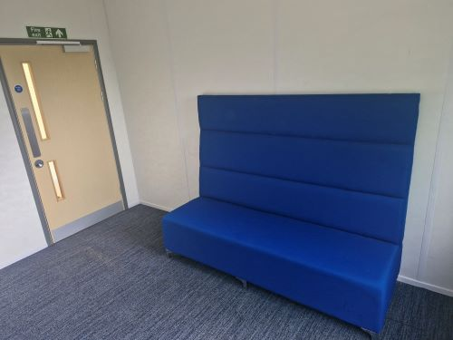

Chestnut [located in Key stage 3]

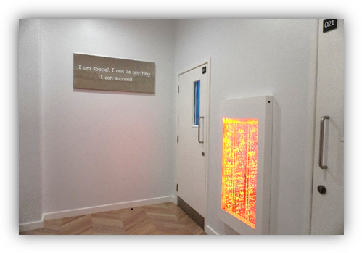
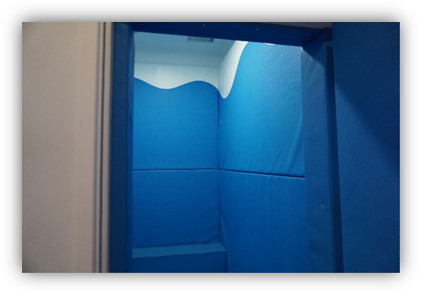

Hazel [located in Key stage 3]

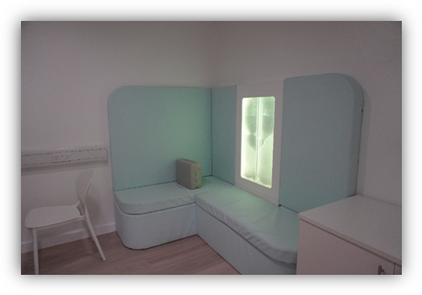
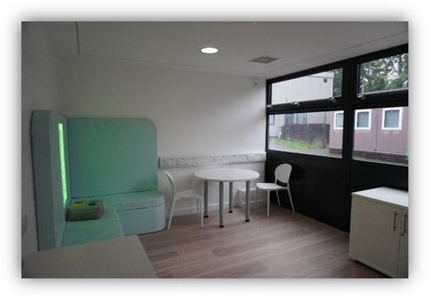

Both Chestnut are Hazel will never be used for the following:
- As a punishment
- As an unplanned or informal restrictive practice
- Any intervention which is not regularly monitored
- As a substitute for inadequate staffing
- Storage or any equipment within it or its immediate vicinity

- Suspensions

Students may be suspended from LPS for their safety as well as others. A student who is dysregulated can cause themselves distress as well as other students on site. The staff at school endeavour to keep the student in school wherever possible.

At the LPS we understand that each student and their behaviour comes with its own unique presentation. It is the decision of the Headteacher as to the student’s suspension and the duration of their suspension. The context of the incident is always taken into account Parents / carers are contacted via phone and a letter is sent to parents confirming the suspension details. A meeting is held with parents / carers before the student is to return to school.

The procedure for sending students is home is detailed further in Appendix C.

- Physical interventions

Physical interventions are always the very last resort at the LPS and only undertaken after a dynamic risk assessment has taken place by staff members to assess the safety of a situation. A wide variety of de-escalation techniques will always be trialled in the first instance as per the student’s risk assessment.

All staff members are highly trained using the ‘Team Teach’ approach to positive handling. If a physical intervention is needed it is due to a safety risk:
- Where there is an imminent risk of injury or harm to the student or another individual
- Where there is a serious and building risk of injury dues the significant damage to property
- Serious and persistent disruption, impacting on the learning of others.

Please refer to the Physical intervention Policy for further information.

- Monitoring and evaluation

REACH scores are recorded weekly on a tracker. Student achievements are celebrated with a half termly leader board displayed in the hall for all students to see. The tracker allows for senior leaders to track behaviour patterns in lessons and time of day. Tracking of data ensures students are able to achieve in their lessons, with extra support given if needed.

At LPS physical interventions are a necessary course of action after undergoing a dynamic risk assessment. Physical interventions are recorded using a Physical Intervention form provided by the Leicester City Council. An in-house tracker is used to identify key patterns in students, times of day / term and physical interventions used. The data from the tracker supports future CPD sessions for staff.

Suspensions and reflections are recorded on a tracker. The information is reviewed and analysed on a half termly basis. We use the data to help shape what type of provision is conducive to meet need for all students.

Appendices

Appendix A – Evidence Based Approaches operates within a trauma-informed framework, recognising that students may experience emotional dysregulation and that they need support to return to a state of regulation, either through co-regulation or supported self-regulation. Staff are trained to understand and respond to each student’s unique needs, acknowledging that these needs may stem from past experiences. This approach ensures that professional relationships remain strong, focusing on re-establishing trust and reconnection, while fostering a sense of safety and support for each student’s emotional well-being and growth.
The process recognises that students will have consequences for their choices in behaviour, with an emphasis on working on ways in which a student can develop their response to dysregulation. Strategies for supporting students displaying challenging behaviours and a range of emotions are based on: an understanding of the functioning and development of the brain, reminders of the link between choices and consequences, the role trauma and adverse childhood experiences has on development and the importance of an emotionally available and trusted adult to support with the 4Rs – Relate, Regulate, Reconnect and Restore (The Neurosequential Model of Therapeutics).

Adverse Childhood Experiences (ACEs) refer to traumatic events that occur during childhood, such as abuse, neglect, or household dysfunction (e.g., substance abuse, mental illness, or domestic violence). Research, particularly the landmark study by Felitti et al. (1998), found that ACEs are strongly linked to a range of negative outcomes in adulthood, including mental health issues, chronic diseases, and social problems. The more ACEs a person experiences, the higher their risk for these outcomes. Recognising ACEs and their impact is crucial in trauma-informed practices, as it helps professionals better understand and support individuals who have experienced early adversity.

Reference:
Felitti, V. J., Anda, R. F., Nordenberg, D., et al. (1998). The Relationship of Adult Health Status to Childhood Abuse and Household Dysfunction. American Journal of Preventive Medicine, 14(4), 245-258.

Restorative practice is an approach focused on repairing harm and building relationships rather than punishing wrongdoing. It emphasises dialogue, accountability, and mutual respect, aiming to address the needs of both those harmed and those who have caused harm. Restorative practices involve creating opportunities for people to discuss the impact of their actions, take responsibility, and work together to find solutions that promote healing and positive behaviour change. The approach is rooted in the belief that fostering empathy, responsibility, and understanding leads to stronger community connections.
Reference:
Zehr, H. (2002). The Little Book of Restorative Justice. Good Books.

Our school children already face barriers to education; however, these barriers can be exacerbated by hunger, which puts them at even further disadvantage to getting the learning and skills they need. A report into the impact of the National School Breakfast Programme by Family Action and Magic Breakfast found that schools felt that providing breakfast was important or extremely important in positively supporting:
- readiness to learn (99%),
- concentration in class (99%),
- healthy eating habits (95%),
- general behaviour (94%), and
- educational attainment (94%).

The study found that following introduction of breakfast provision at schools, there was a 28% reduction in late marks in a term, and a 24% reduction in behavioural incidents.
Catch 22 – November 2023 (Education and nutrition – the catch-22 in Catch22 | Catch22)

Sensory / time out breaks: Children with sensory processing difficulties may struggle with processing and responding to sensory information in their environment, which can impact their behaviour, emotions, and ability to learn. It is important to understand how to support these children and create a positive learning environment for them. Children may find it challenging to focus and learn in a traditional classroom environment. They may experience distractions from sensory stimuli, have difficulty following instructions, and struggle to engage in group activities. This can lead to feelings of frustration, anxiety, and low self-esteem. Children with sensory processing difficulties require support and understanding from their teachers to succeed in the classroom. By creating a sensory-friendly environment, providing visual aids, breaking tasks into smaller steps, offering sensory breaks, and using positive reinforcement, teachers can help these children thrive and reach their full potential.

ADHD Foundation – August 2023 (A Practitioners Guide to Sensory Processing)
PACE stands for Playfulness, Acceptance, Curiosity, and Empathy. It is an approach used in trauma-informed care, particularly in working with children, to foster emotional regulation and strengthen relationships.
- Playfulness: Engaging with children in a light-hearted, fun, and creative way to help reduce tension and encourage connection.
- Acceptance: Unconditionally accepting the child’s feelings and behaviours without judgment, allowing them to feel safe and understood.
- Curiosity: Showing genuine interest in the child’s experience and perspective, fostering open communication and trust.
- Empathy: Understanding and validating the child’s emotions, demonstrating care and compassion.

The PACE model, developed by Dr. Dan Hughes, is used to create a supportive, relational environment that promotes emotional healing, self-regulation, and secure attachment. It is particularly effective with children who have experienced trauma.
Appendix B – One Page Profiles and Risk Assessments

One Page Profiles

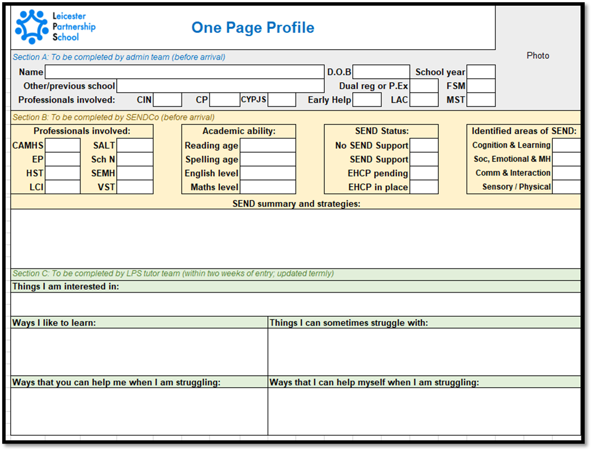

One-page profiles are a one-stop source of information to aid the smooth transition of young people from their mainstream school to LPS. The document has three key areas:
Section A includes basic information about the young person as well as whether they are dual registered or permanently excluded, whether they receive free school meals and any professional health and care agencies that have been involved. This should be completed by the admin team of the referring school before arrival.

Section B is completed in collaboration between the SENDCos at the referring school and LPS, before the young person's arrival. It includes a record of SEN professionals involved, academic levels attained (including reading and spelling ages), SEND status (including whether the young person has an Education, Health and Care Plan) and their identified areas of SEN (Cognition and learning; Social, emotional and mental health; Communication and interaction; Sensory and/or physical). A qualitative section then details a summary of the young person's SEN as well as strategies used.

Sections A and B allow LPS staff to plan lessons that meet the individual needs of the young person from their very first lesson.

Finally, Section C provides the opportunity for student voice. Similar to 'all about me' pages, this is completed by the young person in conversation with their trusted staff member after a fortnight of their enrolment at LPS. They describe in detail the things that the young person is interested in, ways they like to learn, things they can sometimes struggle with, ways staff can help them when they are struggling and ways, they can help themselves in these situations. This section helps young people reflect on their behaviour, including triggers to dysregulation, and take ownership of a plan to manage it.

Risk assessments

Risk assessments are completed by the tutor upon arrival and includes key information about the student. The information is based on details given by the host school on their information passport, PSP, school behaviour logs and other relevant information. The risk assessments are continuously reviewed and updated after every serious incident.

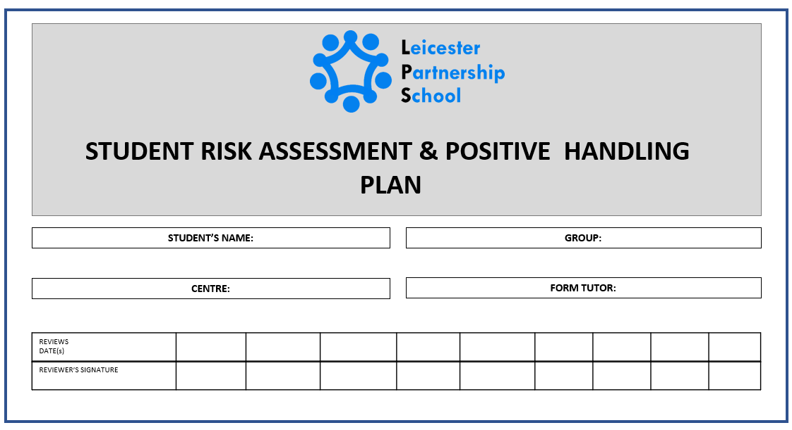
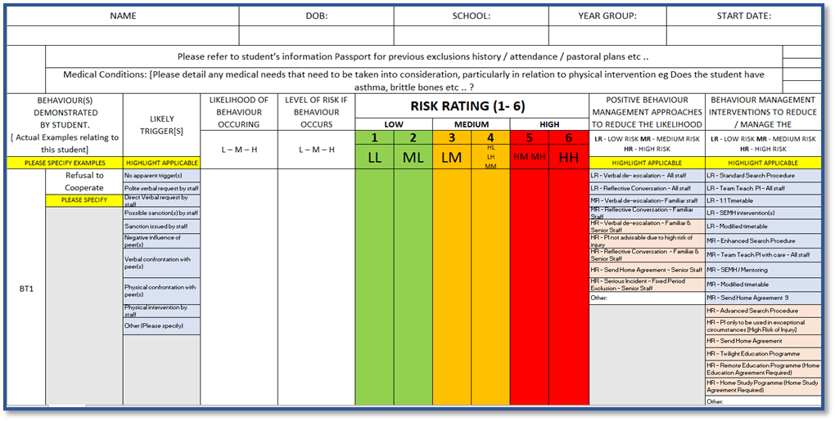

Appendix C – Suspensions

Sending Home (LPS):
If it is decided that an LPS student needs to be sent home for H&S reasons, the following procedure must be followed:
- If a student is sent home for a behavioural incident before the register is closed, a full day suspension (or part thereof if on a part time timetable) must be issued.
- If a student is sent home for a behavioural incident after the register is closed, a half day suspension must be issued.
- A telephone call will be made to parents/carers by the admin team and a letter produced to be signed off by either the Headteacher (cc’d by an Assistant Head of School in their absence)
- If a part time student is sent home after the register is closed but is close to the end of their session, a suspension will not be issued. A telephone call will be made to parents/carers by the admin team.
- If a dysregulated student is sent home pre-emptively to prevent a serious incident from occurring, this will be recorded as an authorised absence. A telephone call will be made to parents/carers by the admin team.

Issuing the Suspension:
Wherever possible if a suspension is issued it should be kept to a minimum.
It is recognised that at times a longer suspension is necessary to enable risk assessment and alternative timetable arrangements to be implemented, in such cases:
- A 1–2-day suspension will be issued. A telephone call will be made to parents/carers by the admin team and a letter produced to be signed off by the Headteacher (cc’d by an Assistant Head of School in their absence).
- In more complex cases needing longer preparation for alternative arrangements or multi-agency meeting, a maximum 5-day suspension will be issued.

This can only be sanctioned by the Headteacher

In their absence a 2-day suspension pending further investigation will be issued to allow Headteacher more time to consider the longer suspension.

Return to School:
It is important that students and parents meet with Assistant Head of school [behaviour] and/or[tutor] before returning to their timetabled lessons but parent/carers being unavailable for the meeting should not prevent students from being readmitted.
- A face-to-face return to school meeting should be held no later than 10am the day after the suspension/sending home with parents/carers, student and the Assistant Head of school [behaviour]
- If a face-to-face meeting is not possible with parents/carers, they will be invited to attend via Teams or by telephone on speaker, with student and the Assistant Head of school [behaviour] or the tutor.

- If a multi-agency meeting is required, this will be held within the 5 day suspension period.

