Maths Policy
Schedule for Development, Monitoring and Review
Approved by governors on: | June 2019
Implementation monitored by: | Lynn Perry/Saj Ahmed
Review arrangements: | Annually  All policies will be reviewed if there are any significant developments or changes to legislation
Reviewed:  The next review of this policy: | June 2020  June 2021  June 2022  June 2023
MATHEMATICS POLICY

AIMS
The aim of this policy is to inform all stakeholders of the teaching and learning within the subject of Mathematics for all students in the Upper and Lower School who are part of The Leicester Partnership School.
A high quality mathematics education provides a foundation for understanding the world, the ability to reason mathematically, an appreciation of the power of mathematics and a sense of enjoyment and curiosity about the subject.
Full time students in the Lower School receive three hours of Mathematics throughout the week. This ensures that they are able to access a fuller Mathematics curriculum that reflects the components of The National Curriculum. This is evidenced in the Schemes of Work.

The Lower School
The aim in the Lower School is to compliment the work that is undertaken in mainstream schools which focuses on the national curriculum for Mathematics. students should:
- Become fluent in the fundamentals of mathematics, including through varied and frequent practice with increasingly complex problems over time, so that they develop conceptual understanding and the ability to recall and apply knowledge rapidly and accurately.
- Be able to reason mathematically by following a line of enquiry, and being able to develop an argument, justification or proof using mathematical language.
- Be able to solve problems by applying their mathematics to a variety of routine and non-routine problems. This includes breaking down problems into a series of simpler steps and persevering in finding solutions.

The aim is that students will progress through the Key Stage showing that they are competent in the above three areas. However the decision as to when to progress, is always based on the security of the student’s understanding and their readiness to move on.

Developing Fluency
In this area students are taught to:
- Consolidate their numerical and mathematical capability from KS2 and extend their understanding of the number system and place value to include decimals, fractions, powers and roots.
- Select and use appropriate calculation strategies to solve increasingly complex problems.
- Use algebra to generalise the structure of arithmetic, including formulating mathematical relationships.
- Substitute values in expressions, rearrange and simplify expressions and solve equations.
- Move freely between different numerical, algebraic, graphical and diagrammatic representations e.g. equivalent fractions, fractions and decimals, equations and graphs.
- Develop algebraic and graphical fluency, including understanding linear and simple quadratic functions.
- Use language and properties precisely to analyse numbers, algebraic expressions, 2-D and 3-D shapes, probability and statistics.
Reason mathematically
- Extend their understanding of the number system; make connections between number relationships and their algebraic and graphical representations.
- Extend and formalise their knowledge of ratio and proportion in working with measures and geometry, and in formulating proportional relations algebraically.
- Identify variables and express relations between variables algebraically and graphically.
- Make and test conjectures about patterns and relationships; look for proofs or counter-examples.
- Begin to reason deductively in geometry, number and algebra, including using geometrical constructions.
- Interpret when the structure of a numerical problem requires additive, multiplicative or proportional reasoning.
- Explore what can and cannot be inferred in statistical and probabilistic settings, and begin to express arguments formally.
Solve problems
- Develop their mathematical knowledge, in part through solving problems and evaluating the outcomes, including multi- step problems.
- Develop their use of formal mathematical knowledge to interpret and solve problems, including in financial mathematics.
- Begin to model situations mathematically and express the results using a range of formal mathematical representations.
- Select appropriate concepts, methods and techniques to apply to unfamiliar and non-routine problems.

CURRICULUM COMPONENTS
- NUMBER
- Students are given a wide range of activities to learn and consolidate skills and produce number work in meaningful contexts. These incorporate an emphasis on students selecting appropriate methods for calculation (mental, written, calculator or estimation).
- ALGEBRA
- Students are given a wide range of activities and investigations in order to develop their algebraic fluency including for example, substituting numerical values into formulae and expressions. Students also taught to use and interpret algebraic notation.
- RATIO, PROPORTION AND RATES OF CHANGE
- Students are given a wide range of activities to develop their understanding and use of vocabulary relating to ratio and proportion. Students are taught to be able to solve problems involving proportional reasoning and to change freely between standard units.
- GEOMETRY AND MEASURES
- Students are given opportunities to develop their understanding of the properties of 2D and 3D shapes. Students are taught to apply formulae to calculate and solve problems, for example the area and perimeter of a given shape/s.
- PROBABILITY AND STATISTICS
- Students are taught to record, describe and analyse the frequency of outcomes of simple probability experiments. They are encouraged to construct and interpret tables, charts and diagrams and to use appropriate calculations to find mean, median and mode.
Upper School
The aim in the Upper School is to enable students to develop into successful learners, confident individuals, effective contributors and responsible citizens. Students build upon their prior knowledge in order to extend their mathematical information, improve in their problem solving skills and be prepared to successfully meet the mathematical challenges of the wider curriculum and the world around them.
In addition the teaching of Mathematics in the Upper School is designed to stimulate student interest, enthusiasm and enjoyment for the subject, whilst preparing them for the demands of national qualifications. Throughout this, student progress is accurately assessed with parents/carers being informed of student achievement.
LPS offers students a Functional Skills programme and a GCSE AQA Mathematics 1 year course for those students who it is viewed would cope with the rigorous demands of this qualification.
The Functional Skills qualification ranges from Entry Level 2 to Level 2 and students are assessed in the areas of number, shape and measure and handling data. In addition GCSE students are supported from Foundation to the higher level.
CURRICULUM COMPONENTS
Number
- Addition, multiplication, subtraction and division in practical circumstances.
- Rounding up and down, order numbers, sequences and prime numbers and number relations.
- Know how to approximate and use ‘best guess’ correctly.
- Add and subtract using 3 digit numbers.
- Solve practical problems involving multiplication and division
- Know how to convert fractions to percentages and decimals. Know how to add, subtract, multiply and divide simple fractions, percentages and decimals. Know how to simplify fractions and to recognise improper fractions. Recognise factors and multiples, to calculate square and cubed numbers and to know how to define a prime number. To use this information to enhance the understanding of fractions.
- Recognise and calculate percentages of a given number. Know how to calculate V.A.T. Add and subtract decimals to 3 decimal places.
- Know how to use a calculator to check answers and calculate more complex problems.
- Complete simple calculations involving money.
- Probability. Use data to assess the likelihood of an outcome.
Measure, shape and space.
- Calculate and convert lengths, capacities, weights and temperatures.
- Calculate simple areas.
- Recognise and calculate perimeters.
- Construct geometric diagrams, models and shapes.
- Calculate capacity. Understand timetables and 12 and 24 hour clocks in digital and analogue formats.
- Estimate lengths, times and weights.
- Recognise and name simple 2d and 3d shapes and their properties.
- Know how to use geometric equipment to construct 2d shapes.
- Draw/Measure angles and perform angle calculations

Data.
- Collect and represent data. Tally charts, pictograms, bar charts and graphs.
- Know how to read and produce a pie chart.
- Calculate mean, median, mode and range
- Finding probabilities and being able to write them as fractions, decimals or percentages
Algebra.
- Become familiar with prime numbers and prime number decomposition.
- work with sequences and find the nth term of a series.
- Become familiar with algebraic notation and writing algebraic expressions.
- Expand and simplify expressions, collecting like parts.
- Solve algebraic equations.
- Understand the index laws.
- Use algebra to factorise and expand algebraic expressions with increased complexity.
- Solve problems using simultaneous equations.

Functional Skills Programme Entry Level 1 to Level 2
Students develop the confidence and ability to be able to:
- Solve problems
- Process calculations
- Interpret and explain situations
Functional skills in mathematics equip learners with the ability to apply these practical skills in a range of different contexts including:
- Work and education
- The community
- Citizenship and the environment
- Media and communication
- Family, home and social services
Integral to Functional Mathematics is the development of process skills. These process skills enable students to:
• understand a situation

• choose an approach to tackle the problem

• formulate a model using mathematics

• use mathematics to provide answers, interpret and check the results
• evaluate the model and approach
• explain the analysis and results
• apply and adapt this experience to other situations as they arise.
Maths is assessed as one component and incorporates 3 skills which involve different types of number and data processing.
The key areas are:
- Number
- Measure Shape and Size
- Handling Data

Assessment Overview
- The single controlled assessment task is 1 hour long for Entry Levels 1 and 2, and 1.5 hours long for Entry Level 3.
- Levels 1 and 2 each have one externally marked test, which is one hour and 30 minutes duration. Tests are available onscreen and on demand.
- EL2 to EL3 teaching is done through work packs on each topic, in order to move onto the next topic they should ensure to get 70% in their packs. These packs are filed in their individual box file. Feedback slips given at the end of each pack.
- L1 and L2 Learners- As these exams are onscreen. The students are given all their work packs on the computer which are put into their drives. They work on the computer and questions and answers are written there.
- This enables them to get familiar with the onscreen testing. The work packs are printed off and placed into their individual folders with their feedback slips.
Trackers are placed in their books/folders to identify what level/topics they are working on and this also shows progression through their levels
GCSE AQA (8300) in Mathematics
http://www.aqa.org.uk/subjects/mathematics/gcse/mathematics-8300
The AQA Mathematics qualification requires students to:
Develop knowledge, skills and understanding of mathematical methods and concepts, including:

Subject content :

1 Number
2 Algebra
3 Ratio, proportion and rates of change
4 Geometry and measures
5 Probability
6 Statistics

(Moved this a line lower)
Assessments GCSE Mathematics has a Foundation tier
(grades 1 – 5) and a Higher tier (grades 4 – 9).

Students must take three question papers at the same tier (one calculator based exam and 2 non-calculator based exams).

All question papers must be taken in the same series.

The information in the table below is the same for both Foundation and Higher tiers. The Subject content section shows the content that is assessed in each tier.
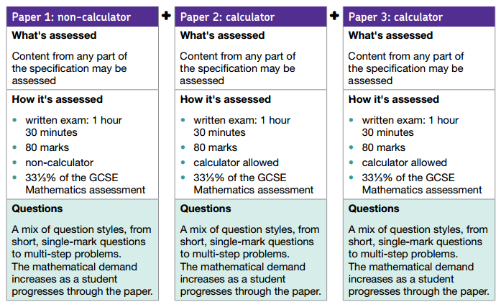
Assessment objectives
Assessment objectives (AOs) are set by Ofqual.

The exams will assess the following AOs in the context of the content set out in the Subject content section.
- AO1: Use and apply standard techniques
Students should be able to:
  - accurately recall facts, terminology and definitions
  - use and interpret notation correctly
  - Accurately carry out routine procedures or set tasks requiring multi-step solutions.

- AO2: Reason, interpret and communicate mathematically
Students should be able to:
  - make deductions, inferences and draw conclusions from mathematical information
  - construct chains of reasoning to achieve a given result
  - interpret and communicate information accurately
  - present arguments and proofs
  - assess the validity of an argument and critically evaluate a given way of presenting information.

- AO3: Solve problems within mathematics and in other contexts
Students should be able to:
  - translate problems in mathematical or non-mathematical contexts into a process or a series of mathematical processes
  - make and use connections between different parts of mathematics
  - interpret results in the context of the given problem
  - evaluate methods used and results obtained
  - evaluate solutions to identify how they may have been affected by assumptions made.

New Grading System
New GCSEs will be graded 9–1, rather than A*–G, with grade 5 considered a good pass and grade 9 being the highest and set above the current A*. The new system is intended to help provide more differentiation, especially among higher achieving students.
By 2019, all GCSE results will be using the new system.
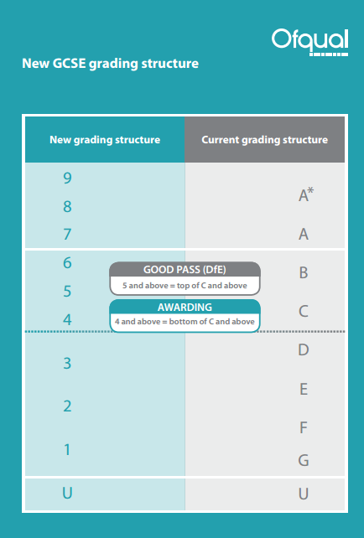

ASSESSMENT
(To be read in conjunction with The Leicester Partnership School Assessment Recording and Reporting Policy)
At KS3 and KS4 students are assessed using a combination of Teacher Assessment and Functional Skills Assessment Criteria. At KS4 those students who undertake G.C.S.E. Mathematics are assessed according to AQA Linear Assessment Criteria.
The recording of student progress at both KS3 and KS4 is completed using The Leicester Partnership School Feedback Slip, Forskills documentation, GCSE documentation and staff records.

MONITORING AND EVALUATION
The monitoring and evaluation of this policy takes place through the following:
- Lesson Observations
- Learning Walks
- Work Scrutinies
- Marking Scrutinies
- Assessment Data Tracking
- Performance Management
- Appraisals
- Staff Meetings

.

