

PSHE Policy

Schedule for Development, Monitoring and Review
Approved by governors on: | 18th March 2021
Implementation monitored by: | Tom Liney
Review arrangements: | Annually  All policies will be reviewed if there are any significant developments or changes to legislation
Reviewed:  The next review of this policy: | June 2022  June 2023  June 2024  June 2025  June 2026

Contents

Page

Aims and Key Principles 4

Programmes of Study 5 - 6

Accredited courses 6

Assessment of Personal and Social Development 7

Monitoring and Evaluation 7

Appendices 9 – 11

CURRICULUM POLICY- PERSONAL, SOCIAL, HEALTH AND ECONOMIC EDUCATION

AIMS
The aim of this policy is to inform all stakeholders of the teaching and learning within the subject of Personal, Social, Health and Economic Education (PSHE) for all students in KS3 and KS4 who are part of the Leicester Partnership School.

The intent of PSHE education is to provide opportunities for pupils to develop essential skills and attributes to keep themselves healthy and safe and to thrive in life and work. These skills and attributes include resilience, managing peer pressure, empathy, communication and negotiation, team-working, adaptability, risk management and personal, interpersonal and social effectiveness. Pupils develop these skills and attributes while learning about the areas in relation to Health and Wellbeing, Relationships and Wider World

Key Principles

PSHE is recognised as one of the building blocks of success in life. It supports a student’s development by helping them to interact effectively and develop positive attitudes to themselves and others. However, this does not happen in isolation and relies on influential adults to help model appropriate behaviour.

Students who attend the Leicester Partnership school (KS3) are expected to follow a PSHE curriculum based on the following 3 core themes linked to the PHSE curriculum.

Core theme 1 (Health & Wellbeing)

- Mental Health and emotional wellbeing
- Healthy Lifestyles
- Managing risk and personal safety
- Drugs, alcohol and tobacco
- Managing risk and personal safety

Core theme 2 (Relationships)

- Positive relationships
- Relationship values
- Respectful relationships
- Consent
- Bullying, abuse and discrimination
- Social influences
- Forming and maintaining respectful relationships
- Parenthood

Core theme 3 (Living in the wider world)

- Learning skills
- Choices and pathways
- Work and career
- Employment rights and responsibilities
- Financial Choices
- Media literacy and digital resilience

The core theme 3 (Living in the wider world) aspect of the curriculum is delivered by an external organisation (Above and Beyond Careers)

Students who attend the KS4 provision at Carisbrooke will complete modules in the areas as above in addition to the qualification-based programmes highlighted below

Level one and two diploma in Personal Social Development

- Stress and stress management techniques
- Cleaning
- Drugs awareness
- Living in the community
- Rights and responsibilities of citizenship
- Personal safety
- General skills for independent living
- Domestic cooking skills
- Understanding self in conflict
- College induction
- Taking part in exercise
- Dealing with bullying
- Engage in discussion

Level one certificate in employability skills

- Action planning for personal planning
- Building a personal career portfolio
- Building confidence and self esteem
- Creating a tailored curriculum vitae
- Time management

Students who attend a vocational placement will be provided with information in the following areas:

Careers Education Information and Guidance

This element of the KS4 upper school provision will follow a stable CEIAG programme that will explore Living in the wider world and eight GATSBY Benchmarks.

The programme will enable our KS4 cohort to gain knowledge and further understanding in the following areas.

- Gain an insight into specific career guidance and potential choices
- Students will gain knowledge of the career and labour market
- Students will access a varied curriculum that will link their learning to career opportunities
- Where appropriate KS4 students will encounter employers and employees to improve understanding of the world of work
- Where appropriate KS4 students will gain experience of the workplace
- Students will gain knowledge of further education opportunities and post-16 pathways
Yr. 11 Students will receive a specific personalised CEIAG package that will allow them to make realistic well-informed decisions about their post -16 destinations. This will be achieved through partnership work with the Connexions service and the completion of their E-prospectus digital platform application.

Accredited Courses

Leicester Partnership School (KS4)

- Level 1 diploma in PSD
- Level 2 diploma in PSD
- Level 1 certificate in employability skills

The above qualifications are governed by Aim Awards under the Skills for Employment and Further Learning umbrella.

Assessment of Personal, Social, Health and Economic Education

(To be read in conjunction with the Assessment Reporting and Recording policy)

Assessment is as central to effective teaching and learning in PSHE education as it is in any other subject. Effective use of assessment allows pupils and teachers to reflect on the learning that has taken place, increases motivation for learning and helps to demonstrate impact.

Framework for assessment

It would be inappropriate for assessment in PSHE education to be about grades, or about passing or failing. The model of assessment that is most meaningful in PSHE education is ipsative assessment.
It is important to carry out a baseline assessment before teaching anything new. As students’ learning in topics such as healthy eating, online safety, relationships and so on will come from a number of sources, we can only see whether they have made progress in their learning if we have established the knowledge, understanding, attributes, skills, strategies, beliefs and attitudes they had before any new teaching took place. The learning we wish to assess will relate to the students’ attributes and skills, as well as their knowledge and understanding related to the topic. (Please see below a brief description of the new PSHE assessment model)

- Baseline (thought shower) to be carried out at the beginning of each topic to assess current level of knowledge. (blue pen) (Appendix a)
- Feedback sheet to be completed at the end of the topic (Appendix B)
- Baseline to be revisited as an end point assessment (red pen)(Appendix a)
- Based on additional information provided students will be given a judgement. (No, partial, good or advanced knowledge gained.(Appendix C)
- Data to be added to the PSHE assessment tracked(Appendix D)

KS4 Educational Skills Centre

KS4 students who attend the RAVE programme are assessed in PSHE in the same way as KS3 students. (As above)

Students who are studying a qualification-based programme related to aspects of PSHE are assessed against a specific criteria as highlighted below

- Level 1 diploma in Personal Social Development
- Level 1 certificate in Employability Skills

The qualification is based on a set of standards that are set within the guidelines of AIM AWARDS.
Learners have to provide a range of portfolio-based evidence to show that the standards have been appropriately achieved against the assessment criteria. Their work is internally assessed and marked against the standards. At the end of the year the work is subjected to quality checks and verification through the Aim Awards External Verifier.

Monitoring and Evaluation

The monitoring and evaluation of this policy takes place through the following:

- Lesson Observations
- Learning Walks
- Schemes of Work
- Marking Scrutinies
- PSHE Assessment Data Tracking
- Leicester Partnership School - KS3 Scrap Book
- Trips and Visits
- Performance Management
- Appraisals
- Staff Meetings

Appendices
Appendix A
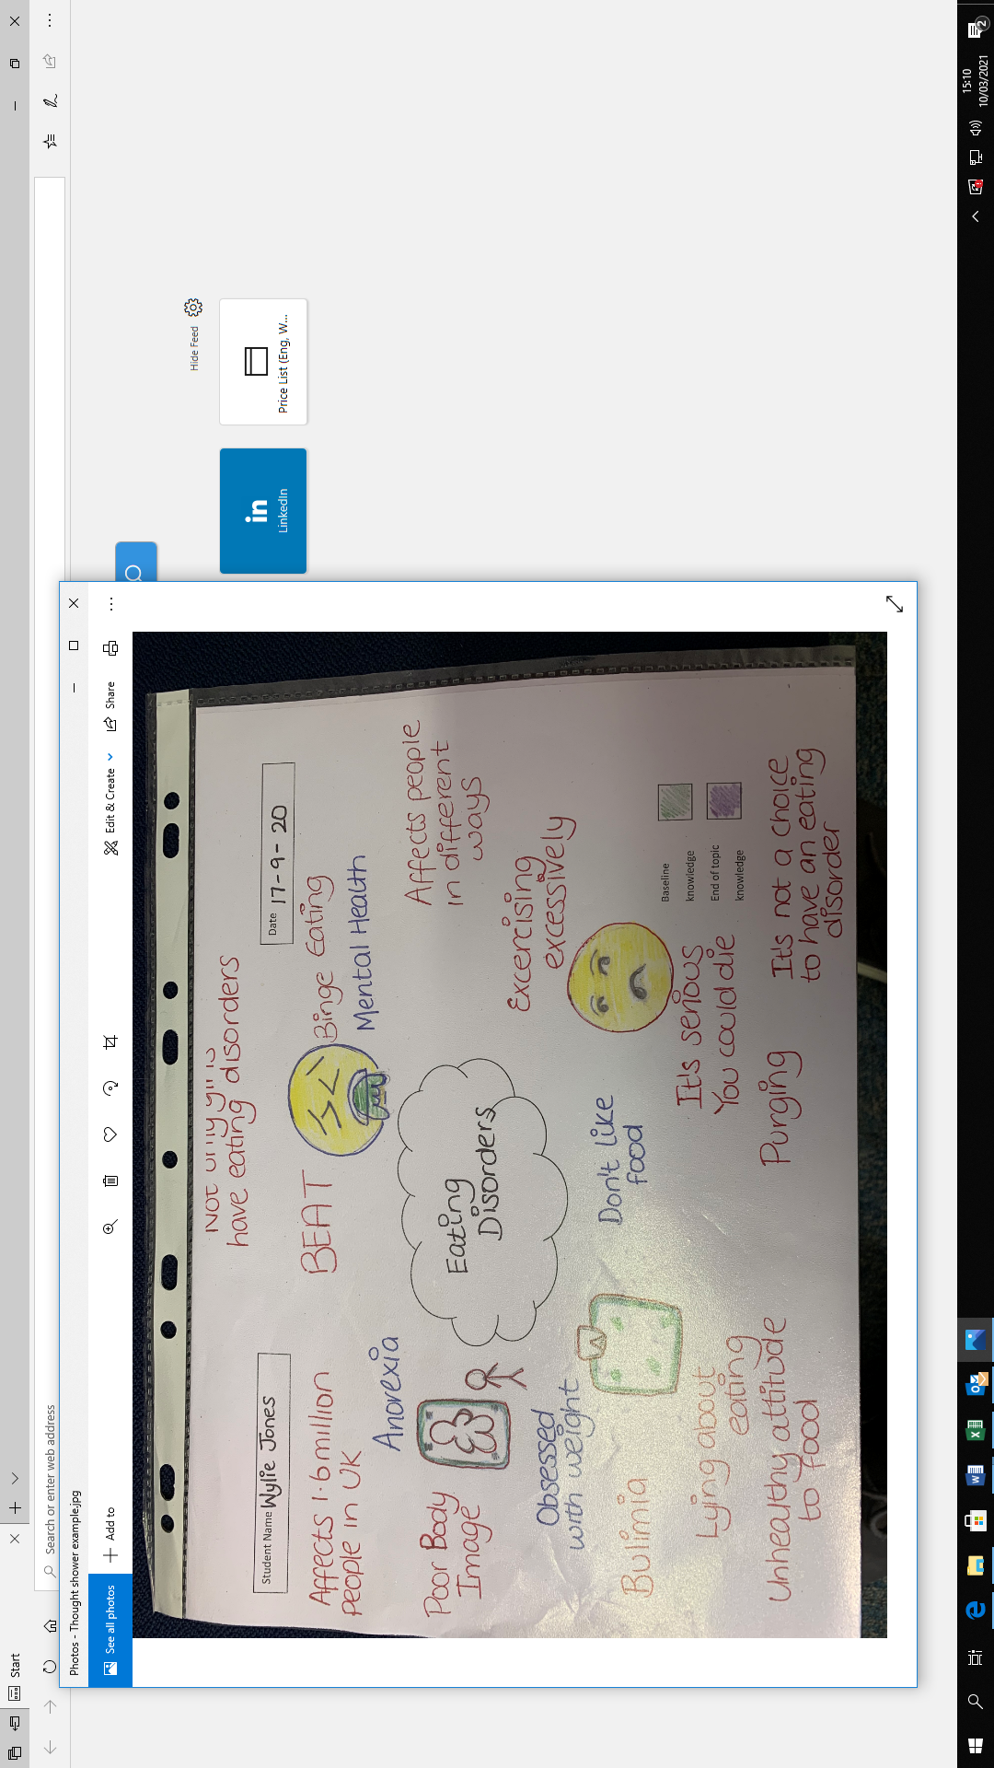

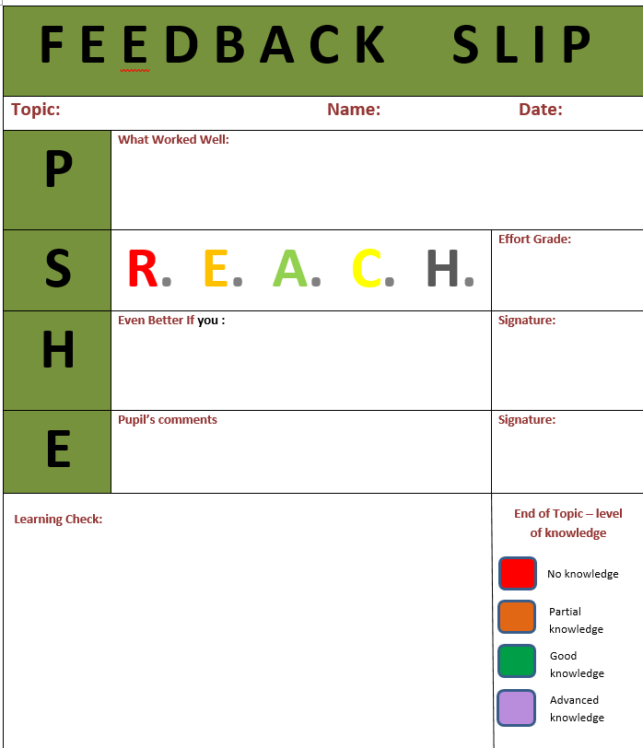
Appendix B

Appendix C

Level of knowledge | Assessment guide | Colour code
No Knowledge | 0
Partial knowledge | 1 - 4
Good knowledge | 5 -8
Advanced knowledge | 9+

Appendix D

