Physical Intervention Policy

Schedule for Development, Monitoring and Review
Approved by governors on: | 21st March 2021
Implementation monitored by: | Hilroy Thomas
Review arrangements: | Annually  All policies will be reviewed if there are any significant developments or changes to legislation
Reviewed:  The next review of this policy: | March 2024  March 2025

Contents
Page

Physical Intervention Policy:- 4

- Staff Training 4
- Use of Restrictive Physical Intervention 6
- Risk Assessment 5 -6
- Recording 6
- Post Incident Management 6 - 7
- Complaints 7
- Statutory Duty of the Service 7
- Monitoring, Evaluation and Review 7

List of Appendices:- 8

Physical Intervention Policy

The Leicester Partnership School recognises that in specific circumstances of serious threat to students, staff or property, it is necessary to use techniques that may involve some physical restraint in order to ensure the health and safety of all.

This policy should be read in conjunction with the Service Behaviour Policy.

Staff Training

Staff involved in the delivery of education/supervision of students, the members of the Senior Management Team and Premises Officers are required to take up the opportunity of participating in the Team Teach Positive Handling techniques training provided regularly in school. On successful completion of the training, staff are expected to develop their skills by periodically attending updates. These updates are held on a regular annual basis, and are run by the LPS’s own Team Teach Instructors. All Instructors attend regular refreshers and have up to date knowledge & experience with Team Teach.

Section 93 of the Education and Inspections Act 2006 enables teachers and staff who have authority over pupils at the school to use restrictive physical interventions. However, in an emergency the use of physical intervention by other people can be justified if it is the only way to prevent injury or to prevent an offence being committed. The use of physical intervention should be reasonable and proportionate and would be expected to reflect the person’s previous training in the appropriate use of Positive Handling Strategies. It is standard practice to update the Risk Assessment & Positive Handling Plan after regularly this is in order to ensure the pupil’s safety is paramount and best practice is employed.

The focus of all training is primarily the 95% de-escalation / 5% physical intervention model promoted by Team Teach and this underpins the LPS’s ethos and approach to behaviour management strategies. The Leicester Partnership School makes sure that all staff are aware and skilled in de-escalation, and ensuring that dignity of the pupil is central to all actions taken.

A register of Team Teach trained staff and staff authorised to use Team Teach Positive Handling techniques is kept on the Service’s Google Drive under TT Register. The Team Teach register is updated following every training event.

Use of Restrictive Physical Intervention

Staff may use, in relation to any student at the school, such force as is reasonable in the circumstances to prevent a pupil from doing, or continuing to do any of the following:

a committing any offence (or, for a pupil under the age of criminal responsibility, what would be an offence for an older pupil);

b causing personal injury to, or damage to the property of, any person (including the student her/himself); or

c prejudicing the maintenance of good order and discipline at the school or among any of its pupils receiving education at the school, whether during a teaching session or otherwise.

The staff to which this power applies are defined in section 95 of the Act. They are:

a any member of the delivery team who works at the school, and

b any other person whom the Head teacher has authorised to have control or charge of pupils. This includes

support staff whose job normally includes supervising pupils such as teaching assistants.

people to whom the Head has given temporary authorisation to have control or charge of pupils such as paid members of staff whose job does not normally involve supervising pupils (for example catering or premises-related staff).

The power may be used where the pupil (including a pupil from another school is on school premises or elsewhere in the lawful control or charge of the staff member (for example on a school visit).

Risk Assessment

Students can be referred to Leicester Partnership School provision via the Pastoral Support Plan (PSP) process. (Refer to LPS Admissions & Exit Policy)

Before commencing any programme a Risk Assessment of each students’ behaviour will be undertaken, taking into account relevant behavioural factors and previous behaviour history. A Positive Behaviour Plan for each student will also be formulated, which aims to encourage and promote good behaviour. Staff should be familiar with the content of these when working with young people who exhibit potentially challenging behaviours and refer to them on a regular basis. Risk assessments should be reviewed, updated and amended as and when necessary. They will also be updated regularly to reflect level of risk or any new triggers.

Parents/Carers will be required to undertake a pre-visit of the Leicester Partnership School prior to the young person commencing their provision. It will be explained to parents / carers by staff at this point that the Leicester Partnership School utilises ‘Team Teach’ positive handling techniques as a last resort to safeguard the health and safety of all, a record of this will be kept within the ‘pre-visit’ paperwork. The parent or carer will sign the consent form as an acknowledgement of the fact that the centre will use Team Teach Physical Intervention when needed.

The LPS acknowledges that all physical interventions involve a degree of risk to both staff and service users. The LPS will aim to keep this to an absolute minimum through regular ‘Team Teach’ physical intervention staff training updates and a regular review of practice and procedures. It is also acknowledged that some of the disengagement techniques may incur minimal discomfort for service users. This should always be kept to an absolute minimum by ensuring that physical intervention is used as a last resort and for the minimum period possible. The following quote from TEAM TEACH is an acknowledgement that physical intervention is not without risk but its aim is always to minimise these risks and avoid harm to service users.

Team-Teach techniques seek to avoid injury to the service user, but it is possible that bruising or scratching may occur accidentally, and these are not to be seen necessarily as a failure of professional technique, but a regrettable and infrequent “side-effect” of ensuring that the service user remains safe”. (George Matthews – Former Director)

Reflection rooms/areas should be used primarily as a positive element of the behaviour management strategy for a student, allowing time to reflect as part of de-escalation strategies.

Students must always be able to leave reflection rooms once the physical intervention has ended although time to reflect and de-briefing if appropriate should be encouraged.

Recording

Incidents where physical interventions have been used should be reported to the Senior Manager, or in his/her absence the Head Teacher, or Head of School - Alternative and Pastoral Services. An Incident report should be completed within 24 hours after the incident and an entry made on the CPOMS system of which is accessible for all members of staff. It is recommended that staff seek advice from a senior colleague when completing the report. The contents of the incident shall be reviewed on a half-termly basis and appropriate action taken. When the report is being completed it must be totally objective and free from emotive or personalised language.

Following a physical intervention, a Positive Handling Plan should be completed for the student involved. If the student already has a Positive Handling Plan then the plan will be reviewed. If appropriate the Risk Assessment will be amended. It is good best practice to review the risk assessment after every physical intervention.

Post Incident Management

Incidents that require the use of restrictive physical intervention can be upsetting to all concerned. After the incident has subsided the staff and student involved will be given emotional support. They will be provided with an opportunity to talk about what happened in a calm and safe environment. Staff and students may be given time away from the group to compose themselves after an incident There will also be a staff de-briefing session following an incident requiring a physical restraint.

Parents/carers will be advised by telephone as soon as possible of an incident involving their child and given the opportunity to discuss it by telephone or meeting within the centre if necessary. A telephone log of the call made to parents/carers will be made and retained for future reference using the CPOMS system.

Complaints

Complaints will be dealt with by the LPS Management Committee. The use of restrictive physical interventions must always be considered within the wider context of other measures. These include establishing and maintaining good relationships with students and using diversion, diffusion, de-escalation and negotiation to respond to difficult situations. Also the preservation of dignity is paramount throughout. If further support is required the Team Teach legal department are at hand for support and guidance.

Use of a physical intervention that is unwarranted, excessive or punitive is not acceptable. Failure to comply with this principle, when considering or using physical force, should be dealt with under the LPS disciplinary procedures.

Statutory Duty of the Service

The Head Teacher takes overall responsibility for the policy and its implementation, for liaison with the LPS Management Committee, parents, Local Authority and appropriate outside agencies. The Head Teacher will ensure that all staff are supported and have the opportunity to attend an appropriate training course including Positive Handling Strategies.

Monitoring, Evaluation and Review

This policy will be monitored and reviewed annually and will be promoted and implemented throughout the Service.

Appendices:

LPS Management Committee

LPS Team Teach Ltd. Positive Handling Instructors

LPS Team Teach Register – Staff Authorisation Record

Incident Report Form – CPOMS

Guidance and Further Information

Appendix 1:

1. Leicester Partnership School Management Committee

Name | Role
Christopher Bruce | Chair & Community Member
Anna White | Community Member
Shaun Whittingham | Head Teacher
Sophie Maltby | LA Member
VACANCY | Parent Member
Rhian Richardson | Community Member

Appendix 2

LPS Team Teach Ltd. Positive Handling Instructors

Name | Job Title | Team Teach Ltd. Status
Shaun Whittingham | Head Teacher | Team Teach Intermediate Level Positive Handling Instructor
Hari Pathak - Mould | Lead Practitioner | Team Teach Intermediate Level Positive Handling Instructor
Callum Bartlam | Lead Practitioner | Team Teach Intermediate Level Positive Handling Instructor

Appendix 3

LPS Team Teach Register - Exemplar:

Name | Current Status [Head Teacher Authorisation] | Next Refresher Due | Certificate Expires [Date]

Appendix 4 - Incident Report Form – CPOMS
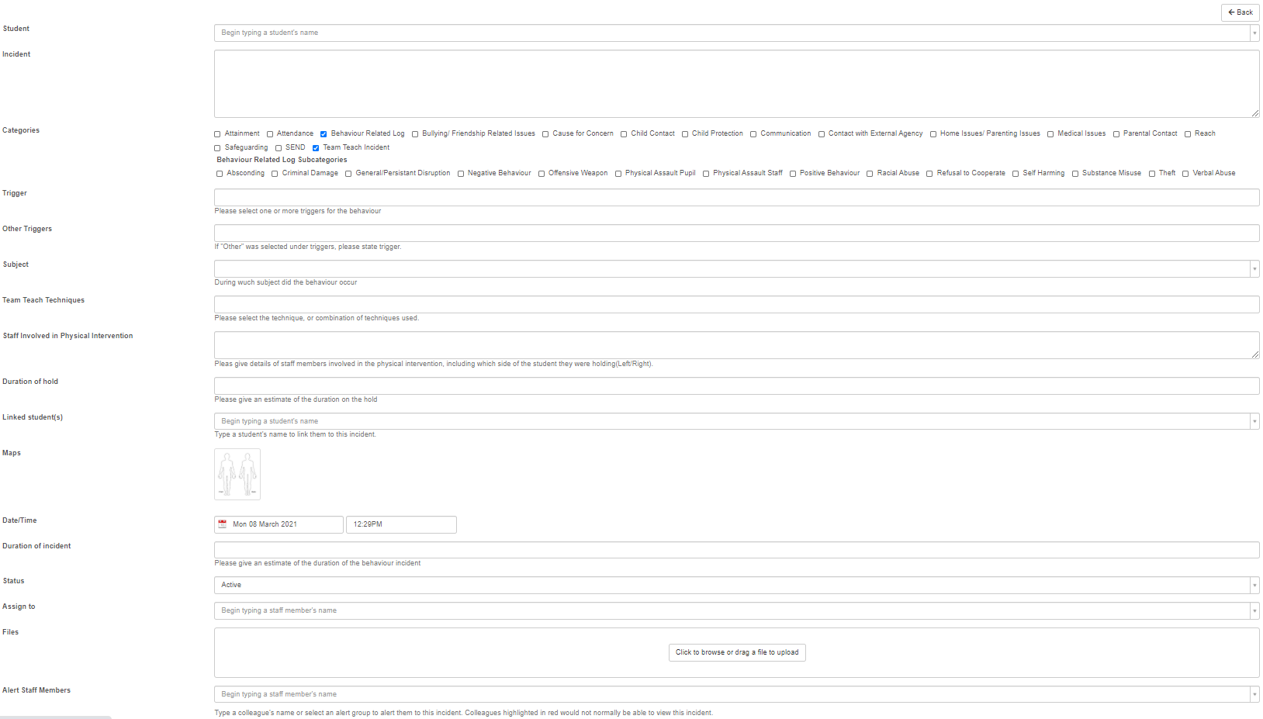

Appendix 5

Guidance & Further Information

‘The Use of Force to Control or Restrain Pupils’. July 2013

https://assets.publishing.service.gov.uk/government/uploads/system/uploads/attachment_data/file/444051/Use_of_reasonable_force_advice_Reviewed_July_2015.pdf

Education and Inspections Act 2006.

https://www.legislation.gov.uk/ukpga/2006/40/contents

Apprenticeships, Skills, Children and Learning Act 2009.

https://www.legislation.gov.uk/ukpga/2009/22/contents

- Team Teach. Ltd.

https://www.teamteach.co.uk/

- Physical Intervention Risk Assessment

https://drive.google.com/file/d/10cZVIVHA3PtGve2dvTXVi_R2CwfRLZId/view?usp=sharing

