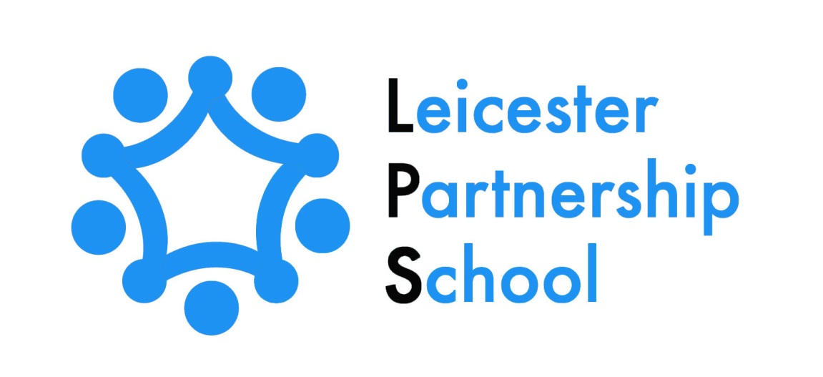

LEICESTER PARTNERSHIP SCHOOL

REMOTE EDUCATION PLAN

March 2024

Schedule for Development, Monitoring and Review
Approved by governors on: | 7TH March 2024
Implementation monitored by: | Shaun Whittingham
Review arrangements: | Annually  All policies will be reviewed if there are any significant developments or changes to legislation
Reviewed:  The next review of this policy: | March 24  March 2025

Remote education provision: Information for parents
This information from Leicester Partnership School is intended to provide clarity and transparency to children and parents or carers about what to expect from remote education. Where national or local restrictions require entire cohorts (or bubbles) to remain at home
This Remote Education Plan may also be applied when, for whatever reason, a student is not able to access their education on an LPS site for an extended period of time eg Due to injury or illness.

The remote curriculum: What is taught to pupils at home
Your child’s first day or two of being educated remotely might look different from our standard approach, while we take all necessary actions to prepare for a longer period of remote teaching.

What should my child expect from immediate remote education in the first day or two of pupils being sent home?
If your child is in KS3 and has to be sent home from Leicester Partnership School, you can expect that they will be able to access remote education immediately. The Remote Education Package will provide a full range of subject based learning materials. Your child will be sent an initial work pack to get them started.
If your child is in KS4, booklets to support learning in the subjects your child is studying will be sent to your home address. Students who attend vocational placements will also receive home study packs. Your child will also receive an email inviting them to join Google Classroom with an explanation of how to do this.
If it is deemed appropriate to offer on-line learning, as part of a student’s Remote Education Programme verification from Parents/Carers/Guardians will be obtained to assure that there is Wi-Fi/Internet access available in the home environment. For those children who do not have the hardware to enable access to the Remote Education Package, this will be “lent” to the child by Leicester Partnership School or learning materials will be provided in the form of paper-based work packs which will be sent to your home by Leicester Partnership School.

Following the first few days of remote education, will my child be taught broadly the same curriculum as they would if they were in school?
At Leicester Partnership School we will provide broadly the same curriculum as is taught in school but his may be in the form of work packs.
We may also offer students the opportunity to access on-line lessons through Google Classroom. These lessons include a three-part structure with Starter, Main and Plenary activities. The on-line learning also includes the use of Videos/Quizzes and Work Packs.

Remote teaching and study time each day

How long can I expect work set by the school to take my child each day?
We expect that remote education (including remote teaching and independent work) will take your child broadly the following number of hours each day:
Key Stage 3 | We expect that the remote education will take children the same amount of time at home, as it would in school, depending on that child’s current time table.  For example, if your child usually has 5 x 45mins lessons a day, this is how long the remote learning day would be. Therefore 3 hours 45 minutes per day.
Key Stage 4 | Each lesson for each subject your child studies lasts 45 minutes and therefore your child is expected to spend the same amount of time working on these set lessons each day. Some work packs extend to a series of lessons.

Accessing remote education

How will my child access any online remote education you are providing?
Your child will access their online remote education through work packs or via the school’s Google Drive, which can be accessed via their own personal school email.

If my child does not have digital or online access at home, how will you support them to access remote education?
We recognise that your child may not have suitable online access at home. We take the following approaches to support your child to access remote education:
- We will provide your child with paper-based work packs which will be sent to you and which you can return to schools for marking once they have been completed.
- LPS is also able to lend a laptop or tablet to your child with a signed consent/loan agreement and with printed instructions as to how to access the lessons online. Staff have and will, drop off this hardware to your address and will show you how to access Google Classroom.
- You can also request any printed materials needed if you do not have online access
- Your child can submit work to their teachers if they do not have online access, by sending back the printed completed work in the stamped addressed envelope provided in the initial posted work pack.

How will my child be taught remotely?
We use a combination of the following approaches to teach your child remotely:
- Telephone Support – Provided by Teachers & Tutors on a daily basis.
We are also able to offer ….
- Printed paper packs produced by teachers (KS4 e.g. Workbooks, Worksheets).
- Text books and reading books pupils have at home.
- Commercially available websites supporting the teaching of specific subjects or areas.
- Short-term project work and/or internet research activities.
- On-line “live” teaching via Google Meet.

Engagement and feedback

What are your expectations for my child’s engagement and the support that we as parents and carers should provide at home?
- LPS expect that your child will fully access the school work provided and engage fully with the work set, as if they were in their lessons in school.
- LPS expect that you as a Parent/Carer/Guardian will provide support to your child wherever possible during the time that they are engaged in remote learning. However, we do understand that there may be times when this could be difficult.
- LPS expect that you as a Parent/Carer/Guardian will establish a routine in your child’s day so your child is able to access their daily education provided and therefore their academic progression is maintained.

How will you check whether my child is engaging with their work and how will I be informed if there are concerns?
- LPS will check your child’s engagement with remote education via regular telephone calls and contact with you and or child. We may also do this via Google Classroom itself, as this platform informs all teachers & tutors involved as to whether your child has logged on and accessed their education.
- LPS will also telephone you on a weekly basis to let you know of your child’s progress and/or the lack of access to their Remote Education Package.
- At KS4, if it is deemed necessary, your child’s Keyworker may collect completed work and return it to your child.

How will you assess my child’s work and progress?
Our approach at LPS to feeding back on your child’s work and progress is as follows:
At KS3
- Returned work will be marked and you and your child will receive feedback in the form of a feedback slip and / or telephone call
- You and your child may also receive feedback electronically via the Google Classroom platform by staff.
- Posted in work will be marked and feedback given and then posted back if necessary. This will be done on a weekly basis.
- There may also be an option for your child to attend the school and work face to face for additional support where appropriate and necessary and it is safe to do so.
At KS4
- Returned work will be marked and you and your child will receive feedback in the form of a feedback slip and / or telephone call
- Electronically via the Google Classroom platform by the allocated curriculum lead.
- Weekly contact from your child’s allocated Keyworker, particularly when your child is completing work from home study packs
- Posted in work will be marked and feedback given and posted back if necessary
- In some cases, completed work can be collected from home by the allocated Keyworker for the curriculum lead to mark and provide feedback.
- There may also be an option for your child to attend the school and work face to face for additional support where appropriate and necessary and it is safe to do so.

Additional support for pupils with particular needs

How will you work with me to help my child who needs additional support from adults at home to access remote education?
We recognise that some children, for example some children with special educational needs and disabilities (SEND), may not be able to access remote education without support from adults at home. We acknowledge the difficulties this may place on families, and we will work with parents and carers to support those children in the following ways:

- LPS is willing to provide work for your child in a variety of different formats eg Work Packs, Booklets, on-line tutorials, videos or resources.
- If required the LPS will issue or lend a laptop or tablet to your child with a signed consent/loan agreement and with printed instructions as to how to access the lessons online if your child does not have access to their own devices. Staff have and will, drop off this hardware to your home and also show you how to access Google Classroom.
- All resources have been differentiated and adapted to be SEND appropriate, and to appeal to the maximum amount of different learning styles as possible.
- At KS4 your child will receive work that is targeted specifically at their “working at” level.
- You will be given details of contact numbers and email addresses of staff so you can access extra support on a daily basis.
- If you are a parent of a child with SEND you can request any printed materials relating to the on-line learning if your child has difficulty in working off a screen.

