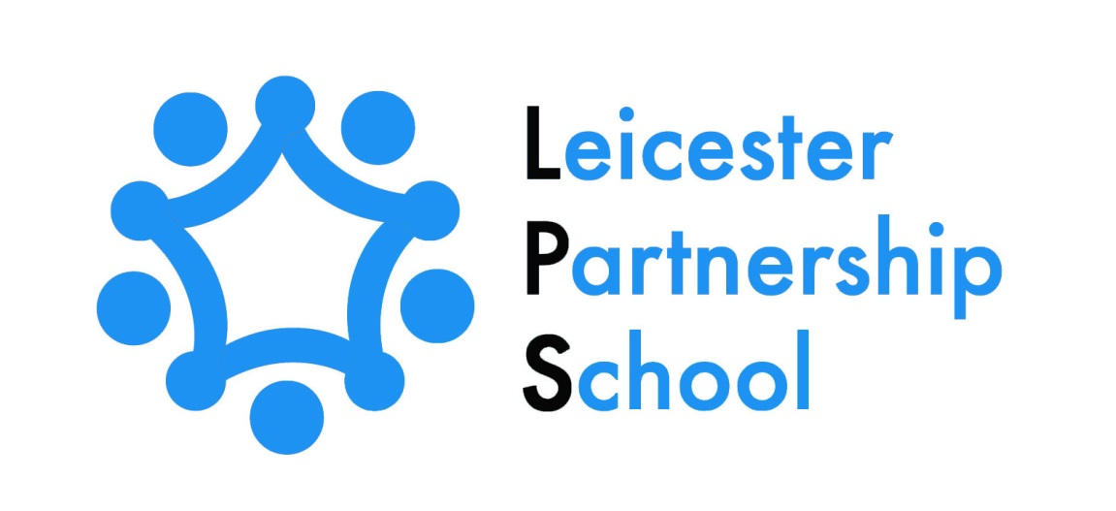

LEICESTER PARTNERSHIP SCHOOL

REMOTE EDUCATION PLAN

JANUARY 2022

Remote education provision: Information for parents
This information from Leicester Partnership School is intended to provide clarity and transparency to children and parents or carers about what to expect from remote education. Where COVID national or local restrictions require entire cohorts (or bubbles) to remain at home
For details of what to expect where individual children are self-isolating, please see the final section of this page.

The remote curriculum: What is taught to pupils at home
Your child’s first day or two of being educated remotely might look different from our standard approach, while we take all necessary actions to prepare for a longer period of remote teaching.

What should my child expect from immediate remote education in the first day or two of pupils being sent home?
If your child is in KS3 and has to be sent home from Leicester Partnership School, you can expect that they will be able to access remote education immediately. The Remote Education Package provides every subject that your child already studies according to their school timetable, with the same number of lessons they would usually undertake during a school week. Your child will be sent an initial work pack to get them started.
If your child is in KS4, booklets to support learning in the subjects your child is studying will be posted to your home address. Students who attend vocational placements will also receive home study packs. Your child will also receive an email inviting them to join Google Classroom with an explanation of how to do this.
For all children, verification from Parents/Carers/Guardians will be obtained to assure that there is Wi-Fi/Internet access available in the home environment. For those children who do not have the hardware to enable access to the Remote Education Package, this will be “lent” to the child by Leicester Partnership School.
Any further work booklets/resources/materials to accompany the on-line lessons, if required, will be sent to your home by Leicester Partnership School.

Following the first few days of remote education, will my child be taught broadly the same curriculum as they would if they were in school?
At Leicester Partnership School we teach the same curriculum remotely as we do in school wherever possible with the same amount of lessons per week being provided. However, in KS3, there has been a need to make some adaptations for the more practical subjects, for example Drama, Cooking and Sport. In these subjects there is more emphasis on theory-based activities.
In KS4 your child has the opportunity to access on line lessons through Google Classroom in Maths/English/PSD and ICT at a level that is appropriate to their “working at” levels. These lessons include a three-part structure with Starter, Main and Plenary activities. The on-line learning also includes the use of Videos/Quizzes and Work Packs.

Remote teaching and study time each day

How long can I expect work set by the school to take my child each day?
We expect that remote education (including remote teaching and independent work) will take your child broadly the following number of hours each day:
Key Stage 3 | We expect that the remote education will take children the same amount of time at home, as it would in school, depending on that child’s current time table.  For example, if your child usually has 5 x 45mins lessons a day, this is how long the remote learning day would be. Therefore 3 hours 45 minutes per day.  In addition to this, your child also has the option to access audio books to help ease anxiety. Your child also has access to extension spelling work.
Key Stage 4 | Each lesson for each subject your child studies lasts 45 minutes and therefore your child is expected to spend the same amount of time working on these set lessons each day. Some work packs extend to a series of lessons.

Accessing remote education

How will my child access any online remote education you are providing?
Your child will access the online remote education through the school’s Google Drive, via their own personal school email and then onto the Google Classroom platform. This ‘classroom’ contains all that weeks’ worth of lessons for your child under labelled titles in various categories.

If my child does not have digital or online access at home, how will you support them to access remote education?
We recognise that your child may not have suitable online access at home. We take the following approaches to support your child to access remote education:
- LPS will issue or lend a laptop or tablet to your child with a signed consent/loan agreement and with printed instructions as to how to access the lessons online. Staff have and will, drop off this hardware to your address and will show you how to access Google Classroom.
- You can also request any printed materials needed if you do not have online access
- Your child can submit work to their teachers if they do not have online access, by sending back the printed completed work in the stamped addressed envelope provided in the initial posted work pack.

How will my child be taught remotely?
We use a combination of the following approaches to teach your child remotely:
- Individual pre-recorded ‘Loom’ lessons for most subjects (predominately KS3).
- Video/audio recordings made by staff
- Printed paper packs produced by teachers (KS4 e.g. Workbooks, Worksheets).
- Text books and reading books pupils have at home.
- Commercially available websites supporting the teaching of specific subjects or areas, including video clips or sequences such as You Tube videos embedded in Loom recorded PowerPoint presentations and other educational links.
- Short-term project work and/or internet research activities.
- On-line “live” teaching via Google Meet

Engagement and feedback

What are your expectations for my child’s engagement and the support that we as parents and carers should provide at home?
- LPS expect that your child will fully access the school work provided and engage fully with the work set, as if they were in their lessons in school.
- LPS expect that you as a Parent/Carer/Guardian will provide support to your child wherever possible during the time that they are engaged in remote learning. However, we do understand that there may be times when this could be difficult.
- LPS expect that you as a Parent/Carer/Guardian will establish a routine in your child’s day so your child is able to access their daily education provided and therefore their academic progression is maintained.

How will you check whether my child is engaging with their work and how will I be informed if there are concerns?
- LPS will check your child’s engagement with remote education through Google Classroom itself, as this platform informs all teachers involved as to whether your child has logged on and accessed their education.

- LPS will also telephone you on a weekly basis to let you know of your child’s progress and/or the lack of access to their Remote Education Package.

- At KS4, if it is deemed necessary, your child’s Keyworker may collect completed work and return it to your child.

How will you assess my child’s work and progress?
Our approach at LPS to feeding back on your child’s work and progress is as follows:
At KS3
- Electronically via the Google Classroom platform by staff.
- Weekly telephone calls
- Posted in work will be marked and feedback given and then posted back if necessary. This will be done on a weekly basis.
At KS4
- Electronically via the Google Classroom platform by the allocated curriculum lead.
- Weekly contact from your child’s allocated Keyworker, particularly when your child is completing work from home study packs
- Posted in work will be marked and feedback given and posted back if necessary
- In some cases, completed work can be collected from home by the allocated Keyworker for the curriculum lead to mark and provide feedback.
- There is also an option for your child to attend the school and work face to face for additional support where appropriate and necessary and it is safe to do so.

Additional support for pupils with particular needs

How will you work with me to help my child who needs additional support from adults at home to access remote education?
We recognise that some children, for example some children with special educational needs and disabilities (SEND), may not be able to access remote education without support from adults at home. We acknowledge the difficulties this may place on families, and we will work with parents and carers to support those children in the following ways:

- LPS will issue or lend a laptop or tablet to your child with a signed consent/loan agreement and with printed instructions as to how to access the lessons online if your child does not have access to their own devices. Staff have and will, drop off this hardware to your home and also show you how to access Google Classroom.
- All resources have been differentiated and adapted to be SEND appropriate, and to appeal to the maximum amount of different learning styles as possible.
- In certain individual cases your child may be given a personalised learning package which is specifically tailored to meet their needs
- At KS4 your child will receive work that is targeted specifically at their “working at” level.
- You will be given details of contact numbers and email addresses of staff so you can access extra support on a daily basis.
- If you are a parent of a child with SEND you can request any printed materials relating to the on-line learning if your child has difficulty in working off a screen.

Remote education for self-isolating pupils
Where individual children need to self-isolate but the majority of their peer group remains in school, how remote education is provided will likely differ from the approach for whole groups. This is due to the challenges of teaching pupils both at home and in school.

If my child is not in school because they are self-isolating, how will their remote education differ from the approaches described above?
There will be very little difference in the remote education that LPS provides for your child if they are self-isolating.
The only difference is that the work your child will be asked to complete remotely during self-isolation, will be the same as the lessons being taught in school at that time. This is to ensure consistency of learning so when your child returns to school they will be working on the same activities as the rest of the class who have remained in school.
During your child’s self-isolation, marking, feedback, and assessment of their work will take place on a daily/weekly basis as previously outlined.

