Year 2
Autumn 1 | 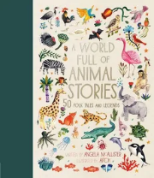  A world full of animal stories - Africa | 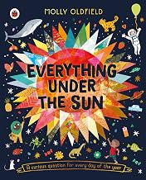  Everything under the sun | 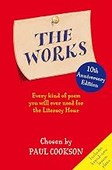  The works
Autumn 2 | Einstein the Penguin  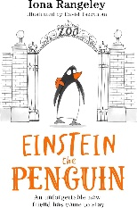 | Big People, Little Dreams Treasury  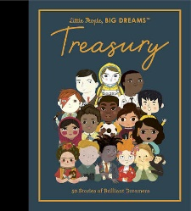 | Poems for every season  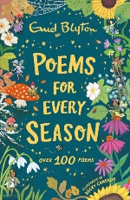
Spring 1 | Aesop Fables  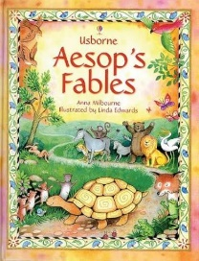 | Never get bored – draw and paint  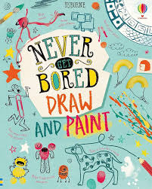 | Words can fly  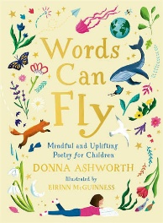
Spring 2 | Grimwood  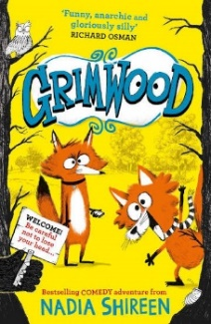 | First big book of how  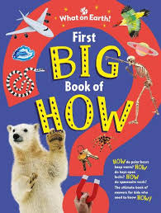 | A first book of nature  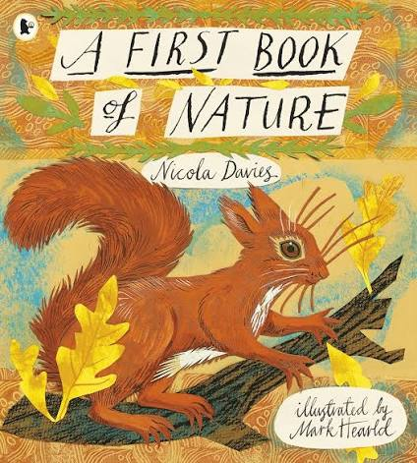
Summer 1 | Leonora Bolt – Secret Inventor  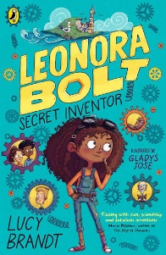 | National Trust – Out & about bird spotter  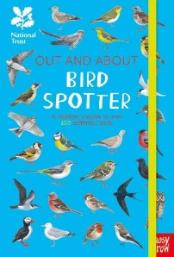 | Jely Boots, Smelly Boots  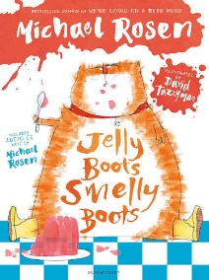
Summer 2 | A Bear Called Paddington  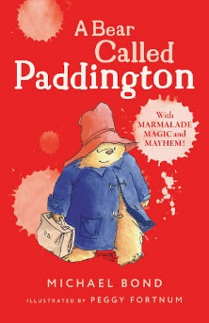 | Complete Children’s Cookbook  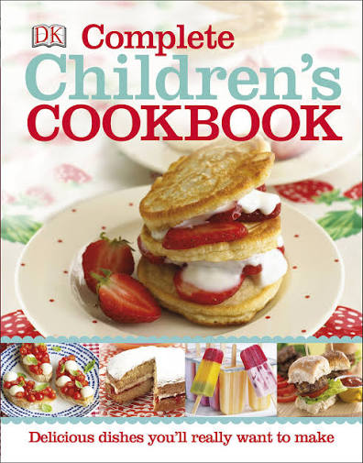 | The Shirley Hughes Treasury  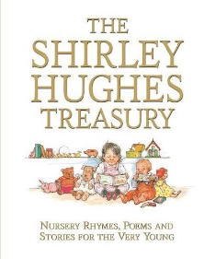

Year 3
Autumn 1 | The one and only Ivan  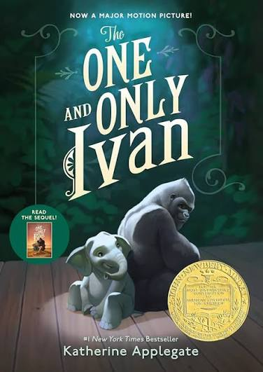 | The Lego ideas book  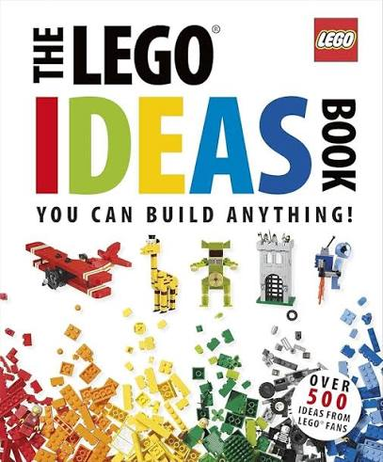 | Welcome To My Crazy Life  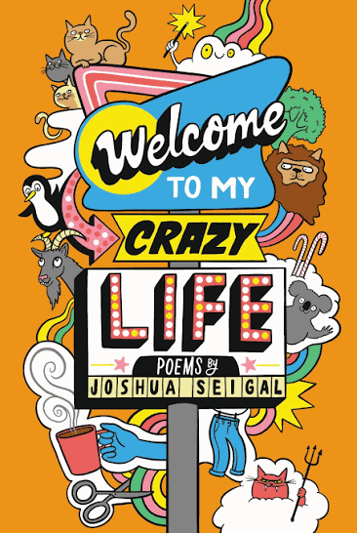
Autumn 2 | The Wild Robot  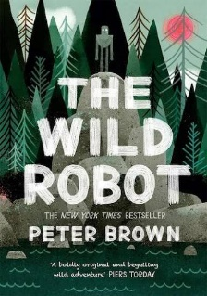 | Usborne Complete Book of Art Ideas  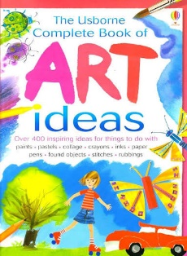 | Ted Hughes Collected Poems  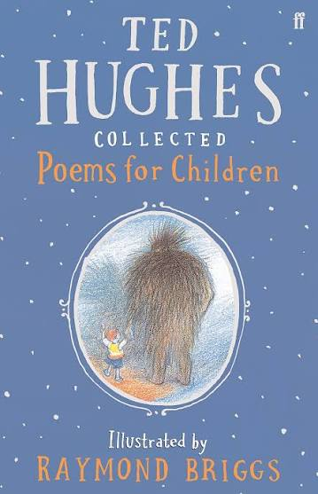
Spring 1 | Charlotte’s Web  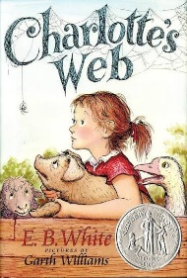 | An Anthology of Intriguing Animals  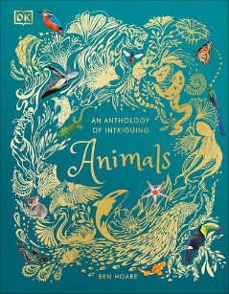 | Hot like fire and other poems  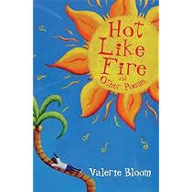
Spring 2 | How to Train Your Dragon  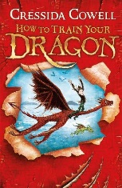 | My Very Important Human Body Encyclopaedia  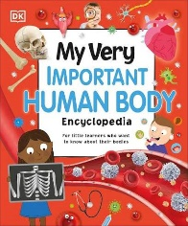 | A Whale of a Time  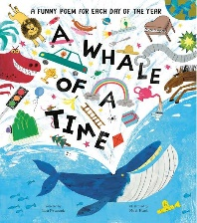
Summer 1 | The day I fell into a fairytale  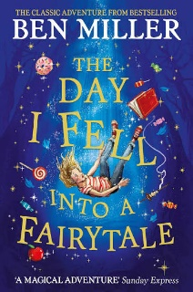 | Hamza’s Wild World  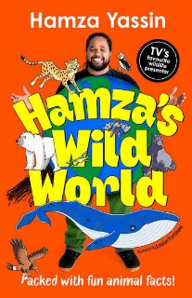 | Pick and Mix Poetry 1  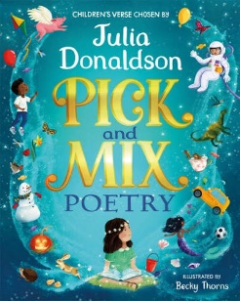
Summer 2 | The Wonder Brothers  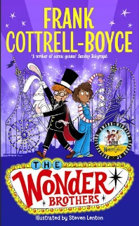 | The Funny life of Football  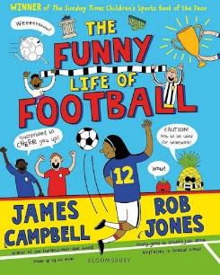 | Pick and Mix Poetry 2

Year 4
Autumn 1 | Beowolf – Michael Morpurgo  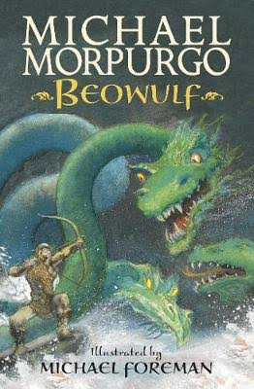 | The Travel Book – Malcolm Croft  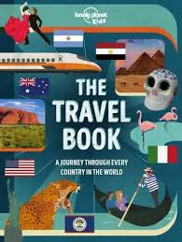 | Werewolf Club Rules – Joseph Coelho  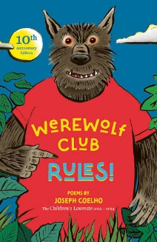
Autumn 2 | When Life Gives You Mangoes – Kereen Getten  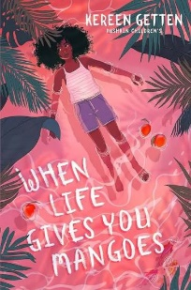 | Quiz Yourself Clever! Animals of the World – DK  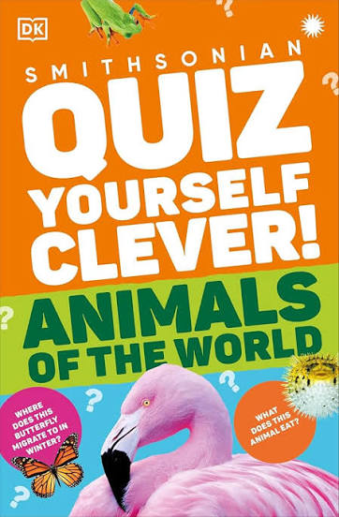 | Gargling With Jelly – Brian Patten  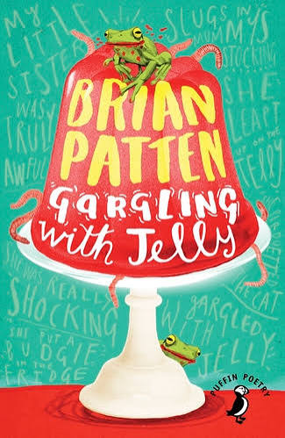
Spring 1 | The Last Bear – Hannah Gold  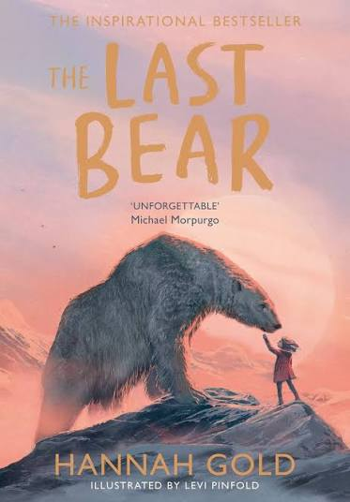 | F2 Ultimate Footballer – The F2  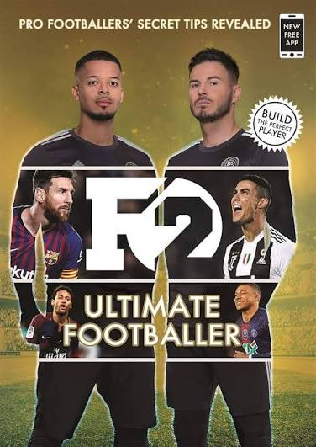 | Over to You – Roger McGough  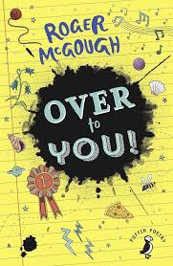
Spring 2 | Viking Boy – Tony Bradman  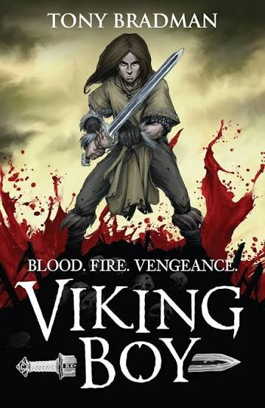 | Start to Cook – Jane Chisholm  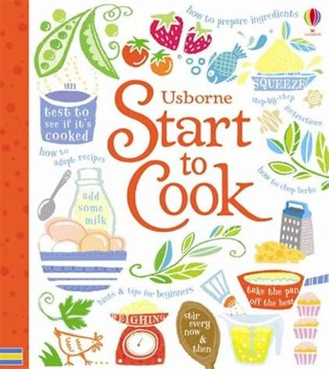 | And Everything Will be Glad to See You – selected by Ella Risbridger  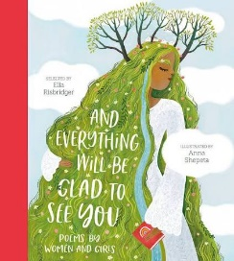
Summer 1 | The Boy at the Back of the Class – Onjali Q. Rauf  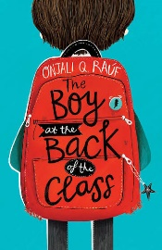 | 42 Artists Everyone Should Know – various  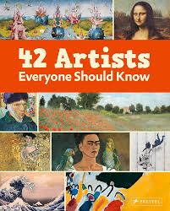 | Pocket Book of Pocket Poems – A.F. Harrold  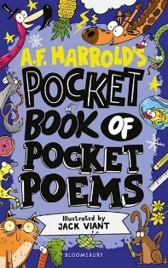
Summer 2 | African and Caribbean Folktales, Myths and Legends – Wendy Shearer  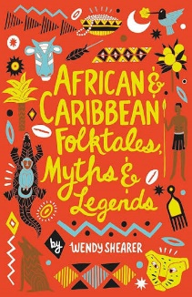 | Kids vs Adults Ultimate Quiz Book – Joe Fullman  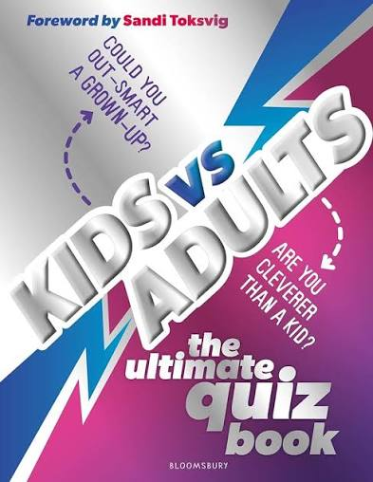 | The Lost Words – Robert MacFarlane  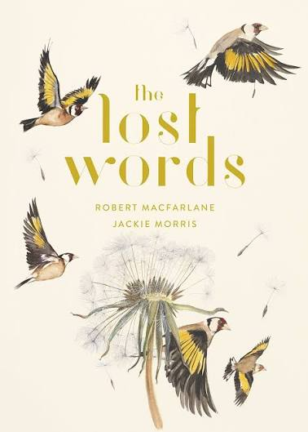

Year 5
Autumn 1 | Between Worlds  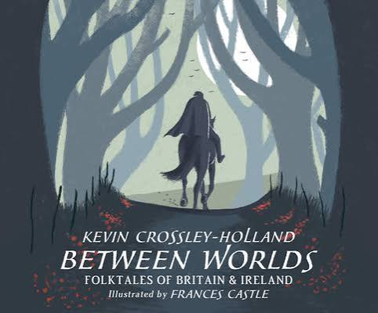 | Coming to England  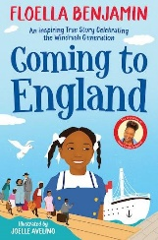 | Where My Wellies Take me  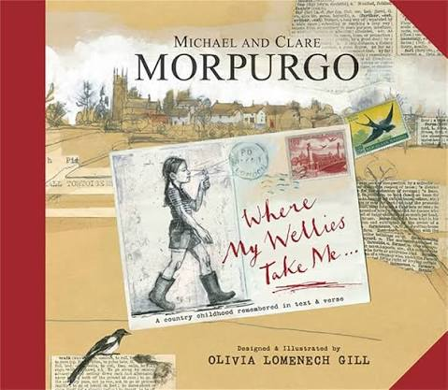
Autumn 2 | Wonder  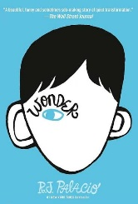 | Knowledge Encyclopaedia: Space  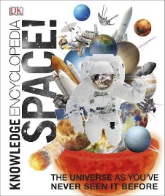 | A Poem for Every Night of the Year  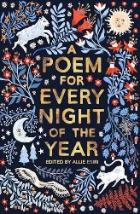
Spring 1 | The Storm Keeper’s Island  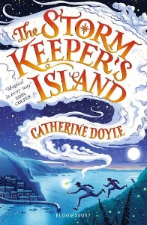 | Magic Your Mind Happy  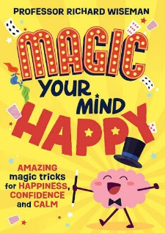 | Wicked World!  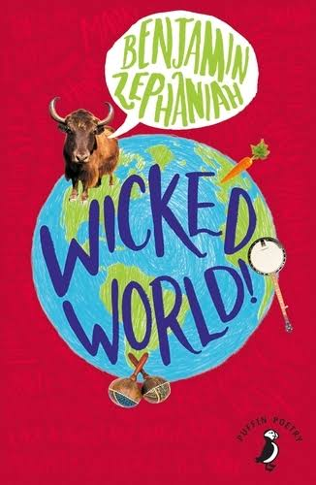
Spring 2 | No Ballet Shoes in Syria  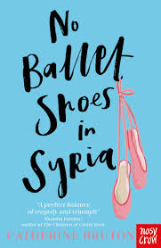 | Mythologica  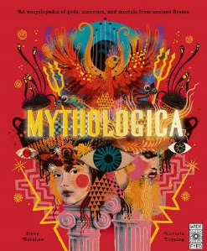 | We Are Family  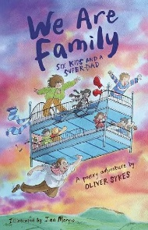
Summer 1 | The Explorer  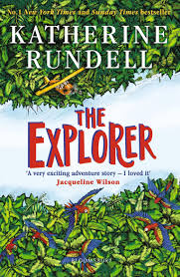 | Sports Legends  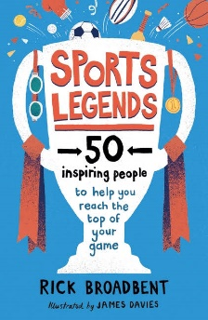 | Inside Out & Back Again  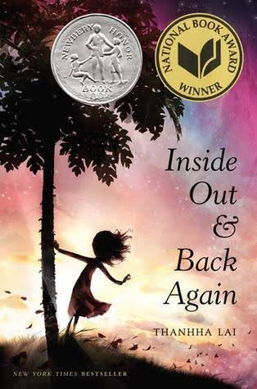
Summer 2 | The Nowhere Emporium  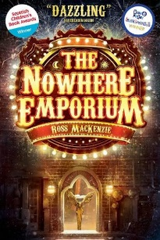 | A World of Flavour  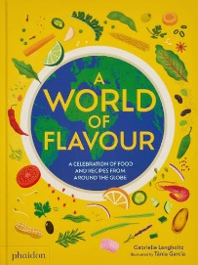 | Bright Bursts of Colour  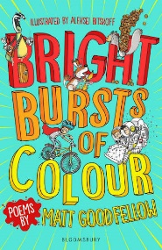

Year 6
Autumn 1 | The Island at the end of everything  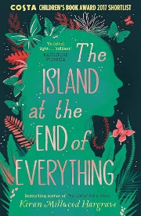 | Women in Science  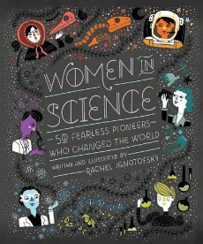 | The Final Year  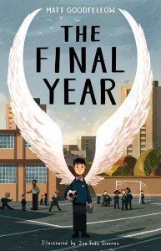
Autumn 2 | Orphans of the tide  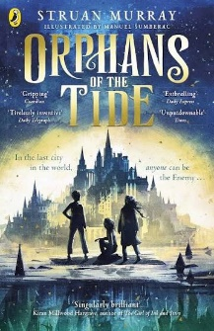 | The Diary of a Young Girl  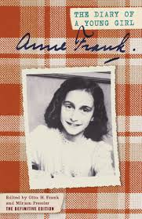 | My heart was a tree  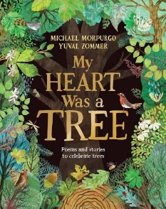
Spring 1 | When the sky falls  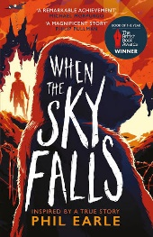 | Marcus Rashford – you can do it  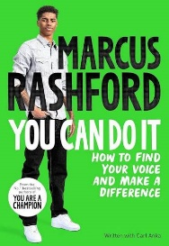 | Stars with flaming tails  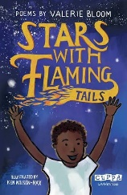
Spring 2 | Black Beauty  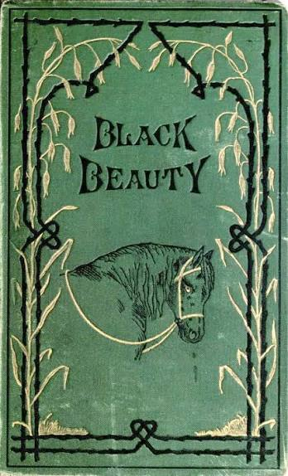 | The Reading Adventure  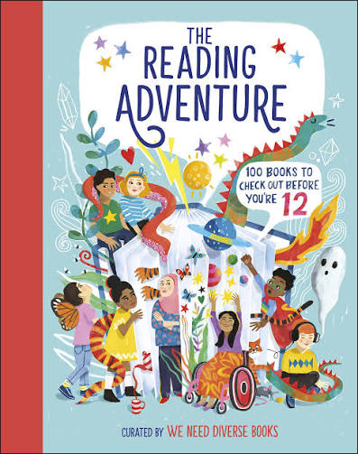 | Overhead in a tower block  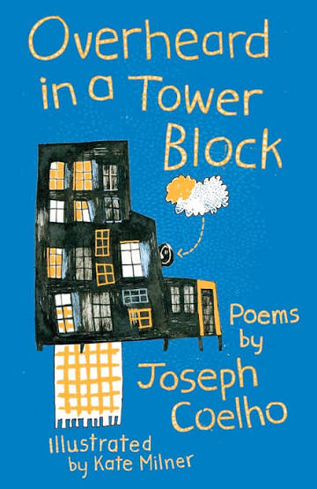
Summer 1 | Grimm’s Fairy Tales  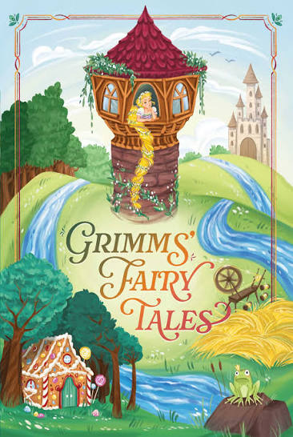 | Survivors  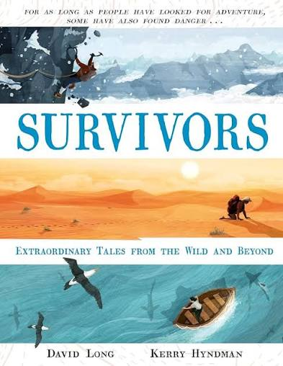 | On The Move  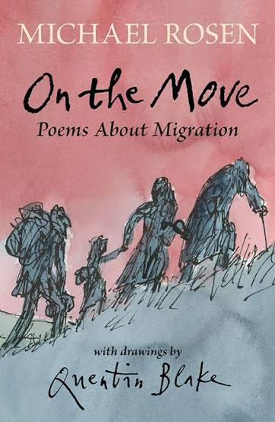
Summer 2 | The Wolves of Willoughby Chase  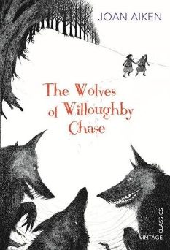 | Cheeky Treats  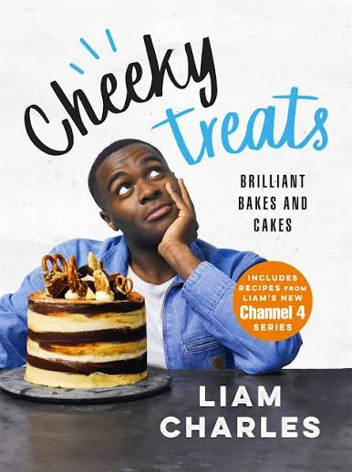 | A Poem for every summer day  