 | Autumn 1 | Autumn 2 | Spring 1 | Spring 2 | Summer 1 | Summer 2
Reception | The Something  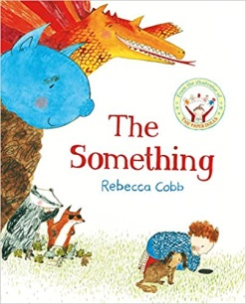  Narrative: A losing story  Recount: Animal information  Wider writing outcomes: | Star in a Jar  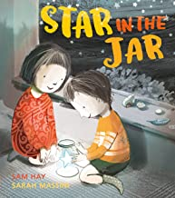  Narrative: A finding story  Information: Poster to find a lost star  Wider writing outcomes: | Juniper Jupiter  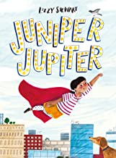  Narrative: A superhero Story  Information: A letter wanting to be a sidekick  Wider writing outcomes: | Little Red  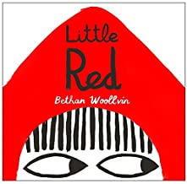  Narrative: A Traditional Tale  Instructions: How to trap an animal  Wider writing outcomes: | The Extraordinary Gardener  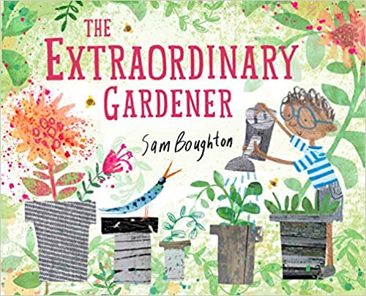  Narrative: A transformational story  Instructions: How to grow a garden plant/vegetable  Wider writing outcomes: | The Storm Whale  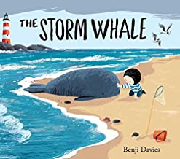  Narrative: A Friendship Story  Poems: Sea Creature Poems  Wider writing outcomes:
Year 1 | Major Glad, Major Dizzy  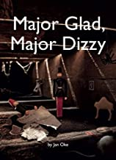  Narrative: Discovery Narrative  Recount: Messages  Wider writing outcomes: | Rapunzel  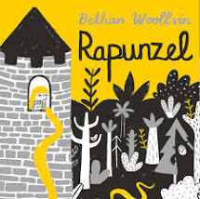  Narrative: A Traditional Tale  Instructions: How to catch a witch  Wider writing outcomes: | Hermelin  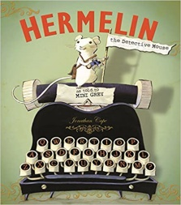  Narrative: A Detective Story  Recount: Letters  Wider writing outcomes: | Where the Wild Things Are  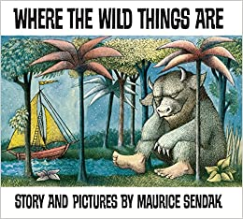  Narrative: A Portal Story  Information: Wild Things  Wider writing outcomes: Diary, Speech Bubbles, Letter, Poetry | The Secret of Black Rock  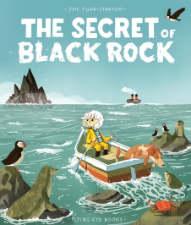  Narrative: A Return Story  Recount: Postcards  Wider writing outcomes: | The Last Wolf  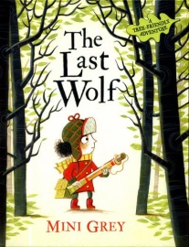  Narrative: A Hunting Story  Instructions: Recipes  Wider writing outcomes:
Year 2 | A River  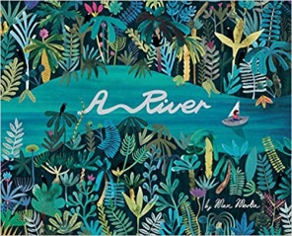  Narrative: Circular Narrative  Recount: Letter  Wider writing outcomes:  Instructions, Diary, Postcard, Setting, Poetry | The Night Gardener  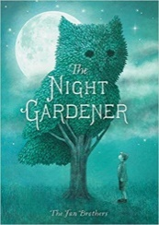  Narrative: Setting Narrative  Recount: Diary  Wider writing outcomes:  Poetry, Character Descriptions | The Bog Baby  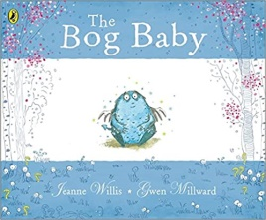  Narrative: Finding Narrative  Instructions: How to build a habitat  Wider writing outcomes:  Setting Description, Character Description, Non-Chronological Report, Poetry, Diary, Sequel, Recipe | Grandad’s Island  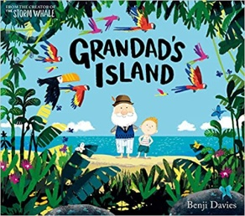  Narrative: Return Narrative  Information: Jungle animals  Wider writing outcomes:  Setting Description, Character Description, Instructions, Poetry, Diary, Postcards, Letters, Journey Narrative | The King Who Banned The Dark  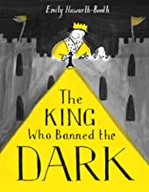  Narrative: A Mistake Narrative  Information: How to be a Regal Leader  Wider writing outcomes: | Rosie Revere  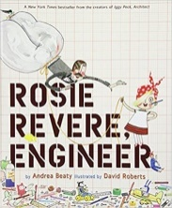  Narrative: Invention Narrative  Explanation: How a Machine Works  Wider writing outcomes: Diary, Letter, Poetry, Instructions
Year 3 | The Iron Man  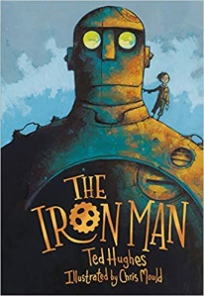  Narrative: Approach Threat Narrative  Explanation: How to capture the Iron Man  Wider writing outcomes: | Fox  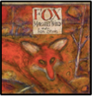  Narrative: Fable Narrative  Information: Fox Report  Wider writing outcomes: | The Rhythm of the Rain  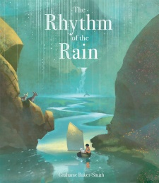  Narrative – Setting Narrative  Information: River Information Leaflet  Wider writing outcomes: | Jemmy Button  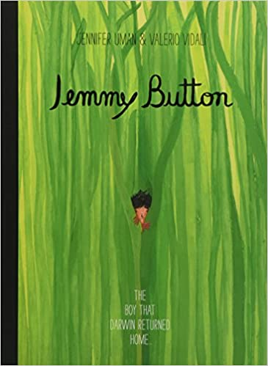  Narrative: Return Narrative  Information: Letters  Wider writing outcomes: | Seen and Not Heard  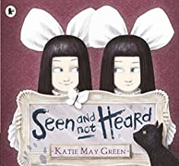  Narrative: Character Narrative  Instructions: How to be a Mischievous Child  Wider writing outcomes: Diary, Leaflet, Letter, Newspaper Report | Into the Forest  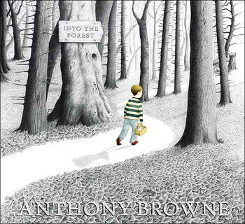  Narrative: Lost Narrative  Recount: Newspaper Report  Wider writing outcomes: Narrative, Poetry, Survival Guide, Characterisation, Diary, Non-chronological Report, Setting Descriptions
Year 4 | The Whale  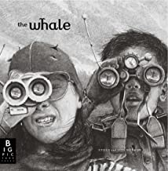  Narrative: Setting Narrative  Recount: Newspaper report  Wider writing outcomes: | Leaf  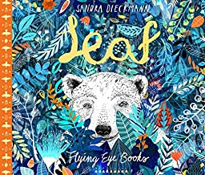  Narrative: Outsider Narrative  Information: Polar Bears  Wider writing outcomes: | Arthur and the Golden Rope  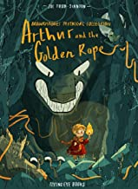  Narrative: Myth Narrative  Information: Defeating a Viking Monster  Wider writing outcomes: | The Lost Happy Endings  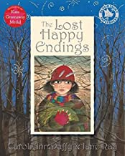  Narrative: Twisted Narrative  Persuasion: Letter  Wider writing outcomes: | The Journey  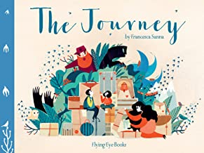  Narrative: Refugee Narrative  Recount: Diary  Wider writing outcomes: | Manfish  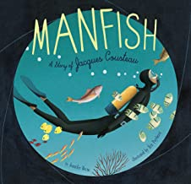  Narrative: Invention Narrative  Recount: Jacques Cousteau Biography  Wider writing outcomes:
Year 5 | Where Once We Stood  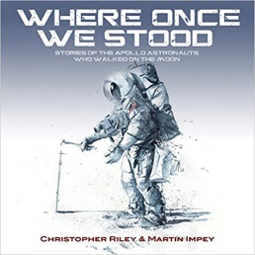  Narrative: Exploration Narrative  Recount: Formal Report  Wider writing outcomes: | FArTHER  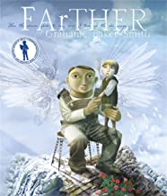  Narrative: Setting Narrative  Recount: Letter  Wider writing outcomes: Non-chronological Report, Diary, Poetry, Manual | The Promise 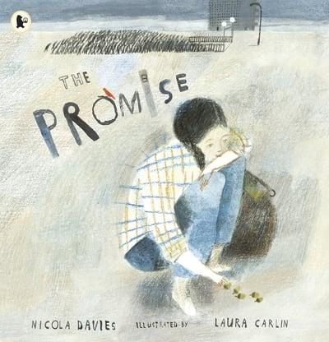  Narrative: Character Narrative  Recount: Newspaper Report  Wider writing outcomes: | The Hound of the Baskervilles  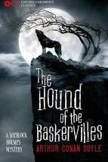  Narrative: Cliff-hanger Narrative  Inform: Formal Event Report  Wider writing outcomes: | The Lost Book of Adventure  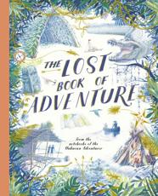  Narrative: Survival Narrative  Explanation: Survival Guide  Wider writing outcomes: | King Kong  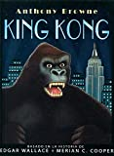  Narrative: Dilemma Narrative  Discussion: Balanced argument  Wider writing outcomes:
Year 6 | Rose Blanche  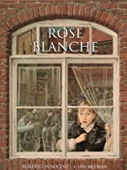  Recount: Diary  Recount: Bravery Speech Award  Wider writing outcomes: Poetry, Letter, Diary, Biography, Newspaper Report, Playscript | A Story Like The Wind  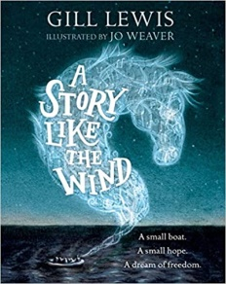  Narrative: Flashback Narrative  Recount: Newspaper report  Wider writing outcomes: | The Origin of the Species  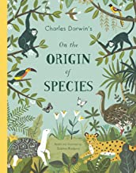  Narrative: Discovery Narrative  Explanation: Adaptation  Wider writing outcomes: | Wolves  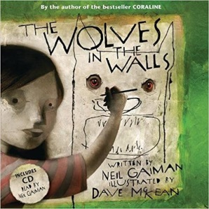  Recount: First Person Narrative  Discussion: Balanced Argument  Information Text: Wolves  Narrative: Suspense Narrative  Wider writing outcomes: | Shackleton’s Journey  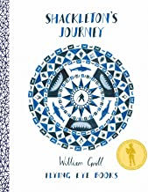  Narrative: Endurance Narrative  Recount: Magazine Article  Wider writing outcomes:  Newspaper Report, Balanced Argument, Letters, Diaries | Hansel & Gretel  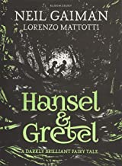  Narrative: Dual Narrative  Persuasion: Letter  Wider writing outcomes:

