



The Lilycroft and St Edmund’s Nursery Schools’ Federation

E-Safety Policy: Keeping Children Safe Online (Reviewed Nov 21)

This policy is about our role in promoting internet safety and how we support staff, governors, parents and pupils themselves in keeping our children safe online. Please also refer to the Safeguarding and Child Protection Policy, the ICT and Communication Systems Policy and the Data Protection Policy.

The Governors appreciate that electronic communications are an essential element in 21st century life for education, business and social interaction. The Governors also support children in using ICT as part of their learning experience across all curricular areas and believe that if used correctly ICT will and prepare children for a digital world.

Aims
- To support children in using ICT resources appropriately and to begin the learning process with the children on how to be e-safe, to recognise when information or material is inappropriate or makes them feel uncomfortable and how to ask for help.
- To support parents to help their children stay safe online.
- To have the appropriate mechanisms to intervene and support any incident where appropriate.

Information system security
In partnership with the school IT support, the Governors will review IT security regularly - virus protection is updated regularly by the authority and filtering software is also used.

Promotion of the Policy
The Governors will promote this policy as part of the Staff Induction process. Information about internet safety will also be made available to parents/carers.

Guidance on use of the Internet

Support for children
At St Edmund’s and Lilycroft, children are taught about safeguarding and how to keep themselves safe, including on the Internet or when using new technology.

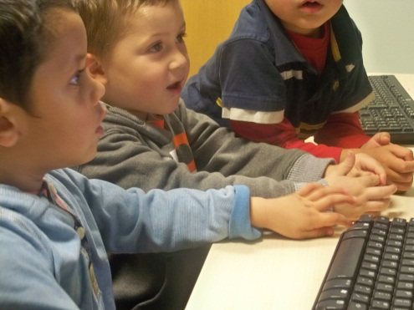
The school will take all reasonable precautions to prevent access to inappropriate material. However, due to the international scale and linked nature of Internet content, it is not possible to guarantee that unsuitable material will never appear on a computer connected to the nursery network. The school cannot accept liability for any material accessed, or any consequences of Internet access. Methods to identify, assess and minimise risks will be reviewed regularly. The Executive Headteacher will ensure that the E-Safety Policy is implemented and compliance with the policy monitored.

The use of computer systems without permission or for inappropriate purposes could constitute a criminal offence under the Computer Misuse Act 1990.

Advice for parents
At St Edmund’s and Lilycroft Nursery Schools we try to raise awareness of issues that may relate to children’s use of electronic information and offer the following guidance.

The Internet offers a means to share and communicate in a variety of different ways. St Edmund’s and Lilycroft supports children to use computers and tablets as part of their learning experience; we talk to children about Internet safety, and make sure that the sites children access when they are in the school are safe. Parents and carers need to take equal care at home:
- Ask your child to use the computer/laptop/tablet/mobile phone in a communal area such as a family room where you can keep an eye on what your child is accessing on the internet.
- Use an appropriate filtering system/parental control to minimise opportunities to access unsuitable material – if you are in doubt about the filtering system you have in place you can contact your service provider to discuss how you can limit access to inappropriate internet sites e.g. pornography or gambling websites.
- Bookmark or create a list of favourite sites and apps, so you and your child can easily find them and not get distracted by pop ups or adverts.
- Beware of in app purchases (optional extras within games that you have to pay for) – use parental controls to disable in-app purchasing.

Get your child into good habits early – make it a rule that:
- Your child always checks with an adult before they use the internet.
- Your child only talks online to people they know.
- Your child never tells anyone how old they are, where they live, or arranges to meet someone they don’t know.
- Your child only uses the internet to look for things they know they are allowed to look at. If they’re not sure they should check with an adult before they search.
- Your child is polite when they talk or post things on the Internet and doesn’t say things that will upset people.
- Limit the time that your child is online, so they have chance to do other things too.
Your child should also know that if they see anything that worries or upsets them on the Internet or in an email that they ask an adult for help straight away. More information is available at Get Safe Online.
Other useful links: Childnet, CEOP Thinkuknow, UK Safer Internet Centre.

Parents taking photos
Parents are requested not to take photographs within the school, either with a camera or mobile telephone. There are circumstances such as school visits where this may, with permission from the lead member of staff, be allowed. However, all parents are made aware that they can choose for their child not to be photographed/videoed in a range of circumstances when they complete the Registration Form.

Mobile Telephones
Mobile phones can cause an unnecessary distraction during the working day and can be considered intrusive when used in the company of others. All service users, including parents, carers, visitors and contractors are advised that mobile phones are not to be used within the children’s areas.

Training
- As part of the policy review process staff and governors will consider the E-Safety programme on a rolling programme.
- Staff are given updates on internet security (eg “How to lock down your Facebook”) and onine safety training.
- Administrative staff are trained in line with Council Policy by the IT training section (eg management of pupil/staff data).

