Year 2 Newsletter
Summer Term
Books we are reading:
Linaker English –
The King who banned the dark.
Rosie Revere Engineer
Linaker Reading –
The Great Fire
The Baker’s Boy and The Great Fire of London
The Great Fire of London

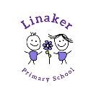
Units of learning this half term:
English – To write a letter and a banning narrative.
Maths – Addition and subtraction /Position and Direction/Multiplication and Division/Statistics
Science – Lifecycles / Master chefs
P.E. – Athletics / Net and Wall games / Team Building / Field games
PSHE – Relationships.
Art – How can we transform an object and turn it into sculpture, using our imagination? (3D Form)
History – Stone Age

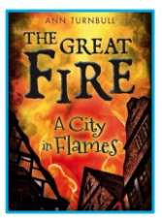
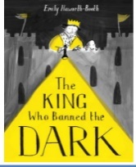
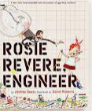
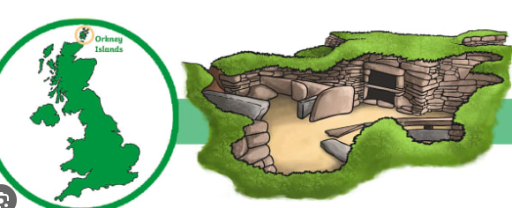
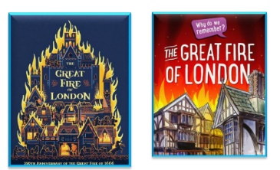

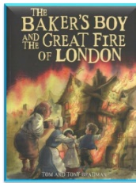

Home learning:
Daily Reading
Top marks (maths online programme)
Times table rockstars
Useful websites:
https://www.topmarks.co.uk/
www.getset4education.co.uk

Weekly reminders for Year 2
Monday | PE day
Tuesday
Wednesday | PE day
Thursday
Friday | Reading books to be changed in school

Some important reminders:
- Please ensure children are bringing a water bottle to school every day.
- Reading books to be brought to school every day for reading.
- Correct uniform is required.

