PSHE / RSHE

At Linden Road, our PSHE / RSHE curriculum is a carefully sequenced, knowledge-rich programme that equips pupils with the understanding, language and confidence they need to navigate an increasingly complex world. It is underpinned by a strong commitment to pupil wellbeing, personal development, and preparation for life in modern Britain.

Our curriculum is structured around clearly defined key themes, including:
- General wellbeing and self-esteem
- Respectful, kind relationships
- Caring friendships
- Families and people who care for me
- Personal safety
- Being safe: respect and privacy
- Physical health and fitness
- Kindness and anti-bullying
- Loss
- Health protection and prevention
- Healthy eating
- Growing up and developing bodies
- British values
- Drugs, alcohol, tobacco and vaping (KS2)

These themes are revisited in an age-appropriate and progressive way from EYFS through to Year 6, ensuring that pupils build secure, connected knowledge over time. Each unit is underpinned by clearly defined “Pupils know…” knowledge statements, enabling staff to focus explicitly on what pupils should understand at each stage of their development.

A central strength of the curriculum is its focus on progression. Pupils begin by learning to recognise basic emotions, relationships, and safety in the early years, before developing a deeper understanding of more complex concepts such as mental wellbeing, identity, diversity, consent, and risk as they move through Key Stage 2. By Year 6, pupils are able to apply this knowledge critically, for example understanding the long-term impact of bullying, the complexity of relationships, and how to seek help and support in a range of situations.

Oracy is embedded throughout the curriculum as both a pedagogical tool and a key outcome. Through structured talk, discussion questions, dialogic teaching and debate, pupils develop the vocabulary and confidence to:
- express their feelings and viewpoints clearly
- listen actively and respectfully to others
- explore sensitive topics in a safe and supportive environment
- articulate needs, boundaries and concerns
This emphasis on talk ensures that pupils not only acquire knowledge, but are also able to use it meaningfully in real-life contexts.
The curriculum is deliberately designed to support mental health and wellbeing. Pupils develop an understanding of emotions, self-regulation, resilience, and help-seeking, with a clear focus on reducing stigma and promoting openness. Themes such as loneliness, self-esteem, loss, and change are taught progressively to ensure pupils are prepared for life experiences in a developmentally appropriate way.
A strong thread of safeguarding and personal safety runs throughout the curriculum. Pupils learn how to recognise risk, understand boundaries (including online), and seek help confidently. This includes explicit teaching on topics such as bullying (including cyberbullying), consent, privacy, and harmful behaviours, ensuring pupils understand both impact and responsibility.

Our PSHE curriculum also places a clear emphasis on equality, diversity and British values. Pupils are supported to develop respect, tolerance and empathy, learning about differences in beliefs, cultures and identities. As they progress, they develop a deeper understanding of fairness, discrimination, stereotypes and their role in creating an inclusive society.

To support engagement and deepen understanding, many units are taught through the use of high-quality texts and stories, providing meaningful contexts for discussion. These texts allow pupils to explore complex themes through characters and narratives, helping them to reflect on their own experiences in a safe and structured way. Learning is explicitly linked back to real-life contexts to ensure relevance and application.

Ultimately, our intent is that pupils leave Linden Road as confident, articulate and informed individuals who:
- understand themselves and others
- can build and maintain positive relationships
- know how to keep themselves safe
- value diversity and act with respect and empathy
- are able to make informed choices about their wellbeing
By combining a clear progression of knowledge with a strong emphasis on oracy, wellbeing and real-life application, our PSHE curriculum ensures that every pupil develops not only the knowledge they need, but also the voice and confidence to thrive.
 |  | Our Key Themes
 |  | General wellbeing  and  Self-esteem |  |  |  |  |  |  |  | Respectful, kind relationships |  |  |  |  |  |  |  | Caring friendships |  |  |  |  |  |  | Families and people who care for me |  |  |  |  |  | Personal safety |  |  | Being safe – Respect and privacy |  |  |  |  | Physical health and fitness
 |  | Focuses on developing pupils’ understanding of physical and mental wellbeing. Pupils learn about emotions, self-regulation, resilience, and the importance of self-care. The theme supports pupils to build self-esteem, recognise their strengths, and understand how lifestyle choices (sleep, exercise, relationships) impact wellbeing. It also develops awareness of loneliness and the importance of seeking support. |  |  |  |  |  |  |  | Explores how to build and maintain positive relationships based on respect, kindness and fairness. Pupils learn about boundaries, communication, managing conflict, and assertiveness. The theme also includes understanding bullying, discrimination, stereotypes, and the importance of mutual respect and equality. |  |  |  |  |  |  |  | Develops pupils’ understanding of what makes a healthy friendship. Pupils learn about trust, kindness, loyalty, and inclusion, as well as how to manage disagreements and recognise unhealthy or unbalanced friendships. The theme supports pupils in building and maintaining positive peer relationships. |  |  |  |  |  |  | Focuses on the role of families in providing care, stability and security. Pupils learn that families can take different forms but should offer love and support. The theme includes understanding healthy family relationships, recognising when relationships may be unsafe, and knowing how to seek help. |  |  |  |  |  | Equips pupils with the knowledge and skills needed to stay safe in a range of real-life situations. This includes road, rail and water safety, fire safety, and safety in public spaces. Pupils also learn basic first aid and how to respond appropriately in emergencies, including seeking help. |  |  | Explores boundaries, consent and personal safety in more depth. Pupils learn about body autonomy, privacy, safe and unsafe touch, and the importance of not keeping unsafe secrets. The theme also includes recognising unsafe situations (including online) and knowing how to report concerns and seek help. |  |  |  |  | Focuses on developing an understanding of the importance of an active lifestyle. Pupils learn how physical activity supports both physical and mental health, the risks of inactivity, and how to build healthy habits into daily life.
 |  | Kindness and  Anti-bullying |  |  |  |  |  |  |  | Loss |  |  |  |  |  |  |  | Drugs, alcohol, tobacco and vaping  (KS2 only) |  |  |  |  |  |  | Health protection and prevention |  |  |  |  |  | Healthy eating |  |  | Growing up – Developing bodies |  |  |  |  | British values
 |  | Develops pupils’ understanding of kindness, empathy and respect. Pupils learn about different forms of bullying, including cyberbullying, and its impact on wellbeing. The theme emphasises responsibility, speaking up, and knowing how to seek support for themselves or others. |  |  |  |  |  |  |  | Supports pupils in understanding change and loss, including bereavement. Pupils learn that loss can bring a range of emotions, that grief is a natural response, and that people cope in different ways. The theme also emphasises support, empathy and help-seeking. |  |  |  |  |  |  |  | Provides pupils in KS2 with age-appropriate knowledge about substances and their effects. Pupils learn about the risks of smoking, vaping, alcohol and drugs, including addiction, and how to make informed, safe choices and seek support if needed. |  |  |  |  |  |  | Focuses on how to maintain good health and prevent illness. Pupils learn about hygiene, sleep, dental health, sun safety, and recognising early signs of illness. It also includes understanding how diseases spread and the role of vaccinations in protecting individuals and communities. |  |  |  |  |  | Develops pupils’ understanding of nutrition and a balanced diet. Pupils learn about food groups, making healthy choices, and how diet affects energy, growth and overall wellbeing. The theme also includes understanding risks associated with unhealthy eating habits. |  |  | Supports pupils in understanding the human lifecycle and physical and emotional changes as they grow. This includes learning about puberty, body changes, personal hygiene, and developing a clear understanding of boundaries and body autonomy. |  |  |  |  | Develops pupils’ understanding of democracy, the rule of law, individual liberty, and mutual respect and tolerance. Pupils learn about fairness, rights and responsibilities, and how to live respectfully in a diverse society.
 | EYFS
 |  |  |  |  |  | 3-4 |  |  |  |  |  |  |  |  |  |  |  |  |  |  |  | Reception |  |  |  |  |  |  |  |  | ELG
 | Communication and Language |  |  |  |  | Be able to express a point of view and to debate when they disagree with an adult or friend, using words as well as actions. • Start a conversation with an adult or a friend and continue it for many turns. |  |  |  |  |  |  |  |  |  |  |  |  |  |  |  | Use talk to help work out problems and organise thinking and activities, and to explain how things work and why they might happen. • Develop social phrases. |  |  |  |  |  |  |  |  | Speaking  Express their ideas and feelings about their experiences using full sentences, including use of past, present and future tenses and making use of conjunctions, with modelling and support from their teacher.
Listening, Attention and Understanding
Hold conversation when engaged in back-and-forth exchanges with their teachers and peers.
 | Personal, Social and Emotional Development |  |  |  |  | Select and use activities and resources, with help when needed. This helps them to achieve a goal they have chosen or one which is suggested to them. Develop their sense of responsibility and membership of a community. Become more outgoing with unfamiliar people, in the safe context of their setting. Show more confidence in new social situations. Play with one or more other children, extending and elaborating play ideas. Help to find solutions to conflicts and rivalries. For example, accepting that not everyone can be Spider-Man in the game, and suggesting other ideas. Increasingly follow rules, understanding why they are important. Remember rules without needing an adult to remind them. Develop appropriate ways of being assertive. Talk with others to solve conflicts. Talk about their feelings using words like ‘happy’, ‘sad’, ‘angry’ or ‘worried’. Understand gradually how others might be feeling. Be increasingly independent in meeting their own care needs, e.g. brushing teeth, using the toilet, washing and drying their hands thoroughly. Make healthy choices about food, drink, activity and toothbrushing. |  |  |  |  |  |  |  |  |  |  |  |  |  |  |  | See themselves as a valuable individual. Build constructive and respectful relationships. Express their feelings and consider the feelings of others. Show resilience and perseverance in the face of challenge. Identify and moderate their own feelings socially and emotionally. Think about the perspectives of others. Manage their own needs. - personal hygiene Know and talk about the different factors that support their overall health and wellbeing: - regular physical activity - healthy eating - toothbrushing - sensible amounts of ‘screen time’ - having a good sleep routine - being a safe pedestrian |  |  |  |  |  |  |  |  | Self-regulation  Show an understanding of their own feelings and those of others, and begin to regulate their behaviour accordingly. • Set and work towards simple goals, being able to wait for what they want and control their immediate impulses when appropriate. • Give focused attention to what the teacher says, responding appropriately even when engaged in activity, and show an ability to follow instructions involving several ideas or actions.
Managing Self
Be confident to try new activities and show independence, resilience and perseverance in the face of challenge. • Explain the reasons for rules, know right from wrong and try to behave accordingly. • Manage their own basic hygiene and personal needs, including dressing, going to the toilet and understanding the importance of healthy food choices.
Building Relationships
Work and play cooperatively and take turns with others. • Form positive attachments to adults and friendships with peers. • Show sensitivity to their own and others’ needs.
 | Physical Development |  |  |  |  | Be increasingly independent as they get dressed and undressed. For example, putting coats on and doing up zips. |  |  |  |  |  |  |  |  |  |  |  |  |  |  |  | Further develop the skills they need to manage the school day successfully: - lining up and queuing - mealtimes |  |  |  |  |  |  |  |  | Gross Motor Skills  Negotiate space and obstacles safely, with consideration for themselves and others.
 | Understanding the World. |  |  |  |  | Begin to make sense of their own life-story and family’s history. • Show interest in different occupations. • Continue developing positive attitudes about the differences between people. • Know that there are different countries in the world and talk about the differences they have experienced or seen in photos. |  |  |  |  |  |  |  |  |  |  |  |  |  |  |  | Talk about members of their immediate family and community. • Name and describe people who are familiar to them. Recognise that people have different beliefs and celebrate special times in different ways. |  |  |  |  |  |  |  |  | Past and Present  Talk about the lives of people around them and their roles in society
 | EYFS |  |  |  | Year 1 |  |  |  |  |  |  | Year 2 |  |  |  | Year 3 |  |  |  |  |  |  | Year 4 |  |  |  |  |  |  |  |  | Year 5 |  |  | Year 6
Health and wellbeing: General Wellbeing
Number of lessons – 2 (WC 7th September and 14th September)
 | 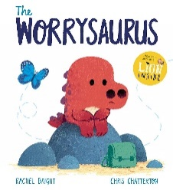  The Worrysaurus  By Rachel Bright and Chris Chatterton |  |  |  | 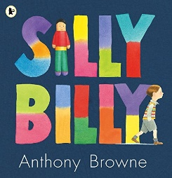  Silly Billy  By Anthony Browne |  |  |  |  |  |  | 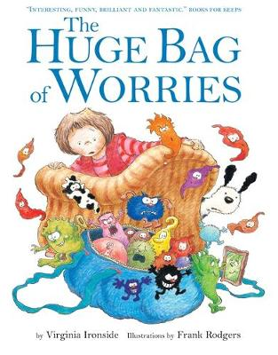  The Huge Bag of Worries  By Virginia Ironside |  |  |  | 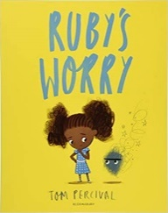  Ruby’s Worry  By Tom Percival |  |  |  |  |  |  | 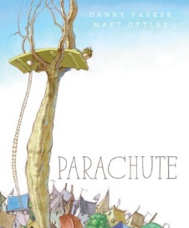  The Parachute  By Danny Parker and Matt Ottley |  |  |  |  |  |  |  |  | 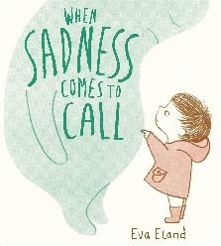  When Sadness Comes to Call  By Eva Eland |  |  |  |  | 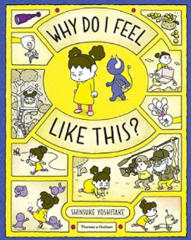  Why do I feel like this  by Shinsuke Yoshitake
 | EYFS  Discussion question: What should you do if you feel worried or sad?  - Tell a grown-up straight away  - Keep it to yourself  - Calm yourself by playing or drawing  - Help a friend who looks sad |  |  |  | Year 1  Discussion question: What helps when you feel worried?  - Talking to an adult  - Exercise or movement  - Keeping worries inside  - Helping someone else |  |  |  |  |  |  | Year 2  Discussion question: Is it okay to feel worried sometimes?  - Yes, everyone worries  - No, we should always be happy  - It’s okay if we talk about it  - Only adults worry |  |  |  | Year 3  Discussion question: What should you do if worries feel too big?  - Talk to someone you trust  - Write or draw your feelings  - Ignore them  - Help a friend instead |  |  |  |  |  |  | Year 4  Discussion question: How can lifestyle choices affect mental health?  - Exercise helps our mood  - Healthy eating gives us energy  - Sleep doesn’t matter  - Screen time has no effect |  |  |  |  |  |  |  |  | Year 5  Discussion question: Why is it important to talk about mental health?  - It helps us get support  - It reduces loneliness  - It shows weakness  - Everyone experiences it |  |  |  |  | Year 6  Discussion question: Is mental health as important as physical health?  - Yes, they are equally important  - Physical health matters more  - Mental health only matters sometimes  - Mental health improves with support
Health and wellbeing: General Wellbeing
Number of lessons – 2 (WC 7th September and 14th September)
 |  |  | EYFS |  |  |  |  |  | Year 1 |  |  |  |  |  | Year 2 |  |  |  |  |  | Year 3 |  |  |  |  | Year 4 |  | Year 5 |  |  |  |  | Year 6
 |  |  | Health, Wellbeing and Self-Care  To understand that being active, playing outside and resting helps our bodies feel good.  To enjoy spending time with friends, family and doing activities they like.  Understanding Emotions  To recognise basic feelings (happy, sad, angry).  To begin to understand that feelings can change.  Talking About Feelings  To begin to talk about their own feelings.  To recognise simple emotions in others.  Managing Feelings  To begin to understand that some behaviours are not helpful (e.g. hitting) and to try simple calming strategies.  Loneliness and Support  To recognise when they feel sad or alone.  To know that they can talk to an adult for help.  Help-Seeking  To know there are trusted adults who can help them feel safe and happy |  |  |  |  |  | Health, Wellbeing and Self-Care  To understand that exercise, rest and fun activities help us feel happy and healthy.  To recognise the importance of spending time with family and friends.  Understanding Emotions  To name a wider range of feelings (e.g. happy, sad, angry, worried).  To understand that everyone experiences different feelings.  Talking About Feelings  To describe their own feelings using simple vocabulary.  To begin to recognise how others may be feeling.  Managing Feelings  To begin to control strong feelings (e.g. through talking, breathing, asking for help).  Loneliness and Support  To understand that sometimes people may feel lonely or left out.  To know that talking can help.  Help-Seeking  To identify adults they can go to if they feel worried. |  |  |  |  |  | Health, Wellbeing and Self-Care  To understand that physical activity, rest and hobbies support wellbeing.  To recognise how helping others can make people feel good.  Understanding Emotions  To describe a broader range of emotions (e.g. excited, nervous, shy).  To understand that feelings can change depending on situations.  Talking About Feelings  To talk about their feelings using more varied vocabulary.  To identify how others might feel in different situations.  Managing Feelings  To begin to think about whether their reactions are appropriate.  To use simple strategies to manage emotions.  Loneliness and Support  To understand that everyone feels lonely sometimes.  To recognise the importance of seeking support.  Help-Seeking  To know when to ask for help and begin to explain how they are feeling. |  |  |  |  |  | Health, Wellbeing and Self-Care  To understand how physical activity, hobbies and social time support mental wellbeing.  To recognise the link between physical and mental health.  Understanding Emotions  To understand a wider range of emotions, including anxiety and frustration.  To recognise that worrying and feeling sad are normal experiences.  Talking About Feelings  To use increasingly varied vocabulary to describe their feelings and those of others.  Managing Feelings  To begin to judge whether their responses are appropriate in different situations.  To apply strategies to manage feelings like anger or worry.  Loneliness and Support  To recognise signs of loneliness in themselves or others.  To understand the benefits of talking to someone.  Help-Seeking  To identify a range of people and places where help is available. |  |  |  |  | Health, Wellbeing and Self-Care  To explain how different aspects of lifestyle (exercise, rest, relationships, hobbies) affect wellbeing.  To understand the benefits of community participation and helping others.  Understanding Emotions  To describe a wide range of emotions and how they vary in intensity.  To understand that experiencing low mood or worry at times is normal.  Talking About Feelings  To express feelings clearly using a broad emotional vocabulary.  Managing Feelings  To reflect on whether their behaviour and reactions are appropriate and proportionate.  To develop strategies for managing complex emotions.  Loneliness and Support  To understand the effects of isolation and loneliness on wellbeing.  To recognise when support may be needed.  Help-Seeking  To understand when it is important to seek help and who to approach in school or beyond |  | Health, Wellbeing and Self-Care  To understand the wide range of factors that support wellbeing (physical activity, relationships, rest, hobbies and helping others).  To evaluate how lifestyle choices affect physical and mental health.  Understanding Emotions  To explain the range and scale of emotions and how they may differ between individuals and situations.  To understand that experiences such as worry or low mood are common and not necessarily a sign of illness.  Talking About Feelings  To use a wide and precise emotional vocabulary to explain their own and others’ feelings.  Managing Feelings  To judge whether feelings and behaviours are appropriate and proportionate.  To independently apply strategies to manage emotions in a range of situations.  Loneliness and Support  To understand the impact of loneliness and the importance of seeking support.  Help-Seeking  To recognise when support is needed for mental wellbeing.  To know where and how to seek help, including identifying trusted sources in school and beyond.  To understand that early help can support mental health. |  |  |  |  | Health, Wellbeing and Self-Care  The benefits of physical activity, time outdoors, and helping others for health, wellbeing and happiness. Simple self-care techniques, including the importance of rest, time spent with friends and family, as well as hobbies, interests and community participation.  The importance of promoting general wellbeing and physical health.  Understanding Emotions  The range and scale of emotions (e.g. happiness, sadness, anger, fear, surprise, nervousness) that they might experience in different situations. Pupils should understand that worrying and feeling down are normal, affect everyone at different times, and are not in themselves a sign of a mental health condition.  Talking About Feelings  How to recognise feelings and use varied vocabulary to talk about their own and others’ feelings.  Managing Feelings  How to judge whether what they are feeling and how they are behaving is appropriate and proportionate.  Loneliness and Support  That isolation and loneliness can affect children, and the benefits of seeking support.  Safety, Help-Seeking and Trust  Where and how to seek support (including recognising the triggers for seeking support), including who in school they should speak to if they are worried about their own or someone else’s mental wellbeing or ability to control their emotions (including issues arising online).  That it is common to experience mental health problems, and early support can help.
Self-esteem
Number of lessons – 2 (WC 21st September and 28th September)
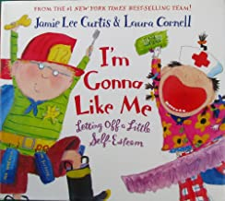  I’m Gonna Like Me  by Jamie Lee Curtis |  |  |  |  |  |  | 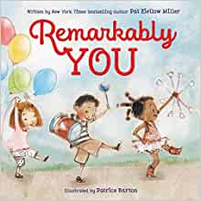  Remarkably You  By Pat Zietlow Miller |  |  |  |  |  | 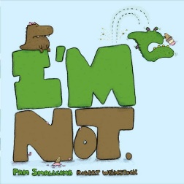  I’m Not  By Pam Smallcomb |  |  |  |  |  |  | 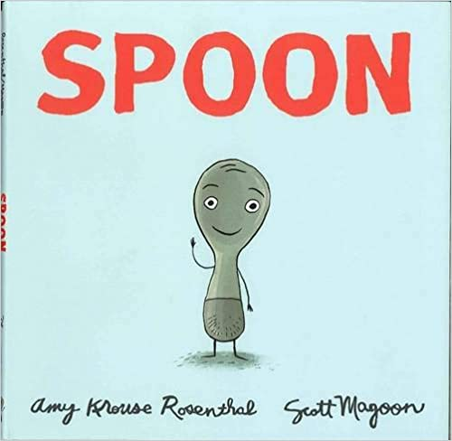  Spoon  by Amy Krouse Rosenthal |  |  |  |  |  |  | 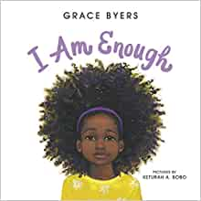  I am Enough  By Grace Byers |  | 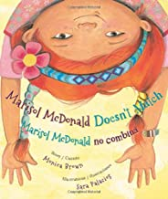  Marisol McDonald Doesn’t Match  By Monica Brown and Sara Palacios |  |  |  |  |  |  | 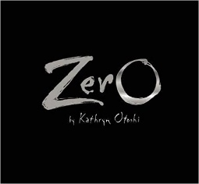  Zero  by Kathryn Otoshi
EYFS  Question: “What makes you feel proud of yourself?”  Viewpoints:  - Doing something new all by myself makes me feel proud.  - I feel proud when someone says well done to me.  - I feel proud when I try hard, even if it’s tricky.  - I feel proud when I help someone else. |  |  |  |  |  |  | Year 1  Question: “Why is it important to say kind things about ourselves and others?”  Viewpoints:  - Kind words make people feel happy and confident.  - Kind words help us make and keep friends.  - If we don’t say kind things, people might feel sad or left out.  - Being kind helps everyone feel proud of themselves. |  |  |  |  |  | Year 2  Question : “How does it feel when we achieve something we’ve been practising?”  Viewpoints:  - It feels exciting because we worked hard.  - It makes us feel proud and happy inside.  - It shows us that practice helps us get better.  - It feels good to share our achievements with others. |  |  |  |  |  |  | Year 3  Question: “How can we stay positive when we find something difficult?”  Viewpoints:  - By remembering that everyone finds things hard sometimes.  - By asking for help and trying again.  - By praising ourselves for effort, not just success.  - By learning from mistakes instead of giving up. |  |  |  |  |  |  | Year 4  Question: “Why is it important to celebrate what we’re good at, and also work on things we’re not as confident in?”  Viewpoints:  - Celebrating strengths helps build self-esteem.  - Working on challenges helps us grow and feel proud.  - Everyone has different talents, so comparing isn’t helpful.  - Improving at something tricky can make us feel even more proud than something easy. |  | Year 5  Question: “How can other people affect our self-esteem, and what can we do to protect it?”  Viewpoints:  - Kind words build us up; unkind words can hurt our confidence.  - We can choose to listen to people who support us.  - We can remind ourselves of our strengths when we doubt ourselves.  - We can challenge negative comments and speak to a trusted adult. |  |  |  |  |  |  | Year 6  Question: “How can we develop a strong sense of self-esteem as we grow older and face new challenges?”  Viewpoints:  - By setting goals and recognising our achievements.  - By understanding that everyone is different and grows at their own pace.  - By being aware of how social media can affect our self-esteem.  - By remembering that mistakes and setbacks are part of learning.
Self-esteem
Number of lessons – 2 (WC 21st September and 28th September)
EYFS |  |  |  |  |  |  | Year 1 |  |  |  |  |  | Year 2 |  |  |  |  |  |  | Year 3 |  |  |  |  |  |  | Year 4 |  | Year 5 ` |  |  |  |  |  |  | Year 6
Begin to recognise what makes them unique (e.g. likes, interests, strengths).  Show awareness of their own feelings and begin to name them.  Develop a positive sense of self through play and relationships. |  |  |  |  |  |  | Identify things they are good at and what they enjoy.  Understand that everyone is different and that this is positive.  Begin to talk about what makes them feel proud or happy. |  |  |  |  |  | Recognise personal strengths and simple achievements.  •  Understand that positive actions and effort can improve confidence.  Begin to describe themselves in terms of interests and abilities. |  |  |  |  |  |  | Recognise how achievements and skills contribute to feeling good about themselves.  Understand the idea of self-belief and how it supports learning.  Begin to explain how their interests help shape who they are. |  |  |  |  |  |  | Explain how strengths, skills and interests contribute to identity.  Understand how positive self-talk and encouragement can build confidence.  Recognise that self-respect influences feelings and behaviour. |  | Describe how self-esteem develops over time and can be influenced by experiences and others.  Explain strategies for building confidence and maintaining self-respect (e.g. setting goals, reflecting on achievements).  Recognise how personal identity is shaped by interests, values, and skills. |  |  |  |  |  |  | Know the importance of self-respect and how this contributes to personal happiness.  Know how to build self-esteem and develop a strong sense of identity, including through interests and skills.
Respectful, kind relationships
Number of lessons – 3 (5th October, 12th October and 19th October)
EYFS |  |  |  |  |  |  |  | Year 1 |  |  |  |  |  | Year 2 |  |  |  |  | Year 3 |  |  |  |  |  |  | Year 4 |  | Year 5 ` |  |  |  |  |  |  |  | Year 6
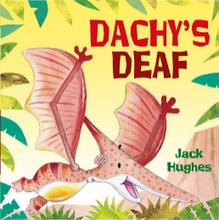  Dachy’s Deaf  By Jack Hughes |  |  |  |  |  |  |  | 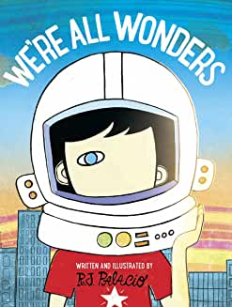  We’re All Wonders  by R J Palacio |  |  |  |  |  | 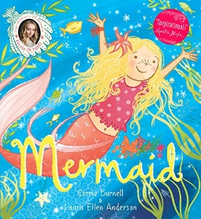  Mermaid  By Cerrie Burnell and Laura Ellen Anderson |  |  |  |  | 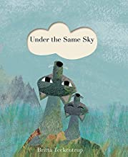  Under the same sky  by Britta Teckentrup |  |  |  |  |  |  | 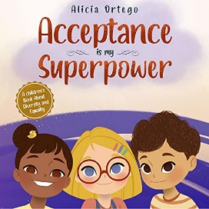  Acceptance is my Superpower  By Alicia Ortego |  | 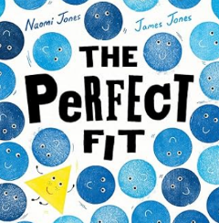  The Perfect Fit  By Naomi Jones |  |  |  |  |  |  |  | 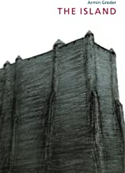  The Island  By Armin Greder
EYFS  Discussion question: What should we do if someone is different from us?  - Be kind and include them  - Only play with people like us  - Ask questions politely  - Ignore them |  |  |  |  |  |  |  | Year 1  Discussion question: How should we speak to people we disagree with?  - Kindly and calmly  - Loudly so they listen  - Walk away  - Listen first |  |  |  |  |  | Year 2  Discussion question: What does being respectful look like?  - Listening to others  - Using good manners  - Letting everyone join in  - Always agreeing |  |  |  |  | Year 3  Discussion question: Why is tolerance important in school?  - Everyone feels safe  - People can be themselves  - It stops arguments  - It doesn’t matter |  |  |  |  |  |  | Year 4  Discussion question: How should we respond to stereotypes?  - Challenge them respectfully  - Ignore them  - Agree to fit in  - Laugh along |  | Year 5  Discussion question: What should we do when we see discrimination?  - Speak up safely  - Report it  - Ignore it  - Support the person affected |  |  |  |  |  |  |  | Year 6  Discussion question: What responsibilities do we have in a diverse society?  - Respect differences  - Challenge discrimination  - Listen to others’ views  - Only care about ourselves
EYFS |  |  |  |  |  |  |  | Year 1 |  |  |  |  |  | Year 2 |  |  |  |  | Year 3 |  |  |  |  |  |  | Year 4 |  | Year 5 ` |  |  |  |  |  |  |  | Year 6
Respectful, kind relationships
Number of lessons – 3 (5th October, 12th October and 19th October)
Relationships and Awareness of Others  - To begin to notice the feelings and needs of others.  - To understand that others may like different things.  Boundaries, Respect and Expectations  - To know that some behaviours are kind and some are not.  - To understand that everyone should be treated kindly.  Communication and Conflict Management  - To begin to talk about their feelings.  - To use simple ways to solve disagreements (e.g. sharing, taking turns).  Assertiveness and Personal Agency  - To begin to express likes, dislikes and feelings.  Relationship Skills and Application (including manners)  - To use kind words (e.g. please, thank you).  - To take turns and share.  Bullying and Harmful Behaviour  - To recognise when someone is being unkind.  - To know to tell an adult.  Equality, Diversity and Stereotypes  - To recognise that people are different and that this is okay.  Safety, Help-Seeking and Trust  - To know there are trusted adults who can help them. |  |  |  |  |  |  |  | Relationships and Awareness of Others  - To recognise that people have different preferences and feelings.  - To begin to think about what others need when playing or working together.  Boundaries, Respect and Expectations  - To know that they can say “no” if something feels wrong or uncomfortable.  - To understand the importance of being kind and fair.  Communication and Conflict Management  - To use words to express feelings rather than actions.  - To begin to resolve small disagreements with support.  Assertiveness and Personal Agency  - To say when something feels unfair or unkind.  Relationship Skills and Application (including manners)  - To use good manners in everyday situations.  - To begin to build friendships through kind behaviour.  Bullying and Harmful Behaviour  - To understand that repeated unkind behaviour is wrong.  - To know that adults can help.  Equality, Diversity and Stereotypes  - To understand that everyone should be treated fairly.  Safety, Help-Seeking and Trust  - To identify trusted adults at home and school. |  |  |  |  |  | Relationships and Awareness of Others  - To understand that different people have different needs and wishes.  - To begin to balance their own needs with those of others.  Boundaries, Respect and Expectations  - To understand that rules help keep people safe and happy.  - To begin to recognise personal space and boundaries.  Communication and Conflict Management  - To understand how to talk about problems calmly.  - To begin to manage feelings like anger or frustration.  Assertiveness and Personal Agency  - To begin to stand up for themselves in simple situations.  Relationship Skills and Application (including manners)  - To understand how politeness helps relationships.  - To develop simple strategies to make and keep friends.  Bullying and Harmful Behaviour  - To recognise different types of unkind behaviour.  - To understand the importance of telling someone.  Equality, Diversity and Stereotypes  - To recognise that differences should be respected.  Safety, Help-Seeking and Trust  - To understand when they should ask for help. |  |  |  |  | Relationships and Awareness of Others  - To recognise that considering others’ needs helps relationships work well.  - To begin to understand that balancing needs can sometimes feel difficult.  Boundaries, Respect and Expectations  - To understand that boundaries help keep relationships safe.  - To recognise that everyone deserves to be treated with respect.  Communication and Conflict Management  - To use respectful communication to solve disagreements.  - To recognise that listening is important in resolving conflict.  Assertiveness and Personal Agency  - To understand the difference between being kind and letting others take advantage.  Relationship Skills and Application (including manners)  - To identify skills that help relationships (e.g. listening, helping, sharing).  Bullying and Harmful Behaviour  - To understand what bullying is and how it affects others.  - To begin to understand the role of bystanders.  Equality, Diversity and Stereotypes  - To understand that assumptions about people are not always correct.  Safety, Help-Seeking and Trust  - To recognise situations where they may feel unsafe or worried. |  |  |  |  |  |  | Relationships and Awareness of Others  - To understand how and why people compromise in relationships.  - To reflect on how decisions can affect different people differently.  Boundaries, Respect and Expectations  - To explain how respecting boundaries supports positive relationships.  - To understand that respect includes accepting differences in others.  Communication and Conflict Management  - To understand how to communicate clearly and respectfully.  - To develop strategies to manage disappointment and frustration.  Assertiveness and Personal Agency  - To recognise the difference between being assertive and being bossy or controlling.  Relationship Skills and Application (including manners)  - To apply relationship skills in different situations (e.g. group work).  Bullying and Harmful Behaviour  - To identify different types of bullying, including online.  - To understand that bystanders should report concerns.  Equality, Diversity and Stereotypes  - To recognise what stereotypes are in simple terms.  - To understand that stereotypes can be unfair.  Safety, Help-Seeking and Trust  - To understand how to seek help in different situations, including online. |  | Relationships and Awareness of Others  - To evaluate how to balance a range of different needs in relationships.  - To understand why managing different needs can be complex.  Boundaries, Respect and Expectations  - To understand the importance of setting and respecting boundaries across relationships.  - To recognise that respect should be mutual and inclusive of differences.  Communication and Conflict Management  - To communicate effectively, including expressing needs and boundaries.  - To manage conflict fairly and respectfully, without aggression.  - To understand how to regulate emotions in challenging situations.  Assertiveness and Personal Agency  - To understand how to be assertive while respecting others.  - To recognise the balance between being kind and meeting their own needs.  Relationship Skills and Application (including manners)  - To apply a range of skills to maintain positive relationships in different contexts.  - To demonstrate consistent courtesy and respectful behaviour.  Bullying and Harmful Behaviour  - To understand the impact of bullying on individuals and communities.  - To recognise their responsibility in responding to and reporting bullying.  Equality, Diversity and Stereotypes  - To understand how stereotypes can be harmful and lead to discrimination.  - To begin to challenge stereotypes respectfully.  Safety, Help-Seeking and Trust  - To recognise more complex situations involving risk or harm.  - To understand how to seek support and who to trust in different contexts. |  |  |  |  |  |  |  | Relationships and Awareness of Others  • How to pay attention to the needs and preferences of others, including in families and friendships.  • Understanding how to balance the needs and wishes of different people in relationships and why this can be complex.  Boundaries, Consent and Respect  • The importance of setting and respecting healthy boundaries in relationships with friends, family, peers and adults.  •That they can expect to be treated with respect by others, and the importance of respecting others, including those who are different (e.g. in appearance, personality, beliefs or choices).  Communication and Conflict Management  • How to communicate effectively and manage conflict with kindness and respect.  •How to be assertive and express needs and boundaries appropriately.  • How to manage emotions, including disappointment and frustration.  Assertiveness and Personal Agency  • Understanding the difference between being assertive and being controlling.  • Understanding the difference between being kind to others and neglecting one’s own needs.  Relationship Skills and Application  • Practical steps and skills that can be used across different contexts to improve and maintain relationships.  • The conventions of courtesy and manners.  Bullying and Harmful Behaviour  •The different types of bullying (including online bullying).  •The impact of bullying on individuals.  •The role and responsibility of bystanders, particularly reporting concerns to an adult.  • How to get help.  Equality, Diversity and Stereotypes  • What stereotypes are and how they can be unfair, negative or harmful.  • How stereotypes can lead to discrimination or bullying.  • How to challenge stereotypes.  Safety, Help-Seeking and Trust  • How to seek help when needed.  • Understanding when they are concerned about violence, harm, or safety.  • Knowing who to trust and how to access support.
Relationships Education – Caring Friendships
Number of lessons – 2 (2nd November and 9th November)
EYFS |  |  |  | Year 1 |  |  |  |  |  |  | Year 2 |  |  |  |  |  | Year 3 |  |  |  |  |  |  | Year 4 |  |  |  |  |  | Year 5 ` |  |  |  |  |  |  |  | Year 6
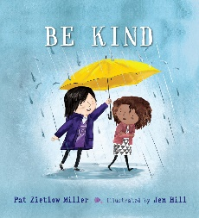  Be Kind  By Pat Zietlow Miller |  |  |  | 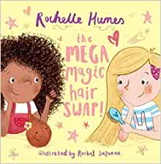  The Mega Magic hair swap  By Rochelle Humes |  |  |  |  |  |  | 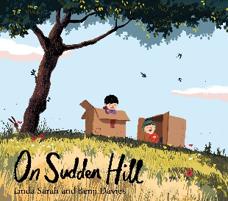  On Sudden Hill  By Linda Sarah and Benji Davies |  |  |  |  |  | 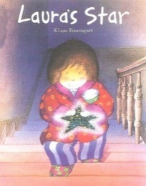  Laura’s Star  By Klaus Baumgart |  |  |  |  |  |  | 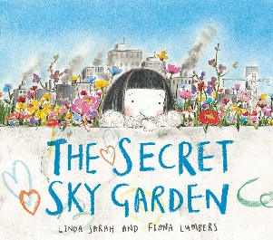  The Secret Sky Garden  By Linda Sarah and Fiona Lumbers |  |  |  |  |  | 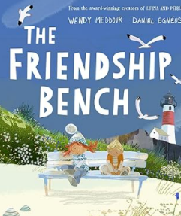  The Friendship Bench  By Wendy Meddour |  |  |  |  |  |  |  | 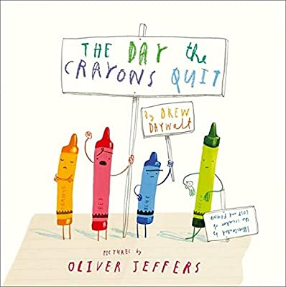  The Day the Crayons Quit  By Drew Daywalt
EYFS  Question: “What makes someone a good friend?”  Viewpoints:  - A good friend plays with you and shares toys.  - A good friend is kind and makes you feel happy.  - A good friend helps you when you feel sad.  - A good friend listens, even if they don’t agree. |  |  |  | Year 1  Question: “Can people who are different from each other still be friends?”  Viewpoints:  - Yes, because friends don’t have to like the same things.  - Yes, because being different makes friendships interesting.  - No, because it might be harder to understand each other.  - Yes, if both people are kind and honest. |  |  |  |  |  |  | Year 2  Question: “What should we do when friends fall out?”  Viewpoints:  - Say sorry and try again.  - Talk to each other and explain how you feel.  - Ask an adult for help if talking is difficult.  - Give each other space and come back when you feel calm. |  |  |  |  |  | Year 3  Question: “How can we show respect and fairness in our friendships?”  Viewpoints:  - By taking turns and listening to each other.  - By including everyone and not leaving people out.  - By letting friends make their own choices.  - By being honest, even when it’s difficult. |  |  |  |  |  |  | Year 4  Question: “Why is it important to repair friendships when things go wrong?”  Viewpoints:  - Because friendships make us happy and feel supported.  - Because saying sorry helps us grow and learn.  - Because misunderstandings happen and can be fixed.  - Because repairing friendships makes them stronger. |  |  |  |  |  | Year 5  Question: “How can we tell the difference between a healthy friendship and an unhealthy one?”  Viewpoints:  - Healthy friendships make you feel safe, included and respected.  - Unhealthy friendships make you feel pressured or upset.  - Healthy friends accept your differences and don’t control you.  - Unhealthy friends might gossip, lie, or leave you out. |  |  |  |  |  |  |  | Year 6  Question: “How can friendships change as we get older, and how can we manage those changes?”  Viewpoints:  - Friendships may change because interests and groups change.  - Sometimes friendships end, but new ones can grow.  - Keeping communication open helps friendships stay strong.  - It’s okay to move on from friendships that aren’t healthy anymore.
Relationships Education – Caring Friendships
Number of lessons – 2 (2nd November and 9th November)
EYFS |  |  |  | Year 1 |  |  |  |  |  |  | Year 2 |  |  |  |  |  | Year 3 |  |  |  |  |  |  | Year 4 |  |  |  |  |  | Year 5 ` |  |  |  |  |  |  |  | Year 6
To know what a friend is and that friends can make us feel happy.  To understand how to play kindly with others (sharing, taking turns, including others).  To recognise when someone is being kind or unkind.  To begin to talk about their feelings and who can help them if they feel sad. |  |  |  | To understand that having friends can help us feel happy and safe.  To know how to be a good friend (being kind, sharing, taking turns, listening).  To recognise when someone feels left out and how to include them.  To understand that sometimes friendships can make us feel sad and we can ask an adult for help. |  |  |  |  |  |  | To understand that friendships should be kind, fair and include others.  To recognise simple ways to build friendships (playing together, talking, helping).  To know that it is normal to sometimes feel lonely and that this feeling will pass.  To begin to manage small disagreements (e.g. saying sorry, taking turns, talking things through). |  |  |  |  |  | To understand that friendships are important for feeling happy and secure.  To identify qualities of a good friend (kindness, honesty, sharing, listening).  To recognise that friendships can change and that people may feel lonely sometimes.  To begin to resolve conflicts by talking, listening and finding solutions.  To know that unkind or excluding behaviour is not acceptable and to seek help if needed. |  |  |  |  |  |  | To understand that healthy friendships are positive, respectful and welcoming.  To describe key characteristics of friendships such as trust, kindness and fairness.  To know that most friendships have challenges and that these can often be worked through.  To develop skills to manage disagreements calmly (speaking respectfully, listening, compromising).  To recognise when a friendship is making them feel unhappy or uncomfortable and know how to get support. |  |  |  |  |  | To understand that friendships contribute to happiness, security and wellbeing.  To describe a range of positive friendship qualities (mutual respect, honesty, loyalty, trust and support).  To develop and apply skills for building and maintaining strong friendships, including resolving conflict appropriately.  To understand that loneliness is a common experience and that it is important to talk about it.  To recognise when friendships are unbalanced, unhealthy or unsafe and know how to seek help.  To understand that conflict should be managed positively and that violence is never acceptable. |  |  |  |  |  |  |  | Pupils know:  How important friendships are in making us feel happy and secure, and how people choose and make friends.  That healthy friendships are positive and welcoming towards others, and do not make others feel lonely or excluded.  Skills for developing caring, kind friendships.  That not every child will have the friends they would like at all times, that most people feel lonely sometimes, and that there is no shame in feeling lonely or talking about it.  The characteristics of friendships that lead to happiness and security, including mutual respect, honesty, trustworthiness, loyalty, kindness, generosity, trust, sharing interests and experiences, and support with problems and difficulties.  That most friendships have ups and downs, and that these can often be worked through so that the friendship is repaired or even strengthened.  How to manage conflict, and that resorting to violence is never right.  How to recognise when a friendship is making them feel unhappy or uncomfortable, and how to get support when needed.

Kindness and Anti-bullying
Number of lessons – 2 (16th November and 23rd November)
EYFS | Year 1 | Year 2 | Year 3 | Year 4 | Year 5 ` | Year 6
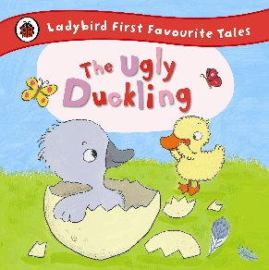  The Ugly Duckling | 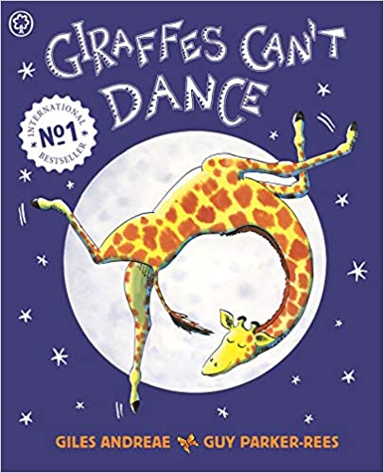  Giraffe’s can’t dance  by Giles Andreae | 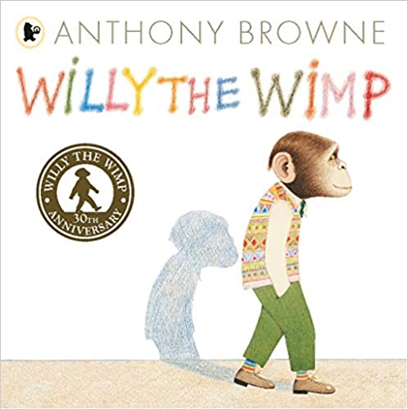  Willy the Wimp  By Anthony Browne | 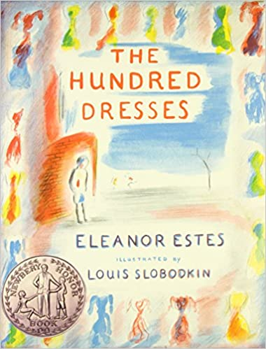  The Hundred Dresses  by Eleanor Estes | 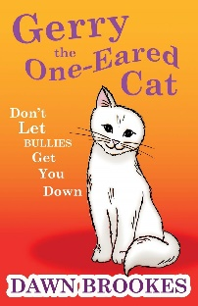  Gerry the one-eared cat  By Dawn Brookes | 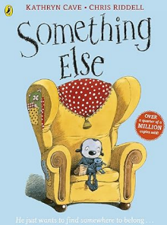  Something Else  by Kathryn Cave | 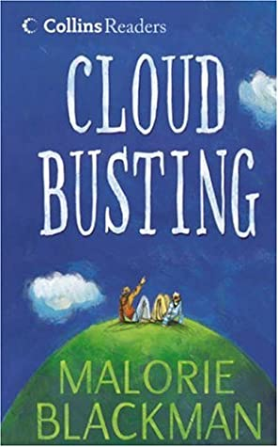  Cloud Busting  By Malorie Blackman
Pupils know that kind and unkind behaviours affect how others feel.  Pupils know that hurting someone’s feelings is wrong.  Pupils know that they should tell a trusted adult if something makes them upset.  Pupils know that they should be kind to others in play and conversation. | Pupils know that unkind behaviour can make others feel sad or hurt.  Pupils know that repeated unkind behaviour is not acceptable.  Pupils know that they should tell an adult if someone is being unkind or makes them feel unsafe.  Pupils know that everyone deserves to feel happy and safe. | Pupils know that bullying is when someone is repeatedly unkind or hurts others on purpose.  Pupils know that bullying can include name-calling and excluding others.  Pupils know that bullying makes people feel upset and unsafe.  Pupils know that they should seek help from a trusted adult if they or others are bullied. | Pupils know that bullying can happen in different ways (physical, verbal, emotional).  Pupils know that bullying has a negative impact on people’s feelings.  Pupils know that it is important to support others who may be experiencing bullying.  Pupils know that reporting bullying is important to keep people safe. | Pupils know that bullying can happen both face-to-face and online.  Pupils know what cyberbullying is and that it can be harmful.  Pupils know that bullying can affect a person’s confidence and wellbeing.  Pupils know different ways to get help (trusted adults, school systems, reporting concerns). | Pupils know that bullying, including cyberbullying, can have serious emotional and mental health impacts.  Pupils know that bullying can have long-lasting effects on how people feel about themselves.  Pupils know the importance of speaking up and supporting others who are being bullied.  Pupils know a range of ways to seek help for themselves or others, both in and out of school.  Pupils know that everyone has a responsibility to help make environments safe and respectful. | Pupils know that bullying (including cyberbullying) has a negative and often lasting impact on mental wellbeing and how to seek help for themselves or others.  Pupils know that bullying can affect a person’s self-esteem, confidence, and emotional health over time.  Pupils know the different forms bullying can take, including physical, verbal, emotional, and online behaviours.  Pupils know that bullying is unacceptable and that everyone has a responsibility to challenge it appropriately.  Pupils know a range of strategies to seek help and support (e.g. trusted adults, reporting systems, peer support).  Pupils know how to respond safely if they witness bullying, including online situations.  Pupils know that early action and reporting can prevent harm from becoming more serious or long-lasting.

British Values
Number of lessons – 2 (30th November and 7th December)
EYFS  Question:  “What does ‘fair’ mean, and how can we help make things fair for everyone?”  Viewpoints:  - Fair means everyone gets the same.  - Fair means everyone gets what they need, even if it's different. ???  - Fair means taking turns so everyone has a chance.  - Fair means following rules so people don’t feel left out. | Year 1  Question: “Why do we have rules in school, and what would happen if no one followed them?”  Viewpoints:  - Rules keep everyone safe.  - Rules help us know what behaviour is expected.  - Without rules, things might get chaotic or unsafe.  - Some people think rules stop us doing what we want — but is that true? | Year 2  Question: “What makes us all different, and why is it important to respect these differences?”  Viewpoints:  - Differences make our class interesting and unique.  - People may look or sound different, but everyone deserves respect.  - Some differences might feel unfamiliar, but we can learn from them.  - Everyone should be treated kindly, even if you don’t understand their differences yet. | Year 3  Question: “Why do we vote for class or school representatives, and how does voting make things fair?”  Viewpoints:  - Voting lets everyone have a say.  - Voting helps us choose someone who will represent the group fairly.  - Sometimes the person you choose won’t win — but the process is still fair.  - Some people think adults should decide everything — is that fair? | Year 4  Question: “What does it mean to have rights and responsibilities, and how can we balance them?”  Viewpoints:  - Rights give us freedom and safety.  - Responsibilities help us look after each other and our environment.  - If we only think about rights, things might become unfair.  - If we only think about responsibilities, we might not feel heard or valued. | Year 5  Question: “How can we respect people’s beliefs, cultures or identities even when they are different from our own?”  Viewpoints:  - We listen and learn from others without judging.  - We don’t have to agree — but we must be respectful.  - Differences can help us understand the world better.  - Ignoring or dismissing someone’s beliefs can lead to unfairness and discrimination. | Year 6  Question: “Why is democracy important, and how does it help keep people safe, equal and free?”  Viewpoints:  - Democracy gives everyone a voice, not just a few people.  - It helps protect people from unfair or harmful laws.  - It encourages debate and shared decision-making.  - Without democracy, power could be misused, leading to inequality or unfair treatment.
British Values
Number of lessons – 2 (30th November and 7th December)
EYFS | Year 1 | Year 2 | Year 3 | Year 4 | Year 5 ` | Year 6
DEMOCRACY  Pupils discuss fairness.  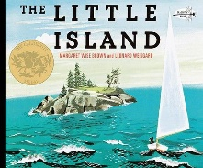  THE RULE OF LAW  Pupils discuss right and wrong.  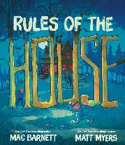  INDIVIDUAL LIBERTY  Pupils discuss similarities and differences between themselves and others.  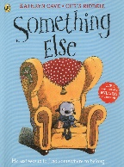  TOLERANCE AND RESPECT  Pupils know what it means to be kind.  I know that sharing and taking turns are important.  Pupils know that people can be different from me.  Pupils know that listening shows respect.  Pupils know that kind words make others feel happy. | DEMOCRACY  Pupils are able to discuss a range of scenarios regarding ‘fairness.’  Pupils take part in some of the decisions that affect them and their communities (e.g. student leadership team).  THE RULE OF LAW  Pupils begin to recognise that all people have needs and wants  Pupils know and follow their class and school rules  INDIVIDUAL LIBERTY  Pupils discuss what it means to respect yourself.  TOLERANCE AND RESPECT  Pupils know that everyone should be treated kindly.  Pupils know that people may have different ideas.  Pupils know some ways people can be different.  Pupils know why polite words are important.  Pupils know that including others is kind and fair. | DEMOCRACY  Pupils vote for student leadership team representative and understand the responsibility of the role.  THE RULE OF LAW  Pupils discuss what is fair and unfair in different situations and identify the difference between peoples’ needs and wants  Pupils know and follow their class and school rules  INDIVIDUAL LIBERTY  Pupils discuss what makes them unique.  TOLERANCE AND RESPECT  Pupils know that respect means treating others fairly and kindly.  Pupils know that people can have different opinions.  Pupils know that their actions can affect other people’s feelings.  Pupils know that everyone should be included and treated fairly.  Pupils know that differences between people should be respected. | DEMOCRACY  Pupils vote for student leadership team representative.  Pupils recognise that in a democracy people have a say in what happens locally and nationally  Pupils can discuss the advantages and disadvantages of democracy.  THE RULE OF LAW  Pupils understand that there are laws for everyone to follow.  Pupils describe some of the rights and responsibilities people have towards each other and the environment and are aware rights can conflict  INDIVIDUAL LIBERTY  Pupils discuss their personality, talents and abilities.  TOLERANCE AND RESPECT  Pupils know why it is important to treat people fairly.  Pupils know that people have different points of view.  Pupils know that people may have different beliefs and traditions.  Pupils know that respect means being kind even when there is disagreement.  Pupils know that unkind behaviour towards others is wrong. | DEMOCRACY  Pupils vote for student leadership team representative.  Pupils begin to explain some of the different ways in which people can participate in democracy in the UK and how they can change things.  Pupils learn how to debate and defend their points of view.  THE RULE OF LAW  Pupils discuss what is fair and unfair and describe how justice is applied in some situations. They explore situations where rights compete  Pupils know their rights and responsibilities (following the rules etc.)  INDIVIDUAL LIBERTY  Pupils discuss their values, needs and wants.  TOLERANCE AND RESPECT  Pupils know what tolerance means.  Pupils know that people from different cultures and backgrounds deserve respect.  Pupils know that everyone has the right to their own beliefs and opinions.  Pupils know that unkind or unfair behaviour should be challenged.  Pupils know why working together respectfully is important. | DEMOCRACY  Pupils vote for student leadership team representative.  Pupils know about the origins of democracy – Ancient Greece.  Pupils compare Ancient Greek democracy to modern day UK democracy.  Pupils describe key features of the political and justice systems in the UK and consider what is fair and unfair to groups in different situations  THE RULE OF LAW  Pupils describe situations where rights or interests conflict and need to be balanced  Pupils understand the importance of the police in a democratic society.  INDIVIDUAL LIBERTY  Pupils discuss body image and the media.  TOLERANCE AND RESPECT  Pupils know that people have different cultures, religions, and lifestyles.  Pupils know why it is important to respect differences in opinions.  Pupils know what discrimination and unfairness are.  Pupils know why empathy helps people understand others.  Pupils know why inclusion is important in a community. | DEMOCRACY  Pupils vote for student leadership team representative.  Pupils know the difference between democracy and dictatorship (link to WW2 and Hitler).  Pupils compare UK democracy and voting system with USA.  THE RULE OF LAW  Pupils explain the different rights need to be protected, supported and balanced, drawing on examples from local to global contexts  Pupils explain what human rights are.  INDIVIDUAL LIBERTY  Pupils discuss freedom of speech, thoughts and actions.  TOLERANCE AND RESPECT  Pupils know why tolerance is important in a diverse society.  Pupils know that respecting differences supports equality and fairness.  Pupils know how stereotypes can harm individuals and groups.  Pupils know why discrimination is wrong and should be challenged.  Pupils know that mutual respect is essential for a fair and inclusive society.

Loss
Number of lessons – 2 (4th January and 11th January)
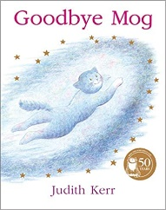  Goodbye Mog  By Judith Kerr | 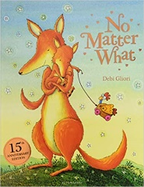  No Matter What  By Debi Gliori | 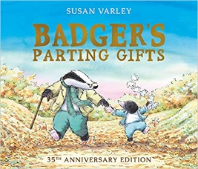  Badgers parting gifts  By Susan Varley | 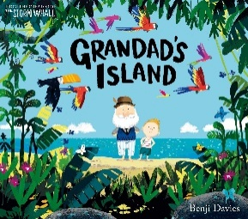  Grandad’s island  By Benji Davies | 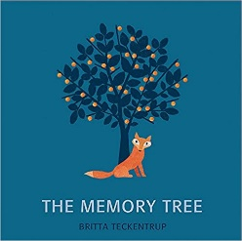  The Memory Tree  by Britta Teckentrup | 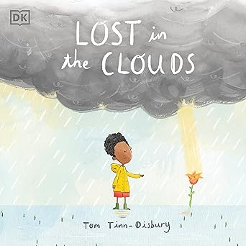  Lost in the Clouds  by DK and Tom Tinn-Disbury | 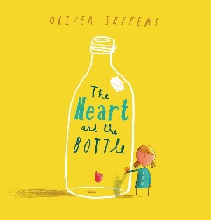  The Heart and the Bottle  By Oliver Jeffers
EYFS  Question: “How might someone feel when they lose something or someone important to them?”  Viewpoints:  - They might feel sad because they miss it or the person.  - They might feel confused because they don’t understand what happened.  - They might feel worried and want to talk to an adult.  - They might feel kind towards others who are sad. | Year 1  Question: “What is the difference between losing something for a little while and losing something forever?”  Viewpoints:  - A temporary loss might make you sad, but you can usually find the item again.  - Some losses are permanent, which can feel much sadder or harder.  - Talking to an adult can help you understand the difference.  - It’s normal to feel upset in both situations. | Year 2  Question: “Who can we talk to when we have questions or worries about loss?”  Viewpoints:  - A parent, teacher or trusted adult can help explain things.  - Friends can help us feel less alone.  - Books or stories can help us understand different feelings.  - Keeping worries inside can make them feel bigger. | Year 3  Question: “How can we show kindness to someone who is feeling sad because of loss?”  Viewpoints:  - By listening to them and letting them share their feelings.  - By being patient if they feel angry or quiet.  - By offering to spend time with them or play together.  - By understanding that feelings about loss can last a long time. | Year 4  Question: “Why do people sometimes feel more than one feeling at the same time when they experience loss?”  Viewpoints:  - Because loss can bring sadness, anger and confusion all at once.  - Because people might feel relieved about one thing but sad about another.  - Because remembering good times can make someone feel happy and sad together.  - Because everyone reacts to loss differently. | Year 5  Question: “How do different people or cultures understand what happens after someone dies?”  Viewpoints:  - Some believe in an afterlife or special resting place.  - Some see death as part of the natural life cycle.  - Some use stories or traditions to remember loved ones.  - Different beliefs should be respected, even if we don’t share them. | Year 6  Question: “How can learning about loss help us support ourselves and others during difficult times?”  Viewpoints:  - It helps us recognise feelings like sadness, guilt or anger.  - It helps us understand that loss is a natural part of life.  - It gives us strategies to cope, like talking, remembering or seeking help.  - It helps us support others with empathy and understanding.
Loss
Number of lessons – 2 (4th January and 11th January)
EYFS | Year 1 | Year 2 | Year 3 | Year 4 | Year 5 ` | Year 6
Pupils know that things can change (e.g. routines, people, environments).  Pupils know that change can make people feel different emotions.  Pupils know that feeling sad or upset is a normal feeling.  Pupils know that they can talk to a trusted adult if they feel upset. | Pupils know that changes can happen in their lives (e.g. moving class, losing a toy, changes in family).  Pupils know that change can make people feel happy, worried, or sad.  Pupils know that it is okay to talk about their feelings with others.  Pupils know that others may feel differently about the same change. | Pupils know that loss can include losing objects, friendships, or routines.  Pupils know that loss can make people feel sad, upset, or confused.  Pupils know that talking to others can help when they feel upset.  Pupils know that people need support when they are feeling sad. | Pupils know that change and loss are part of life.  Pupils know that losing someone or something can cause strong emotions.  Pupils know that people may react to loss in different ways.  Pupils know that it is important to seek help and support when dealing with difficult feelings. | Pupils know that bereavement is when someone dies.  Pupils know that bereavement can cause a range of emotions such as sadness, anger, or confusion.  Pupils know that people may cope with loss in different ways.  Pupils know that support from others can help people manage feelings of loss. | Pupils know that change and loss, including bereavement, can have a significant emotional impact.  Pupils know that people may experience a range of feelings when dealing with loss.  Pupils know that these feelings may change over time.  Pupils know that there are different ways people can cope with grief and loss.  Pupils know the importance of seeking help and supporting others during times of loss. | Pupils know that change and loss, including bereavement, can provoke a range of feelings, that grief is a natural response to bereavement, and that everyone grieves differently.  Pupils know that grief can affect people in emotional, physical, and social ways.  Pupils know that there is no “right” way or time frame to grieve.  Pupils know that people may need different types of support when experiencing loss.  Pupils know how and where to seek help for themselves or others experiencing grief.

Relationships Education - Families and people who care for me
Number of lessons – 2 (18th January and 25th January)
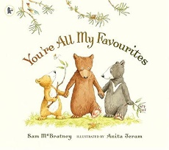  You’re all my favourites  By Sam McBratney |  |  |  | 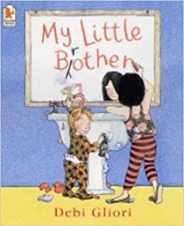  My Little brother  By Debi Gliori |  | 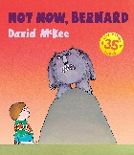  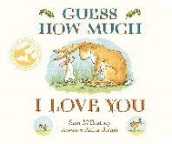  Guess how much I love you  By Sam McBratney  And  Not now Bernard  By David McKee  (comparison) |  | 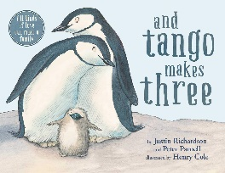  And Tango Makes Three  By Justin Richardson and Peter Parnell |  |  |  |  |  | 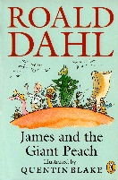  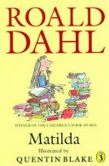  Matilda + James and the Giant Peach (comparison)  By Roald Dahl |  |  |  | 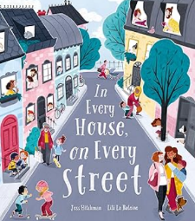  In Every House on Every Street  by Jess Hitchman |  |  |   Ghost  Jason Reynolds  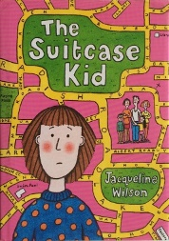  The Suitcase kid  By Jaqueline Wilson
EYFS  Discussion question: What does family mean?  - People who look after me  - People who live with me  - People who love me  - All of these |  |  |  | Year 1  Discussion question: How can families help each other?  - Caring for each other  - Spending time together  - Helping when someone is sad  - Arguing |  | Year 2  Discussion question: Do all families look the same?  - Yes  - No, families can be different  - Only big families are real families  - Families are about love, not looks |  | Year 3  Discussion question: What makes a family healthy and happy?  - Love and care  - Spending time together  - Supporting each other  - Never arguing |  |  |  |  |  | Year 4  Discussion question: Can families change over time?  - Yes, and that’s normal  - No, families stay the same  - Change can be difficult but manageable  - Change always makes families unhappy |  |  |  | Year 5  Discussion question: Why are stable relationships important for children?  - They provide security  - They help children feel safe  - They support wellbeing  - They stop all problems |  |  | Year 6  Discussion question: What makes a family supportive during difficult times?  - Communication  - Care and protection  - Seeking help when needed  - Keeping problems secret
Relationships Education - Families and people who care for me
Number of lessons – 2 (18th January and 25th January)
EYFS |  |  |  | Year 1 |  | Year 2 |  | Year 3 |  |  |  |  |  | Year 4 |  |  |  | Year 5 ` |  |  | Year 6
To know that families care for us and help us stay safe.  To recognise that people who love us can look after us at home.  To understand that families can be different but still care for each other. |  |  |  | To understand that families are important because they help children feel safe and loved.  To recognise that different families may look different but all can provide care.  To know that people in families should be kind and look after each other. |  | To know that families help children grow up feeling safe, secure and cared for.  To understand that families spend time together and support each other.  To recognise that families can be different and that these differences should be respected. |  | To understand that positive relationships within families help people feel happy and secure.  To identify ways families care for one another, including helping, listening and spending time together.  To recognise that stable relationships are important for feeling safe and supported.  To know that if something in a family makes them feel worried or unhappy, they should talk to a trusted adult. |  |  |  |  |  | To understand that strong, caring relationships are important for safe and happy families.  To describe how commitment, support and care help families during both good and difficult times.  To recognise that families may be structured in different ways but should provide love and care.  To know how to recognise when a relationship does not feel safe and how to seek help. |  |  |  | To understand that stable and caring relationships are central to family life and support children’s wellbeing.  To describe key features of positive family relationships, including commitment, mutual respect and spending time together.  To understand that marriage and civil partnerships are ways people can choose to make a committed, long-term relationship.  To recognise signs that family relationships may be unhealthy or unsafe and know how and where to seek advice or help. |  |  | Pupils know  That families are important for children growing up safe and happy because they can provide love, security and stability.  The characteristics of safe and happy family life, such as commitment to each other, including in times of difficulty, protection and care for children and other family members, the importance of spending time together and sharing each other’s lives.  That the families of other children, either in school or in the wider world, sometimes look different from their family, but that they should respect those differences and know that other children’s families are also characterised by love and care.  That stable, caring relationships are at the heart of safe and happy families and are important for children’s security as they grow up.  That marriage and civil partnerships represent a formal and legally recognised commitment of two people to each other which is intended to be lifelong.  How to recognise if family relationships are making them feel unhappy or unsafe, and how to seek help or advice from others if needed.
Personal Safety
Number of lessons – 6 (1st February, 8th February, 22nd February, 1st March, 8th March and 15th March)
 | EYFS  “What should you do if you feel worried, lost or see something scary on a screen?”  Talk about trusted adults and how to ask for help.  Possible viewpoints:  - Tell a grown-up straight away because they can help you feel safe again.  - Turn the screen off because it stops the scary thing.  - Ignore it and keep watching because you think it will go away.  - Tell a friend instead because you might feel shy telling an adult. |  |  | Year 1  “Who keeps us safe, and why do we have safety rules at home, school and online?”  Cover people who help us, age restrictions, and basic safety rules.  Why do we need safety rules at home, school and online?  Possible viewpoints:  - To keep us safe from dangers like roads, fire, or strangers online.  - Because adults tell us to, even if we don’t understand why.  - So everyone knows what to do, especially in emergencies.  - We don’t always need rules because nothing bad usually happens. |  |  | Year 2  “What is the difference between a secret and a surprise, and what should we do if a secret feels wrong?”  Introduce trusted adults, safe vs unsafe online communication, and not keeping uncomfortable secrets.  Question: Is it ever okay to keep a secret that makes you feel uncomfortable?  Possible viewpoints:  - No — you should always tell an adult if a secret worries you.  - Yes, if a friend asked you to, so you don’t upset them.  - Only if it’s a surprise, like a birthday treat.  - You could try and solve it yourself before telling someone. |  |  |  | Year 3  “How can we keep ourselves safe in different places — online, at home, on the road, and near water?”  Discuss assessing risks, resisting unsafe peer pressure, reporting concerns, and age-appropriate online behaviour.  Question: How can we tell when something online is unsafe?  Possible viewpoints:  - If someone asks for private information, it’s unsafe.  - If a friend of a friend messages you, it might be okay.  - If the website looks ‘real’, then it must be safe.  - If it makes you feel unsure, you should stop and ask an adult. |  |  |  |  |  | Year 4  “How do our choices keep us and others safe, and what should we do when we feel pressured to take risks?”  Include consequences of actions, online safety, first-aid basics, and recognising unsafe situations.  Question: What should you do if friends try to pressure you into doing something unsafe (online or offline)?  Possible viewpoints:  - Say no and walk away because safety is more important.  - Tell an adult because they can protect you.  - Join in to keep your friends happy.  - Try to persuade your friends to make a safer choice. |  |  | Year 5  “How can we stay safe online when people may not be who they say they are?”  Explore manipulation, privacy, reporting, cyber safety, and balancing on-/offline time.  Question: How do you know if someone online might not be who they say they are?  Possible viewpoints:  - If they won’t video chat or show their face, they might be pretending.  - If they talk like your age group, they must be your age.  - If they ask to meet in real life, something might be wrong.  - If they know your friends, they must be safe. |  |  | Year 6  “How do we stay safe as we become more independent, both online and in the real world?”  Cover managing risky situations, knowing when and how to ask for help, emergency first-aid, and responsible online communication.  Question: How can we keep ourselves safe as we become more independent (walking home, online, activities)?  Possible viewpoints:  - Tell a trusted adult where you are and who you’re with.  - Rely on your mobile phone because you can always call for help.  - Go alone and figure things out yourself to build confidence.  - Stay with friends because groups feel safer.
Personal Safety
Number of lessons – 6 (1st February, 8th February, 22nd February, 1st March, 8th March and 15th March)
Understand hazards (including fire risks) that may cause harm, injury or risk and ways to reduce risks.
How to recognise risk and keep safe around roads, railways, including level crossings, and water, including the water safety code.
 | EYFS |  |  | Year 1 |  |  | Year 2 |  |  |  |  | Year 3 |  |  | Year 4 |  |  |  |  | Year 5 ` |  |  | Year 6
 | Road  Know that roads can be dangerous and adults help keep them safe.  Begin to practise simple rules (stop, look, listen). |  |  | Road  Identify basic road safety rules (stop, look both ways, listen).  Recognise safe places to cross with an adult. |  |  | Road  Describe safe behaviours, including using crossings where possible.  Understand the importance of looking and listening carefully |  |  |  |  | Road  Explain why road safety rules exist.  Recognise hazards such as parked cars and junctions. |  |  | Road  Apply road safety skills independently in familiar places.  Choose safer crossing points. |  |  |  |  | Road  Evaluate different road situations and select the safest option.  Understand distractions (e.g. phones, headphones) increase risk. |  |  | Road  Analyse complex situations (speed, visibility, traffic flow).  Demonstrate responsible, independent road use.
 | Rail  Know trains and tracks are dangerous and to stay away unless with an adult. |  |  | Rail  Recognise that train tracks and platforms can be dangerous. |  |  | Rail  Understand specific risks (fast trains, staying behind lines). |  |  |  |  | Rail  Identify hazards (level crossings, trespassing, distractions). |  |  | Rail  Describe safe behaviours (obey signals, stand back from platform edge). |  |  |  |  | Rail  Understand consequences (injury, legal issues, disruption). |  |  | Rail  Explain risks in depth (electrified lines, peer pressure, unsafe shortcuts).  Make responsible decisions in real-life scenarios.
 | Water  Know water can be dangerous and to stay with an adult. |  |  | Water  Understand simple safety rules (don’t enter water alone). |  |  | Water  Recognise safe behaviours (stay supervised, wear flotation aids). |  |  |  |  | Water  Identify risks in different environments (rivers, lakes, pools). |  |  | Water  Understand basic self-rescue strategies (float and call for help). |  |  |  |  | Water  Explain how to respond in emergencies (raise alarm, don’t jump in). |  |  | Water  Understand advanced concepts (cold water shock, currents).  Know rescue principles (reach or throw, don’t go).
 | Fire  Recognise fire as dangerous and avoid hot objects. |  |  | Fire  Know not to play with matches or fire.  Identify fire as a hazard. |  |  | Fire  Know what to do if they see fire or smoke (tell an adult, leave safely). |  |  |  |  | Fire  Understand how fire spreads and why safety rules exist. |  |  | Fire  Identify fire risks and how to reduce them. |  |  |  |  | Fire  Understand prevention and basic responses (stop, drop, roll). |  |  | Fire  Explain fire safety procedures (evacuation plans, alarms, meeting points).
 | Public Spaces  Stay close to trusted adults in public places.  Begin to recognise safe vs unsafe situations. |  |  | Public Spaces  Know who can help (police, staff, teachers).  Understand the importance of staying with a group. |  |  | Public Spaces  Recognise unsafe situations (getting lost, approaching strangers).  Understand how to seek help. |  |  |  |  | Public Spaces  Identify hazards (crowds, unfamiliar environments).  Know strategies for getting help. |  |  | Public Spaces  Identify and manage risks in unfamiliar places.  Understand planning routes and staying aware. |  |  |  |  | Public Spaces  Assess risks in different public environments (parks, transport hubs).  Develop safe behaviours when more independent. |  |  | Public Spaces  Evaluate complex risks and make informed decisions.  Show confidence in staying safe and seeking help when needed.
 | First Aid  Making emergency calls and seeking help  - Know to tell a trusted adult if someone is hurt or needs help.  - Begin to recognise that some situations are emergencies.  Basic first aid concepts  - Know that we can help keep ourselves safe by being careful.  - Understand that adults can help when someone is hurt. |  |  | First Aid  Making emergency calls and seeking help  - Know that emergency services help people in danger.  - Know that calling for help is important in an emergency.  Basic first aid concepts  - Recognise when someone might be hurt and needs help.  - Know simple ways to help (e.g. getting an adult, staying calm). |  |  | First Aid  Making emergency calls and seeking help  - Know how to ask for help clearly in an emergency (e.g. saying what has happened).  - Understand that emergencies should be reported to adults or services straight away.  Basic first aid concepts  - Know some simple first aid actions (e.g. cleaning a small cut, using a plaster).  - Recognise common injuries such as cuts and bumps and that they need care. |  |  |  |  | First Aid  Making emergency calls and seeking help  - Know what information is needed when calling for help (location, what happened).  - Understand the importance of staying calm and speaking clearly.  Basic first aid concepts  - Understand basic first aid for common injuries (e.g. cuts, grazes, minor burns).  - Know how to keep themselves safe while helping others. |  |  | First Aid  Making emergency calls and seeking help  - Know how to contact emergency services (e.g. dialing 999/112).  - Understand the importance of giving clear, accurate information and answering questions.  Basic first aid concepts  - Know how to respond safely to a range of common injuries (e.g. bleeding, burns, bumps).  - Understand that some injuries (e.g. head injuries) can be serious and need medical attention. |  |  |  |  | First Aid  Making emergency calls and seeking help  - Explain how to make an effective emergency call, including giving key information (location, incident, people involved).  - Understand the importance of acting responsibly in emergencies, including reporting incidents rather than watching or recording them.  Basic first aid concepts  - Describe and demonstrate basic first aid responses to common injuries and illnesses (e.g. bleeding, burns, choking).  - Understand how to respond appropriately to more serious injuries, including head injuries, and when to seek urgent help. |  |  | First Aid  Making emergency calls and seeking help  How to make a clear and efficient call to emergency services if necessary, including the importance of reporting incidents rather than filming them.  Basic first aid concepts  Concepts of basic first aid, for example dealing with common injuries and ailments, including head injuries.
Being Safe - Respect and Privacy
Number of lessons – 2 (13th April and 20th April)
 | Boundaries (including play and sharing)  - To take turns and share toys and space with others.  - To begin to understand simple rules in play.  Privacy and Secrets  - To understand that some things belong to them (e.g. their body, their belongings).  - To know that they should tell an adult if something worries or confuses them.  Body Safety  - To know that their body belongs to them.  - To recognise safe and kind touches.  Recognising and Responding to Adults  - To know that adults help to keep them safe.  - To follow simple safety instructions from trusted adults.  Recognising Safe/Unsafe Situations  - To begin to recognise when something feels wrong or makes them uncomfortable.  Reporting Concerns  - To know how to tell a trusted adult if they feel unsafe or worried.  Help-Seeking  - To identify trusted adults at home and school. |  | Boundaries (including play and sharing)  - To understand rules about sharing space, toys and games.  - To begin to recognise that people have personal space.  Privacy and Secrets  - To understand that some things are private.  - To know that secrets that make them feel worried should be shared with an adult.  Body Safety  - To know that their body belongs to them.  - To recognise appropriate and inappropriate touch in simple terms.  Recognising and Responding to Adults  - To understand that most adults are safe, but not all adults are known to them.  - To know basic ways to stay safe around strangers.  Recognising Safe/Unsafe Situations  - To recognise when something makes them feel uncomfortable or unsure.  Reporting Concerns  - To know that they should tell an adult if something feels wrong.  Help-Seeking  - To name trusted adults they can go to for help. |  |  |  | Boundaries (including play and sharing)  - To understand that boundaries help keep people safe and happy.  - To begin to respect others’ space and belongings.  Privacy and Secrets  - To understand the difference between a good surprise and a secret that should not be kept.  - To know that unsafe secrets should always be shared.  Body Safety  - To understand the difference between safe and unsafe physical contact.  - To know that they can say “no” to unwanted touch.  Recognising and Responding to Adults  - To understand how to behave safely around unfamiliar adults.  - To know simple online safety rules (e.g. not sharing personal information).  Recognising Safe/Unsafe Situations  - To recognise situations that may be unsafe in real life or online.  Reporting Concerns  - To know how to tell an adult if they feel unsafe and what words to use.  Help-Seeking  - To understand that they should keep asking for help until someone listens. |  |  | Boundaries (including play and sharing)  - To understand that boundaries apply in friendships, including sharing space and resources.  - To begin to recognise personal boundaries in different situations.  Privacy and Secrets  - To understand the importance of privacy for themselves and others.  - To recognise that keeping secrets about safety is not appropriate.  Body Safety  - To understand more clearly the difference between appropriate and inappropriate contact.  - To know that they have the right to feel safe at all times.  Recognising and Responding to Adults  - To understand how to respond safely to adults they do and do not know.  - To develop awareness of safe behaviour both offline and online.  Recognising Safe/Unsafe Situations  - To recognise warning signs that a situation or relationship may be unsafe.  Reporting Concerns  - To know how to report concerns clearly to a trusted adult.  Help-Seeking  - To identify a range of people and places where they can get help (home, school, community). |  |  |  |  |  | Boundaries (including play and sharing)  - To understand that different relationships require different boundaries.  - To begin to apply boundaries in a range of contexts, including online.  Privacy and Secrets  - To understand the concept of privacy for both children and adults.  - To know when it is important to share concerns rather than keep a secret.  Body Safety  - To describe appropriate and inappropriate contact in more detail.  - To understand that they should speak up if they feel uncomfortable.  Recognising and Responding to Adults  - To understand how to evaluate whether an adult is safe or trustworthy.  - To apply strategies for staying safe in different environments, including online.  Recognising Safe/Unsafe Situations  - To begin to recognise patterns of behaviour that may indicate a harmful situation.  Reporting Concerns  - To understand how to report concerns about real-life or online experiences.  Help-Seeking  - To understand when and how to seek help for themselves or others. |  |  |  | Boundaries (including play and sharing)  - To understand appropriate boundaries in a wide range of relationships, including online interactions.  - To apply boundaries confidently in social, digital and group contexts.  Privacy and Secrets  - To understand the implications of privacy for themselves and others.  - To recognise that safety concerns should never be kept secret.  Body Safety  - To confidently describe the differences between appropriate, inappropriate and unsafe contact.  - To understand personal rights over their own body.  Recognising and Responding to Adults  - To apply strategies for responding safely to known and unknown adults across contexts.  - To demonstrate safe behaviours online, including managing contact from others.  Recognising Safe/Unsafe Situations  - To recognise when a relationship may be harmful or unsafe.  - To evaluate who they can trust in different situations.  Reporting Concerns  - To know how to report concerns clearly and confidently, including online issues or unsafe experiences.  Help-Seeking  - To understand how to seek advice or help for themselves and others in a range of situations.  - To recognise the importance of persisting in seeking help until they feel heard. |  |  |  | Pupils know what sorts of boundaries are appropriate in friendships with peers and others (including in a digital context)  Pupils know about the concept of privacy and the implications of it for both children and adults; including that it is not always right to keep secrets if they relate to being safe  Pupils know that each person’s body belongs to them, and the differences between appropriate and inappropriate or unsafe physical, and other, contact  Pupils know how to respond safely and appropriately to adults they may encounter (in all contexts, including online) whom they do not know  Pupils know how to recognise and report feelings of being unsafe or feeling bad about any adult  Pupils know how to ask for advice or help for themselves or others, and to keep trying until they are heard,  Pupils know how to report concerns or abuse, and the vocabulary and confidence needed to do so  Pupils know where to get advice, for example family, school or other sources
Health and Wellbeing - Physical Health and Fitness
Number of lessons – 2 (26th April and 3rd May)
EYFS  Question: “Why is it important to look after our bodies every day?”  Viewpoints:  - Because eating healthy food helps us grow strong.  - Because washing our hands and brushing our teeth keeps us clean and healthy.  - Because exercising helps our bodies move and feel good.  - Because looking after our bodies helps stop us from getting poorly. |  | Year 1  Question: “What choices can we make that help us stay healthy?”  Viewpoints:  - Choosing healthy foods helps our bodies work properly.  - Going to bed early helps us feel awake and happy the next day.  - Washing our hands and keeping clean stops germs spreading.  - Brushing our teeth twice a day keeps our teeth strong. |  |  | Year 2  Question: “Why is it important to eat a balanced diet and drink plenty of water?”  Viewpoints:  - A balanced diet gives our bodies the energy they need.  - Drinking water stops us feeling tired or unwell.  - Eating too much sugar can damage our teeth.  - Healthy eating helps us stay active and enjoy playing. |  |  |  | Year 3  Question: “How does sleep, exercise and hygiene help our bodies stay healthy?”  Viewpoints:  - Sleep helps our bodies rest and repair.  - Exercise makes our muscles and heart strong.  - Good hygiene stops germs from making us ill.  - All three work together to keep us healthy and happy. |  |  |  | Year 4  Question: “Why do our choices about food, exercise and hygiene matter for our long-term health?”  Viewpoints:  - Healthy choices help prevent illnesses in the future.  - Poor choices can affect energy, mood and learning.  - Looking after our teeth and bodies now prevents problems later.  - Being active every day helps us build healthy habits. |  |  |  |  |  | Year 5  Question: “How can we make informed choices about our health when there are so many influences around us?”  Viewpoints:  - We should understand how food, exercise and sleep affect our bodies.  - We need to recognise that adverts and social media can influence our decisions.  - We can ask adults or experts when we’re unsure.  - We can choose what feels healthy and right for us, even if others don’t. |  |  | Year 6  Question: “How can learning about our bodies help us stay healthy as we become more independent?”  Viewpoints:  - We learn to recognise early signs of illness and seek help.  - We understand how lifestyle choices impact long-term health.  - We learn how to keep safe in the sun, deal with basic first aid and stay active.  - We understand risks such as poor diet, lack of sleep, harmful substances and unsafe habits.
Health and Wellbeing - Physical Health and Fitness
Number of lessons – 2 (26th April and 3rd May)
EYFS |  | Year 1 |  |  | Year 2 |  |  |  | Year 3 |  |  |  | Year 4 |  |  |  |  |  | Year 5 ` |  |  | Year 6
Active Lifestyle  - To enjoy physical activity such as running, jumping, climbing and playing outside.  - To understand that moving their body helps them feel good.  Building Activity into Routines  - To take part in active play every day.  Health and Wellbeing  - To know that being active helps keep their body healthy.  Risks of Inactivity  - To begin to understand that sitting still for too long is not healthy.  Help-Seeking  - To know that adults can help them stay healthy. |  | Active Lifestyle  - To understand that physical activity is important for keeping bodies healthy and strong.  - To recognise that being active can make them feel happy.  Building Activity into Routines  - To know that they should be active every day (e.g. playing, running, games).  Health and Wellbeing  - To understand that exercise is part of staying healthy.  Risks of Inactivity  - To begin to recognise that not being active can affect their health.  Help-Seeking  - To know that they can talk to an adult if they are worried about their health. |  |  | Active Lifestyle  - To understand that different types of physical activity help both body and mind.  - To recognise how exercise can affect how they feel.  Building Activity into Routines  - To understand the importance of regular activity in daily routines (e.g. playtime, clubs, walking).  Health and Wellbeing  - To recognise that being active supports overall wellbeing.  Risks of Inactivity  - To begin to understand that not being active regularly can be unhealthy.  Help-Seeking  - To identify trusted adults they can speak to if they are worried about their health. |  |  |  | Active Lifestyle  - To understand the physical and mental benefits of an active lifestyle.  Building Activity into Routines  - To describe ways to be active regularly (e.g. sports, walking, outdoor play).  Health and Wellbeing  - To understand that physical activity contributes to both physical health and mental wellbeing.  Risks of Inactivity  - To recognise that an inactive lifestyle can have negative effects on health.  Help-Seeking  - To know how to ask for help if they are concerned about their health. |  |  |  | Active Lifestyle  - To explain the key characteristics of an active lifestyle and its benefits for health and wellbeing.  Building Activity into Routines  - To understand how to include regular physical activity in daily and weekly routines.  Health and Wellbeing  - To explain how physical activity supports overall wellbeing.  Risks of Inactivity  - To understand the risks of inactivity and how it can impact health.  Help-Seeking  - To understand when it is important to seek support for health concerns. |  |  |  |  |  | Active Lifestyle  - To understand in detail the benefits of an active lifestyle for both mental and physical health.  Building Activity into Routines  - To explain how to build regular physical activity into daily and weekly routines (e.g. walking, cycling, structured exercise).  Health and Wellbeing  - To evaluate the importance of maintaining physical activity for overall wellbeing.  Risks of Inactivity  - To understand the health risks associated with an inactive lifestyle, including obesity.  Help-Seeking  - To know when and how to seek support for health concerns, including identifying appropriate adults in school. |  |  | Active Lifestyle  - The characteristics and mental and physical benefits of an active lifestyle.  Building Activity into Routines  - The importance of building regular physical activity into daily and weekly routines and how to achieve this; for example, walking or cycling to school, a daily active mile or other forms of regular, moderate and/or vigorous physical activity.  Risks of Inactivity  - The risks associated with an inactive lifestyle, including obesity.  Help-Seeking  - How and when to seek support including which adults to speak to in school if they are worried about their health.

Health and Wellbeing - Drugs, alcohol, tobacco and vaping
Number of lessons – 2 (10th May and 17th May)
EYFS | Year 1 | Year 2 | Year 3 | Year 4 | Year 5 ` | Year 6
 |  |  | To understand that some substances can be harmful to the body if they are not used correctly (e.g. medicines, household products).  To know that some substances should only be used by adults or with adult supervision.  To recognise that putting unknown substances into their body can be dangerous.  To understand that they should never take medicines or substances without a trusted adult’s permission.  To know how to seek help if they find something potentially harmful. | To understand that some substances are legal (e.g. medicines, alcohol for adults) and some are illegal.  To recognise that legal substances can still be harmful if misused.  To understand basic risks linked to smoking and alcohol use.  To recognise that substances can affect both the body and behaviour.  To know that they can ask a trusted adult if they are worried about substances or something they have seen. | To understand the difference between legal and illegal substances and why laws exist to control them.  To describe the risks associated with smoking, vaping, alcohol use and drug-taking.  To understand that substances can have short- and long-term effects on physical and mental health.  To begin to understand the concept of addiction, including how substances like nicotine can be addictive.  To recognise situations where substances might be present and understand how to respond safely.  To know where and how to seek help or advice about substances for themselves or others. | The facts about legal and illegal harmful substances and associated risks, including smoking, vaping, alcohol use and drug-taking. This should include the risks of nicotine addiction, which are also caused by other nicotine products such as nicotine pouches.

Health and Wellbeing – Health protection and prevention
Number of lessons – 3 (24th May, 14th June and 21st June)
EYFS | Year 1 | Year 2 | Year 3 | Year 4 | Year 5 ` | Year 6
Recognising early signs of physical illness  - Know how to tell a trusted adult if they feel unwell or in pain.  Sun safety and reducing risk  - Know that the sun can be hot and we need hats and sunscreen.  Sleep and its impact  - Know that sleep helps us grow and feel good.  Dental health and oral hygiene  - Know we brush our teeth to keep them clean.  Personal hygiene, germs, and handwashing  - Know we wash hands to stay clean.  Vaccination and immunisation  - Know that doctors help keep us healthy. | Recognising early signs of physical illness  - Know simple signs that show someone might be unwell (e.g. feeling hot or tired).  Sun safety and reducing risk  - Understand that too much sun can hurt skin and we should stay in shade.  Sleep and its impact  - Recognise that bedtime routines help us stay healthy.  Dental health and oral hygiene  - Understand brushing teeth twice a day keeps them healthy.  Personal hygiene, germs, and handwashing  - Understand that germs can make us ill and handwashing helps stop this.  Vaccination and immunisation  - Begin to understand that some treatments help stop us getting ill. | Recognising early signs of physical illness  - Understand that bodies can change when we are ill (e.g. coughs, rashes) and to seek help.  Sun safety and reducing risk  - Know basic sun safety (hat, sunscreen, water, shade).  Sleep and its impact  - Know that not getting enough sleep can make us tired and unable to learn well.  Dental health and oral hygiene  - Know that sugary foods can harm teeth and the role of dentists.  Personal hygiene, germs, and handwashing  - Know that germs can spread through touch, sneezing, and coughing.  Vaccination and immunisation  - Know that medicines can prevent or treat illness (basic awareness). | Recognising early signs of physical illness  - Recognise a wider range of symptoms and understand that changes to the body may need checking.  Sun safety and reducing risk  - Understand UV rays can damage skin and the importance of protection.  Sleep and its impact  - Understand basic sleep needs and simple ways to rest well.  Dental health and oral hygiene  - Understand how to care for teeth properly (brushing technique, dentist visits).  Personal hygiene, germs, and handwashing  - Understand basic types of germs (bacteria and viruses) and how they spread.  Vaccination and immunisation  - Understand that vaccines help protect people from certain diseases. | Recognising early signs of physical illness  - Understand that some illnesses show gradual or unusual changes and should not be ignored.  Sun safety and reducing risk  - Know the risks of too much sun exposure and how to stay safe in different conditions.  Sleep and its impact  - Know recommended sleep amounts and factors that affect sleep (routine, environment).  Dental health and oral hygiene  - Know about plaque, tooth decay, and the importance of fluoride toothpaste.  Personal hygiene, germs, and handwashing  - Know how infections spread and ways to reduce risk (hygiene habits).  Vaccination and immunisation  - Know that vaccinations help stop diseases spreading in communities. | Recognising early signs of physical illness  - Describe early warning signs of illness, including unexpected changes in weight, energy, or appearance, and know when to seek advice.  Sun safety and reducing risk  - Explain how sun damage builds up over time and how to reduce long-term risks.  Sleep and its impact  - Understand the impact of poor sleep on mood, behaviour, learning, and health, and how to improve sleep (including reducing screen use).  Dental health and oral hygiene  - Explain good oral hygiene practices including brushing, cleaning between teeth, diet, and regular check-ups.  Personal hygiene, germs, and handwashing  - Explain how bacteria and viruses affect the body, how illness is treated, and why handwashing is important.  Vaccination and immunisation  - Understand in simple scientific terms how vaccines work to protect individuals and others (immunity). | Recognising early signs of physical illness  - How to recognise early signs of physical illness, such as weight loss, or unexplained changes to the body.  Sun safety and reducing risk  - About safe and unsafe exposure to the sun, and how to reduce the risk of sun damage, including skin cancer.  Sleep and its impact  - The importance of sufficient good quality sleep for health, the amount of sleep recommended for their age, and practical steps for improving sleep, such as not using screens in the bedroom. The impact of poor sleep on weight, mood and ability to learn.  Dental health and oral hygiene  - About dental health and the benefits of good oral hygiene, including brushing teeth twice a day with fluoride toothpaste, cleaning between teeth, and regular checkups at the dentist.  Personal hygiene, germs, and handwashing  - About personal hygiene and germs including bacteria, viruses, how they are spread and treated, and the importance of handwashing.  Vaccination and immunisation  - The facts and scientific evidence relating to vaccination and immunisation. The introduction of topics relating to vaccination and immunisation should be aligned with when vaccinations are offered to pupils.

Health and Wellbeing - Healthy Eating
Number of lessons – 3 (28th June, 5th July and 12th July)
Healthy Diet  - To recognise that some foods are good for our bodies (e.g. fruit, vegetables, water).  - To understand that we need food and drink to grow and stay healthy.  Relationship with Food  - To enjoy trying different foods.  - To begin to recognise when they are hungry or full.  Preparing Food  - To take part in simple food preparation with support (e.g. washing fruit, mixing).  Unhealthy Diet and Risks  - To recognise that some foods are “sometimes foods” (e.g. sweets, treats).  - To begin to understand that too many sugary foods can harm their teeth. | Healthy Diet  - To understand that a healthy diet includes a variety of foods.  - To recognise different food groups in simple terms (e.g. fruit, vegetables, protein).  Relationship with Food  - To understand that eating well helps their body and mind feel good.  Preparing Food  - To follow simple steps to prepare healthy snacks.  Unhealthy Diet and Risks  - To understand that eating too many sugary or unhealthy foods can affect health.  - To know that sugar can damage teeth. | Healthy Diet  - To understand that a balanced diet includes different types of food in the right amounts.  - To recognise the importance of regular meals and healthy snacks.  Relationship with Food  - To understand that food provides energy for learning, play and growth.  Preparing Food  - To begin to plan and prepare simple healthy meals or snacks with guidance.  Unhealthy Diet and Risks  - To understand that too much fat or sugar can be unhealthy.  - To recognise simple links between diet and health (e.g. energy, growth, teeth). | Healthy Diet  - To understand the main food groups and their role in keeping the body healthy.  - To begin to understand nutritional balance in meals.  Relationship with Food  - To recognise that a healthy relationship with food includes balance and variety.  Preparing Food  - To plan and prepare simple healthy meals safely with increasing independence.  Unhealthy Diet and Risks  - To recognise that an unbalanced diet can affect health and wellbeing.  - To understand that too much sugar can lead to tooth decay. | Healthy Diet  - To understand more about what makes a healthy diet, including portion balance.  - To begin to understand nutritional content (e.g. sugar, fat, basic energy).  Relationship with Food  - To understand that healthy eating involves making balanced choices without restriction or overconsumption.  Preparing Food  - To plan and prepare simple balanced meals using a range of ingredients.  Unhealthy Diet and Risks  - To understand the risks of poor diet, including effects on teeth, energy levels and general health. | Healthy Diet  - To understand in more detail what constitutes a healthy diet, including basic awareness of calories and nutritional content.  - To evaluate food choices in relation to health and wellbeing.  Relationship with Food  - To understand the importance of a healthy relationship with food, including balance and moderation.  Preparing Food  - To plan and prepare a range of healthy meals, understanding key principles of nutrition and balance.  Unhealthy Diet and Risks  - To understand the characteristics of a poor diet and associated risks, including obesity and tooth decay.  - To begin to understand how other behaviours (e.g. alcohol use) can impact diet and health. | Healthy Diet  - What constitutes a healthy diet (including understanding calories and other nutritional content).  Relationship with Food  - Understanding the importance of a healthy relationship with food.  Preparing Food  - The principles of planning and preparing a range of healthy meals.  Unhealthy Diet and Risks  - The characteristics of a poor diet and risks associated with unhealthy eating (including, for example, obesity and tooth decay) and other behaviours (e.g. the impact of alcohol on diet or health).

Growing up – Developing bodies
Number of lessons – 2 (19th July and 26th July)
EYFS  Question: “How do we change as we grow bigger?”  Viewpoints:  - We learn to do new things, like talking, running and getting dressed.  - We get taller and stronger as our bodies grow.  - We change by trying things on our own instead of needing lots of help.  - Everyone grows at different speeds, and that’s okay. | Year 1  Question: “What is the difference between a child and an adult?”  Viewpoints:  - Adults have more responsibilities, like cooking and working.  - Children are still learning and need help to stay safe.  - Adults’ bodies are bigger and stronger.  - Children and adults sometimes enjoy different things, but both can learn and have fun. | Year 2  Question: “How do people change as they grow from babies into children and then into adults?”  Viewpoints:  - Their bodies grow and develop new abilities.  - Their needs change — babies need lots of care; older children can do more independently.  - People learn new skills and responsibilities as they grow.  - Growing up can bring exciting changes, but also new challenges  . | Year 3  Question: “Why do different people grow and develop at different rates?”  Viewpoints:  - Everyone’s body is unique and changes in its own time.  - Sometimes families share similar growth patterns.  - Health, food and exercise can affect how we grow.  - Different rates of growth are normal — there is no ‘right’ pace. | Year 4  Question: “What changes happen in our bodies as we move through different stages of the human life cycle?”  Viewpoints:  - Our bodies grow stronger, taller and change shape.  - We gain independence and responsibilities as we grow.  - Life cycle stages bring new feelings and experiences.  - All humans experience the same stages, but in different ways. | Year 5  Question: “How can learning about puberty help us feel more confident as our bodies begin to change?”  Viewpoints:  - Knowing what will happen helps us feel prepared instead of worried.  - Understanding the science behind changes makes them feel normal.  - Talking about puberty helps us share concerns and get support.  - Everyone changes at different times, and that’s completely normal. | Year 6  Question: “How can we take care of our bodies and mental wellbeing as we go through puberty and prepare for new responsibilities?”  Viewpoints:  - Looking after hygiene and health helps us feel comfortable and confident.  - Recognising emotional changes helps us manage mood and stress.  - Seeking help from trusted adults and friends supports us through challenges.  - Understanding our bodies gives us independence and helps keep us safe.
Growing up – Developing bodies
Number of lessons – 2 (19th July and 26th July)
EYFS | Year 1 | Year 2 | Year 3 | Year 4 | Year 5 ` | Year 6
The Growing Story  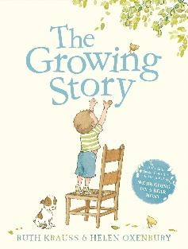  By Ruth Krauss  Growth, change and the human lifecycle  - Know that people grow and change from babies to children.  - Talk about things they can do now that they could not do before.  Naming body parts and personal boundaries  - Name basic body parts (e.g. head, arms, legs).  - Understand that some parts of the body are private.  - Know they can say “no” and tell a trusted adult if they feel uncomfortable.  Preparing for body changes (early awareness)  - Recognise that bodies grow and change as we get older. | Pupils identify, name, draw and label the basic parts of the human body and say which part of the body is associated with each sense  Growth, change and the human lifecycle  - Understand that humans grow and change over time (baby → child → adult).  Naming body parts and personal boundaries  - Name main external body parts,  - Know that private parts should be covered and are not for others to see or touch.  - Know the importance of telling a trusted adult if something feels wrong.  Preparing for body changes  - Begin to understand that growing up brings changes for everyone. | Pupils notice that animals, including humans, have offspring which grow into adults  Growth, change and the human lifecycle  - Describe the basic human lifecycle and how needs change as we grow.  Naming body parts and personal boundaries  - Use correct basic vocabulary for body parts.  - Understand that private parts are private and they belong to them.  - Know they have a right to privacy and to set boundaries.  Preparing for body changes  - Recognise that bodies will continue to change as they get older. | Growth, change and the human lifecycle  - Understand that growth continues into adulthood and includes physical and emotional changes.  Naming body parts and personal boundaries  - Use correct terminology for a wider range of body parts (including vagina, penis, breasts and testicles).  - Understand personal boundaries and respect the boundaries of others.  - Know how to seek help if boundaries are not respected.  Preparing for body changes  - Begin to understand that puberty is a stage of growing up when bodies start to change. | Growth, change and the human lifecycle  - Understand that puberty is part of the human lifecycle and brings physical and emotional changes.  Naming body parts and personal boundaries  - Confidently use correct names for body parts (including vagina, penis, breasts and testicles).  - Understand the meaning of privacy, consent (in an age-appropriate way), and personal space.  Menstrual cycle and body changes  - Know that girls’ bodies will change during puberty, including the start of periods.  - Understand that periods are a natural part of growing up and can begin from around 8 years old. | Pupils describe the differences in the life cycles of a mammal, an amphibian, an insect and a bird  Pupils describe the life process of reproduction in some plants and animals  Pupils describe the changes as humans develop to old age (Pupils should draw a timeline to indicate stages in the growth and development of humans. They should learn about the changes experienced in puberty)  Pupils identify the changes to the body during puberty and know that people develop at different rates (including the menstrual cycle).  Pupils know how to care for themselves during their menstrual cycles.  Pupils know about different types of reproduction, including sexual and asexual reproduction in plants, and sexual reproduction in animals.  Growth, change and the human lifecycle  - Explain the human lifecycle, including adolescence as a stage of development.  - Understand a range of physical and emotional changes that happen during puberty.  Naming body parts and personal boundaries  - Use accurate scientific vocabulary for body parts and explain why they are private. (including vagina, penis, breasts, nipples and testicles).  - Demonstrate understanding of personal boundaries, respect, and how to seek support if needed.  Menstrual cycle and body changes  - Understand the key facts about the menstrual cycle, including why periods happen.  - Recognise both physical and emotional changes linked to menstruation and puberty.  - Feel prepared and reassured about body changes before they happen. | Pupils recognise that living things produce offspring of the same kind, but normally offspring vary and are not identical to their parents  About growth and other ways the body can change and develop, particularly  during adolescence. This topic should include the human lifecycle, and puberty  should be discussed as a stage in this process.  The correct names of body parts, including the penis, vulva, vagina, testicles,  scrotum, nipples. Pupils should understand that all of these parts of the body are  private and have skills to understand and express their own boundaries around  these body parts.  The facts about the menstrual cycle, including physical and emotional changes,  whilst the average age of the onset of menstruation is twelve, periods can start at  eight, so covering this topic before girls’ periods start will help them understand  what to expect and avoid distress.

