Key Text and Topic Overview
2021 - 2022

FS1

Autumn 1 | Autumn 2 | Spring 1 | Spring 2 | Summer 1 | Summer 2
Dear Zoo  By Rod Campbell  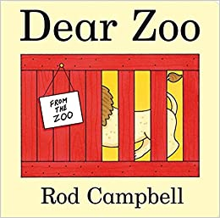  Dig Dig Digging  By Margaret Mayo 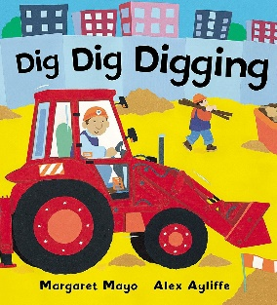 | Hooray for Fish  By Lucy Cousins  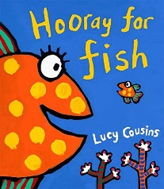  Naughty Bus  By Jan and Jerry Oke  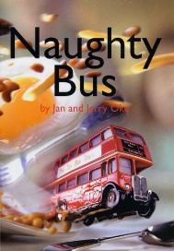  Stick Man  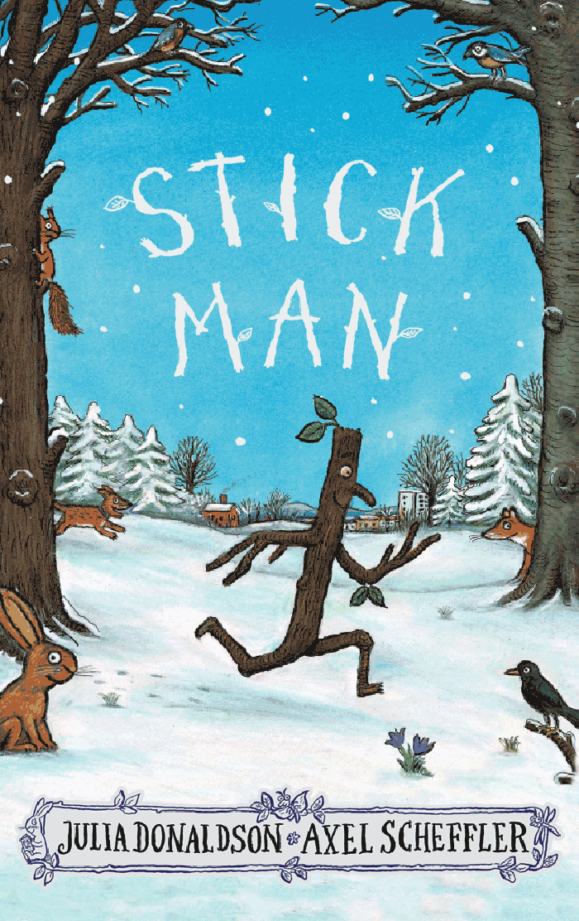  By Julia Donaldson | Harry and his Bucket Full of Dinosaurs  By Ian Whybrow  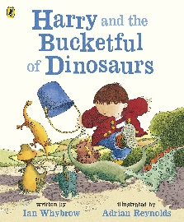  The Train Ride  By June Crebbin  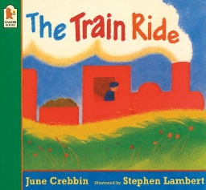  Supertato  By Sue Hendra and Paul Linnet  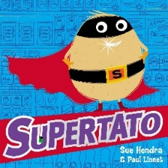 | Owl Babies  By Martain Waddell  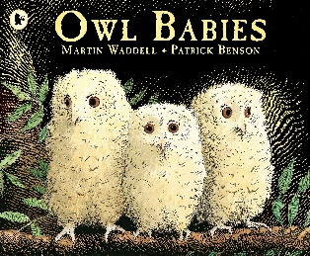  Q Pootle 5  By Nick Butterworth  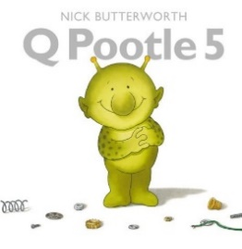  Tanka Tanka Skunk  By Steve Webb  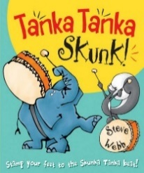 | Each Peach Pear Plum  By Janet and Allan Ahlberg  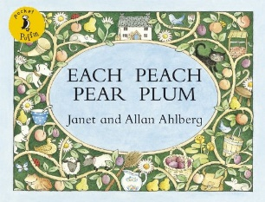  Where’s Spot?  By Eric Hill  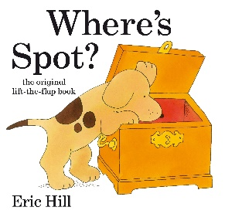  The Tiny Seed  By Eric Carle  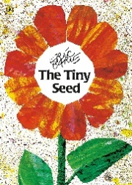 | Billy’s Bucket  By Kes Gray and Garry Parsons  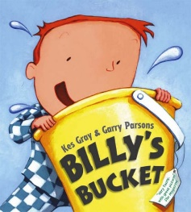  The Hungry Caterpillar  By Eric Carle  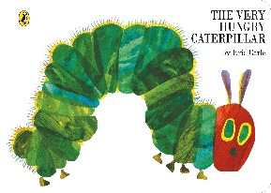

FS2
Autumn 1 | Autumn 2 | Spring 1 | Spring 2 | Summer 1 | Summer 2
You Can’t Take and Elephant on the Bus  By Patricia Cleveland-Peck  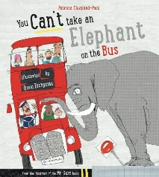  Commotion in the Ocean - By Giles Andreae  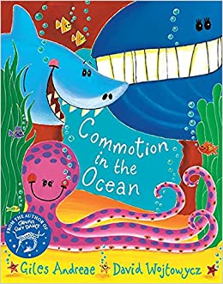  Squash and a Squeeze - By Julia Donaldson  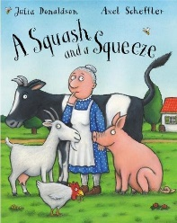  Dinosaur Roar By Paul and Henrietta Stickland  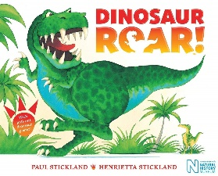 | The Light in the Night  By Marie Voigt  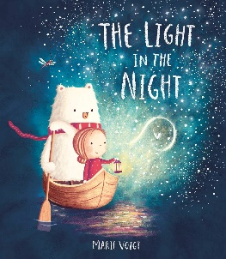  Mr Grumpy’s Outing  By John Burningham  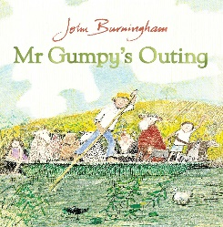  Oh, No, Mr Snowman!  By Nick Page  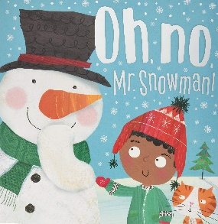 | Rosie’s Walk  By Pat Hutchins  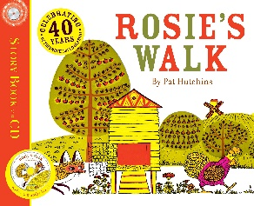  Elliot Midnight Superhero  By Anne Cottringer  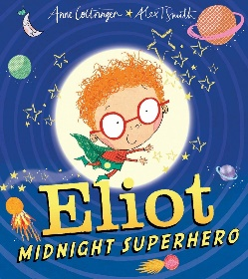  Moth  By Isabel Thomas  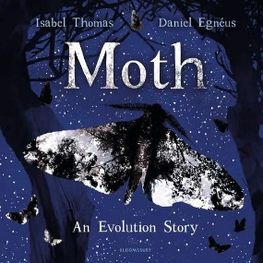 | On Sudden Hill  By Linda Sarah  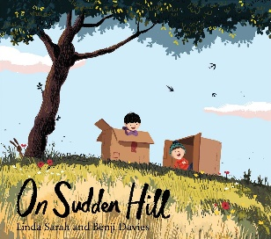  Leopard’s Drum  By Jessica Souhami  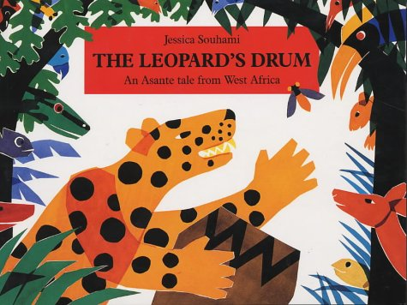  Man on the Moon  By Simon Bartram  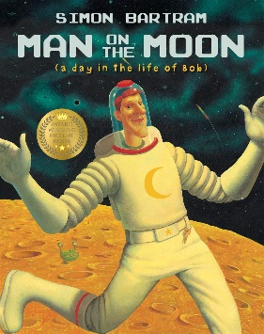 | We’re going on a Bear Hunt  By Michael Rosen  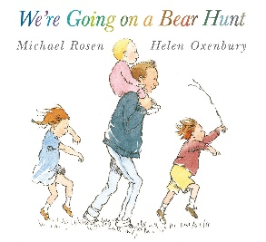  Jasper’s Beanstall  By Nick Butterworth  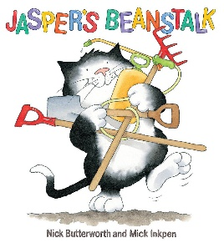  The Cave  By Rob Hodgson  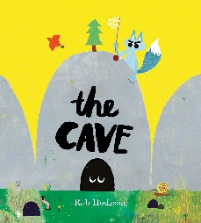 | The Gruffalo  By Julia Donaldson  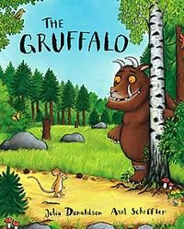  The Snail and the Whale  By Julia Donaldson  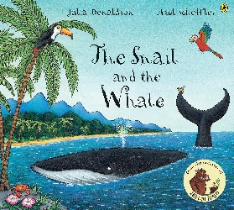

 | Year 1 | Year 2 | Year 3 | Year 4 | Year 5 | Year 6
Autumn | Pirates | Africa | South America | Save Our World | Survival | Is it Worth the Risk?
Book Stimulus | 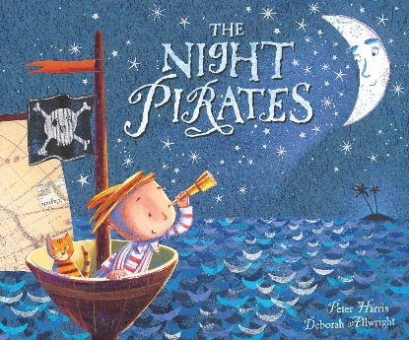  The Night Pirates by Peter Harris & Deborah Allwright  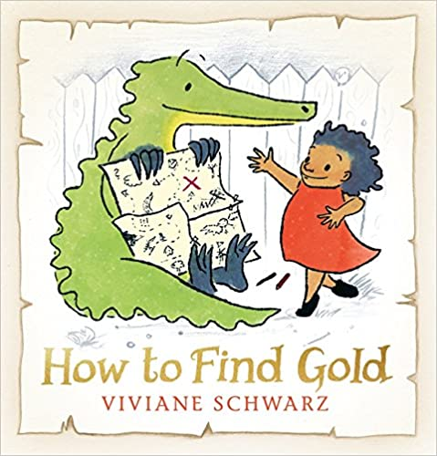  How to find Gold by Viviane Schwarz | 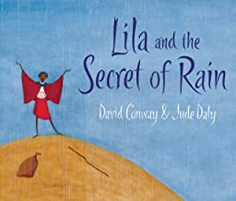  Lila and the Secret of Rain by David Conway and Jude Daly  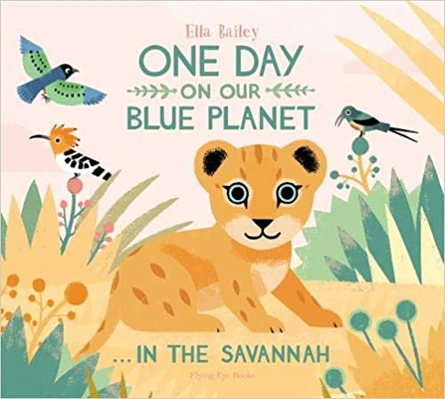  One Day on Our Blue Planet – Savannah by Ella Bailey  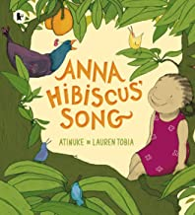  Anna Hibiscus by by Atinuke and Lauren Tobia | 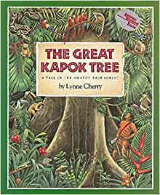  The Great Kapok Tree by Lynne Cherry  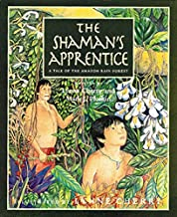  The Shaman’s Apprentice by Lynne Cherry | 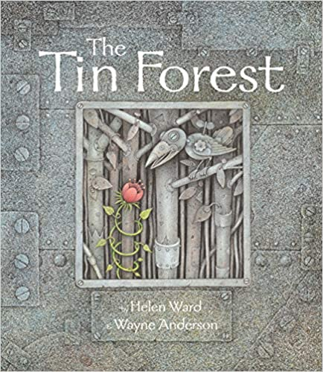  The Tin Forest by Helen Ward - English writing  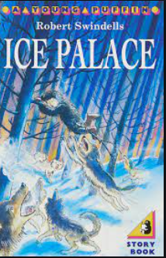  Ice Palace – Robert Swindells | 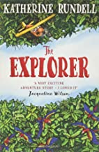  The Explorer by Katherine Rundell | 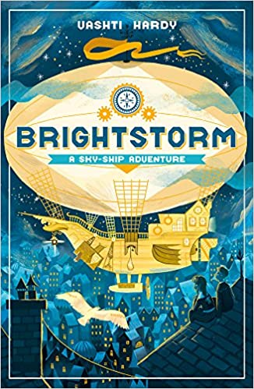  Brightstorm by by Vashti Hardy  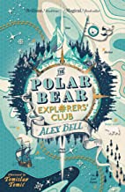  The Polar Bear Explorers Club by by Alex Bell and Scott Brown
 | Year 1 | Year 2 | Year 3 | Year 4 | Year 5 | Year 6
Spring | Heroes | Explorers | Invaders | Egyptians | WW1 | WW2
Book Stimulus | 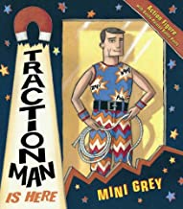  Traction Man by Mini Grey  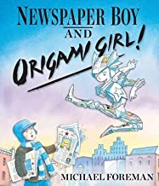  Newspaper Boy and Origami Girl by Michael Foreman | 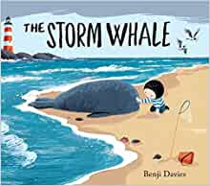  The Storm Whale by Benji Davies  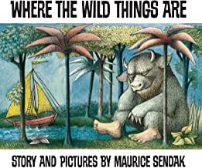  Where the wild things are by Maurice Sendak  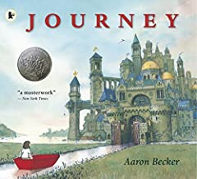  Journey by Aaron Becker  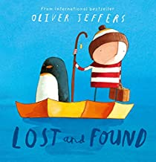  Lost and Found by Oliver Jeffers | 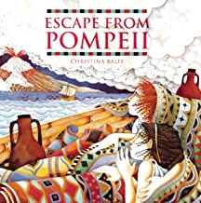  Escape from Pompeii by Christina Balit  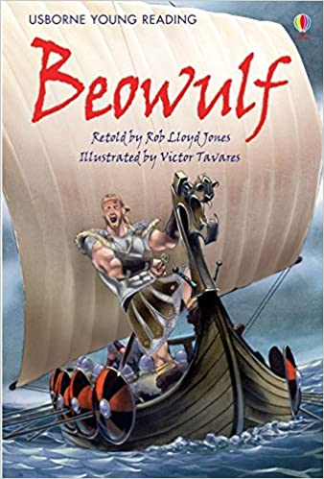  Beowulf – Retold by Rob Lloyd Jones | 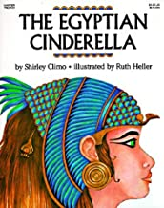  Egyptian Cinderella by Shirley Climo -  and playscript  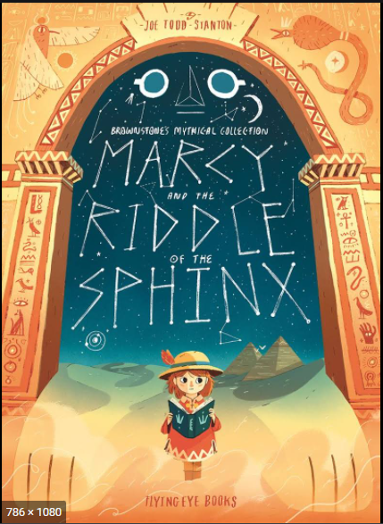  Marcy an the Riddle of the Sphinx – Joe Todd-Stanton | Private Peaceful by Michael Morpurgo | 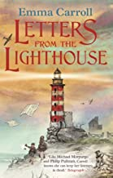  Letters from the lighthouse by Emma Carroll
 | Year 1 | Year 2 | Year 3 | Year 4 | Year 5 | Year 6
Summer | King of the Jungle | Bugs Life | Defy the Force | Super Senses | Out of this World | Where did it all begin?
Book Stimulus | 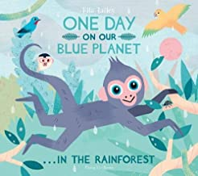  One Day on Our Blue Planet by Ella Bailey  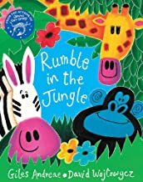  Rumble in the Jungle by Giles Andreae and David Wojtowycz  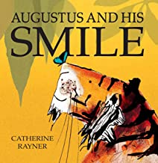  Augustus and his smile by Catherine Rayner | 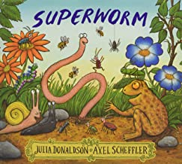  Super Worm by Julia Donaldson  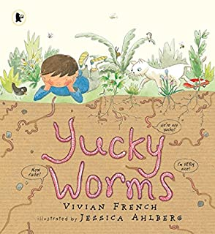  Yucky Worms by Vivian French and Jessica Ahlberg  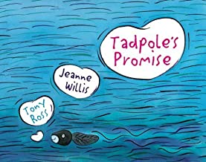  Tadpole's Promise by Jeanne Willis and Tony Ross | 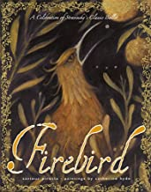  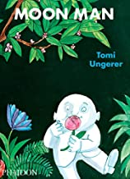  Fire Bird by Saviour Pirotta and Catherine Hyde  Moon Man by Tomi Ungerer  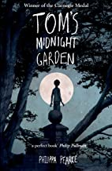  Tom’s midnight garden by Philippa Pearce | 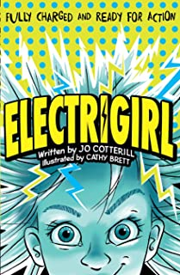  Electra Girl by Jo Cotterill and Cathy Brett | 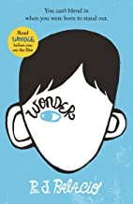  Wonder by R J Palacio | 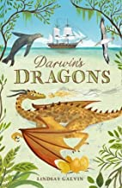  Darwin’s Dragon’s by Lindsay Galvin

