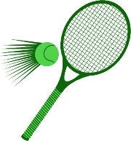

PE Intent

Our Aims
At Linden Road Academy, we strive to deliver a high-quality physical education curriculum that inspires all pupils to succeed and excel in competitive sport and other physically demanding activities.

It provides opportunities for pupils to become physically confident in a way that supports their health and fitness.
There are opportunities to compete in sport and other activities that build character and help to embed values such as fairness and respect.

The curriculum at Linden Road Academy for physical education aims to ensure that all pupils:
- develop competence to excel in a broad range of physical activities.
- are physically active for sustained periods of time.
- engage in competitive sports and activities.
- lead healthy, active lives.

By the end of each key stage, pupils will be expected to know, apply and understand the matters, skills and processes specified in the relevant programme of study.

When our students move on to high school they will be expected in Key Stage Three to build on and embed the physical development and skills learned in key stages 1 and 2, become more competent, confident and expert in their techniques, and apply them across different sports and physical activities. They should understand what makes a performance effective and how to apply these principles to their own and others’ work. They should develop the confidence and interest to get involved in exercise, sports and activities out of school and in later life, and understand and apply the long-term health benefits of physical activity.

In order to prepare our students for the PE expectations in high school, our curriculum is created to ensure that pupils are exposed to:
- a range of tactics and strategies to overcome opponents in direct competition through team and individual games.
- chances to develop their technique and improve their performance in other competitive sports.
- opportunities to perform dances using advanced dance techniques within a range of dance styles and forms.
- partake in outdoor and adventurous activities which present intellectual and physical challenges and be encouraged to work in a team, building on trust and developing skills to solve problems, either individually or as a group.
- analyse their performances compared to previous ones and demonstrate improvement to achieve their personal best.
- take part in competitive sports and activities outside school through community links or sports clubs.

Evidence of our PE learning can be found on twitter by searching #LindenPE

EYFS
In the Early Years Foundation Stage, PE is taught in weekly sessions as well as part of continuous provision.

Here, pupils will develop skills to meet the Early Learning Goals such as:

- running safely on whole foot.
- squatting with steadiness to rest or play with object on the ground, and rises to feet without using hands.
- climbing confidently and is beginning to pull themselves up on nursery play climbing equipment.
- able to kick a large ball.
- moves freely and with pleasure and confidence in a range of ways, such as slithering, shuffling, rolling, crawling, walking, running, jumping, skipping, sliding and hopping.

Key Stage One
Key Stage One pupils, will develop fundamental movement skills, become increasingly competent and confident and access a broad range of opportunities to extend their agility, balance and coordination, individually and with others. They will be able to engage in competitive (both against self and against others) and co-operative physical activities, in a range of increasingly challenging situations.

Pupils will be taught to:
- master basic movements including running, jumping, throwing and catching, as well as developing balance, agility and co-ordination, and begin to apply these in a range of activities.
- participate in team games, developing simple tactics for attacking and defending.
- perform dances using simple movement patterns.

Key Stage Two
Key Stage Two pupils, will continue to apply and develop a broader range of skills, learning how to use them in different ways and to link them to make actions and sequences of movement. They will be development enjoyment in communicating, collaborating and competing with each other. They will develop an understanding of how to improve in different physical activities and sports and learn how to evaluate and recognise their own success.

Pupils will be taught to:
- use running, jumping, throwing and catching in isolation and in combination.
- play competitive games, modified where appropriate [for example, badminton, basketball, cricket, football, hockey, netball, rounders and tennis], and apply basic principles suitable for attacking and defending.
- develop flexibility, strength, technique, control and balance [for example, through athletics and gymnastics.
- perform dances using a range of movement patterns.
- take part in outdoor and adventurous activity challenges both individually and within a team.
- compare their performances with previous ones and demonstrate improvement to achieve their personal best.

Programme of study
Each PE lesson begins with a PE quiz which aims to develop and consolidate knowledge. The content includes questions related to safety, equipment, sports stars, sport rules and much more. Each PE quiz builds on from one year to the next and hopefully helps our pupils retain key information relating to their own health and the world of sport.

A typical PE lesson will begin with a warm up and a recap prior knowledge. Followed by the introduction of new learning in small steps and modelled throughout. This will then be applied and practiced by pupils through games and activities.

Our sports include:
- Gymnastics
- Netball
- Basketball
- Volleyball
- Dance
- Football
- Rugby
- Hockey
- Athletics
- Orienteering
- Cricket
- Tennis

Our mapped PE progression aims to build upon skills yearly, with sports revisited in a sequential order. This careful mapping ensures our pupils make great progress in their PE journey.

Fitness Friday
In addition to our sport themed lessons, we also take part in weekly ‘Fitness Friday’. In these sessions pupils try to improve their fitness, strength and stamina with an aim to achieve a new goal each week.

The Daily Mile
As a whole school, we take part in The Daily Mile, where the aim is to improve the mental and physical health of children.

The Daily Mile makes children fitter, healthier, happier and has a positive impact on their behaviour and concentration levels. It is simple and effective, enabling every child, including those with special needs, to be active every day.

The children jog or run with their classmates in the safety of the playground. Everyone has fun taking part — it is not P.E. and it is not competitive — while building relationships, confidence and resilience. This can be summed up in The Daily Mile’s Five F’s:

1. Fitness — children become more aware of a healthy lifestyle
2. Fresh air — children thrive on the sights, sounds and seasons
3. Friends — children use the language of friendship to support each other, improving their social and leadership skills
4. Fun — children enjoy taking part — This is what makes The Daily Mile so successful
5. Focus — daily physical activity helps children concentrate in the classroom and is proven to raise attainment

Swimming
Here at Linden Road Academy we provide swimming instruction in Key Stage 2 during Year 4.

Pupils are taught to:
- swim competently, confidently and proficiently over a distance of at least 25 metres.
- use a range of strokes effectively [for example, front crawl, backstroke and breaststroke.
- perform safe self-rescue in different water-based situations.

Events
We also hold annual Sports Days and Danceathons, which are open for parental engagement and have proven a great success in the past.

Extra-curricular
Outside of the school day, we also offer after school clubs, which are voted for by the children and include sports such as:
- Hockey
- Cosmic yoga
- Basketball
- Football
- Competition Sports

Pupils also attend matches and competitions against local schools, which are always a great opportunity to develop resilience and teamwork skills.

Programme of Study

Term | EYFS | Year 1 | 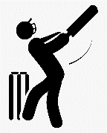  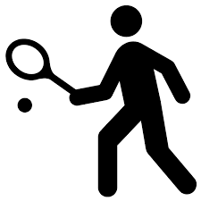  Year 2 | Year 3 | Year 4 | Year 5 | Year 6
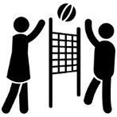  Autumn 1 | Netball  Little Stars | Netball | Basketball | Volleyball | Netball | Basketball | Volleyball
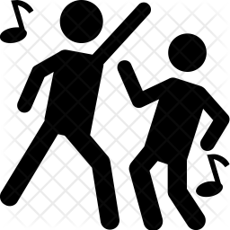  Autumn 2 | Dance  LittleMovers | Dance  Pirates | Dance  Africa | Dance  South America | Dance | Dance | Dance
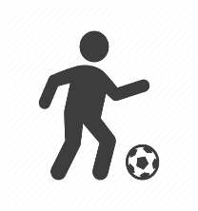  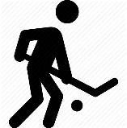  Spring 1 | Football  LittleExplorers | Football | Hockey | Rugby | Football | Hockey | Rugby
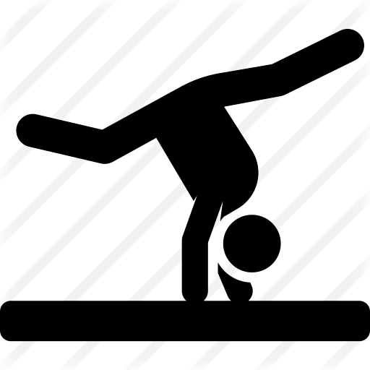  Spring 2 | Gymnastics  LittleTumblers | Gymnastics | Gymnastics | Gymnastics | Gymnastics | Gymnastics | Gymnastics
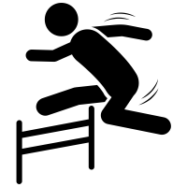  Summer 1 | Athletics  Little Athletes | Athletics | Athletics | Athletics | Athletics | Athletics | Athletics
Summer 2 | Tennis  Little Stars | Tennis | Cricket | Orienteering | Tennis | Cricket | Orienteering

Lesson Construct
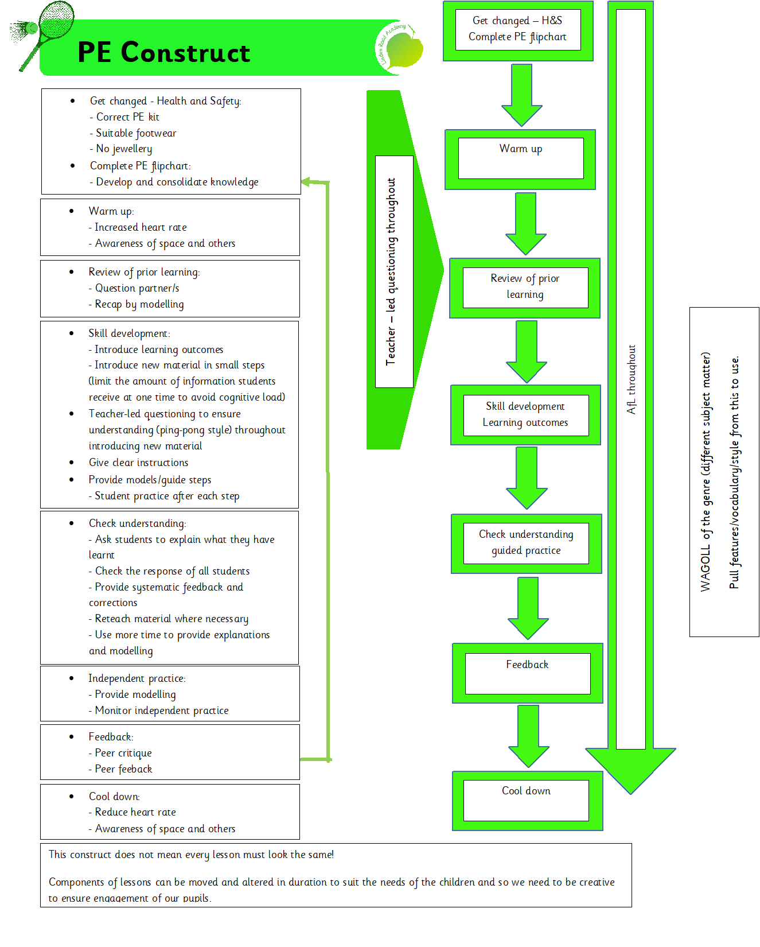

 | FS | Y1 | Y2 | Y3 | Y4 | Y5 | Y6
Autumn 1 | Little Stars  Understand the importance of a warm-up in PE.  Practise different catching and throwing techniques. | Netball  Understand the importance of a warm-up and suggest a way of doing so.  Develop netball passing and receiving skills with increasing accuracy.  Begin to apply the rules of netball with support. | Basketball  Understand importance of a warm-up and suggest a variety of different ways of doing so.  Develop Basketball dribbling technique.  Develop Basketball dribbling in a 1v1 context  Develop passing and receiving skills and apply the rules of Basketball with support. | Volleyball  Understand importance of a warm-up and begin to suggest a variety of different ways of doing so for each part of the body.  To introduce new techniques and begin to use correctly.  -Feeding technique.  -Movement and positioning under the ball.  -Hand positioning.  -Understand the basic techniques for the underarm serve.  -Improve ability to move to get under the ball.  -Develop correct technique when playing their shots. E.G Volley, forearm pass and serve.  -Play in small sided volleyball competition.  -Understand the importance of playing to set rules.  -Understand the serves rotation. | Netball  Understand importance of a warm-up and suggest a variety of different ways of doing so for each part of the body.  To develop skills in passing and receiving the ball with control.  To practise footwork including balancing, landing and pivoting.  To begin to develop a shooting technique.  To use movement to support attacking and defending.  To apply the rules of netball with increasing confidence. | Basketball  Understand importance of a warm-up with increasing independence and suggest a variety of different ways of doing so for each part of the body.  Develop Basketball dribbling technique with increasing control whilst moving.  Experiment dribbling with the left and right hand.  Develop Basketball dribbling in a 1v1 context with increasing control.  Develop variety of passing and receiving techniques and apply the rules of Basketball confidently.  To develop the technique of shooting a Basketball, making the use of the backboard.  To develop the correct footwork skills.  To develop defending skills.  To understand how the game of basketball is played.  Gain a good knowledge and understanding of rules.  To get used to playing matches / competition.  To show an understanding of the basic rules and actions. | Volleyball  Understand importance of a warm-up and independently suggest a variety of different ways of doing so for each part of the body.  To use techniques correctly and confidently.  -Feeding technique.  -Movement and positioning under the ball.  -Hand positioning.  -Understand the basic techniques for the underarm and overarm serve.  -Improve ability to move to get under the ball.  -Develop correct technique when playing their shots. E.G Volley, forearm pass and serve.  -Play in small sided volleyball competition.  -Understand the importance of playing to set rules and use tactics to work successfully as a team.  - Understand the serves rotation  Be capable of keeping the ball up in a rally situation.  Understanding the importance of moving and stay low when playing the forearm pass.  Applying volleying and passing skills to game situations.  To gain understanding of both competing and officiating in a volleyball competition.
Autumn 2 | Little Movers  Understand the importance of a warm-up in PE.  To explore movement of the body.  To move the body to music.  Develop spatial awareness with support.  To sequence three movements with support.  To remember the sequence of three movements with support.  To perform the sequence of movements with support. | Dance  Understand the importance of a warm-up and suggest a way of doing so.  To suggest ways the body can move.  To move the body to the rhythm of the music.  Develop spatial awareness.  To sequence five movements with support.  To remember the sequence of five movements with support.  To perform the sequence of movements with support. | Dance  Understand importance of a warm-up and suggest a variety of different ways of doing so.  To suggest ways the body can move in response to music.  To move the body to different rhythms of music.  Understand the importance of spatial awareness.  To sequence a variety of movements with increasing independence.  To remember the sequence of movements with increasing independence.  To perform the sequence of movements with increasing independence. | Dance  Understand importance of a warm-up and begin to suggest a variety of different ways of doing so for each part of the body.  To suggest ways the body can move and travel.  To move and travel the body to the rhythm of different genres of music.  To recognise and name some of the different genres of music.  Understand the importance of spatial awareness whilst moving and travelling.  To begin to suggest and sequence movements of their own choice.  To remember the sequence independently.  To collaborate with others to create a sequence of movements.  To perform the sequence of movements independently. | Dance  Understand importance of a warm-up and suggest a variety of different ways of doing so for each part of the body.  To suggest ways the body can move and travel with smooth transitions.  To use movement and travel which are appropriate to the genre of music.  To recognise and name a variety of different genres of music.  Understand the importance of spatial awareness whilst moving and travelling with increasing independence.  To suggest and sequence movements of their own choice.  To remember the sequence independently with increasing confidence.  To collaborate with others effectively to create a sequence of movements.  To perform the sequence of movements independently with increasing confidence. | Dance  Understand importance of a warm-up with increasing independence and suggest a variety of different ways of doing so for each part of the body.  To suggest ways the body can move and travel with smooth transitions in time to the music.  To use a range of movement and travel which are appropriate to the genres of music.  To recognise and name the different genres of music and begin to reason their preferences.  Understand the importance of spatial awareness whilst moving and travelling independently.  To suggest and sequence appropriate movements of their own choice in accordance with the chosen music.  To remember the sequence independently with confidence.  To collaborate with others effectively to create a sequence of movements.  To perform the sequence of movements independently with confidence. | Dance  Understand importance of a warm-up and independently suggest a variety of different ways of doing so for each part of the body.  To suggest ways the body can move and travel with smooth transitions in time to different section of a musical track.  To use a range of movement and travel which are appropriate to the genres of music and understand when to change these.  To recognise and name the different genres of music and reason their preferences.  Understand and demonstrate the importance of spatial awareness whilst moving and travelling independently.  To suggest and sequence appropriate movements of their own choice in accordance with the chosen music with increasing length and complexity.  To remember more complex sequences independently with confidence.  To collaborate with others effectively to create longer and more complex sequences of movements.  To perform the longer and more complex sequence of movements independently with confidence.
Spring 1 | Little Explorers  Understand the importance of a warm-up in PE.  To begin to use relevant equipment safely.  To follow simple rules and instructions.  To work together in groups. | Football  Understand the importance of a warm-up and suggest a way of doing so.  To follow the main rules of the game.  To work together in teams.  To develop football techniques  -passing  -dribbling  -changing direction  To begin to use some attacking and defending techniques. | Hockey  Understand importance of a warm-up and suggest a variety of different ways of doing so.  To use relevant equipment safely.  To follow the main rules of the game.  To work together in teams effectively.  To develop hockey techniques  -holding the stick correctly  -passing  -dribbling  -changing direction  To use some attacking and defending techniques.  To begin to apply learnt skills in a competitive game. | Rugby  Understand importance of a warm-up and begin to suggest a variety of different ways of doing so for each part of the body.  To follow the main rules of the game and know the differences between different types of rugby.  To work together in teams with some effective communication.  To develop rugby techniques with increasing accuracy  -holding the ball correctly  -passing  -throwing  -catching  -kicking  -changing direction  To use some attacking and defending techniques incorporating spacial awareness.  To apply learnt skills in a competitive game. | Football  Understand importance of a warm-up and suggest a variety of different ways of doing so for each part of the body.  To follow the main rules of the game and know the different positions.  To work together in teams with effective communication.  To develop football techniques with increasing accuracy  -the part of the foot to:  dribble, pass, control, shoot  -passing  -kicking  -heading  -changing direction  To use a variety of attacking and defending techniques incorporating special awareness.  To apply learnt skills in a competitive game. | Hockey  Understand importance of a warm-up with increasing independence and suggest a variety of different ways of doing so for each part of the body.  To use relevant equipment safely, accurately and confidently.  To follow the main rules of the game.  To work together in teams effectively and confidently.  To implement hockey techniques confidently  -passing  -dribbling  -changing direction  -playing in different positions  To use attacking and defending techniques effectively with confidence.  To apply learnt skills in a competitive game confidently.  To analyse team performance and discuss ways to improve. | Rugby  Understand importance of a warm-up and independently suggest a variety of different ways of doing so for each part of the body.  To enforce the main rules of the game and know the differences between different types of rugby.  To work together in teams with effective communication.  To use rugby techniques with accuracy  -holding the ball correctly  -passing  -throwing  -catching  -kicking  -changing direction  To use attacking and defending techniques incorporating special awareness.  To independently apply skills in a competitive game.  To analyse their own and others’ performance and discuss ways to improve.
Spring 2 | Little Tumblers  Understand the importance of a warm-up in PE.  To practise some gymnastic shapes.  To balance on different body parts.  To travel in different ways using all parts of the body.  To understand the importance of spatial awareness with support.  To perform 3 gymnastic shapes to their peers with support. | Gymnastics  Understand the importance of a warm-up and suggest a way of doing so.  To practise a variety of gymnastic shapes.  To balance on different body parts with some control.  To travel in different ways using all parts of the body with some control and an awareness of take-off and landing strategies.  To understand the importance of spatial awareness with increasing independence.  To perform 5 gymnastic shapes to their peers with increasing independence. | Gymnastics  Understand importance of a warm-up and suggest a variety of different ways of doing so.  To practise a variety of gymnastic shapes with control and accuracy.  To balance on different body parts with control.  To travel in different ways using all parts of the body with control and an awareness of take-off and landing strategies.  To understand the importance of spatial awareness with independence.  To perform a variety of gymnastic shapes to their peers with independence.  To feedback on others’ performance and discuss ways to improve. | Gymnastics  Understand importance of a warm-up and begin to suggest a variety of different ways of doing so for each part of the body.  To practise gymnastic shapes with control and accuracy.  To combine gymnastic shapes into a short routine of their own.  To balance on different body parts with control and increasing still ness  To travel in different ways using all parts of the body with control and ensure smooth transitions between take-off and landing strategies.  To understand the importance of spatial awareness with independence and begin to demonstrate this independently when planning routines.  To perform gymnastic shapes to their peers with independence and increasing length.  To feedback on others’ performance and discuss ways to improve with some technical vocabulary. | Gymnastics  Understand importance of a warm-up and suggest a variety of different ways of doing so for each part of the body.  To practise a variety of gymnastics actions, balances and body shapes accurately.  To combine variety of gymnastics action into a longer routine of their own.  To balance on different body parts with control and still ness.  To travel in different ways using all parts of the body with control and ensure smooth transitions between take-off and landing strategies.  To begin to suggest the best ways to travel between balances.  To understand the importance of spatial awareness with independence and demonstrate this independently when planning routines.  To perform gymnastics actions, balances and body shapes independently.  To feedback on others’ performance and discuss ways to improve with technical vocabulary. | Gymnastics  Understand importance of a warm-up with increasing independence and suggest a variety of different ways of doing so for each part of the body.  To combine a variety of gymnastics actions into a longer and more complex routine of their own with an emphasis on control.  To balance on different body parts with control and still ness for an increasing period of time.  To travel in different ways using all parts of the body with control and ensure smooth transitions between take-off and landing strategies.  To suggest the best ways to travel between balances.  To experiment travelling with equipment.  To understand the importance of spatial awareness with independence and demonstrate this independently when planning routines to ensure safety.  To perform gymnastics actions, balances and body shapes independently with increasing confidence.  To feedback on others’ performance and discuss ways to improve with a range of technical vocabulary. | Gymnastics  Understand importance of a warm-up and independently suggest a variety of different ways of doing so for each part of the body.  To combine a variety of gymnastics actions into a longer and more complex routine of their own with an emphasis on control.  To use a range of solo and group gymnastics actions, balances and body shapes to create a more complex routine.  To balance on different body parts solo and as a group with control and still ness for a longer period of time.  To travel in different ways using all parts of the body solo and as a group with control and ensure smooth transitions between take-off and landing strategies.  To suggest the best ways to travel between balances solo and as a group.  To travelling with equipment confidently.  To plan safe, smooth and engaging routines with a good understanding of  spatial awareness.  To perform gymnastics actions, balances and body shapes independently with confidence.  To constructively feedback on others’ performance and discuss ways to improve with a range of technical vocabulary.
Summer 1 | Little Athletes  Understand the importance of a warm-up in PE.  To practise the techniques of running, jumping and throwing.  To make attempts to improve on their own performances. | Athletics  Understand importance of a warm-up and suggest a variety of different ways of doing so.  To practise the techniques of:  Running:  To practise running techniques and apply to relay races and sprints.  Jumping:  To practise a range of jumping techniques safety.  Throwing:  To practise a range of throwing techniques with different equipment safely.  To improve on their own performances. |  | Athletics  Understand importance of a warm-up and suggest a variety of different ways of doing so for each part of the body.  To practise the techniques of:  Running:  To practise running techniques and apply to relay races and sprints.  To learn how to handle the baton during relay races.  To work as a team and show encouragement of one and another.  Jumping:  To practise a range of jumping techniques safety.  To show good take-off and landing techniques with increasing confidence and accuracy.  Throwing:  To practise a range of throwing techniques with different equipment such as Javelin and Discus safely and with increasing accuracy.  To improve on their own performances with resilience. |  | Athletics  Understand importance of a warm-up and independently suggest a variety of different ways of doing so for each part of the body.  To practise the techniques of:  Running:  To apply running techniques to relay races and sprints.  To handle the baton effectively during relay races.  To work as a team and show encouragement of one and another with an emphasis on each other’s’ strengths.  Jumping:  To apply a range of jumping techniques safety.  To demonstrate good take-off and landing techniques with confidence and accuracy.  To judge measure and record jumps independently.  Throwing:  To use the three stride run up technique to throw longer distances accurately.  To improve on their own performances with resilience and constructive criticism.
Summer 2 | Little Stars  Understand the importance of a warm-up in PE.  To learn different throwing techniques.  To practise catching with increasing smaller equipment.  To practise balancing an object on a racquet. | Tennis  Understand the importance of a warm-up and suggest a way of doing so.  To hold a tennis racquet correctly.  To practise balancing a ball on the racquet.  To practise striking the ball with the racquet solo and against a wall. | Cricket  Understand importance of a warm-up and suggest a variety of different ways of doing so.  To recognise the correct technique to hold a cricket bat.  To introduce good catching techniques.  To introduce good throwing techniques.  To introduce hitting the ball.  To practise striking a ball with a cricket bat  To understand some roles within cricket.  To apply learnt skill in a pair activity. | Orienteering  Understand importance of a warm-up and begin to suggest a variety of different ways of doing so for each part of the body.  To use team work, problem solving and co-operation.  To use clear instructions.  To use different methods of communication.  To understand the symbols on maps with increasing independence.  To draw a map of their own and understand how to use it.  To give some feedback to others’ of the design of their map. | Tennis  Understand importance of a warm-up and suggest a variety of different ways of doing so for each part of the body.  To use the basic grip on tennis racket.  To understand and use a forehand and backhand stroke.  To strike the ball with the racquet in a paired rally.  To practise the Volley stroke.  To understand when to use different strokes.  To understand the rules of Tennis.  To apply the rules and practise skills in a double match  To give constructive feedback to others on their performance and technique. | Cricket  Understand importance of a warm-up with increasing independence and suggest a variety of different ways of doing so for each part of the body.  To hold a cricket bat correctly.  To demonstrate good catching techniques with increased accuracy.  To demonstrate good throwing techniques with increased accuracy and distance.  To know when to use the correct underarm or overarm throw.  To learn how to perform the basic bowling action.  To accurately hit the ball with increasing power.  To understand the roles and rules of cricket.  To apply learnt skills in a cricket match.  To analyse team performance and discuss ways to improve. | Orienteering  Understand importance of a warm-up and independently suggest a variety of different ways of doing so for each part of the body.  To use team work, problem solving and co-operation effectively in challenging situations.  To use clear and concise instructions in order to work effectively as a group.  To use different methods of communication effectively in challenging situations.  To understand the symbols on maps independently.  To create a complex map of their own for others to follow.  To use the 8 points of a compass when creating a route of their choice.  To analyse and suggest ways to improve the design of their and others’ maps.

