PSHE
2023-2024
PSHE is arguably one of the most important lessons we teach at Linden Road. Our curriculum intends to support pupils on their journey through life and provide them with the skills, knowledge and experiences to help them through the challenges of modern society. We intent to give our children the tools to make their own informed opinions, choices and decisions and help them to develop their own set of values that they will take with them through life.
Ultimately, staff and parents want the children to be happy and we understand that many factors can influence a child’s emotional well-being. Our curriculum has a strong focus on mental health and well-being, self-esteem, feelings, identity and belonging to support children with their understanding and management of emotions.
Our curriculum also supports children to develop their understanding and tolerance of others – hoping to encourage pupils to be respectful, considerate, empathic and understanding of people’s differences. Our aim is that children are brave and empowered individuals who celebrate individuality and are confident to be themselves.
Throughout all of our PSHE themes there is an overriding emphasis on tolerance and respect – our aim is that children and staff have mutual respect for each other. We advocate kindness and celebrate this throughout school, praising children for acts of kindness and for being supportive to others.
Safety is paramount and our curriculum covers many aspects that aim to keep children safe. Themes such as Respect and Privacy and Family cover complex and sensitive content, which aim to educate children on forms of abuse and where they can find support networks if they are worried about anything in relation to this. Online safety is a growing concern that our curriculum aims to tackle, supporting children to keep safe online as well as in the real world.
Many of our themes within our PSHE curriculum at Linden Road are taught within the context of a fiction book. These books are used as a stimulus to start conversations in the classroom. Children empathise with the characters in the books to talk about their own experiences in a safe environment. Whilst the fiction books provide a starting point for our learning, it is vital that our children are able to apply this to real life so we ensure that we make explicit links to real life contexts to support children in their development.
Staff, parents and the safeguarding team at Linden Road work closely together to support children in every aspect of their lives and we hope that our bespoke programme of study helps us to achieve this.
 | Our Key Themes
 | Mental health and wellbeing  Self Esteem |  |  | Identity and Belonging |  | Tolerance and Respect |  |  |  |  | Friendships |  | Kindness and  Anti-bullying | Gender |  | Feelings
 | Family |  |  | Safety |  | Respect and Privacy |  |  |  |  | British Values |  | Loss | Being healthy |  | Growing up
EYFS
 |  |  | 3-4 |  |  |  |  |  |  | Reception |  |  | ELG
Communication and Language |  |  | Be able to express a point of view and to debate when they disagree with an adult or friend, using words as well as actions. • Start a conversation with an adult or a friend and continue it for many turns. |  |  |  |  |  |  | Use talk to help work out problems and organise thinking and activities, and to explain how things work and why they might happen. • Develop social phrases. |  |  | Speaking  Express their ideas and feelings about their experiences using full sentences, including use of past, present and future tenses and making use of conjunctions, with modelling and support from their teacher.
Listening, Attention and Understanding
Hold conversation when engaged in back-and-forth exchanges with their teachers and peers.
Personal, Social and Emotional Development |  |  | Select and use activities and resources, with help when needed. This helps them to achieve a goal they have chosen or one which is suggested to them. Develop their sense of responsibility and membership of a community. Become more outgoing with unfamiliar people, in the safe context of their setting. Show more confidence in new social situations. Play with one or more other children, extending and elaborating play ideas. Help to find solutions to conflicts and rivalries. For example, accepting that not everyone can be Spider-Man in the game, and suggesting other ideas. Increasingly follow rules, understanding why they are important. Remember rules without needing an adult to remind them. Develop appropriate ways of being assertive. Talk with others to solve conflicts. Talk about their feelings using words like ‘happy’, ‘sad’, ‘angry’ or ‘worried’. Understand gradually how others might be feeling. Be increasingly independent in meeting their own care needs, e.g. brushing teeth, using the toilet, washing and drying their hands thoroughly. Make healthy choices about food, drink, activity and toothbrushing. |  |  |  |  |  |  | See themselves as a valuable individual. Build constructive and respectful relationships. Express their feelings and consider the feelings of others. Show resilience and perseverance in the face of challenge. Identify and moderate their own feelings socially and emotionally. Think about the perspectives of others. Manage their own needs. - personal hygiene Know and talk about the different factors that support their overall health and wellbeing: - regular physical activity - healthy eating - toothbrushing - sensible amounts of ‘screen time’ - having a good sleep routine - being a safe pedestrian |  |  | Self-regulation  Show an understanding of their own feelings and those of others, and begin to regulate their behaviour accordingly. • Set and work towards simple goals, being able to wait for what they want and control their immediate impulses when appropriate. • Give focused attention to what the teacher says, responding appropriately even when engaged in activity, and show an ability to follow instructions involving several ideas or actions.
Managing Self
Be confident to try new activities and show independence, resilience and perseverance in the face of challenge. • Explain the reasons for rules, know right from wrong and try to behave accordingly. • Manage their own basic hygiene and personal needs, including dressing, going to the toilet and understanding the importance of healthy food choices.
Building Relationships
Work and play cooperatively and take turns with others. • Form positive attachments to adults and friendships with peers. • Show sensitivity to their own and others’ needs.
Physical Development |  |  | Be increasingly independent as they get dressed and undressed. For example, putting coats on and doing up zips. |  |  |  |  |  |  | Further develop the skills they need to manage the school day successfully: - lining up and queuing - mealtimes |  |  | Gross Motor Skills  Negotiate space and obstacles safely, with consideration for themselves and others.
Understanding the World. |  |  | Begin to make sense of their own life-story and family’s history. • Show interest in different occupations. • Continue developing positive attitudes about the differences between people. • Know that there are different countries in the world and talk about the differences they have experienced or seen in photos. |  |  |  |  |  |  | Talk about members of their immediate family and community. • Name and describe people who are familiar to them. Recognise that people have different beliefs and celebrate special times in different ways. |  |  | Past and Present  Talk about the lives of people around them and their roles in society
EYFS |  | Year 1 |  |  | Year 2 |  |  | Year 3 | Year 4 |  |  | Year 5 |  |  | Year 6
Mental Health and Wellbeing Date: WC 4/9 and 11/9
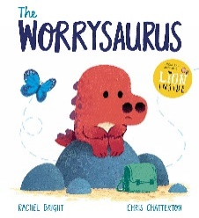  The Worrysaurus  By Rachel Bright and Chris Chatterton |  | 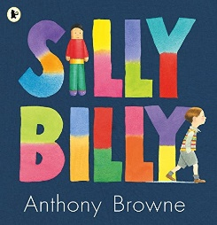  Silly Billy  By Anthony Browne |  |  | 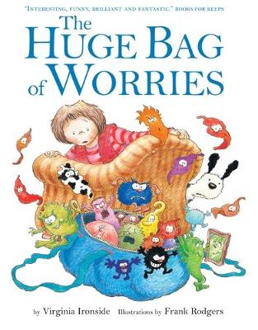  The Huge Bag of Worries  By Virginia Ironside |  | 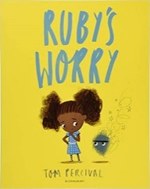  Ruby’s Worry  By Tom Percival | 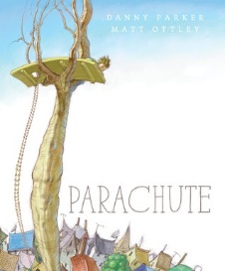  The Parachute  By Danny Parker and Matt Ottley |  |  |  | 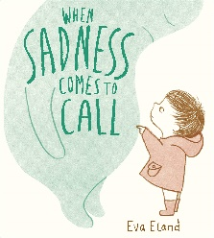  When Sadness Comes to Call  By Eva Eland |  |  | 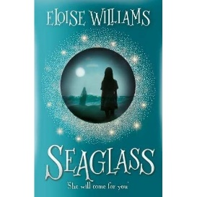  Seaglass  By Eloise Williams
Pupils will recognise a feeling when they are worried.  Pupils will be able to label they are sad.  Pupils will seek an adult when they are feeling sad.  Pupils know that you need to eat healthy food and exercise to be healthy |  | Pupils will recognise that a feeling can be a result of a worry.  Pupils will be able to articulate that they are worried and label how it makes them feel.  Pupils will seek an adult when they are feeling sad and speak to the adult about how they feel.  Pupils will identify that exercise makes them feel happy. |  |  | Pupils will know that they are feeling worried.  Pupils will be able to recognise a range of feelings that come with feeling worried.  Pupils will discuss with an adult how they are feeling and start to develop strategies they can do to help them.  Pupils will notice others feelings and worries.  Pupils know that exercise helps us to feel positive and better.  Pupils will identify that eating well gives you energy and allows you to be active which gives feelings of joy. |  | Pupils will recognise a worry and know that big feelings can come from this worry.  Pupils will recognise that feelings can be complex and mixed.  Pupils know different ways to discuss their worries and can suggest a way that suites them, verbal, written or art form.  Pupils will help their peers when they recognise they have big feelings.  Pupils know that exercise helps us to feel positive and better.  Pupils will identify that eating well gives you energy and allows you to be active which gives feelings of joy.  Pupils will link healthy eating with exercise.  Pupils know what constitutes a healthy diet (including understanding calories and other nutritional content) | Pupils will recognise a worry and know that big feelings can come from this worry.  Pupils can explain some of these feelings and recognise that feelings can be complex and mixed.  Pupils know different ways to discuss their worries and can suggest a way that suites them, verbal, written or art form.  Pupils will help their peers when they recognise they have big feelings and can support peers in talking about these  Pupils know the characteristics and mental and physical benefits of an active lifestyle  Pupils know the importance of building regular exercise into daily and weekly routines and how to achieve this; for example walking or cycling to school, a daily active mile or other forms of regular, vigorous exercise  Pupils know the risks associated with an inactive lifestyle (including obesity)  Pupils know the characteristics of a poor diet and risks associated with unhealthy eating (including, for example, obesity and tooth decay) and other behaviours (e.g. the impact of alcohol on diet or health)  Pupils know that for most people the internet is an integral part of life and has many benefits  Pupils know why social media, some computer games and online gaming, for example, are age restricted  Pupils know that the internet can also be a negative place where online abuse, trolling, bullying and harassment can take place, which can have a negative impact on mental health  Pupils know where and how to report concerns and get support with issues online |  |  |  | Pupils know that mental wellbeing is a normal part of daily life, in the same way as physical health  Pupils know how and when to seek support including which adults to speak to in school if they are worried about their health  Pupils know that there is a normal range of emotions (e.g. happiness, sadness, anger, fear, surprise, nervousness) and scale of emotions that all humans experience in relation to different experiences and situations  Pupils know how to recognise and talk about their emotions, including having a varied vocabulary of words to use when talking about their own and others’ feelings  Pupils know how to judge whether what they are feeling and how they are behaving is appropriate and proportionate  Pupils know the benefits of physical exercise, time outdoors, community participation, voluntary and service-based activity on mental wellbeing and happiness  Pupils know simple self-care techniques, including the importance of rest, time spent with friends and family and the benefits of hobbies and interests  Pupils know that isolation and loneliness can affect children and that it is very important for children to discuss their feelings with an adult and seek support  Pupils know that bullying (including cyberbullying) has a negative and often lasting impact on mental wellbeing  Pupils know where and how to seek support (including recognising the triggers for seeking support), including whom in school they should speak to if they are worried about their own or someone else’s mental wellbeing or ability to control their emotions (including issues arising online)  Pupils will know that it is common for people to experience mental ill health. For many people who do, the problems can be resolved if the right support is made available, especially if accessed early enough. |  |  | Pupils will recognise their worries and know that it is normal to worry  Pupils have strategies to cope with their worries  Pupils can explain big feelings and recognise that feelings can be complex and mixed.  Pupils understand what anxiety and depression are and how we might recognise feeling this way  Pupils know different ways to discuss their worries and can suggest a way that suites them, verbal, written or art form.  Pupils will help their peers to recognise their big feelings and can support peers in talking about these and suggest ways to act on them  Pupils know what mental health is and can suggest various ways to improve mental health  Pupils will identify the benefits of healthy eating and understand how the science of this works  Pupils know that exercise helps us to feel positive and better  Pupils will link healthy eating with exercise with a healthy lifestyle  Pupils know the principles of planning and preparing a range of healthy meals  Pupils know about the benefits of rationing time spent online, the risks of excessive time spent on electronic devices and the impact of positive and negative content online on their own and others’ mental and physical wellbeing  Pupils know how to consider the effect of their online actions on others and know how to recognise and display respectful behaviour online and the importance of keeping personal information private  Pupils know how to be a discerning consumer of information online including understanding that information, including that from search engines, is ranked, selected and targeted
Identity and Belonging – Date: WC 18/9 and 25/9
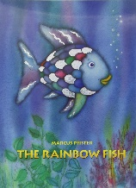  Rainbow fish  By Marcus Pfister | 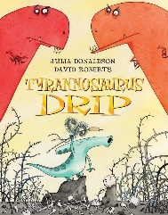  Tyranasaurus Drip  By Julia Donaldson and David Roberts | 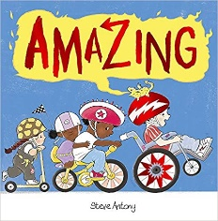  Amazing  By Steve Antony | 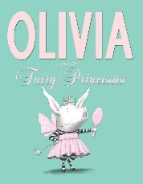  Olivia and the Fairy Princesses  By Ian Falconer | 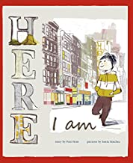  Here I am  by Patti Kim and Sonia Sánchez | 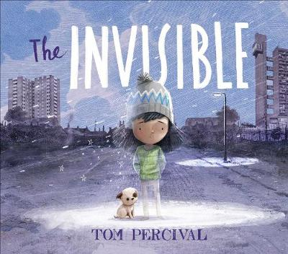  Invisible  By Tom Percival | 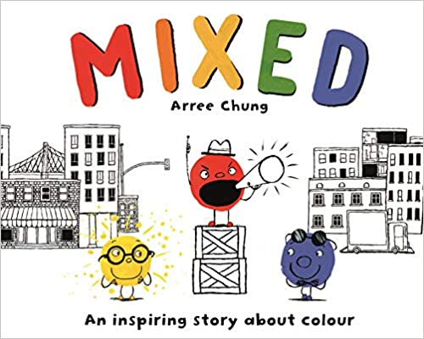  Mixed  by Arree Chung
Pupils talk about their favourites and preference and things belonging to them.  Pupils begin to talk about themselves, their appearance, personality and their life.  Pupils talk about what they like and who they love.  Pupils begin to talk about feelings related to situations - including happiness and sadness.  Pupils understand that talking about how they feel is important and who they can speak to for support.  Pupils talk about what they want to achieve as they get older e.g. a career or other aspiration. | Pupils talk more confidently about what makes them unique – their favourites and preferences and things that make them special.  Pupils talk more confidently about themselves, their appearance, personality and their life and how this compares to others positively.  Pupils talk about what they like and who they love and what they belong to. E.g. family, school, friends.  Pupils start to independently relate more complex emotions (building upon happy and sad) E.g. Excitement, loneliness and worry and relate these to different situations.  Pupils understand the importance of talking about how they feel and who they can speak to for support.  Pupils comment on what they would like to achieve, thinking about their own goals and aspirations. If I had one wish…  And start to consider how they might achieve this. | Pupils talk confidently about what makes them unique – their favourites, preferences, personality, family, talents and other things that make them special.  Pupils talk confidently about themselves, their appearance, personality and their life and acknowledge that everyone is different and that is okay.  Pupils talk about what they like, who they love and what they belong to. E.g. family, school, friends. Thinking about how being a part of these makes them feel. Pupils will explore whether they always feel the same in these situations and whether their feelings change.  Pupils use a range of more complex emotions E.g. Excitement, loneliness and worry and understand that these feelings can change all the time.  Pupils understand the importance of talking about how they feel, ways to manage their emotions and who they can speak to for support.  Pupils to consider what they would like to achieve in their life - thinking about their own goals and aspirations.  Pupils start to discuss the differences between valuing material objects and valuing being happy and loved and healthy. | Pupils talk confidently about what makes them unique – their favourites, preferences, personality, family, talents and other things that make them special. Pupils start to discuss how their life, interests and personalities can change as they get older and that this is normal.  Pupils talk confidently about themselves, their appearance, personality and their life and acknowledge that everyone is different and that is okay.  Pupils begin to consider their role in making others feel welcome and give them a sense of belonging.  Pupils talk about what they like, who they love and what they belong to. E.g. family, school, friends. Thinking about how being a part of these makes them feel. Pupils will explore whether they always feel the same in these situations and whether their feelings change.  Pupils consider that not everyone feels the same sense of belonging at all times and how they can support others by being kind and inclusive.  Pupils use a range of more complex emotions E.g. Shame, guilt, pride, intrigue, hopeful and confidently talk about times they have felt certain ways and how they dealt with it.  Pupils can explain the importance of talking about how they feel, ways to manage their emotions and who they can speak to for support.  Pupils talk confidently about their aspirations and how they plan on achieving these.  Pupils acknowledge the importance of the things that actually make them happy. | Pupils can describe confidently what makes them unique – their favourites, preferences, personality, family, talents and other things that make them special. Pupils describe how their life, interests and personalities have changed as they got older and that this is normal.  Pupils talk confidently about themselves, their appearance, personality and their life and appreciate that society is full of different kinds of people, embracing, welcoming and encouraging diversity.  Pupils can articulate their responsibility in school in making others feel welcome and giving them a sense of belonging.  Pupils talk about what they like, who they love and what they belong to. E.g. family, school, friends. Thinking about how being a part of these makes them feel.  Pupils consider that not everyone feels the same sense of belonging at all times and how they can support others by being kind and inclusive.  Pupils will explore how different people can sometimes feel isolated, why this is and what can be done about it.  Pupils use a range of more complex emotions E.g. isolated, regret, uncertainty, humiliated and talk openly and listen sensitively about times they or others have felt certain ways and how feelings and situations can be dealt with.  Pupils can explain the importance of talking about how they feel, ways to manage their emotions and who they can speak to for support. They can also suggest ways in which they can support others as a friend.  Pupils talk confidently about their aspirations and how they plan on achieving these. Articulating short-term, medium-term and long-term goals.  Pupils acknowledge the importance of the things that actually make them happy but acknowledge that you don’t have to be happy all the time. | Pupils can describe confidently what makes them unique – their favourites, preferences, personality, family, talents and other things that make them special. Pupils start to consider what their place is in the wider world.  Pupils talk confidently about their differences and similarities compared to others - embracing, welcoming and encouraging diversity.  Pupils start to consider the responsibility of humans in the wider world in making others feel welcome and giving them a sense of belonging.  Pupils explain times that they have felt a sense of belonging and empathise with others who have at times felt a sense of isolation and loneliness.  Pupils are advocates for  kindness and inclusive behaviour and will stand up for others and provide support to others in times of need  Pupils will explore how different groups of society can sometimes feel isolated, why this is and what can be done about it.  Pupils use and empathise with a range of more complex emotions - talking openly and listening sensitively about times they or others have felt certain ways. Pupils can make a variety of helpful suggestions to overcome or seek support with this.  Pupils can explain the importance of talking about how they feel, ways to manage their emotions and who they can speak to for support. They can also suggest ways in which they can support others as a friend.  Pupils talk confidently about their aspirations and how they plan on achieving these. Pupils understand that everyone deserves success and happiness and that equal opportunities is an important part of today’s society.  Pupils talk about money and happiness and debate on whether money can buy you happiness.  Pupils can make informed choices about what they feel is most important in life. | Pupils can describe confidently what makes them unique – their favourites, preferences, personality, family, talents and other things that make them special. Pupils start to consider what their place is in the wider world and what morals and values they live by.  Pupils talk confidently about their differences and similarities compared to others - embracing, welcoming and encouraging diversity, being comfortable in their own skin and also standing up for what they believe in.  Pupils can articulate the responsibility of humans in the wider world in making others feel welcome and giving them a sense of belonging and the negative affects this has on people if belonging is absent.  Pupils explain times that they have felt a sense of belonging and empathise with others who have at times felt a sense of isolation and loneliness.  Pupils discuss the sense of belonging felt at Primary School and how that belonging and identity might change as they move into High School and how to cope with these changes.  Pupils are advocates and role models for  kindness and inclusive behaviour and will stand up for others and provide support and sensible advice to others in times of need  Pupils can describe how different groups of society can sometimes feel isolated, why this is and what can be done about it. They can also link this learning to what they know about discrimination throughout history and how we have overcome this.  Pupils use and empathise with a range of more complex emotions - talking openly and listening sensitively about times they or others have felt certain ways. Pupils can make a variety of helpful suggestions to overcome or seek support with this.  Pupils can explain the importance of talking about how they feel, ways to manage their emotions and who they can speak to for support. They can also suggest ways in which they can support others as a friend.  Pupils talk confidently about their aspirations and how they plan on achieving these. Pupils understand that everyone deserves success and happiness and that equal opportunities is an important part of today’s society.  Pupils acknowledge the power of an online identity and how important it is that this identity is true to who you are.  Pupils consider the differences between happiness in real life and virtual “likes” and the effects that relying on virtual satisfaction can have on people.  Pupils can make justified choices about what they feel is most important in life.
Red objectives have been taken directly from RSE Government Guidance.
Purple objectives have been taken directly from the Science National Curriculum.
Green objectives - parents/carers have a right to withdraw their child from these objectives once any concerns have been discussed with SLT.
Teachers must send a reminder on their weekly newsletter about the upcoming PSHE lesson in the subsequent week.
Teaching staff should always discuss pupils’ needs with the Safeguarding Team before planning and delivering lessons with sensitive content*
Any concerns raised during PSHE lesson should be discussed with the Safeguarding Team and logged on CPOMS.

Tolerance and Respect (British Values) – Dates: WC 2/10 and 9/10

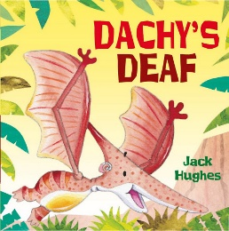  Dachy’s Deaf  By Jack Hughes |  |  | 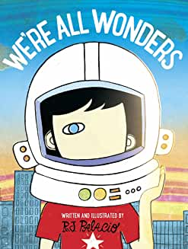  We’re All Wonders  by R J Palacio |  |  | 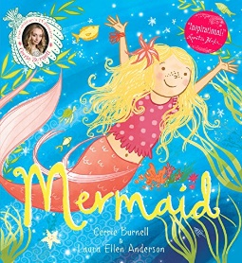  Mermaid  By Cerrie Burnell and Laura Ellen Anderson |  |  |  | 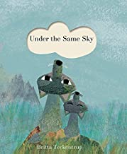  Under the same sky  by Britta Teckentrup |  |  |  | 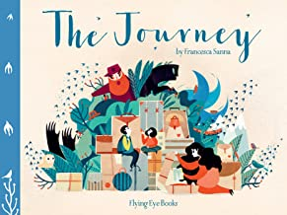  The Journey  by Francesca Sanna |  |  |  | 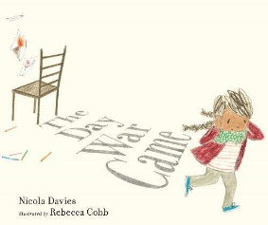  The day the war came  by Nicola Davies |  |  |  | 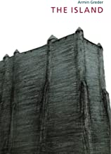  The Island  By Armin Greder
Pupils listen to the ideas of others.  Pupils to talk about what makes us different and what makes us similar.  Pupils use kind words to talk about each other.  Pupils use good manners when talking to each other and staff.  Pupils recognise what is fair/unfair, kind/unkind, and right/wrong.  Pupil’s understand that people’s bodies and feelings can be hurt  Pupils talk about the rules in their class. |  |  | Pupils listen respectfully to the ideas and views of others even when one disagrees.  Pupils to discuss similarities and differences between people - introduce the word diversity.  Pupils can cooperate with others (for example by playing and working with friends of classmates).  Pupils are introduced to the word tolerance.  Pupils understand how their behaviour affects others.  Pupils understand that people’s bodies and feelings can be hurt (including what makes them feel comfortable/uncomfortable).  Pupils talk about school rules |  |  | Pupils understand how to listen to others and respect their viewpoints.  Pupils are able to offer constructive support and feedback to others.  Pupils identify and respect differences and similarities between people of different ethnicities, cultures, faiths, genders or abilities.  Pupils to acknowledge ways in which we are all the same as all other people and identify what we have in common with everyone else.  Pupils know that boys and girls are equal and able to play with what they choose.  Pupils understand the importance of manners  Pupils understand what tolerance is and how this is demonstrated.  Pupils talks about school rules and why they think we have them. |  |  |  | Pupils know the importance of respecting others, even when they are very different from them (for example, physically, in character, personality or backgrounds), or make different choices or have different preferences or beliefs  Pupils know practical steps they can take in a range of different contexts to improve or support respectful relationships  Pupils know the conventions of courtesy and manners  Pupils know the importance of self-respect and how this links to their own happiness  Pupils know that in school and in wider society they can expect to be treated with respect by others, and that in turn they should show due respect to others, including those in positions of authority  Pupils know what a stereotype is, and how stereotypes can be unfair, negative or destructive  Pupils know the importance of permission-seeking and giving in relationships with friends, peers and adults |  |  |  | Pupils understand how to take responsibility for their own behaviour and realise that their actions have consequences.  Pupils understand that in order to resolve differences they need to respect other’s points of view and respect their decisions but be able to explain their choices and viewpoint.  Pupils understand that most friendships have ups and downs and that these can often be worked through so that the friendship is repaired or even strengthened and that resorting to violence is never right.  Pupils understand that they can be expected to be treated with respect and in turn, they should show respect to others, including those in positions of authority.  Pupils know that there are different kinds of families and partnerships (includes same sex).  Pupils begin to respond to or challenge negative behaviours such as racism, stereotyping, homophobia, transphobia and biphobia.  Pupils demonstrate how to show respect and tolerance towards people different from themselves.  Pupils know that the same principles apply to online relationships as to face-to-face relationships, including the importance of respect for others online including when we are anonymous  Pupils understand that rules are similar to laws we have to abide by. |  |  |  | Pupils express their views confidently and listen to and show respect for the views of others.  Pupils understand the importance of being respectful and to recognise and care about other’s feelings. If appropriate, they feel able to confidently challenge another person’s viewpoint.  Pupils know that similarities and differences between people arise from a number of factors, including, family, cultural, ethnic, racial, and religious diversity, age, sex, sexual orientation and disability (The Equality Act 2010).  Pupils acknowledge the difference between families including how some parents may be married and others may not.  Pupils understand the meaning of tolerance as a British Value.  Pupils understand that there are consequences of breaking the law and how the criminal justice system works in the UK. |  |  |  | Pupils recognise the difference between aggressive and assertive behaviour and develop some strategies to resolve disputes and conflict.  Pupils understand what being part of a community means and to take part more fully in school and community activities.  Pupils understand the importance of tolerance as a British Value.  Pupils realise the consequences of discrimination, homophobia, transphobia, biphobia and racism on individuals and communities and how to respond to them and ask for help.  Pupils appreciate the range of national, regional, religious and ethnic identities in the UK and the benefits of being a multi-cultural nation.
Red objectives have been taken directly from RSE Government Guidance.
Purple objectives have been taken directly from the Science National Curriculum.
Green objectives - parents/carers have a right to withdraw their child from these objectives once any concerns have been discussed with SLT.
Teachers must send a reminder on their weekly newsletter about the upcoming PSHE lesson in the subsequent week.
Teaching staff should always discuss pupils’ needs with the Safeguarding Team before planning and delivering lessons with sensitive content*
Any concerns raised during PSHE lesson should be discussed with the Safeguarding Team and logged on CPOMS.
Friendship – Dates: WC 30/10 and 6/11

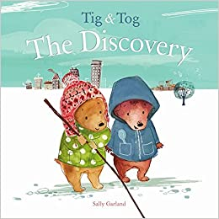  Tig and Tog - The Discovery  By Sally Garland |  | 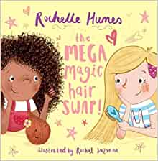  The Mega Magic hair swap  By Rochelle Humes |  |  | 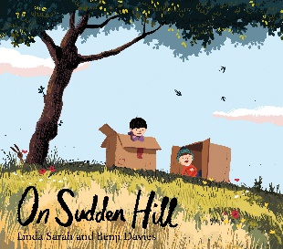  On Sudden Hill  By Linda Sarah and Benji Davies |  |  | 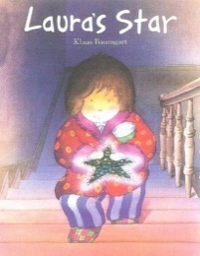  Laura’s Star  By Klaus Baumgart |  |  |  | 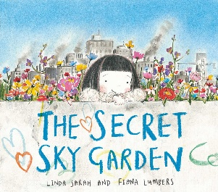  The Secret Sky Garden  By Linda Sarah and Fiona Lumbers |  |  | 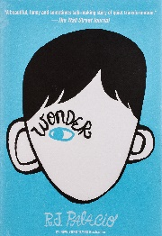  Wonder  By RJ Palacio |  |  |  | 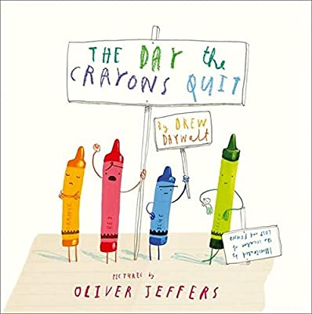  The Day the Crayons Quit  By Drew Daywalt
Pupils can say who their friends are and why they are friends  Pupils can say what friends do together e.g. play and share  Pupils recognise that having friends makes them happy  Pupils know that to be a good friend you must be kind |  | Pupils can say who their friends are and why they are friends  Pupils know that you can be friends even though everyone is different  Pupils can say what friends do together e.g. play, share, laugh, help each other  Pupils recognise that having friends makes them happy and that loneliness can make us unhappy  Pupils know that to be a good friend you must be kind, honest and trustworthy |  |  | Pupils value their friends can explain what is good about having friends like them  Pupils know that people can be friends even if they have different interests or hobbies.  Pupils know positive ways to make and manage friendships – turn taking, listening to others, fairness, inclusivity  Pupils know that friendships can fall out but understand how to repair disputes in friendships by apologising and forgiving  Pupils recognise that having friends makes them happy and that loneliness can make us unhappy.  Pupils know that a good friend is kind, honest, trustworthy, forgiving and understanding. |  |  | Pupils value their friends and recognise the impact that friendships have on their own happiness and mental health.  Pupils know that you can be friends with a range of different people even if they have different interests or beliefs and do not discriminate against any characteristic  Pupils model and encourage positive ways to make and manage friendships – turn taking, listening to others, fairness, inclusivity, honesty, trust.  Pupils know that friendships can fall out but understand how to repair disputes in friendships by acknowledging responsibility, apologising and forgiving  Pupils recognise that having friends makes them happy and that loneliness can make us unhappy. They use this to ensure they welcome others into their friendships if they are feeling isolated.  Pupils know that a good friend is kind, honest, trustworthy, forgiving, understanding and respectful. |  |  |  | Pupils know how important friendships are in making us feel happy and secure, and how people choose and make friends  Pupils know the characteristics of friendships, including mutual respect, truthfulness, trustworthiness, loyalty, kindness, generosity, trust, sharing interests and experiences and support with problems and difficulties  Pupils know that healthy friendships are positive and welcoming towards others, and do not make others feel lonely or excluded  Pupils know that most friendships have ups and downs, and that these can often be worked through so that the friendship is repaired or even strengthened, and that resorting to violence is never right  Pupils know how to recognise who to trust and who not to trust, how to judge when a friendship is making them feel unhappy or uncomfortable, managing conflict, how to manage these situations and how to seek help or advice from others, if needed |  |  | Pupils value their friends and recognise what a healthy friendship is and the impact that this has on mental health.  Pupils understand what an unhealthy friendship may look like and where to go to for support if experiencing this.  Pupils understand that friendship groups can change (especially as hormonal changes begin), and this is okay if we continue to be kind and inclusive.  Pupils know that you can be friends with a range of different people even if they have different interests or beliefs and do not discriminate against any characteristic.  Pupils model and encourage positive ways to make, manage and sustain friendships (both on and offline) – turn taking, speaking respectfully, listening to others, fairness, inclusivity, honesty, trust and collaboration.  Pupils find ways to resolve conflict (on and offline) between friends and try to do this sensibly and independently.  Pupils respond appropriately and proportionately in friendship disputes by acknowledging responsibility, apologising and forgiving  Pupils recognise their role in ensuring others feel welcome, included and supported by friends.  Pupils stand up to those who are being unkind.  Pupils state which quality is most important to them in a good friend: kindness, honesty, trustworthy, forgiving, understanding, respectful, supportive, loyal, generous etc. |  |  |  | Pupils value their friends and recognise what a healthy friendship is and the impact that this has on mental health.  Pupils understand what an unhealthy friendship may look like on or offline (manipulating, controlling, peer pressure, grooming, feeling uncomfortable) and where to go to for support if experiencing this.  Pupils understand that friendship groups can change (especially as hormonal changes begin, and transitions are made into high school).  Pupils know that you can be friends with a range of different people even if they have different interests or beliefs and do not discriminate against any characteristic.  Pupils model and encourage positive ways to make, manage and sustain friendships (both on and offline) – turn taking, speaking respectfully, listening to others, fairness, inclusivity, honesty, trust and collaboration.  Pupils find ways to resolve conflict (on and offline) between friends and try to do this sensibly and independently.  Pupils respond appropriately and proportionately in friendship disputes by acknowledging responsibility, apologising and forgiving  Pupils recognise their role in ensuring others feel welcome, included and supported by friends and are advocates for inclusive behaviour and against discrimination.  Pupils state which quality is most important to them in a good friend: kindness, honesty, trustworthy, forgiving, understanding, respectful, supportive, loyal, generous etc.
Red objectives have been taken directly from RSE Government Guidance.
Purple objectives have been taken directly from the Science National Curriculum.
Green objectives - parents/carers have a right to withdraw their child from these objectives once any concerns have been discussed with SLT.
Teachers must send a reminder on their weekly newsletter about the upcoming PSHE lesson in the subsequent week.
Teaching staff should always discuss pupils’ needs with the Safeguarding Team before planning and delivering lessons with sensitive content*
Any concerns raised during PSHE lesson should be discussed with the Safeguarding Team and logged on CPOMS.
 | Kindness and Anti-bullying - Dates: WC 13/11 - 20/11
 | 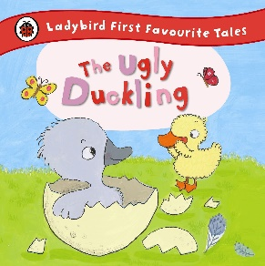  The Ugly Duckling |  | 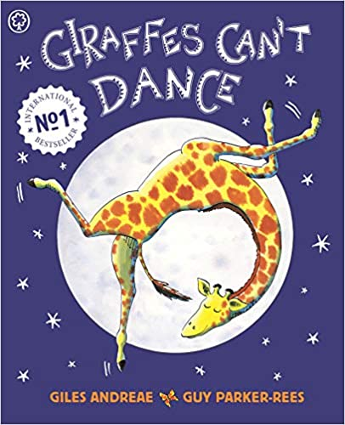  Giraffe’s can’t dance  by Giles Andreae |  |  |  | 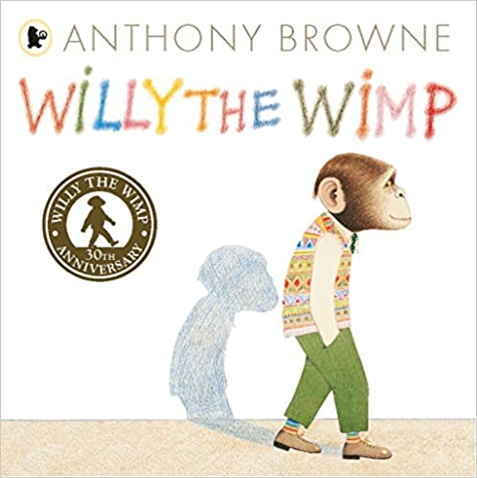  Willy the Wimp  By Anthony Browne |  | 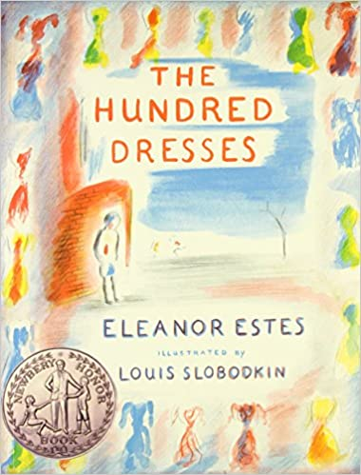  The Hundred Dresses  by Eleanor Estes |  |  |  | 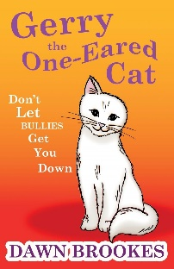  Gerry the one-eared cat  By Dawn Brookes |  |  |  | Wonder  By RJ Palacio |  |  |  | 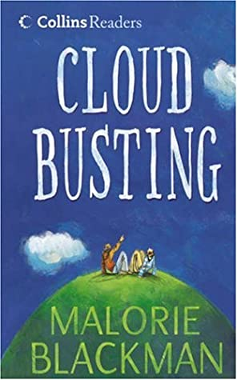  Cloud Busting  By Malorie Blackman
 | Pupils know that some people can be unkind, but this is not the right behaviour  Pupils know to tell an adult if someone is being unkind  Pupils know that they should be kind to everyone  Pupils use kind words and kind hands  Pupils can name some ways to be kind – sharing etc. |  | Pupils know that some people can be unkind, but this is not the right behaviour and that they should tell an adult if they see someone being unkind.  Pupils associate kindness with feeling happy in themselves and making others feel happy.  Pupils know that they should be kind to everyone and know ways to do this  Pupils model kindness, inside and outside of the classroom with increasing independence.  Pupils know that being unkind can make others feel sad.  Pupils know that if someone is repeatedly unkind, it could be classed as bullying and this is unacceptable.  Pupils know where to seek support if they are a victim or witness of bullying. |  |  |  | Pupils understand the difference between being unkind and bullying and that neither are appropriate ways to behave.  Pupils know where to seek support if someone is being unkind to them or someone else.  Pupils know that being unkind or bullying can make others feel extremely sad, lonely and anxious.  Pupils know the positive impact of kindness on themselves and others.  Pupils know that they should be kind to everyone, no matter what, and know lots of ways to do this  Pupils model kindness, inside and outside of the classroom independently and encourage others to be kind. |  | Pupils understand the difference between being unkind and bullying and know that neither are appropriate ways to behave.  Pupils know different types of bullying, including online.  Pupils know where to seek support if someone is being unkind to them or someone else, and also ways to report bullying online (cyber bullying)  Pupils know that being unkind or bullying can make others feel extremely sad, lonely and anxious and that it can have lasting effects.  Pupils know the positive impact of kindness on themselves and others.  Pupils know that they should be kind to everyone, no matter what, and know lots of ways to do this  Pupils model kindness, inside and outside of the classroom independently and encourage others to be kind. |  |  |  | Pupils can describe the difference between being unkind and bullying and know that neither are appropriate ways to behave.  Pupils know about different types of bullying (including cyberbullying), the impact of bullying, responsibilities of bystanders (primarily reporting bullying to an adult) and how to get help  Pupils know where to seek support if someone is being unkind to them or someone else, and also ways to report bullying online (cyber bullying)  Pupils know that being unkind or bullying can make others feel extremely sad, lonely and anxious and that it can have lasting effects.  Pupils know the positive impact of kindness on themselves and others.  Pupils know that they should be kind to everyone, no matter what, and know lots of ways to do this.  Pupils model kindness, inside and outside of the classroom independently and encourage others to be kind. |  |  |  | Pupils can explain the difference between being unkind and bullying and know that neither are appropriate ways to behave.  Pupils can describe different types of bullying, including online.  Pupils can suggest some reasons why people may choose to bully or be unkind/  Pupils know where to seek support if someone is being unkind to them or someone else, and also ways to report bullying online (cyber bullying)  Pupils know that being unkind or bullying can make others feel extremely sad, lonely and anxious and that it can have lasting effects.  Pupils know that they should be kind to everyone and not discriminate or stereotype.  Pupils understand the positive impacts of kindness on mental health.  Pupils model kindness inside and outside of the classroom independently and actively encourage others to be kind. |  |  |  | Pupils can explain the difference between being unkind and bullying and know that neither are appropriate ways to behave.  Pupils can describe different types of bullying, including cyber bullying, online abuse and harassment and trolling.  Pupils understand the impact of social media on mental health and how it can be easily used as a platform of hate crimes.  Pupils can suggest some reasons why people may choose to bully or be unkind.  Pupils know where to seek support if they are a victim or witness to any of the above.  Pupils know that they should be kind to everyone and not discriminate or stereotype.  Pupils understand the positive impacts of kindness on mental health.  Pupils model kindness inside and outside of the classroom independently and actively encourage others to be kind.
Red objectives have been taken directly from RSE Government Guidance.
Purple objectives have been taken directly from the Science National Curriculum.
Green objectives - parents/carers have a right to withdraw their child from these objectives once any concerns have been discussed with SLT.
Teachers must send a reminder on their weekly newsletter about the upcoming PSHE lesson in the subsequent week.
Teaching staff should always discuss pupils’ needs with the Safeguarding Team before planning and delivering lessons with sensitive content*
Any concerns raised during PSHE lesson should be discussed with the Safeguarding Team and logged on CPOMS.
Gender – Dates: WC 27/11 and 4/12
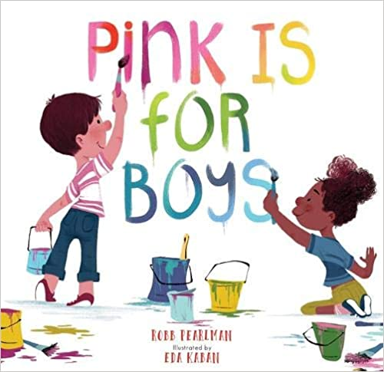  Pink is for boys  By Eda Kaban and Robb Pearlman |  |  |  | 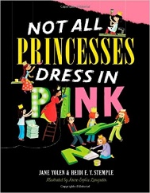  Not all princesses dress in pink  By Jane Yolen and Heidi E. Y. Stemple |  |  |  | 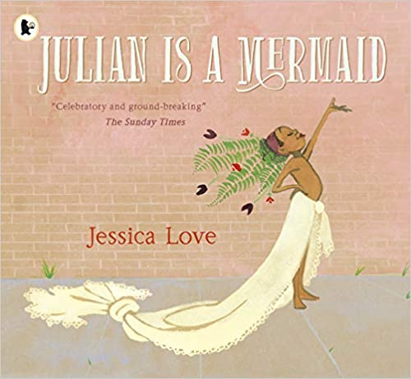  Julian is a mermaid  By Jessica Love |  |  | 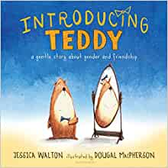  Introducing Teddy  By Jess Walton |  |  | 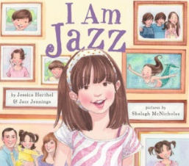  I am Jazz  By Jazz Jennings |  | 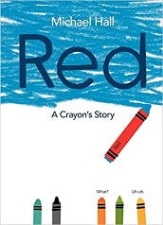  Red – a crayon’s story  By Michael Hall |  |  |  | 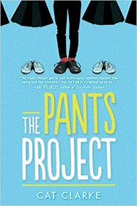  The Pants Project  By Cat Clarke
Pupils identify as a gender and can identify the gender of others  Pupils are kind to each  other and are inclusive of each other, not discriminating by gender |  |  |  | Pupils identify as a gender and can identify the gender of others.  Pupils are kind to each other and are inclusive of each other, not discriminating by gender.  Pupils know that girls and boys can like the same and different things and they can still be friends. |  |  |  | Pupils identify as a gender and welcome the identity of others (gender identity).  Pupils know the physical differences between gender and the correct scientific names for external body parts.  Pupils are kind to each other and are inclusive of each other, not discriminating by gender.  Pupils know that girls and boys can like the same and different things and they can still be friends. |  |  | Pupils identify as a gender and welcome the identity of others.  Pupils know the physical differences between gender and the correct scientific names for external body parts.  Pupils are kind to each other and are inclusive of each other, not discriminating by gender.  Pupils know that girls and boys can like the same and different things and they can still be friends.  Pupils talk about how gender is used in daily life and whether they think this is fair |  |  | Pupils identify as a gender and welcome the identity of others.  Pupils know the physical differences between gender and the correct scientific names for external body parts (the sex of a person).  Pupils are kind to each other and are inclusive of each other, not discriminating by gender.  Pupils know that girls and boys can like the same and different things and they can still be friends.  Pupils understand that gender equality hasn’t always been as fair as it is today and can make comparisons across history |  | Pupils understand that people identify as different genders and that gender equality must continue no matter what someone’s gender.  Pupils know the physical differences between gender and the correct scientific names for external body parts (the sex of a person).  Pupils are kind to each other and are inclusive of each other, not discriminating or stereotyping.  Pupils know that girls and boys can express themselves in different ways – the way they behave, act, dress (gender expression)  Pupils understand that gender equality hasn’t always been as fair as it is today and can make comparisons across history  Pupils understand some difficulties that are associated with gender and that some people do not feel a sense of belonging to the gender that is assigned at birth. |  |  |  | Pupils know the different types of genders that people can choose to identify as and that gender equality must continue no matter how someone identifies (gender identity)  Pupils know the physical differences between gender and the correct scientific names for external body parts (the sex of a person).  Pupils are kind to each other and are inclusive of each other, not discriminating or stereotyping.  Pupils know that girls and boys can express themselves in different ways – the way they behave, act, dress (gender expression)  Pupils understand that gender equality hasn’t always been as fair as it is today, can describe some historical changes and can think of ways in which they would like to further improve the gender equality in today’s society.  Pupils understand some difficulties that are associated with gender and that some people do not feel a sense of belonging to the gender that is assigned at birth.
Red objectives have been taken directly from RSE Government Guidance.
Purple objectives have been taken directly from the Science National Curriculum.
Green objectives - parents/carers have a right to withdraw their child from these objectives once any concerns have been discussed with SLT.
Teachers must send a reminder on their weekly newsletter about the upcoming PSHE lesson in the subsequent week.
Teaching staff should always discuss pupils’ needs with the Safeguarding Team before planning and delivering lessons with sensitive content*
Any concerns raised during PSHE lesson should be discussed with the Safeguarding Team and logged on CPOMS.

 | Feelings – Dates: WC 08/1 and 15/1
 | Pupils will start to recognise different feelings whilst in different situations.  Pupils will be able to verbalise own feelings such as, Happy, Sad and Angry.  Pupils will be able to label feelings against physical changes, such as facial expression and body language. | Pupils will recognise different feelings whilst in different situations.  Pupils will be able to verbalise own feelings such as, Happy, Sad and Angry.  Pupils will be able to label feelings against physical changes, such as facial expression and body language.  Pupils will become more aware of the feelings of others.  Pupils will be able to connect feelings with actions. |  |  |  | Pupils will recognise different feelings whilst in different situations.  Pupils will be able to verbalise own feelings such as, Happy, Sad and Angry.  Pupils will be able to label feelings against physical changes, such as facial expression and body language.  Pupils will become more aware of the feelings of others.  Pupils will be able to connect feelings with actions.  Pupils will be able to identify more complex emotions.  Pupils will be able to differentiate between different feelings.  Pupils will be able to identify that they can have more than one feeling at a time.  Pupils are able to see the difference with appropriate behaviour and inappropriate behaviour and link feelings to those situations.  Pupils will be able to verbalise what strategies they can do to manage their feelings.  Pupils will be able to have more control over feelings that lead to frustration and anger. |  |  | Pupils will recognise different feelings whilst in different situations.  Pupils will be able to verbalise own feelings such as, Happy, Sad and Angry.  Pupils will be able to label feelings against physical changes, such as facial expression and body language.  Pupils will become more aware of the feelings of others.  Pupils will be able to connect feelings with actions.  Pupils will be able to identify more complex emotions.  Pupils will be able to identify complex feelings in themselves and others.  Pupils will verbalise how feelings can affect a person’s behaviour.  Pupils will be able to differentiate between different feelings.  Pupils will be able to identify that they can have more than one feeling at a time.  Pupils are able to see the difference with appropriate behaviour and inappropriate behaviour and link feelings to those situations.  Pupils will be able to verbalise what strategies they can do to manage their feelings.  Pupils will be able to have more control over feelings that lead to frustration and anger.  Pupils will recognise a link with a healthy lifestyle and positive feelings. |  |  |  |  |  | Pupils will recognise different feelings whilst in different situations.  Pupils will be able to verbalise own feelings such as, Happy, Sad and Angry.  Pupils will be able to label feelings against physical changes, such as facial expression and body language.  Pupils will become more aware of the feelings of others.  Pupils will be able to connect feelings with actions.  Pupils will be able to identify more complex emotions.  Pupils will be able to identify complex feelings in themselves and others.  Pupils will verbalise how feelings can affect a person’s behaviour.  Pupils will be able to differentiate between different feelings.  Pupils will be able to identify that they can have more than one feeling at a time.  Pupils are able to see the difference with appropriate behaviour and inappropriate behaviour and link feelings to those situations.  Pupils will be able to verbalise what strategies they can do to manage their feelings.  Pupils will be able to have more control over feelings that lead to frustration and anger.  Pupils will recognise a link with a healthy lifestyle and positive feelings.  Pupils will be able to articulate and speak confidently about their own feelings to adults. |  |  | Pupils will recognise different feelings whilst in different situations.  Pupils will be able to verbalise own feelings such as, Happy, Sad and Angry.  Pupils will be able to label feelings against physical changes, such as facial expression and body language.  Pupils will become more aware of the feelings of others.  Pupils will be able to connect feelings with actions.  Pupils will be able to identify more complex emotions.  Pupils will be able to identify complex feelings in themselves and others.  Pupils will verbalise how feelings can affect a person’s behaviour.  Pupils will be able to differentiate between different feelings.  Pupils will be able to identify that they can have more than one feeling at a time.  Pupils are able to see the difference with appropriate behaviour and inappropriate behaviour and link feelings to those situations.  Pupils will be able to verbalise what strategies they can do to manage their feelings.  Pupils will be able to have more control over feelings that lead to frustration and anger.  Pupils will recognise a link with a healthy lifestyle and positive feelings.  Pupils will be able to articulate and speak confidently about their own feelings to adults.  Pupils will be able to discuss their feelings towards others in a calm and confident manor. |  |  |  | Pupils will recognise different feelings whilst in different situations.  Pupils will be able to verbalise own feelings such as, Happy, Sad and Angry.  Pupils will be able to label feelings against physical changes, such as facial expression and body language.  Pupils will become more aware of the feelings of others.  Pupils will be able to connect feelings with actions.  Pupils will be able to identify more complex emotions.  Pupils will be able to identify complex feelings in themselves and others.  Pupils will verbalise how feelings can affect a person’s behaviour.  Pupils will be able to differentiate between different feelings.  Pupils will be able to identify that they can have more than one feeling at a time.  Pupils are able to see the difference with appropriate behaviour and inappropriate behaviour and link feelings to those situations.  Pupils will be able to verbalise what strategies they can do to manage their feelings.  Pupils will be able to have more control over feelings that lead to frustration and anger.  Pupils will recognise a link with a healthy lifestyle and positive feelings.  Pupils will be able to articulate and speak confidently about their own feelings to adults.  Pupils will be able to discuss their feelings towards others in a calm and confident manor.  Pupils will establish a link with hormonal changes and the impact upon their mood and feelings.
Red objectives have been taken directly from RSE Government Guidance.
Purple objectives have been taken directly from the Science National Curriculum.
Green objectives - parents/carers have a right to withdraw their child from these objectives once any concerns have been discussed with SLT.
Teachers must send a reminder on their weekly newsletter about the upcoming PSHE lesson in the subsequent week.
Teaching staff should always discuss pupils’ needs with the Safeguarding Team before planning and delivering lessons with sensitive content*
Any concerns raised during PSHE lesson should be discussed with the Safeguarding Team and logged on CPOMS.
Family – Dates: WC 22/1 and 29/1
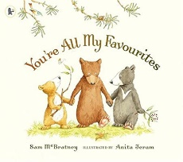  You’re all my favourites  By Sam McBratney |  |  |  | 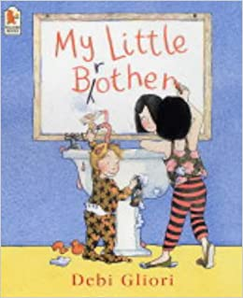  My Little brother  By Debi Gliori |  |  | 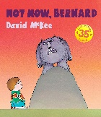  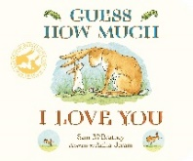  Guess how much I love you  By Sam McBratney  And  Not now Bernard  By David McKee  (comparison) |  |  | 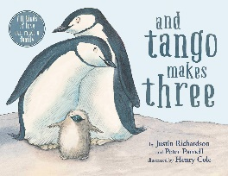  And Tango Makes Three  By Justin Richardson and Peter Parnell |  |  |  |  |  | 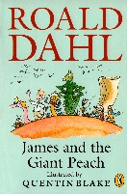  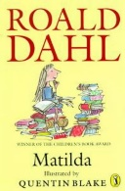  Matilda + James and the Giant Peach (comparison)  By Roald Dahl |  |  | 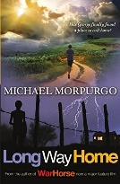  Long way home  by Michael Morpurgp  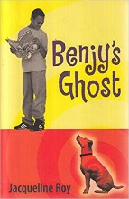  Benjy’s Ghost  by Jaqueline Roy |  |  |  | 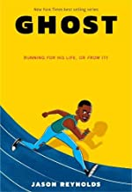  Ghost  Jason Reynolds  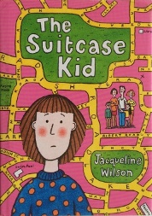  The Suitcase kid  By Jaqueline Wilson
Pupils can talk about people they love  Pupils can talk about who is in their family  Pupils can say why they love people in their family  Pupils can suggest some roles of family members |  |  |  | Pupils can talk about people they love and say why  Pupils can talk about who is in their family and say what a family is  Pupils can suggest some roles of family members  Pupils can talk about happy family memories  Pupils can talk about times in a family that may not have been as happy and how family can support each other  Pupils know that families have similarities and differences |  |  | Pupils can talk about people they love and justify with different reasons  Pupils can talk about who is in their family and give an explanation to what they believe a family is  Pupils can suggest some roles of family members and how these roles can differ in different families  Pupils can talk about happy family memories and family activities they enjoy  Pupils can talk about times in a family that may not have been as happy and how family can support each other  Pupils can suggest reasons why families might not be happy and know who to talk to if they are feeling upset or worried  Pupils know that families have similarities and differences and can begin to describe some of these  Pupils are accepting of other families that are different to theirs |  |  | Pupils can talk about people they love and associate family with feeling happy  Pupils can talk about who is in their family and give deeper explanation to what they believe a family is  Pupils can suggest some roles of family members and how these roles can differ in different families  Pupils know that stereotypes of family roles have changed over time  Pupils can talk about happy family memories and family activities they enjoy  Pupils can talk about times in a family that may not have been as happy and how family can support each other  Pupils can suggest reasons why families might not be happy and know who to talk to if they are feeling upset or worried  Pupils can distinguish between everyday bickering and unhealthy domestic relationships  Pupils understand the term domestic violence  Pupils know where to seek support if they are worried about domestic violence  Pupils know that families have similarities and differences and can begin to describe some of these  Pupils are accepting of other families that are different to theirs |  |  |  |  |  | Pupils know that families are important for children growing up because they can give love, security and stability  Pupils know the characteristics of healthy family life, commitment to each other, including in times of difficulty, protection and care for children and other family members, the importance of spending time together and sharing each other’s lives  Pupils know that others’ families, either in school or in the wider world, sometimes look different from their family, but that they should respect those differences and know that other children’s families are also characterised by love and care  Pupils know that stable, caring relationships, which may be of different types, are at the heart of happy families, and are important for children’s security as they grow up  Pupils know that marriage represents a formal and legally recognised commitment of two people to each other which is intended to be lifelong  Pupils know how to recognise if family relationships are making them feel unhappy or unsafe, and how to seek help or advice from others if needed  Pupils can distinguish between everyday bickering and unhealthy domestic relationships  Pupils understand the term domestic violence  Pupils know where to seek support if they are worried about domestic violence |  |  | Pupils can talk about people they love and associate family with different feelings  Pupils can talk about who is in their family and give deeper explanation to what they believe a family is  Pupils can suggest some roles of family members and how these roles can differ in different families  Pupils know that stereotypes of family roles have changed over time and can explain why these changes have occurred  Pupils can talk about happy family memories and family activities they enjoy  Pupils can talk about times in a family that may not have been as happy and how family can support each other  Pupils can suggest reasons why families might not be happy and know who to talk to if they are feeling upset or worried  Pupils can distinguish between everyday bickering and unhealthy domestic relationships  Pupils understand the term domestic violence and know different types of domestic violence  Pupils know where to seek support if they are worried about domestic violence  Pupils know that families have similarities and differences and can describe these  Pupils are accepting of other families that are different to theirs  Pupils understand that equality and kindness are integral features of a fair and modern society |  |  |  | Pupils can talk about people they love and associate family with different and more complex feelings  Pupils can talk about who is in their family and give deeper explanation to what they believe a family is – referring to different family structures  Pupils can suggest some roles of family members and how these roles can differ in different families  Pupils know that stereotypes of family roles have changed over time and can explain why these changes have occurred  Pupils can talk about happy family memories and family activities they enjoy  Pupils can talk about times in a family that may not have been as happy and how family can support each other  Pupils can explain different ways in which families can support each other  Pupils can suggest reasons why families might not be happy and know who to talk to if they are feeling upset or worried  Pupils can distinguish between everyday bickering and unhealthy domestic relationships  Pupils understand the term domestic violence and know different types of domestic violence  Pupils know where to seek support if they are worried about domestic violence  Pupils know that families have similarities and differences and can describe these  Pupils are accepting of other families that are different to theirs  Pupils understand that equality and kindness are integral features of a fair and modern society
Red objectives have been taken directly from RSE Government Guidance.
Purple objectives have been taken directly from the Science National Curriculum.
Green objectives - parents/carers have a right to withdraw their child from these objectives once any concerns have been discussed with SLT.
Teachers must send a reminder on their weekly newsletter about the upcoming PSHE lesson in the subsequent week.
Teaching staff should always discuss pupils’ needs with the Safeguarding Team before planning and delivering lessons with sensitive content*
Any concerns raised during PSHE lesson should be discussed with the Safeguarding Team and logged on CPOMS.
 | Safety – Dates: WC 19/2 and 26/2
 | Pupils can identify the special people in their lives, what makes them special and how special people care for one another.  Pupils discuss what to do if you are lost away from home or upset.  Pupils discuss what to do if they see something scary or upsetting on the computer/tablet/phone. |  |  | Pupils can identify the people who look after them, who to go to if they are worried and how to attract their attention.  Pupils recognise the need for safety rules – road, fire, water, rail, school environment, online, playground and home and can follow the rules.  Pupils know that there are people and services who can help us including knowing how to call 999 in an emergency.  Pupils know that they don’t need to keep secrets – both online and offline.  Pupils know the positives of the internet but also discuss the dangers and that ‘stranger danger’ applies online as well as offline.  Pupils know not to share private information with people they don’t know online and offline.  Pupils know that some websites, games and social media sites have age restrictions and pupils know how to get help if they see something that they ar4e unhappy with online. |  |  |  | Pupils know the difference between secrets and surprises and the importance of not keeping a secret that makes them feel uncomfortable, worried or afraid.  Pupils know the simple skills which will help to maintain their personal safety both online and offline – passwords, parents knowing what they are doing online / stranger danger.  Pupils can recognise what is right and wrong both on and offline.  Pupils understand that pressure to behave in an unsafe way can come from a range of people including people they know as well as people online.  Pupils know how to ask for help when they need it and can name a range of people to help them. They also know how to call 999 in an emergency.  Pupils know that the internet has many benefits but they know they need to balance their time spent on and offline and they know they should play age appropriate games.  Pupils have an understanding of a range of risks when communicating online and can demonstrate ways of reducing the risk to ensure they are safe  Pupils know that people sometimes behave differently online, including friends or by pretending to be someone they are not  Pupils have an understanding of what a healthy online friendship is and awareness of the risks associated with people they have never met |  |  |  |  | Pupils can identify the difference between secrets and surprises, knowing when it is right to break a confidence and share a secret.  Pupils can identify and explain how to manage risks in different situations including on and offline line  Pupils can make judgements and decisions and use basic techniques for resisting negative peer pressure both on and offline  Pupils can explain how their behaviour may have consequences for themselves and others both on and offline  Pupils can demonstrate basic safety procedures when using medicines, sun protection, crossing roads, riding a bike, swimming etc.  Pupils know school rules for health and safety, basic first-aid procedures and where to get help for themselves and others in need, including how to call 999 in an emergency  Pupils know the internet has many benefits but know they need to balance their time spent on and offline and adhere to the age rating of computer games  Pupils have a growing understanding of a range of risks when communicating online and can demonstrate ways of reducing the risk to ensure themselves and their friends are safe online  Pupils know how to report concerns and get support with issues online  Pupils know that people sometimes behave differently online, including by pretending to be someone they are not  Pupils know the rules and principles for keeping safe online, how to recognise risks, harmful content and contact, and how to report them |  |  |  |  | Pupils recognise when they may need help to manage a situation and have developed the skills to ask for help.  Pupils can describe what risk means to them both on and offline  Pupils can take responsibility for their own behaviour and safety and realise that actions have consequences both on and offline  Pupils can recognise, predict and assess risk, relating to themselves and others and know how to get help (includes risks in the home, road, water, rail, online, electricity and personal safety) and they know how to call 999 in an emergency  Pupils have some effective strategies to cope with peer influence and peer pressure both on and offline  Pupils know the internet has many benefits but they know they need to balance their time spent on and offline and adhere to the age rating of social media and computer games  Pupils know that not everything on the internet is true and know what to do if they access something that makes them unhappy or uncomfortable  Pupils understand the need to keep information private in order to protect themselves when communicating online and they can implement strategies to do this  Pupils recognise how online communications (including from friends) may be used for manipulation or persuasion and they have ways of managing this.  Pupils know how to recognise and display respectful behaviour online  Pupils know how to critically consider their online friendships and sources of information including awareness of the risks associated with people they have never met  Pupils know how information and data is shared and used online |  |  | Pupils have considered how to manage accidental exposure to explicit images and upsetting online material, including who to talk to about what they have seen.  Pupils can identify strategies they can use to keep themselves physically and emotionally safe including road safety, cycle safety, online safety and in the local environment(rail, road, water and fire) and they know how to call 999 in an emergency  Pupils know that the pressure to behave in an unacceptable, unhealthy or risky way can come from a variety of sources including people they know both on and offline and the media  Pupils know the internet has many benefits but know they need to balance their time spent on and offline and adhere to the age rating of social media and computer games  Pupils understand how some people use online technology to bully other people and know how to seek help if this happens to themselves or a friend  Pupils know how to present themselves safely online and understand the potential risks of providing personal information online |  |  | Pupils develop the confidence and skills to know when, who and how to ask for help independently or with support.  Pupils can take responsibility for their own safety and know about health and safety, basic emergency first aid procedures (including head injuries) and where to get help, including how to call 999 in an emergency  Pupils know how to recognise early signs of physical illness, such as weight loss, or unexplained changes to the body  Pupils recognise the responsibility they have both on and offline due to increased independence and can keep themselves and others safe  Pupils can respond to challenges including recognising, managing and assessing risks in different situations both on and offline and can manage them responsibly  Pupils know that the pressure to behave in an unacceptable, unhealthy or risky way can come from a variety of sources both on and offline, including people they know and the media  Pupils know the internet has many benefits but they know they need to balance their time spent on and offline and adhere to the age rating of social media and computer games  Pupils can select appropriate tools to collaborate and communicate confidently and safely with others, including friends they know in real life
Red objectives have been taken directly from RSE Government Guidance.
Purple objectives have been taken directly from the Science National Curriculum.
Green objectives - parents/carers have a right to withdraw their child from these objectives once any concerns have been discussed with SLT.
Teachers must send a reminder on their weekly newsletter about the upcoming PSHE lesson in the subsequent week.
Teaching staff should always discuss pupils’ needs with the Safeguarding Team before planning and delivering lessons with sensitive content*
Any concerns raised during PSHE lesson should be discussed with the Safeguarding Team and logged on CPOMS.
Respect and Privacy – Dates: WC 4/3 and 11/3
PANTS - NSPCC
 | Pupils are taught that some areas of the body are private.  Pupils know that their body belongs to them.  Pupils know that people’s bodies should not be touched by other people without permission.  Pupils know that toilets are private areas and that this privacy should be respected.  Pupils become increasingly independent with toileting and getting dressed.  Pupils know that they should speak with an adult if they are upset about anything.  Pupils speak to adults about any secrets that are upsetting. |  | Pupils explore what the word private means.  Pupils understand that you should not touch other people’s bodies without permission and that some areas of the body are private.  Pupils know the scientific name for external body parts.  Pupils know that some activities like toileting and showering are private and should be done in privately as you get older.  Pupils know that their body belongs to them.  Pupils know that there is good and bad touching.  Pupils know that good touching should make you feel happy (like a kiss or cuddle from a family member)  Pupils know that some touching is necessary even though they might not like it – e.g. Grabbing a hand to stop you at a busy road, or a doctor or dentist touching for health purposes.  Pupils know that they can say ‘no’ to touching that makes them worried.  Pupils know that bad touching is when it makes you feel worried.  Pupils know that if any touching makes them feel unhappy, they should tell an adult.  Pupils know that they should not be told to keep secrets related to touching.  Pupils know that if any secret makes them feel worried, they should tell someone.  Pupils know that if they are being asked to keep a secret and they don’t understand why, they should talk to an adult. |  |  |  |  | Pupils explore what the word private means.  Pupils understand that you should not touch other people’s bodies without permission and that some areas of the body are private.  Pupils know the scientific name for external body parts.  Pupils know that some activities like toileting and showering are private and should be done in privately as you get older.  Pupils know that their body belongs to them.  Pupils know that there is good and bad touching.  Pupils know that good touching should make you feel happy (like a kiss or cuddle from a family member)  Pupils know that some touching is necessary even though they might not like it – e.g. Grabbing a hand to stop you at a busy road, or a doctor or dentist touching for health purposes.  Pupils know that they can say ‘no’ to touching that makes them worried.  Pupils know that bad touching is when it makes you feel worried.  Pupils know that if any touching makes them feel unhappy, they should tell an adult.  Pupils know that they should not be told to keep secrets related to touching.  Pupils know that if any secret makes them feel worried, they should tell someone.  Pupils know that if they are being asked to keep a secret and they don’t understand why, they should talk to an adult. |  |  |  | Pupils know what the word private means.  Pupils understand that you should not touch other people’s bodies without permission and that some areas of the body are private.  Pupils know the scientific name for external body parts.  Pupils know that some activities like toileting and showering are private and should be done in privately as you get older.  Pupils know that their body belongs to them.  Pupils know that there is good and bad touching.  Pupils know that good touching should make you feel happy (like a kiss or cuddle from a family member)  Pupils know that some touching is necessary even though they might not like it – e.g. Grabbing a hand to stop you at a busy road, or a doctor or dentist touching for health purposes.  Pupils know that they can say ‘no’ to touching that makes them worried.  Pupils know that bad touching is when it makes you feel worried.  Pupils know that if any touching makes them feel unhappy, they should tell an adult.  Pupils know that they should not be told to keep secrets related to touching - this includes secrets online.  Pupils know that if any secret makes them feel worried, they should tell someone - this includes online.  Pupils know that if they are being asked to keep a secret and they don’t understand why, they should talk to an adult – this includes secrets online |  |  |  |  | Pupils know what sorts of boundaries are appropriate in friendships with peers and others (including in a digital context)  Pupils know about the concept of privacy and the implications of it for both children and adults; including that it is not always right to keep secrets if they relate to being safe  Pupils know that each person’s body belongs to them, and the differences between appropriate and inappropriate or unsafe physical, and other, contact  Pupils know how to respond safely and appropriately to adults they may encounter (in all contexts, including online) whom they do not know  Pupils know how to recognise and report feelings of being unsafe or feeling bad about any adult  Pupils know how to ask for advice or help for themselves or others, and to keep trying until they are heard,  Pupils know how to report concerns or abuse, and the vocabulary and confidence needed to do so  Pupils know where to get advice, for example family, school or other sources |  |  | Pupils know what the word private means and understand that some people interpret private differently.  Pupils know what is private and personal and their rights to privacy both online and in the real world.  Pupils understand that you should not touch other people’s bodies without permission and that some areas of the body are private.  Pupils know they have autonomy and the right to protect their body from inappropriate and unwanted contact.  Pupils understand that any actions that are in breach of these rights are against the law and constitute abuse.  Pupils know how to get support if they are a worried about themselves or another regarding abuse.  Pupils know the scientific name for external body parts.  Pupils know that some activities like toileting and showering are private and should be done in privately as you get older.  Pupils know that their body belongs to them and that it is not okay for someone to touch their body without permission.  Pupils know that there is good and bad touching.  Pupils know that good touching should make you feel happy (like a kiss or cuddle from a family member)  Pupils know that some touching is necessary even though they might not like it – e.g. Grabbing a hand to stop you at a busy road, or a doctor or dentist touching for health purposes.  Pupils know that they can say ‘no’ to touching that makes them worried.  Pupils know that bad touching is when it makes you feel worried.  Pupils know that if any touching makes them feel unhappy, they should tell an adult.  Pupils know that they should not be told to keep secrets related to touching - this includes secrets online.  Pupils know that if any secret makes them feel worried, they should tell someone - this includes online.  Pupils know that if they are being asked to keep a secret and they don’t understand why, they should talk to an adult – this includes secrets online  Pupils know that it is against the law to send inappropriate pictures online.  Pupils know that they have the right to say no to anything that makes them feel uncomfortable, on or offline, including peer pressure, adult pressure and social media pressures.  Pupils understand what sexual abuse and paedophilia are and that these are both against the law.  Pupils know that they must seek support if they are a victim or a witness of abuse online or in the real world.  Pupils know ways in which they can protect themselves from abuse online (only talking to people they know, no private information) etc.  Pupils know that not all secrets can be kept secret if they have made you feel uncomfortable or someone is at risk of harm.
Red objectives have been taken directly from RSE Government Guidance.
Purple objectives have been taken directly from the Science National Curriculum.
Green objectives - parents/carers have a right to withdraw their child from these objectives once any concerns have been discussed with SLT.
Teachers must send a reminder on their weekly newsletter about the upcoming PSHE lesson in the subsequent week.
Teaching staff should always discuss pupils’ needs with the Safeguarding Team before planning and delivering lessons with sensitive content*
Any concerns raised during PSHE lesson should be discussed with the Safeguarding Team and logged on CPOMS.
 | British Values – Dates: WC 18/3 and 25/3
 | DEMOCRACY  Pupils discuss fairness.  THE RULE OF LAW  Pupils discuss right and wrong.  INDIVIDUAL LIBERTY  Pupils discuss similarities and differences between themselves and others. |  |  |  | DEMOCRACY  Pupils are able to discuss a range of scenarios regarding ‘fairness.’  Pupils take part in some of the decisions that affect them and their communities (e.g. student leadership team).  THE RULE OF LAW  Pupils begin to recognise that all people have needs and wants  Pupils know and follow their class and school rules  INDIVIDUAL LIBERTY  Pupils discuss what it means to respect yourself. |  |  |  |  |  | DEMOCRACY  Pupils vote for student leadership team representative and understand the responsibility of the role.  THE RULE OF LAW  Pupils discuss what is fair and unfair in different situations and identify the difference between peoples’ needs and wants  Pupils know and follow their class and school rules  INDIVIDUAL LIBERTY  Pupils discuss what makes them unique. |  |  | DEMOCRACY  Pupils vote for student leadership team representative.  Pupils recognise that in a democracy people have a say in what happens locally and nationally  Pupils can discuss the advantages and disadvantages of democracy.  THE RULE OF LAW  Pupils understand that there are laws for everyone to follow.  Pupils describe some of the rights and responsibilities people have towards each other and the environment and are aware rights can conflict  INDIVIDUAL LIBERTY  Pupils discuss their personality, talents and abilities. |  |  |  | DEMOCRACY  Pupils vote for student leadership team representative.  Pupils begin to explain some of the different ways in which people can participate in democracy in the UK and how they can change things.  Pupils learn how to debate and defend their points of view.  THE RULE OF LAW  Pupils discuss what is fair and unfair and describe how justice is applied in some situations. They explore situations where rights compete  Pupils know their rights and responsibilities (following the rules etc.)  INDIVIDUAL LIBERTY  Pupils discuss their values, needs and wants. |  |  | DEMOCRACY  Pupils vote for student leadership team representative.  Pupils know about the origins of democracy – Ancient Greece.  Pupils compare Ancient Greek democracy to modern day UK democracy.  Pupils describe key features of the political and justice systems in the UK and consider what is fair and unfair to groups in different situations  THE RULE OF LAW  Pupils describe situations where rights or interests conflict and need to be balanced  Pupils understand the importance of the police in a democratic society.  INDIVIDUAL LIBERTY  Pupils discuss body image and the media. |  |  | DEMOCRACY  Pupils vote for student leadership team representative.  Pupils know the difference between democracy and dictatorship (link to WW2 and Hitler).  Pupils compare UK democracy and voting system with USA.  THE RULE OF LAW  Pupils explain the different rights need to be protected, supported and balanced, drawing on examples from local to global contexts  Pupils explain what human rights are.  INDIVIDUAL LIBERTY  Pupils discuss freedom of speech, thoughts and actions.
Red objectives have been taken directly from RSE Government Guidance.
Purple objectives have been taken directly from the Science National Curriculum.
Green objectives - parents/carers have a right to withdraw their child from these objectives once any concerns have been discussed with SLT.
Teachers must send a reminder on their weekly newsletter about the upcoming PSHE lesson in the subsequent week.
Teaching staff should always discuss pupils’ needs with the Safeguarding Team before planning and delivering lessons with sensitive content*
Any concerns raised during PSHE lesson should be discussed with the Safeguarding Team and logged on CPOMS.

Loss – Dates: WC 15/4 and 22/4
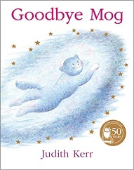  Goodbye Mog  By Judith Kerr | 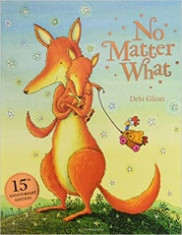  No Matter What  By Debi Gliori |  |  | 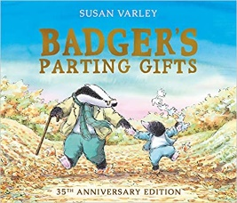  Badgers parting gifts  By Susan Varley |  |  | 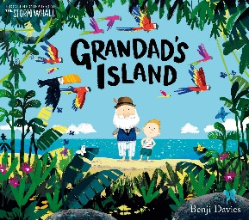  Grandad’s island  By Benji Davies |  |  | 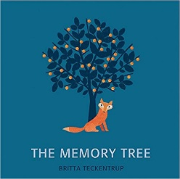  The Memory Tree  by Britta Teckentrup |  |  | 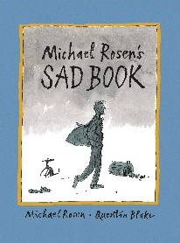  Sad Book  By Michael Rosen |  | 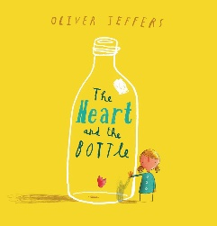  The Heart and the Bottle  By Oliver Jeffers
Pupils develop a curiosity about loss.  Pupils know who to speak to when they have curiosity around loss.  Pupils acknowledge other’s sadness and be kind towards others.  Pupils recognise the feeling of sadness towards any kind of loss - animal, person, place, and item. | Pupils develop a curiosity about loss.  Pupils know who to speak to when they have curiosity around loss.  Pupils acknowledge other’s sadness and be kind towards others.  Pupils recognise the feeling of sadness towards any kind of loss - animal, person, place, and item.  Pupils progress to question that loss can be temporary or irreversible.  Pupils know to seek adult support to answer their questions around loss.  Pupils begin to understand that there are different types of loss but guidance from adults to distinguish. |  |  | Pupils develop a curiosity about loss.  Pupils know who to speak to when they have curiosity around loss.  Pupils acknowledge other’s sadness and be kind towards others.  Pupils recognise the feeling of sadness towards any kind of loss - animal, person, place, and item.  Pupils progress to question that loss can be temporary or irreversible.  Pupils know to seek adult support to answer their questions around loss.  Pupils begin to understand that there are different types of loss but need guidance from adults to distinguish.  Pupils are able to identify the difference of a lost item to that of a being.  Pupils begin to question if the loss of a person results in a belief on after life or resting place, this can be fantasy led or from cultural beliefs. |  |  | Pupils develop a curiosity about loss.  Pupils know who to speak to when they have curiosity around loss.  Pupils acknowledge other’s sadness and be kind towards others.  Pupils recognise the feeling of sadness towards any kind of loss - animal, person, place, and item.  Pupils progress to question that loss can be temporary or irreversible.  Pupils know to seek adult support to answer their questions around loss.  Pupils begin to understand that there are different types of loss but need guidance from adults to distinguish.  Pupils are able to identify the difference of a lost item to that of a being.  Pupils begin to question if the loss of a person results in a belief on after life or resting place, this can be fantasy led or from cultural belief.  Pupils start to recognise mixed feelings relating to loss.  Pupils recognise that loss of being is irreversible and happens eventually to all living things. |  |  | Pupils develop a curiosity about loss.  Pupils know who to speak to when they have curiosity around loss.  Pupils acknowledge other’s sadness and be kind towards others.  Pupils recognise the feeling of sadness towards any kind of loss - animal, person, place, and item.  Pupils progress to question that loss can be temporary or irreversible.  Pupils know to seek adult support to answer their questions around loss.  Pupils begin to understand that there are different types of loss but need guidance from adults to distinguish.  Pupils are able to identify the difference of a lost item to that of a being.  Pupils begin to question if the loss of a person results in a belief on after life or resting place, this can be fantasy led or from cultural belief.  Pupils are able to describe their belief on after life or resting place.  Pupils start to recognise mixed feelings relating to loss.  Pupils recognise and are able to label feelings of anger, sadness, guilt and fear around loss.  Pupils recognise that loss of being is irreversible and happens eventually to all living things. |  |  | Pupils develop a curiosity about loss.  Pupils know who to speak to when they have curiosity around loss.  Pupils acknowledge other’s sadness and be kind towards others.  Pupils recognise the feeling of sadness towards any kind of loss - animal, person, place, and item.  Pupils progress to question that loss can be temporary or irreversible.  Pupils know to seek adult support to answer their questions around loss.  Pupils begin to understand that there are different types of loss but need guidance from adults to distinguish.  Pupils are able to identify the difference of a lost item to that of a being.  Pupils begin to question if the loss of a person results in a belief on after life or resting place, this can be fantasy led or from cultural belief.  Pupils are able to describe their belief on after life or resting place.  Pupils start to recognise mixed feelings relating to loss.  Pupils recognise and are able to label feelings of anger, sadness, guilt and fear around loss.  Pupils are able to add strategies to support their feelings and recognise that they are natural feelings to loss.  Pupils recognise that loss of being is irreversible and happens eventually to all living things. |  | Pupils develop a curiosity about loss.  Pupils know who to speak to when they have curiosity around loss.  Pupils acknowledge other’s sadness and be kind towards others.  Pupils can relay strategies to others to support with their loss.  Pupils recognise the feeling of sadness towards any kind of loss - animal, person, place, and item.  Pupils progress to question that loss can be temporary or irreversible.  Pupils know to seek adult support to answer their questions around loss.  Pupils begin to understand that there are different types of loss but need guidance from adults to distinguish.  Pupils are able to identify the difference of a lost item to that of a being.  Pupils begin to question if the loss of a person results in a belief on after life or resting place, this can be fantasy led or from cultural belief.  Pupils are able to describe their belief on after life or resting place.  Pupils start to recognise mixed feelings relating to loss.  Pupils recognise and are able to label feelings of anger, sadness, guilt and fear around loss.  Pupils are able to add strategies to support their feelings and recognise that they are natural feelings to loss.  Pupils recognise that loss of being is irreversible and happens eventually to all living things.  Pupils can describe the difference between loss of living things and of items/places and distinguish the difference between temporary and irreversible.
Red objectives have been taken directly from RSE Government Guidance.
Purple objectives have been taken directly from the Science National Curriculum.
Green objectives - parents/carers have a right to withdraw their child from these objectives once any concerns have been discussed with SLT.
Teachers must send a reminder on their weekly newsletter about the upcoming PSHE lesson in the subsequent week.
Teaching staff should always discuss pupils’ needs with the Safeguarding Team before planning and delivering lessons with sensitive content*
Any concerns raised during PSHE lesson should be discussed with the Safeguarding Team and logged on CPOMS.
Self-esteem – Dates: WC 29/4 and 6/5
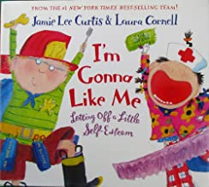  I’m Gonna Like Me  by Jamie Lee Curtis |  | 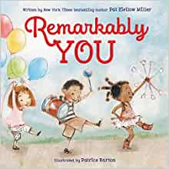  Remarkably You  By Pat Zietlow Miller |  |  | 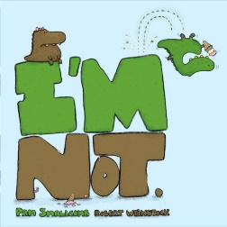  I’m Not  By Pam Smallcomb |  |  | 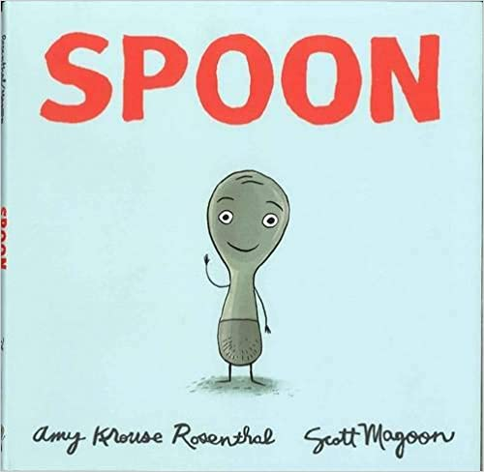  Spoon  by Amy Krouse Rosenthal |  |  | 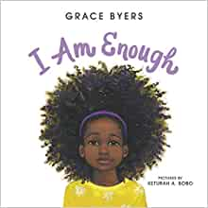  I am Enough  By Grace Byers |  | 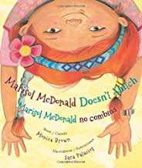  Marisol McDonald Doesn’t Match  By Monica Brown and Sara Palacios |  | 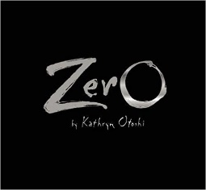  Zero  by Kathryn Otoshi
Pupils are exposed to the word “proud” and “pride” and begin to understand what this means  Pupils feel proud when they achieve something  Pupils will recognise a feeling of happiness and pride when they are praised.  Pupils can say what they are good at. |  | Pupils use the word proud to describe how they feel  Pupils feel proud when they achieve something  Pupils know that someone else can be proud of you  Pupils give praise to others and themselves  Pupils will recognise a feeling of happiness and pride when they are praised.  Pupils can say what they are good at and begin to say what others are good at |  |  | Pupils use the word proud to describe how they feel  Pupils feel proud when they achieve something  Pupils know that you can be proud of someone else and that someone else can be proud of you  Pupils give praise to others and themselves  Pupils will recognise a feeling of happiness and pride when they are praised and know that to praise others can have the same impact on them  Pupils can say what they are good at and celebrate what others are good at too  Pupils begin to think about what they’re not as good at and develop a growth mindset with this  Pupils will reflect upon their efforts and their achievement.  Pupils will start to feel different when comparing their activities or themselves to others.  Pupils will start to recognise a negative feeling when they have not achieved their goal.  Pupils suggest words to describe the opposite of feeling proud |  |  | Pupils can explain times in their life when they have felt pride.  Pupils feel proud when they achieve something  Pupils know that you can be proud of someone else and that someone else can be proud of you - explaining who is often proud of them.  Pupils give praise to others and themselves  Pupils will recognise a feeling of happiness and pride when they are praised and know that to praise others can have the same impact on them  Pupils can say what they are good at and celebrate what others are good at too  Pupils begin to think about what they’re not as good at and develop a growth mindset with this  Pupils know that pride can be felt by overcoming something that you initially struggled with – resilience  Pupils will reflect upon their efforts and their achievement positively  Pupils will start to feel different when comparing their activities or themselves to others but know that everyone is different and have different talents and strengths.  Pupils recognise a negative feeling when they have not achieved their goal.  Pupils suggest words to describe their negative feelings such as disappointed or ashamed. |  |  | Pupils can explain times in their life when they have felt pride.  Pupils feel proud when they achieve something  Pupils know that you can be proud of someone else and that someone else can be proud of you - explaining who is often proud of them.  Pupils give praise to others and themselves  Pupils will recognise a feeling of happiness and pride when they are praised and know that to praise others can have the same impact on them  Pupils can say what they are good at and celebrate what others are good at too  Pupils begin to think about what they’re not as good at and develop a growth mindset with this  Pupils know that pride can be felt by overcoming something that you initially struggled with – resilience  Pupils will reflect upon their efforts and their achievement positively  Pupils will start to feel different when comparing their activities or themselves to others but know that everyone is different and have different talents and strengths.  Pupils recognise a negative feeling when they have not achieved their goal.  Pupils suggest words to describe their negative feelings such as disappointed or ashamed.  Pupils know that other people can affect your self-esteem and ways to cope with this |  | Pupils can explain times in their life when they have felt pride about themselves and proud of others.  Pupils feel proud when they achieve something and share this with others confidently.  Pupils know that you can be proud of someone else and that someone else can be proud of you - explaining who is often proud of them and who they are proud of.  Pupils give praise to others and themselves  Pupils will recognise a feeling of happiness and pride when they are praised and know that to praise others can have the same impact on them  Pupils can say what they are good at and celebrate what others are good at too  Pupils begin to think about what they’re not as good at and develop a growth mindset with this  Pupils understand what a growth mindset is and can explain this  Pupils know that sometimes more pride can be felt by overcoming something that you initially struggled with – resilience  Pupils will reflect upon their efforts and their achievement positively and constructively  Pupils will start to feel different when comparing their activities or themselves to others but know that everyone is different and have different talents and strengths.  Pupils recognise a negative feeling when they have not achieved their goal.  Pupils suggest words to describe their negative feelings such as disappointed or ashamed.  Pupils know that other people can affect your self-esteem and ways to cope with this  Pupils begin to understand how the media and social media can impact on self-esteem |  | Pupils can explain times in their life when they have felt pride about themselves and proud of others.  Pupils feel proud when they achieve something and share this with others confidently.  Pupils know that you can be proud of someone else and that someone else can be proud of you - explaining who is often proud of them and who they are proud of.  Pupils give praise to others and themselves  Pupils will recognise a feeling of happiness and pride when they are praised and know that to praise others can have the same impact on them  Pupils can say what they are good at and celebrate what others are good at too  Pupils begin to think about what they’re not as good at and develop a growth mindset with this  Pupils understand what a growth mindset is and can explain this  Pupils know that sometimes more pride can be felt by overcoming something that you initially struggled with – resilience  Pupils will reflect upon their efforts and their achievement positively and constructively  Pupils will start to feel different when comparing their activities or themselves to others but know that everyone is different and have different talents and strengths.  Pupils recognise a negative feeling when they have not achieved their goal.  Pupils suggest words to describe their negative feelings such as disappointed or ashamed.  Pupils know that other people can affect your self-esteem and ways to cope with this  Pupils understand how the media and social media can impact on self-esteem  Pupils understand how their actions can impact others self-esteem and how to be kind in the real and virtual world  Pupils understand the links between mental health and self-esteem and where to go for support if they are struggling with this
Red objectives have been taken directly from RSE Government Guidance.
Purple objectives have been taken directly from the Science National Curriculum.
Green objectives - parents/carers have a right to withdraw their child from these objectives once any concerns have been discussed with SLT.
Teachers must send a reminder on their weekly newsletter about the upcoming PSHE lesson in the subsequent week.
Teaching staff should always discuss pupils’ needs with the Safeguarding Team before planning and delivering lessons with sensitive content*
Any concerns raised during PSHE lesson should be discussed with the Safeguarding Team and logged on CPOMS.

Being Healthy – Dates: WC 13/5 and 20/5
Pupils discuss which foods are healthy.  Pupils discuss how to look after their bodies including regular exercise.  Pupils talk about why getting plenty of sleep is important.  Pupils know to wash their hands before eating/ after going to the toilet and when they are dirty/ after sneezing and coughing.  Pupils know that they should brush their teeth twice a day and that a dentist looks after their teeth.  Pupils talk about who helps them if they are feeling unwell (in and out of school).  Pupils know that they have to wear suncream to protect them when it is sunny.  Pupils know the school rules about health and safety and where to get help if they or their friends are hurt.  Pupils know that the emergency services number is 999 and they can speak to the police, ambulance or fire service. |  |  | Pupils know what constitutes a healthy lifestyle including the benefits of physical activity, rest, healthy eating and dental health.  Pupils talk about healthy choices and unhealthy choices (in terms of eating and exercise.)  Pupils talk about going to bed early and how it makes them feel when they’re tired.  Pupils know the importance of and how to maintain personal hygiene.  Pupils understand the importance of washing their hands so that they don’t spread germs which make people ill.  Pupils know the importance of brushing their teeth.  Pupils talk about who helps them if they are feeling unwell (in and out of school).  Pupils know that they have to wear suncream to protect them when it is sunny.  Pupils know the school rules about health and safety and where to get help if they or their friend are hurt.  Pupils know that the emergency services number is 999 and they can speak to the police, ambulance or fire service and they know who they need to speak to about what. |  |  | Pupils understand what a balanced diet constitutes.  Pupils know the importance of drinking water (not lots of juice and fizzy drinks - tooth decay)  Pupils understand the benefits of exercise.  Pupils talk about the benefits of getting plenty of sleep and that good quality of sleep is important for good health, concentration etc.  Pupils know about personal hygiene and germs including bacteria, viruses, how they are spread and treated, and the importance of handwashing  Pupils can explain what will happen if they don’t brush their teeth and which food choices affect dental health.  Pupils talk about a time when they’ve been ill (childhood illness e.g. chicken pox) and what they did – doctors? Calpol? Antibiotics?  Pupils know that the sun can be dangerous and that if they don’t wear suncream they might get sunburn which is very uncomfortable.  Pupils know the school rules about health and safety and where to get help if they or their friend are hurt.  Pupils know that the emergency services number is 999 and they can speak to the police, ambulance or fire service and talk about simple scenarios where they may have to call that number. |  |  | Pupils identify that animals, including humans, need the right types and amount of nutrition, and that they cannot make their own food; they get nutrition from what they eat.  Pupils recognise the importance of building regular exercise into daily and weekly routines and how to achieve this (walking to school daily mile etc.)  Pupils know the importance of sufficient good quality sleep for good health and that a lack of sleep can affect weight, mood and ability to learn  Pupils know how some diseases are spread and can be controlled and the responsibilities they have for their own health and that of others.  Pupils know about dental health and the benefits of good oral hygiene, including regular check-ups at the dentist.  Pupils talk about signs that they are unwell and who can help them.  Pupils know about safe and unsafe exposure to the sun, and how to reduce the risk of sun damage, including skin cancer  Pupils know the school rules about health and safety and where to get help if they or their friend are hurt.  Pupils know how to make a clear and efficient call to emergency services if necessary:  - Dial 999 and ask for the appropriate service.  - Give your telephone number.  - Give your location (as clearly as you can).  - Give your name.  - Give the name (if you know it) of the person who needs help (if it’s an ambulance) and their symptoms. |  |  | Pupils recognise opportunities to make their own choices about food, what might influence their choices and the benefits of eating a balanced diet.  Pupils recognise the physical and mental benefits of regular exercise and know how much exercise they should be doing.  Pupils talk about the benefits of getting plenty of sleep and that good quality of sleep is important for good health, concentration and can affect weight and mood.  Pupils know how some diseases are spread and can be controlled and the responsibilities they have for their own health and that of others.  Pupils know the scientific vocabulary for each tooth and can use scientific vocabulary to explain the importance of good oral hygiene (decay etc.).  Pupils talk about signs that they are unwell and who can help them.  Pupils know how to protect themselves in hot weather and that sunburn causes skin damage and can cause, sun stroke/heat stroke which can make you feel unwell.  Pupils know the concepts of basic first-aid, for example dealing with common injuries, including head injuries  Pupils know how to make a clear and efficient call to emergency services if necessary:  - Dial 999 and ask for the appropriate service.  - Give your telephone number.  - Give your location (as clearly as you can).  - Give your name.  - Give the name (if you know it) of the person who needs help (if it’s an ambulance) and their symptoms.  Pupils know which, why and how commonly available substances and drugs (including tobacco and alcohol) could damage their immediate and future health and safety. |  | Pupils know how to make informed choices (including recognising that choices can have positive, neutral and negative consequences) and to begin to understand the concept of a balanced lifestyle.  Pupils recognise the physical and mental benefits of regular exercise and know how much exercise they should be doing.  Pupils talk about the benefits of getting plenty of sleep and that good quality of sleep is important for good health, concentration and can affect weight and mood.  Pupils know that bacteria and viruses can affect health and that following simple routines can reduce their spread.  Pupils know about dental health and the benefits of good oral hygiene and dental flossing including regular check-ups at the dentist.  Pupils know how to recognise early signs of physical illness, such as weight loss, or unexplained changes to the body.  Pupils know about safe and unsafe exposure to the sun and how to reduce the risk of sun damage, including skin cancer.  Pupils know the concepts of basic first aid – ask for help, clean wounds, ice pack for bumps and discuss more serious scenarios and what they would do in those circumstances.  Pupils know how to make a clear and efficient call to emergency services if necessary:  - Dial 999 and ask for the appropriate service.  - Give your telephone number.  - Give your location (as clearly as you can).  - Give your name.  5. Give the name (if you know it) of the person who needs help (if it’s an ambulance) and their symptoms.  Pupils know that pressure to behave in an unacceptable, unhealthy or risky way can come from a variety of sources, including people they know and the media. | Pupils know the characteristics of a poor diet and risks associated with unhealthy eating (obesity, tooth decay) and other behaviours (impact of alcohol on diet and health).  Pupils recognise the physical and mental benefits of regular exercise and know how much exercise they should be doing.  Pupils talk about the benefits of getting plenty of sleep and that good quality of sleep is important for good health, concentration and can affect weight and mood.  Pupils know the facts and science relating to allergies, immunisation and vaccination.  Pupils know about dental health and the benefits of good oral hygiene and dental flossing including regular check-ups at the dentist.  Pupils know how to recognise early signs of physical illness, such as weight loss, or unexplained changes to the body.  Pupils know about safe and unsafe exposure to the sun and how to reduce the risk of sun damage, including skin cancer.  Pupils know the concepts of basic first aid – ask for help, clean wounds, ice pack for bumps and know basic CPR and how to put someone in the recovery position.  Pupils know how to make a clear and efficient call to emergency services if necessary:  - Dial 999 and ask for the appropriate service.  - Give your telephone number.  - Give your location (as clearly as you can).  - Give your name.  - Give the name (if you know it) of the person who needs help (if it’s an ambulance) and their symptoms.  Pupils know which, why and how commonly available substances and drugs (including tobacco and alcohol) could damage their immediate and future health and safety and that some are legal, some are restricted and some are illegal to own, use and supply to others.  Pupils know the facts about legal and illegal harmful substances and associated risks, including smoking, alcohol use and drug-taking
Red objectives have been taken directly from RSE Government Guidance.
Purple objectives have been taken directly from the Science National Curriculum.
Green objectives - parents/carers have a right to withdraw their child from these objectives once any concerns have been discussed with SLT.
Teachers must send a reminder on their weekly newsletter about the upcoming PSHE lesson in the subsequent week.
Teaching staff should always discuss pupils’ needs with the Safeguarding Team before planning and delivering lessons with sensitive content*
Any concerns raised during PSHE lesson should be discussed with the Safeguarding Team and logged on CPOMS.

Growing up/Lifecycles – Dates: WC 10/6 and 17/6

Please note: Purple objectives are taken directly from the Science National Curriculum and so are compulsory. Parents/Carers may wish with withdraw their child from objectives in green. To do so, please speak with a member of the Senior Leadership Team and or your child’s class teacher.

The Growing Story  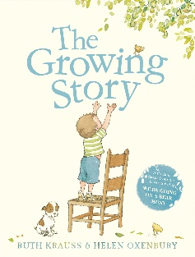  By Ruth Krauss  Pupils talk about who adults are and what adults do. |  | Pupils identify, name, draw and label the basic parts of the human body and say which part of the body is associated with each sense  Pupils discuss the differences between children and adults – child-led (physical, responsibilities, roles, rules, etc.).  Pupils talk about the process of growing from young to old and how people’s needs change. |  |  | Pupils notice that animals, including humans, have offspring which grow into adults  Pupils discuss growing and changing and new opportunities and responsibilities that increasing independence may bring. |  | Pupils recognise the stages in a human life cycle and discuss the differences between each stage.  Pupils know that human life begins when a male and a female reproduce.  Pupils use to the scientific names of body parts when required. | Pupils look at human life cycles and look at the physical differences between bodies – use correct scientific vocabulary. Are all bodies the same?  Pupils recognise that everyone’s bodies are different and that they change at different rates. |  | Pupils describe the differences in the life cycles of a mammal, an amphibian, an insect and a bird  Pupils describe the life process of reproduction in some plants and animals  Pupils describe the changes as humans develop to old age (Pupils should draw a timeline to indicate stages in the growth and development of humans. They should learn about the changes experienced in puberty)  Pupils identify the changes to the body during puberty and know that people develop at different rates (including the menstrual cycle).  Pupils know how to care for themselves during their menstrual cycles.  Pupils identify the main parts of the body (including external genitalia and the human reproductive system) and know the functions of these for the purposes of reproduction.  Pupils know about different types of reproduction, including sexual and asexual reproduction in plants, and sexual reproduction in animals. |  | Pupils recognise that living things produce offspring of the same kind, but normally offspring vary and are not identical to their parents  Pupils know what will happen to their bodies/emotions during puberty.  Pupils know how to take care of their bodies (personal hygiene, mental wellbeing)  Pupils know how to care for themselves during their menstrual cycles.  Pupils recognise what positively and negatively affects their physical and mental health (including the media/ social media).  Pupils recognise their increasing independence brings increased responsibility to keep themselves and others safe.  Pupils discuss their worries and fears about growing up throughout including but not limited to transition to high school.
Red objectives have been taken directly from RSE Government Guidance.
Purple objectives have been taken directly from the Science National Curriculum.
Green objectives - parents/carers have a right to withdraw their child from these objectives once any concerns have been discussed with SLT.
Teachers must send a reminder on their weekly newsletter about the upcoming PSHE lesson in the subsequent week.
Teaching staff should always discuss pupils’ needs with the Safeguarding Team before planning and delivering lessons with sensitive content*
Any concerns raised during PSHE lesson should be discussed with the Safeguarding Team and logged on CPOMS.

Feelings – Dates: WC 24/6 and 1/7

Pupils will start to recognise different feelings whilst in different situations.  Pupils will be able to verbalise own feelings such as, Happy, Sad and Angry.  Pupils will be able to label feelings against physical changes, such as facial expression and body language. | Pupils will recognise different feelings whilst in different situations.  Pupils will be able to verbalise own feelings such as, Happy, Sad and Angry.  Pupils will be able to label feelings against physical changes, such as facial expression and body language.  Pupils will become more aware of the feelings of others.  Pupils will be able to connect feelings with actions. |  | Pupils will recognise different feelings whilst in different situations.  Pupils will be able to verbalise own feelings such as, Happy, Sad and Angry.  Pupils will be able to label feelings against physical changes, such as facial expression and body language.  Pupils will become more aware of the feelings of others.  Pupils will be able to connect feelings with actions.  Pupils will be able to identify more complex emotions.  Pupils will be able to differentiate between different feelings.  Pupils will be able to identify that they can have more than one feeling at a time.  Pupils are able to see the difference with appropriate behaviour and inappropriate behaviour and link feelings to those situations.  Pupils will be able to verbalise what strategies they can do to manage their feelings.  Pupils will be able to have more control over feelings that lead to frustration and anger. | Pupils will recognise different feelings whilst in different situations.  Pupils will be able to verbalise own feelings such as, Happy, Sad and Angry.  Pupils will be able to label feelings against physical changes, such as facial expression and body language.  Pupils will become more aware of the feelings of others.  Pupils will be able to connect feelings with actions.  Pupils will be able to identify more complex emotions.  Pupils will be able to identify complex feelings in themselves and others.  Pupils will verbalise how feelings can affect a person’s behaviour.  Pupils will be able to differentiate between different feelings.  Pupils will be able to identify that they can have more than one feeling at a time.  Pupils are able to see the difference with appropriate behaviour and inappropriate behaviour and link feelings to those situations.  Pupils will be able to verbalise what strategies they can do to manage their feelings.  Pupils will be able to have more control over feelings that lead to frustration and anger.  Pupils will recognise a link with a healthy lifestyle and positive feelings. |  | Pupils will recognise different feelings whilst in different situations.  Pupils will be able to verbalise own feelings such as, Happy, Sad and Angry.  Pupils will be able to label feelings against physical changes, such as facial expression and body language.  Pupils will become more aware of the feelings of others.  Pupils will be able to connect feelings with actions.  Pupils will be able to identify more complex emotions.  Pupils will be able to identify complex feelings in themselves and others.  Pupils will verbalise how feelings can affect a person’s behaviour.  Pupils will be able to differentiate between different feelings.  Pupils will be able to identify that they can have more than one feeling at a time.  Pupils are able to see the difference with appropriate behaviour and inappropriate behaviour and link feelings to those situations.  Pupils will be able to verbalise what strategies they can do to manage their feelings.  Pupils will be able to have more control over feelings that lead to frustration and anger.  Pupils will recognise a link with a healthy lifestyle and positive feelings.  Pupils will be able to articulate and speak confidently about their own feelings to adults. |  |  | Pupils will recognise different feelings whilst in different situations.  Pupils will be able to verbalise own feelings such as, Happy, Sad and Angry.  Pupils will be able to label feelings against physical changes, such as facial expression and body language.  Pupils will become more aware of the feelings of others.  Pupils will be able to connect feelings with actions.  Pupils will be able to identify more complex emotions.  Pupils will be able to identify complex feelings in themselves and others.  Pupils will verbalise how feelings can affect a person’s behaviour.  Pupils will be able to differentiate between different feelings.  Pupils will be able to identify that they can have more than one feeling at a time.  Pupils are able to see the difference with appropriate behaviour and inappropriate behaviour and link feelings to those situations.  Pupils will be able to verbalise what strategies they can do to manage their feelings.  Pupils will be able to have more control over feelings that lead to frustration and anger.  Pupils will recognise a link with a healthy lifestyle and positive feelings.  Pupils will be able to articulate and speak confidently about their own feelings to adults.  Pupils will be able to discuss their feelings towards others in a calm and confident manor. |  | Pupils will recognise different feelings whilst in different situations.  Pupils will be able to verbalise own feelings such as, Happy, Sad and Angry.  Pupils will be able to label feelings against physical changes, such as facial expression and body language.  Pupils will become more aware of the feelings of others.  Pupils will be able to connect feelings with actions.  Pupils will be able to identify more complex emotions.  Pupils will be able to identify complex feelings in themselves and others.  Pupils will verbalise how feelings can affect a person’s behaviour.  Pupils will be able to differentiate between different feelings.  Pupils will be able to identify that they can have more than one feeling at a time.  Pupils are able to see the difference with appropriate behaviour and inappropriate behaviour and link feelings to those situations.  Pupils will be able to verbalise what strategies they can do to manage their feelings.  Pupils will be able to have more control over feelings that lead to frustration and anger.  Pupils will recognise a link with a healthy lifestyle and positive feelings.  Pupils will be able to articulate and speak confidently about their own feelings to adults.  Pupils will be able to discuss their feelings towards others in a calm and confident manor.  Pupils will establish a link with hormonal changes and the impact upon their mood and feelings.
Red objectives have been taken directly from RSE Government Guidance.
Purple objectives have been taken directly from the Science National Curriculum.
Green objectives - parents/carers have a right to withdraw their child from these objectives once any concerns have been discussed with SLT.
Teachers must send a reminder on their weekly newsletter about the upcoming PSHE lesson in the subsequent week.
Teaching staff should always discuss pupils’ needs with the Safeguarding Team before planning and delivering lessons with sensitive content*
Any concerns raised during PSHE lesson should be discussed with the Safeguarding Team and logged on CPOMS.

