### C:\Users\Peter Greaves\SkyDrive\school data\linden-header.png

Dear Parents/Carers,

**Children in Need Day – Friday 17th November**

The Children in Need Appeal raises money to make a positive change to the lives of disadvantaged children and young people throughout the UK. We have decided to support this very worthy cause this year and would like all the children (and staff) to join in with the fundraising fun on Friday, 17th November. We have decided to ask the children to wear something spotty or Pudsey related. If your child doesn’t want to dress up or doesn’t have something spotty, they can wear their uniform. Please can children still wear their school trousers or skirts in return for a minimum donation of £1 towards the charity.

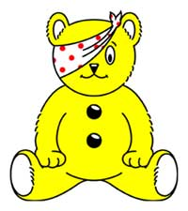

Yours sincerely,

Mr Greaves,

Principal.



Dear Parents/Carer,

**Children in Need Day – Friday 17th November**

The Children in Need Appeal raises money to make a positive change to the lives of disadvantaged children and young people throughout the UK. We have decided to support this very worthy cause this year and would like all the children (and staff) to join in with the fundraising fun on Friday, 17th November. We have decided to ask the children to wear something spotty or Pudsey related. If your child doesn’t want to dress up or doesn’t have something spotty, they can wear their uniform. Please can children still wear their school trousers or skirts in return for a minimum donation of £1 towards the charity.



Yours sincerely,

Mr Greaves,

Principal.