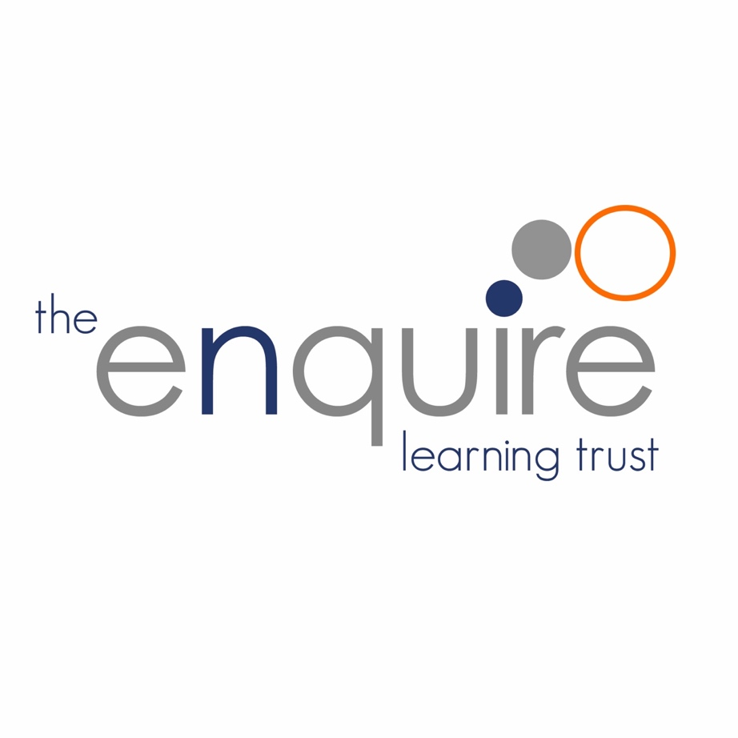
Early Years Policy

The Enquire Learning Trust

Approved by: | Trustees
Last reviewed: | NEW POLICY – SEPT 2023
Next review due by: | Sept 2024

Contents

Section | Title | Page
1 | Aims | 3
2 | Legislation | 3
3 | Structure of Early Years | 3
4 | Early Years Curriculum | 4
5 | Teaching and Learning | 5
6 | Play | 6
7 | Enabling Environments | 6
8 | Assessment | 7
9 | Role of Parents/Carers | 7
10 | Safeguarding and Welfare Procedures | 8
11 | Monitoring arrangements | 8

Version History

Date | Author | Version | Comment
August 23 | Delyth Linacre | 1 | NEW POLICY

The Enquire Learning Trust

1. Aims

This policy should be read in conjunction with the Trust’s Improvement Policy – its values and aspirations, keystones, curriculum and assessment.
Our vision is to provide the very best learning environment for every child for them to reach their full potential. This includes children reaching a Good Level of Development (GLD) by the end of the reception year and therefore providing a solid foundation to build upon, for the start of Year 1. We recognise that within the Trust we have high levels of disadvantage and actively seek to diminish gaps through our provision and day-to-day practice.
The early Years education we offer our children is based on the following principles:
- it builds on what our children already know and can do.
- it ensures that no child is excluded or disadvantaged.
- it offers a structure for learning that has a range of starting points, content that matches the needs of young children and activity that provides opportunities for learning both indoors and outdoors.
- it lays solid foundations for literacy and numeracy learning.
- it provides a rich and stimulating environment.
- it encourages children to play and explore.
- it promotes active learning.
- it offers rich cultural capital to help diminish the disadvantage gap.
- it fosters creative and critical thinkers.

Our Early Years settings, including those with high levels of disadvantage, equip all our children with the necessary skills, knowledge and understanding for future learning, but also for them to leave Early Years as empowered, independent and resilient individuals that have the confidence and ability to communicate effectively, problem solve, develop ideas and think creatively.

Our settings have a commitment to close partnership working with parents and carers to ensure an active and flourishing learning community.

2. Legislation

This policy is based on requirements set out in the statutory framework for the Early Years Foundation Stage (EYFS) for 2023.

3. Structure of Early Years

Across our academies our Early Years settings support children from 2 – 5 years old.
All our academies provide provision for 3 – 5-year-olds, and some also provide 2 year old provision.

Individual settings set and organise their hours for nursery provision. All provide 15 hours a week and some have provision for 30 hours. Some settings have flexibility as to how these hours are taken over the week.

4. Early Years Curriculum

All development and learning is guided by the EYFS Framework; our settings and provision reflect the four themes:

- Unique Child
- Positive Relationships
- Enabling Environments
- Learning and Development

Early Years staff plan together to ensure that the curriculum is broad and balanced across the following areas of learning:

- Communication and Language
- Physical Development
- Personal, Social and Emotional Development
- Literacy
- Mathematics
- Understanding of the World
- Expressive Arts and Design

The Characteristics of Effective Learning are evident throughout all activities.

Play and Exploring = Engagement
Active Learning = Motivation
Creative and Thinking Critically = Thinking

Each of our Early Years settings have their own unique curriculum which draws on a number of influences and educational theory.

What and how we teach is in direct response to the needs of the children.

Learning is planned and built on the familiar. What the child can do is the starting point of their education.

Practitioners establish a clear understanding of children’s strengths, interests and learning styles so that they can respond accordingly, delivering a curriculum that builds sensitively and effectively upon starting points.

Children start to learn about the world around them from the moment they are born. Our Early Years settings help our youngest children to continue to do this by providing a wide range of experiences that are appropriate for their age and stage of development.

Practitioners understand that each age phase has special qualities, strengths and needs, and their reflective practice supports these.

Practitioners plan all learning through active, first-hand experiences where time is given for sustained play to explore, experiment and discover within a social environment which emphasises what the child thinks and enjoys.

Practitioners offer each child the opportunity to learn indoors and outdoors by planning the most appropriate curriculum for their stage of development.

For our youngest children, practitioners focus strongly on the three prime areas – communication and language, physical and personal, social and emotional development, and gradually shift towards a more equal focus on all areas, as children grow and develop.

Curriculums are relevant to local surroundings and draw upon the resources available in the community to strengthen cultural capital and help diminish any disadvantage gap.

In the reception year, children have daily direct teaching of mathematics, literacy and phonics. There is a strong emphasis on laying the foundations of literacy and numeracy.

5. Teaching and Learning

Each area of learning and development is implemented through planned, purposeful play, and through a mix of adult-led and child-initiated activities. Staff respond to each child’s emerging needs and interests, guiding their development through warm, positive interaction.

Features of good Early Years practice in our academies include:

- the partnership between teachers and parents, so that our children feel secure at school and develop a sense of well-being and achievement.
- the understanding that teachers have of how children develop and learn, and how this affects their teaching.
- the range of approaches used that provide first-hand experiences, give clear explanations, make appropriate interventions and extend and develop play and talk or other means of communication.
- the carefully planned curriculum that helps children achieve the Early Learning Goals by the end of the Foundation Stage.
- the provision for children to take part in activities that build on and extend their interests and develop their intellectual, physical, social and emotional abilities.
- the encouragement for children to communicate and talk about their learning, and to develop independence and self-management, extending their vocabulary.
- the support for learning with appropriate and accessible indoor and outdoor space, facilities and equipment.
- the identification of the progress and future learning needs of children through observations, which are regularly shared with parents.
- the clear aims for our work, and the regular monitoring to evaluate and improve what we do.
- the regular identification of training needs of all adults working within the EYFS.

Children learn best through the use of effective pedagogy – a mix of different approaches. Our practitioners understand that children learn through play, by adults modelling, by observing each other, and through guided learning and direct teaching.

Practitioners carefully organise enabling environments for high-quality play. Sometimes, they make time and space available for children to invent their own play. Sometimes, they join in to sensitively support and extend children’s learning.

Children also learn through group work, when practitioners guide their learning. We recognise that older children need more guided learning.

A well-planned learning environment, indoors and outside, is an important aspect of our pedagogy.

Highly skilled adults support, extend and challenge learning, and develop knowledge through the provision of continuous and enhanced play, and by offering new experiences.

Where a child may have a special educational need or disability, staff consider whether specialist support is required, linking with relevant services from other agencies, where appropriate.

6. Play

Play is important because it is the elemental learning process by which humankind has developed. Children have an instinctive desire to play whatever culture they are born into.

Play encompasses children’s behaviour which is freely chosen, personally directed and intrinsically motivated. It is performed for no external goal or reward and is a fundamental and integral part of healthy development. Physical, social, mental, emotional and creative skills, all of which underpin academic development, are all developed through play. It also allows the beneficial exposure of children to some levels of risk and challenge, giving them the chance to learn about the real consequences of risk taking. Play provides the opportunities for children to apply skills taught formally into real life situations.

In our Early Years settings, we do not see teaching as separate from play or infer teaching to mean one fixed view of how things should be done. We see teaching as the many ways in which adults, consciously or otherwise, help children to learn. Our Early Years seek every opportunity to support play and create an environment that fosters it.

7. Enabling Environments

The Characteristics of Effective Learning underpin everything that we do in our EYFS environments. They are rooted in the science of how children learn, and therefore guide and support the ways in which we create our learning spaces.

Our Early Years settings:
- Foster environments that actively encourage children to play and explore. Not only to play freely, but support children’s learning through implicit and explicit challenge.
- Have lots of elements of ‘ambiguity’ and ‘open-endedness’ where resources are open to interpretation and exploration depending on who is holding them.
- Present interesting and relevant learning opportunities within the environment in order to support children to be ‘active learners’, demonstrating engagement, concentration and resilience when attempting a task. This includes creating environments led by children’s interests.
- Enable children to think, puzzle and work things out on their own and with others.
- Are great thinking environments! Where adults and children are developing and applying thinking strategies, accepting differences, hypothesising and extending thinking using ever-expanding vocabularies.
- Encompass both indoors and outside. Outdoor provision is such a crucial part of the EYFS curriculum and receives equal weighting in terms of planning and resourcing as indoors.

8. Assessment

In our academies’, ongoing assessment is an integral part of learning and development processes. Staff observe pupils to identify their level of achievement, interests and learning styles. These observations are used to shape future planning. Staff also consider observations shared by parents and/or carers.

When a child is aged between 2 and 3, staff review their progress and provide parents and/or carers with a written summary of the child’s development in the 3 prime areas. This ‘progress check’ highlights the areas in which a child is progressing well and the areas in which additional support is needed.

Within the first 6 weeks that a child starts reception, staff will administer the Reception Baseline Assessment (RBA).

At the end of the EYFS, staff complete the EYFS profile for each child. Pupils are assessed against the 17 early learning goals, indicating whether they are:

- Meeting expected levels of development
- Not yet reaching expected levels (‘emerging’)
The profile reflects ongoing observations, and discussions with parents and/or carers. The results of the profile are shared with parents and/or carers for their child.

The profile is moderated internally (referring to the Development Matters guidance) and in partnership with other local schools and academies within the Trust, to ensure consistent assessment judgements.

EYFS profile data is submitted to the local authority upon request.

9. Role of Parents/Carers

We recognise that children learn and develop well when there’s a strong partnership between staff and parents and/or carers.

Parents and/or carers are kept up to date with their child’s progress and development. The progress check and EYFS profile helps to provide parents and/or carers with a well-rounded picture of their child’s knowledge, understanding and abilities.

Each child is assigned a key person who helps to ensure that their learning and care is tailored to meet their needs. The key person supports parents and/or carers in guiding their child’s development at home. The key person also helps families to engage with more specialist support, if appropriate.

10. Safeguarding and Welfare Procedures

We recognise that children learn best when they are healthy safe and secure, when their individual needs are met and when they have positive relationships with the adults caring for them.

We follow safeguarding and welfare requirements to provide a welcoming, safe and stimulating environment where children can enjoy learning and grow in confidence.

We make sure that the appropriate statutory staff:child ratios are maintained in our settings to meet the needs of all children and ensure their safety:
- For children aged under 2, we have at least 1 member of staff for every 3 children.
- For children aged 2, we have at least 1 member of staff for every 5 children.
  - For children aged 3 and over:
  - Where there is a person with Qualified Teacher Status, Early Years Professional Status, Early Years Teacher Status or another approved level 6 qualification, an instructor or another suitably qualified overseas trained teacher:
    - For classes where the majority of children will reach the age of 5 or older within the school year, we have at least 1 member of staff for every 30 children.
    - For all other classes, we have at least 1 member of staff for every 13 children
  - Where a person with the above qualifications is not working directly with the children, we have at least 1 member of staff for every 8 children.
Settings have always at least one person with a current paediatric first aid (PFA) certificate on the premises and available when children are present, including on outings. This PFA certificate is renewed every 3 years as required.

Our academies promote good oral health, as well as good health in general by talking to the children about:

- The effects of eating too many sweet things
- The importance of brushing your teeth

Some of our academies have introduced supervised tooth brushing. Here we follow the Public Health England guidance on supervised toothbrushing to make sure that it is evidence-based and safe.

The rest of our safeguarding and welfare procedures are outlined in our school’s child protection and safeguarding policy.

11. Monitoring arrangements

This policy will be reviewed and approved by Delyth Linacre (Early Years Lead) annually.

At every review, the policy will be shared with The Trust Board and academies.

