Geography Curriculum Intent
Through our teaching of Geography, we intend to open up the world for our pupils; providing them with knowledge about places, environments and people alongside the skills they need to successfully explore and study them.
In the Early Years, pupils begin their geographical journey through “Understanding the World” - it is here that the geographical foundations of learning begin. From human and physical characteristics discussed in story books to getting outside and observing the weather, our learning environments and topics encourage pupils to become inquisitive and curious learners from the moment they walk through the door.
Continuing through school, our thematic curriculum aims to immerse pupils into their learning. Year 1 pupils explore Geography through a Pirate Adventure whilst Year 2 expand and deepen their knowledge in Awesome Africa – here pupils begin to compare geographical similarities and differences between where they live and other places around across the world.
Year 3 continues the journey into Key Stage Two with geographical studies focussing around Amazing South America. Year 4 pupils aim to ‘Save Our World’ by understanding issues around protecting our planet and climate change.
Year 5 consolidates learning through the context of ‘Survival’ and finally, Year 6 pupils question whether treacherous journeys across the globe are really ‘Worth the Risk?’ - pulling together all of their knowledge and skills that have been acquired throughout their time at Linden Road.
Our progressive and sequential planning aims for skills and knowledge to be built upon, embedded and recapped with an aim to commit learning to long-term memory. Key knowledge is taught from EYFS and throughout KS1 and KS2, which includes: learning about the local area, the UK and the world and its continents. Geographical understanding is taught through understanding places, making comparisons and physical and human themes. Skills, knowledge and understanding progress carefully throughout the years under the Key themes of: Locational knowledge, Place knowledge, Human Processes, Physical Processes and Geographical Techniques.

Geography – Big Ideas

Key themes | 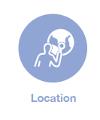 | Place | 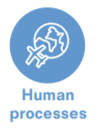 |  | 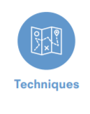

Procedural  Geographical Concepts | Place | 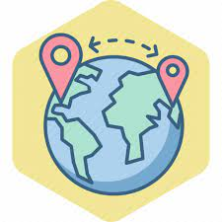  Space | Human and Physical Processes | Cultural Understanding and Diversity | Interconnection and Scale | 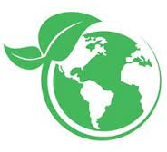  Environmental interaction and sustainability | Relational Thinking

Our Topics | EYFS | Year 1 | Year 2 | Year 3 | Year 4 | Year 5 | Year 6
 | Understanding the World | Pirates | 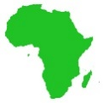  Africa | 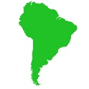  South America | How can we save our world? | Survival | Is it Worth the Risk?

Geography Progression and Programme of Study
National Curriculum | 3-4 year olds | Reception | Y1  Pirate Adventure | Y2  Awesome Africa | Y3  Amazing South America | Y4  Save Our World | Y5  Survival | Y6  Is it Worth the Risk?
Locational Knowledge | Understand position through words alone. For example, “The bag is under the table,” – with no pointing.  Describe a familiar route.  Discuss routes and locations, using words like ‘in front of’ and ‘behind’.  Use all their senses in hands-on exploration of natural materials.  Begin to understand the need to respect and care for the natural environment and all living things.  Know that there are different countries in the world and talk about the differences they have experienced or seen in photos  To begin to understand where we live and what the UK is .To introduce the concept of continents and oceans I wonder why it is cold? Spring 1  Comment and ask questions about aspects of their familiar world such as the place where they live or the natural world I wonder what is beyond the sky? Spring 2 | Recognise some similarities and differences between life in this country and life in other countries. I wonder if dark is important – Autumn 2  I wonder what makes a hero – Spring 1  I wonder what’s under my feet – Spring 2  Explore the natural world around them. I wonder what makes a hero – Spring 1  Recognise some environments that are different to the one in which they live I wonder if you've heard this one – Autumn 1  Explain some similarities and differences between life in this country and life in other countries, drawing on knowledge from stories, non-fiction texts and (when appropriate) maps.  Describe their immediate environment using knowledge from observation, discussion, stories, non-fiction texts and maps. | Name and locate the four countries of the UK. | Name and locate the four countries of the UK with a focus on capital cities. | Locate the world’s countries, using maps to focus on Europe (including the location of Russia) and North and South America.  Locate the countries and capital cities of South America. | Identify the position and significance of latitude, longitude, Equator, Northern Hemisphere, Southern Hemisphere, the Tropics of Cancer and Capricorn.  Build on work from Year 2 and Year 3 | Recap - the location of world’s countries concentrating  Teach -  Their environmental regions, key physical and human characteristics, countries, and major cities. | Recap – latitude, longitude, Equator, Northern Hemisphere, Southern Hemisphere, the Tropics of Cancer and Capricorn.  Teach -  Identify the position and significance of the Arctic and Antarctic Circle, the Prime/Greenwich Meridian and time zones (including day and night)
 |  |  | Name and locate the surrounding seas of the UK | Name and locate the seven continents and the oceans. | Recap countries and cities of the United Kingdom. | Recap countries and cities of the United Kingdom.  Locate geographical regions of the UK and key topographical features (coasts and rivers)  - How are our rivers and coasts changing? | Identify UK land-use patterns; and understand how some of these aspects have changed over time  How could you survive here and is it getting easier or worse to survive? | Describe and compare land-use in the Arctic and Antarctica compared to other areas in the world.
Place Knowledge |  |  | Identify human and physical features of the local area (use simple fieldwork and observational skills to study the geography of their school and its grounds and the key human and physical features of its surrounding environment.) | Compare human and physical features of the UK/local area with the human and physical features of a country in Africa (use simple fieldwork and observational skills to study the geography of their school and its grounds and the key human and physical features of its surrounding environment.) | Identify and compare  human characteristics of a region of the UK to a region of South America.  Identify and compare physical characteristics of UK and South America with a focus on hills and mountains.  Identify how land use has changed (in a region of the UK and a region of South America) over time | Study the human characteristics (of the UK and compare to another country) with a focus on the impact of human geography on land use.  Study the physical characteristics (of the UK and compare to another country) with a focus on coasts and rivers and how these have changed over time. | Compare geographical similarities and differences through the study of human and physical geography of a region of the United Kingdom, a region in a European country, and a region within South America  Build on work from Year 3 | Compare geographical similarities and differences through the study of human and physical geography of Antarctica with other places in the world, considering how these may change with global warming and the impact this may have on
Human | To begin to understand aspects of human and physical geography. I wonder if you have heard this one? - Autumn 1  Explore vocabulary of human geography through the use of stories with a focus on:  Town, farm, house, shop zoo I wonder if dinosaurs lived in zoos? - Autumn 2 |  | Recap – vocabulary from EYFS  Teach -  Explore vocabulary within human geography with a focus on:  Town, farm, office, house, factory shop, port | Explore vocabulary within human geography with a focus on:  Recap -  Town, farm, office, house, factory, shop, city, port.  Teach -  Village, city, harbour. | Recap -  Teach -  Describe and understand key aspects of:  The distribution of natural resources including energy, food, minerals and water (in South America) | Recap – what are natural resources and how do we use them?  Describe and understand key aspects of:  Types of settlement and land use, economic activity including trade links (and the positives and negatives these bring to the wider world)  Build on work from KS1 | Recap – Different types of settlement, land use, economic activity and trade  The distribution of natural resources including energy, food, minerals and water (in South America and how this compares to the UK and other countries)  Build on work from Year 3 | Explore all aspects of the human geography taught throughout the key stage and apply this to a study of Antarctica:  - Types of settlement  - Trade  - Natural resources  - Land use
Physical Geography | To begin to understand aspects of human and physical geography. I wonder if you have heard this one? - Autumn 1  To explore vocabulary of physical geography through the use of stories with a focus on: Beach, hills, mountains and weather I wonder if dinosaurs lived in zoos? - Autumn 2 | Know some similarities and differences between the natural world around them and contrasting environments, drawing on their experiences and what has been read in class.  Understand some important processes and changes in the natural world around them, including the seasons. | Recap – vocabulary from EYFS  Teach -  Describe UK weather and seasons. | Recap – weather and seasons and link to weather in different countries  Teach -  Understand and explain how climate changes depending on proximity to the Equator and the North and South Poles. | Recap – The position of the equator and the impact this has on climate.  Teach -  Describe and understand key aspects of:  - Climate zones (locating and labelling) | Recap – What are the climate zones  What is a vegetation belt and a biome.  Teach -  Describe and understand key aspects of:  - Rivers  - The water cycle  - Forests and the impact of deforestation (as an example of a biome) | Recap – the rainforest and forest as examples of a biome and vegetation belt)  Teach -  Describe and understand key aspects of:  - Deserts (Vegetation belts and biomes)  Recap – Earthquakes (from Year 3)  Teach -  - Volcanoes  - Mountains | Use and apply their knowledge of climate zones and biomes to a comparative study of different geographical journeys.  Focus in greater depth on:  Desert Biome: Antarctica  Rivers and the water cycle  Build on work from Year 4
 |  |  | Recap – vocabulary from EYFS  Teach -  Vocabulary within physical geography with a focus on:  Beach, hill, forest, sea, mountain, season, soil, weather | Vocabulary within physical geography with a focus on:  Recap -  Beach, sea, hill mountain, season, soil, weather  Teach -  Coast, ocean, cliff, valley, forest, vegetation. | Recap – vocabulary within physical geography (From Year 2)  Teach -  - The rainforest (as an example of a vegetation belt and biome and introduce this new vocabulary  - Earthquakes  - Mountains (Andes)
Geographical Techniques | To begin to use and create simple maps and symbols  I wonder if you have heard this one? - Autumn 1  I wonder how I will get there? Summer 1 | Draw information from a simple map. I wonder if you've heard this one – Autumn 1  I wonder what makes a hero – Spring 1  I wonder what’s under my feet – Spring 2  I wonder if it’s real – Summer 1  I wonder where we will go – Summer 2 | Use world maps, atlases and globes to identify the United Kingdom and its countries | Use world maps, atlases and globes to identify the countries, continents and oceans studied at this key stage | Use maps, atlases and globes to locate countries and describe features studied.  Build on work from KS1 | use the eight points of a compass, four figure grid references, symbols and key (including the use of Ordnance Survey maps) to build their knowledge of the United Kingdom and the wider world  Build on work from KS1 | Use maps, atlases, globes and digital/computer mapping to locate countries and describe features studied  Build on work from Year 3 | use the eight points of a compass, six figure grid references, symbols and key (including the use of Ordnance Survey maps) to build their knowledge of the United Kingdom and the wider world (journeys)  Build on work from Year 4
 |  |  | Use simple compass directions (North, South, East and West) and locational and directional language [for example, near and far; left and right], to describe the location of features and routes on a map (within the UK) | Use simple compass directions (North, South, East and West) and locational and directional language [for example, near and far; left and right], to describe the location of features and routes on a map (wider world)
 |  |  | Use aerial photographs and plan perspectives to recognise landmarks and basic human and physical features of local area | Use aerial photographs and plan perspectives to devise a simple map; and use and construct basic symbols in a key. | use fieldwork to observe, measure, record and present the human and physical features in the local area using a range of methods, including sketch maps and plans (local area) | use fieldwork to observe, measure, record and present the human and physical features in the local area using a range of methods, including sketch maps, plans and graphs. (Local area – Tame Valley – River Tame Pollution) | use fieldwork to observe, measure, record and present the human and physical features in the local area using a range of methods, including sketch maps, plans and graphs, and digital technologies. (Accurate map of school grounds) | To use and apply their fieldwork skills acquired from throughout the key stage to a study of Antarctica using a range of methods, including sketch maps, plans and graphs, and digital technologies.

Procedural Geographical Concepts | KS1 | LKS2 | UKS2
PLACE | Understanding the characteristics of the human and physical features of places | Understanding the human and physical characteristics of places and how it became like that. | Understanding the human and physical characteristics of places, how it became like that and how it has changed over time.
SPACE | Understand the ways in which is space is used and humanised (where things are located) | Understand the ways in which space is used and humanised to create meaningful places (where things are located and why) | Understand the ways in which space is used and humanised to create meaningful places (where things are located, why and the impact of this)
HUMAN AND PHYSICAL PROCESSES | Describe some changes as a result of human and physical processes | Understand how environments, landscapes and societies are continually changing as a result of human and physical processes | Describe how and why environments, landscapes and societies are continually changing as a result of human and physical processes
CULTURAL UNDERSTANDING AND DIVERSITY | Describe some differences and similarities between people, places, environments and cultures | Appreciating differences and similarities between people, places, environments and cultures | Appreciating differences and similarities between people, places, environments and cultures – and how these can lead to inequality and conflict
INTERCONNECTION AND SCALE | Understand how the place in which they live is connected to other places nationally  Begin to make connections between geographical concepts | Understand that the place in which they live and how it is connected to the wider world  Understand geographical concepts and make connections across different content studied | Understand that the place in which they live and how it is connected to the wider world and how this impacts on climate, population, economy and culture.  Understand geographical concepts and make connections across different content studied  How technology has altered the proximity and distance of the world
ENVIRONMENTAL INTERACTION AND SUSTAINABILITY | Recognise some of the challenges facing the people and the planet | Recognising the challenges facing the people and the planet  Develop a sense of social and environmental agency | Recognising the challenges facing the people and the planet and how these have changed over time  Exploring the connection between human and physical geography -  How humans make use of the environment for their survival whilst also exploring how humans impact the environment negatively.  Consider how to address injustices and inequalities  Develop a sense of social and environmental agency and make suggestions on how they could contribute towards its improvement
RELATIONAL THINKING | Ask geographical questions  Use sources to make geographical conclusions  Discuss and acknowledge different viewpoints  Begin to develop and use subject specific vocabulary | Asking geographical questions and conducting geographical enquiries  Analyse data that supports enquiries and make conclusions based on this  Evaluate the reliability sources of information  Discuss different standpoints and interpretations, acknowledging the viewpoints of others  Develop dialogue using subject specific vocabulary accurately | Asking geographical questions and conducting geographical enquiries, collecting data and research where required  Gather data to support enquiries, making conclusions based on qualitative and quantitative analysis  Evaluate the reliability sources of information including the methods used to collect data  Debate, challenge and discuss different standpoints and interpretations, acknowledging the viewpoints of others  Develop dialogue using subject specific vocabulary accurately

Geography Lesson Construct
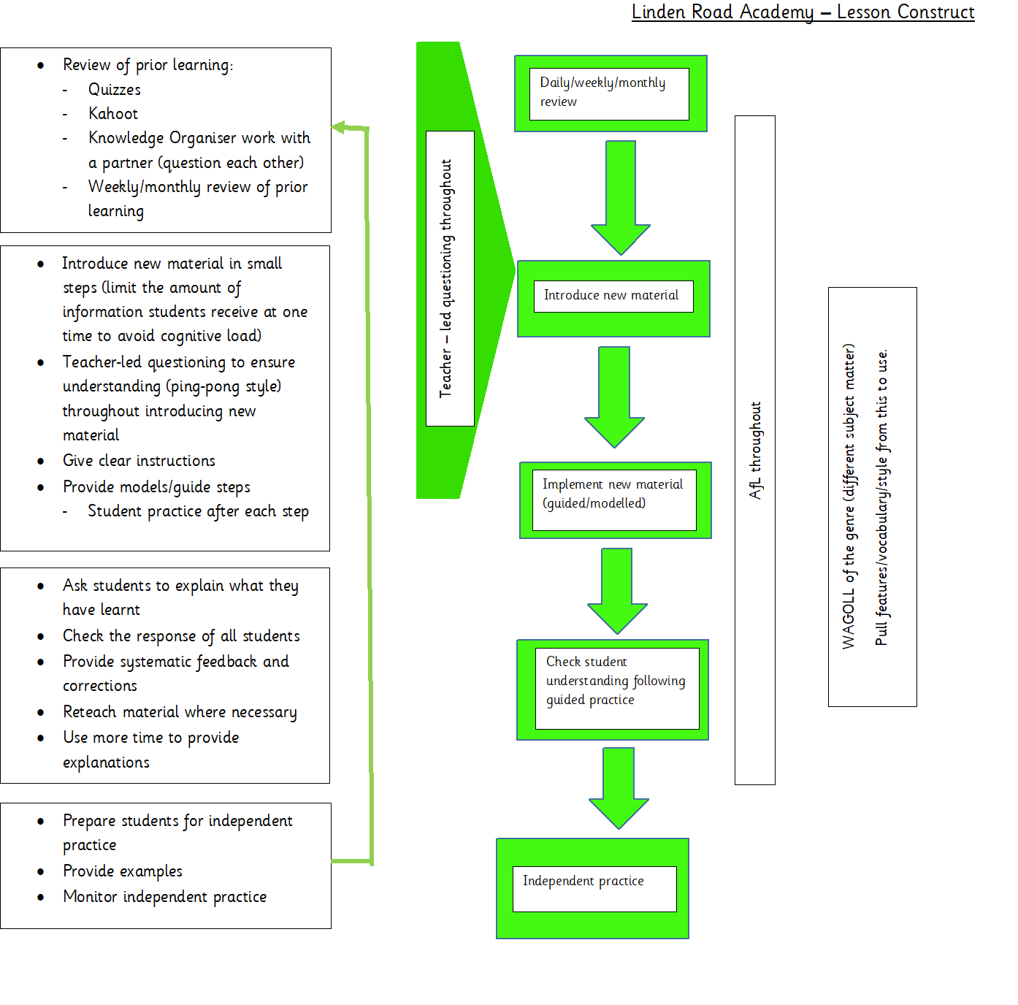
The immersive classroom, outdoor learning and trips should be used to enhance the cultural capital and engagement of our pupils.
This construct does not mean every lesson must look the same – components of lessons can be moved and altered in duration to suit the needs of the children.
Be as creative and innovative as you like!

