History Curriculum Intent
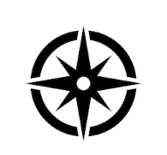
Our History Curriculum aims to enhance our pupils’ historical knowledge and conceptual understanding of developments and changes over time, relating this to the significance and impact of history on the modern world in which we live.
The historical journey begins in EYFS where it is mainly taught through the area of learning: Understanding the World and communication and language. This is where the children will begin to understand and speak confidently about the passing of time from past to present looking at their own personal lives and that of their families. The key skills mentioned below will be built through talk, real experiences, role play and handling artefacts. This will give the children the foundations of historical concepts and skills to build on through the following 2 key stages.
We focus on the development of four Key Skills: Historical Chronology, Historical Concepts, Working Historically and Communicating Historically. Within these, pupils are taught to construct and sequence the past, understand and articulate concepts such as cause and effect, plan and conduct historical enquiries and use appropriate historical terminology.
Our Topics provide a broad and culturally diverse experience for pupils and key themes within topics are revisited sequentially so that pupils can connect their learning, build upon prior knowledge and commit learning into long term memory. Our Key themes are: Location, Main Events, Conflict, Society, Travel and Exploration, Settlement, Culture and Pastimes, Beliefs and Food and Farming.
These themes are visited through the contexts of our History Topics:

EYFS  Taught throughout the year in a range of contexts | Year 1  Heroes | Year 2  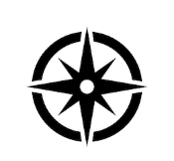  Explorers | Year 3  Invaders | Year 4  Egyptians | Year 5  The Great War  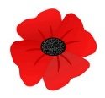 | Year 6  World War Two
 |  |  |  |  | Ancient Greek Democracy | Stone Age Evolution

At the end of a topic, pupils answer an assessment question, which gives pupils an opportunity to present their understanding of what they have learnt. Teachers assess the depth of understanding through these answers and use this to inform assessment.
Alongside our historically themed topics, we also run a ‘local history week’ – each class focuses on a different theme of local history within our local area. They become detectives, investigating the past, making comparisons from then to now…. How has Denton changed?
Linden Road Academy History – Big Ideas

Key themes |  |  |  |  |  |  | 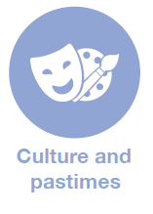 |  | 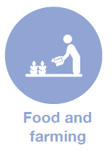

Key Skills | Historical Chronology |  | Historical Concepts |  |  | Working Historically |  | Communicating Historically
 | Constructing the past | Sequencing the past | Change and development | Cause and effect | Significance and interpretations | Planning and carrying out a historical enquiry | Using sources as evidence | Using key historical terminology | Using key contextual terminology

Our Topics | EYFS | Year 1 | Year 2 | Year 3 | Year 4 | Year 5 | Year 6 | Whole School
 | Taught throughout the year in a range of contexts | Heroes | 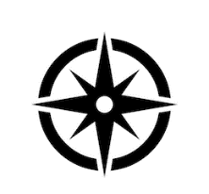  Explorers | Invaders | Ancient Egypt | The Great War  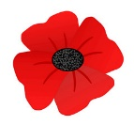  Ancient Greek Democracy | World War Two  Stone Age Evolution | Local History Project

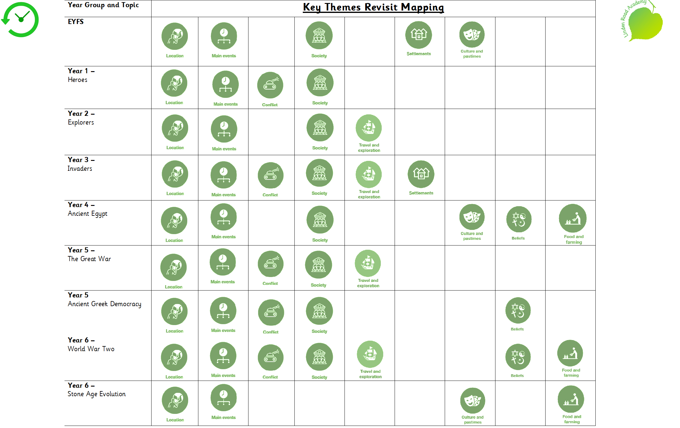

Whole School History Progression
Topic | EYFS | Year 1  Heroes  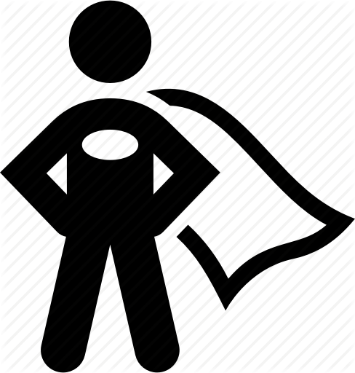 | Year 2  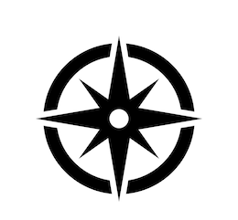  Explorers | Year 3  Invaders | Year 4  Egyptians | Year 5  The Great War  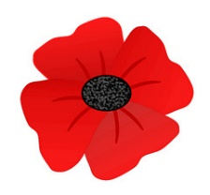  Ancient Greek Democracy  .m k | Year 6  World War Two  Stone Age Evolution
Assessment Question |  | Who has inspired you the most and why? | Who made the greatest discovery? | Did invaders have a positive or negative impact on Britain? Which invader had the best impact on Britain? | How was life in Ancient Egypt different to life in Ancient Britain? | What was the key factor that led to The Triple Entente winning World War One?  How has democracy developed since Ancient Greece? | To what extent was everyone affected by the events of World War Two?  To what extent was the Stone Age period the greatest evolution of man-kind?
National Curriculum | Communication and Language  ELG 03: Speaking  They use past, present and future forms accurately when talking about events that have happened or are to happen in the future  • They develop their own narratives and explanations by connecting ideas or events  ELG 12 Shape, Space and Measure  Children use everyday language to talk about time to compare objects, quantities and to problem solve.  Understanding the world 2020  ELG 13 People and communities: • Children talk about past and present events in their own lives and in the lives of family members  Understanding the world 2021  Past and Present ELG  Talk about the lives of the people around them and their roles in society; - Know some similarities and differences between things in the past and now, drawing on their experiences and what has been read in class;- Recall some important narratives, characters and figures from the past encountered in books read in class. | Events beyond living memory that are significant nationally or globally for example:  The lives of significant individuals in the past who have contributed to national and international achievements. Some should be used to compare aspects of life in different periods. | Events beyond living memory that are significant nationally or globally for example:  The lives of significant individuals in the past who have contributed to national and international achievements. Some should be used to compare aspects of life in different periods. | The Roman Empire and its impact on Britain  Britain’s settlement by Anglo-Saxons and Scots  The Viking and Anglo-Saxon struggle for the Kingdom of England to the time of Edward the Confessor  (Within South America)  A non-European society that provides contrasts with British history – Mayan civilization | The achievements of the earliest civilizations – an overview of where and when the first civilizations appeared and a depth study of Ancient Egypt. | A study of an aspect or theme in British history that extends pupils’ chronological knowledge beyond 1066  Within PSHE Democracy  Ancient Greece – a study of Greek life and achievements and their influence on the western world | A study of an aspect or theme in British history that extends pupils’ chronological knowledge beyond 1066  Within ‘Where did it all begin?’  Changes in Britain from the Stone Age to the Iron Age (will be moved to Y6 Next Year)
Historical Chronology

1. Constructing the past | To understand events happened in the past.  Briefly describe features of particular themes, events and people from family and local history. | Briefly describe features of particular themes, events and people from family, local, national and global history. | Explain a range of features covering family, local, national and global history and draw a range of conclusions. | Identify details from local, national  and global history to demonstrate some overall awareness of themes, societies, events and people. | Describe the main context of particular themes, societies, people and events including some explanation. | Provide overviews of the most significant features of different themes, individuals, societies and events covered. | Show a detailed awareness of the themes, events, societies and people covered across the Upper Key Stage 2 topics, e.g. explain different dimensions and characteristics.
2. Sequencing the past | Uses talk to sequence events on a personal level and from key events in the past using the correct tense- past, present, future.  To understand and begin to use a range to time terms. | Sequence independently on an annotated timeline a number of objects or events related to particular themes, events, periods, societies and people.  Understand securely and use a wider range of time terms. | Give a valid explanation for their sequence of objects and events on timelines or narratives they have devised.  Use more complex time terms, such as 'BCE'/'AD' and period labels and terms. | Sequence a number of the most significant events, objects, themes, societies, periods and people in Lower Key Stage 2 topics using some dates, period labels and terms. | Sequence accurately the key events, objects, themes, societies, periods and people within and across topics confidently using key dates, period labels and terms. | Sequence with independence the key events, objects, themes, societies and people in Upper Key Stage 2 topics covered using dates, period labels and terms. | Explain independently the sequence of key events, objects, themes, societies and people in topics covered using dates, period labels and terms accurately.
Historical Concepts

3. Change and development | Identify similarities, difference and changes from their past and the past of others, key events and people. | Identify independently a range of similarities, differences and changes within a specific time period. | Describe independently and accurately similarities, differences and changes both within and across time periods and topics. | Make valid statements about the main similarities, differences and changes occurring within topics. | Explain why certain changes and developments were of particular significance within topics and across time periods. | Compare similarities, differences and changes within and across some topics, e.g. in terms of importance, progress or the type and nature of the change. | Compare independently how typical similarities, differences and changes were.
4. Cause and effect | Understand that things can happen for a reason and other things can happen as a result.  Identify a cause and effect for a main event covered. Explain how or why something has happened. | Identify a few relevant causes and effects for some of the main events covered. | Comment on a few valid causes and effects relating to many of the events covered. | Comment on the importance of causes and effects for some of the key events and developments within topics. | Explain with confidence the significance of particular causes and effects for many of the key events and developments. | Explain the role and significance of different causes and effects of a range of events and developments. | Comment independently on the different types of causes and effects for most of the events covered, including longer- and shorter-term aspects.
5. Significance and interpretations | Identify and explain a key feature of an event or person showing understanding of the significance from class reading or drawing on other experiences. | Identify a range of significant aspects of a theme, society, period or person and offer some comments on why they have selected these aspects. | Provide some valid reasons for selecting an event, development or person as significant. | Explain why some aspects of historical accounts, themes or periods are significant. | Explain independently why a historical topic, event or person was distinctive or significant. | Explain reasons why particular aspects of a historical event, development, society or person were of particular significance. | Compare the significance of events, development and people across topics and time periods.
 |  |  |  |  | Explain historical situations, events, developments and individuals from more than one viewpoint. | Explain how and why it is possible to have different interpretations of the same event or person. | Understand and explain the nature and reasons for different interpretations in a range of topics.
 |  |  |  | Comment on a range of possible reasons for differences in a number of accounts.
Working Historically

6. Planning and carrying out a historical enquiry | Ask questions and try to find answers to explain things that have happened | Plan questions and produce answers to a few historical enquiries using historical terminology. | Pose independently a series of valid questions for different enquiries and produce effective responses using appropriate vocabulary confidently. | Devise independently a range of historically valid questions for a series of different types of enquiry and answer them with substantiated responses. | Devise independently significant historical enquiries to produce substantiated and focused responses.. | Reach a valid and substantiated conclusion to an independently planned and investigated enquiry with suggestions for development or improvement. | Plan and produce quality responses to a wide range of historical enquiries requiring the use of some complex sources and different forms of communication with detailed ideas on ways to develop or improve responses.
7. Using sources as evidence |  | Select information independently from several different types of source including written, visual and oral sources and artefacts to answer historical questions. | Critically evaluate the usefulness of sources and parts of sources to answer historical questions. | Recognise possible uses of a range of sources for answering historical enquiries. | Comment on the usefulness and reliability of a range of sources for particular enquiries. | Comment with confidence on the  value of a range of different types of source for enquiries, including extended enquiries. | Evaluate independently a range of sources for historical enquiries considering factors such as purpose, audience, accuracy, reliability and how the source was compiled.

Communicating historically

 | EYFS | Year 1  Heroes | 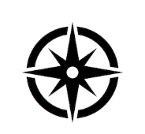  Year 2  Explorers | Year 3  Invaders | Year 4  Egyptians | 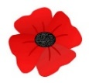  Year 5  World War one  Ancient  Greek Democracy | Year 6  World War two  Stone Age Evolution
9. General vocabulary through the age phases. | Vocabulary associated with describing the passing of recent time.  Before, now, next, then, later, soon, young, old | General historic: a long time ago,  Recently, When my parents/carers were young….  Years, decades, centuries to describe the passing of time.  Concepts: nation and its history, Civilisation, Monarch  Parliament, Democracy, War and peace. |  | Use appropriate historical vocabulary to communicate including:  Dates, Time period, Era, Change, chronology |  | Use appropriate historical vocabulary to communicate including:  Dates, Time period, Era, Change, Chronology, Continuity, Century, Decade, Legacy
10. Using historical terminology | Last week, next week, last year  Yesterday, tomorrow | Legacy, decade | Centuries, legacy | Archaeologists,  Medieval, Legacy | Historical sources, Archaeologists  c.- around, ancient, approximately  legacy | Century, Historical sources, suitable  Testable, reliable, culture  Analyse, justify, propaganda  Bias, Characteristic features | Decade, Legacies, Archaeologists  Suitable, hypothesis, testable  Reliable, culture, racial, diverse  Ethnic, Characteristic features  Analyse, justify, propaganda, bias
11. Using key contextual terminology. |  | Florence: Insanitary, significant  Improved, Conditions, Influential, Crimea /Crimean War  Marie: Radioactivity  Achievements, Diagnose  Emily D and Emmeline P: suffragettes, Law, Hunger strike, Democracy, Vote  Rosa P: activist, Segregation boycott  Martin: inequality, Inspiring  Discrimination, Race, Assassinated  Mandela: President, Racial equality, Apartheid  Greta Thunberg Activist, Climate change , Global warming  Malala - Nobel peace prize  Campaigner, Education  Human rights | Mary Anning: Fossil  Palaeontologist, Prehistoric  Christopher C: Explorer  Civilisations, Diseases  Colonised, voyage  Neil A + Moon landing : commander, Achievements  Breakthrough, Plaque  Exploration, Lunar  Rivals, Orbit  Helen Sharmann  Astronaut, Space station  Tim Peake – British, Astronaut, Rocket, Mission, Launch, Satellite, International Space Station  Tim B.L.- world wide web  Internet, Communication  Influential, Significant  Wright brothers: sustained  Discoveries, Ancient, Achievement, Influential  Aircraft  Amelia Earhart Aviator  Important legacy,  Titanic – Iceberg, propeller, New York, collision, survivors, lifeboat, unsinkable | Romans: Turmoil  Frontiers, Territory  Constitution, Dictator  Assassinated, Economy  Importing, Exporting  Prosperous, Acknowledged  Emperor, Sanitation  Resistance, Preservation  Erosion, Mosaics  Construction, Architects  Anglo Saxons: descendants, Conquered  Stabilit, Collapse, Chaos  Upheaval, Consequences  Independent, Allegiance  Christianisation, Pagan  Literature  Vikings:  Scandinavia, Explorers  Colonisation, Colonised  Evidence , Raid, Accounts  Seaborne, Navigation  Symmetrical, Reputation  Volatile, Descendants | Ancient Egypt  Influential, Fertile, Irrigation  Immortality, Rituals, Decipher  Canopic jars, Sarcophagus Mummy, Temples, Engineering  Architects, Commemorate, Achievements, Afterlife, Preserve  Essential, Embalmed, Eternity  Pharaoh | World War one  Conditions, Propaganda  Assassination, Invade, Invasion  Treaties, Armistice, Alliance  Allie, Artillery, Enemy, Conscription  Front line, No Man’s land, Trenches  Troops, Army, Navy, Cavalry  Uboat, Blockade, Neutral, Home front  Triple alliance, Triple entente, casualty, Weaponry  Ancient Greeks  Democracy, Citizens, Philosophy  Civilisations, Democratic, Characteristic features, Generation  Literature, Architects, Engineering | World War Two  Communism, Significant, Influential, Allies, Axis power, Evacuated  Evacuation, Black out, Air raid shelter, Home Guard, Propaganda, Amphibious, Blitz, Atomic, Nazi, Fascism, Holocaust  Declaration, Dispute, rationing, Persecution Racism Prejudice Nuremberg Laws Kristallnacht Concentration Camps Dictatorship Democracy Lebensraum Ration book Gas mask Air raid warden Women’s Land Army Victory Garden VE Day  Stone Age – Evolution  Stone Age :  Palaeolithic, Mesolithic, Neolithic, ancestors, Consequence, Climate  Nomadic, Communal, Identities, Density, Scavenging, Technology  Migrate, Permanent, Predators, Sophisticated, Preoccupied  Hunter gatherers, Farmers, Flint, Homo-habilis, Homo-erectus  Homosapiens  Bronze Age- societies, Trade, Custom, Hoard, States, Irrigation  Extracting, Communication, Preserved, Intricate communal  Bronze, alloy  Iron Age Conquest, Significant, Influential, Consequence, Fortified  Ore, Civilisations, Specialist, Efficient, Dominant, Fortifications  Inhabited, Surplus

Local History
 | EYFS  Homes | Year 1  What was our school like? | Year 2  Street Detectives- A look back at Hyde Road | Year 3  The role of women in the hatting industry. | Year 4  Crown Point north- Investigation into the past. | Year 5  Who was Albert Hill? (VC) | Year 6  Home front in Denton.
12. Investigation into Local History | Ask questions about artefacts, suggesting what they might be used for  Make accurate comparisons between modern and old objects  understand the passage of time and how things change over time | Understand some of the ways we find out about the past, and understand the importance of basing ideas on evidence.  Identify independently a range of similarities, differences and changes within a specific time period. | Identify similarities/differences between periods  Understand some of the ways we find out about the past, and understand the importance of basing ideas on evidence.  Analyse artefacts, ask questions about them and consider how they might find out the answers  Develop the skills of hypothesising, questioning and investigating to study history | Devise independently a range of historically valid questions for a series of different types of enquiry and answer them with substantiated responses.  Comment on the importance of causes and effects for some of the key events and developments within topics.  Recognise possible uses of a range of sources for answering historical enquiries. | Devise independently significant historical enquiries to produce substantiated and focused responses.  Sequence accurately the key events, objects, themes, societies, periods and people within and across topics confidently using key dates, period labels and terms  Explain why certain changes and developments were of particular significance within topics and across time periods.  Explain with confidence the significance of particular causes and effects for many of the key events and developments. | Reach a valid and substantiated conclusion to an independently planned and investigated enquiry with suggestions for development or improvement.  Comment with confidence on the  value of a range of different types of source for enquiries, including extended enquiries.  Explain reasons why particular aspects of a historical person were of particular significance.  Provide overviews of the most significant features of different themes, individuals, societies and events covered. | Plan and produce quality responses to a wide range of historical enquiries requiring the use of some complex sources and different forms of communication with detailed ideas on ways to develop or improve responses.  Regularly address and sometimes devise historically valid questions about change, cause, similarity and difference, and significance  Construct informed responses by selecting and organising relevant historical information  Comment independently on the different types of causes and effects for most of the events covered, including longer- and shorter-term aspects.

History Lesson Construct

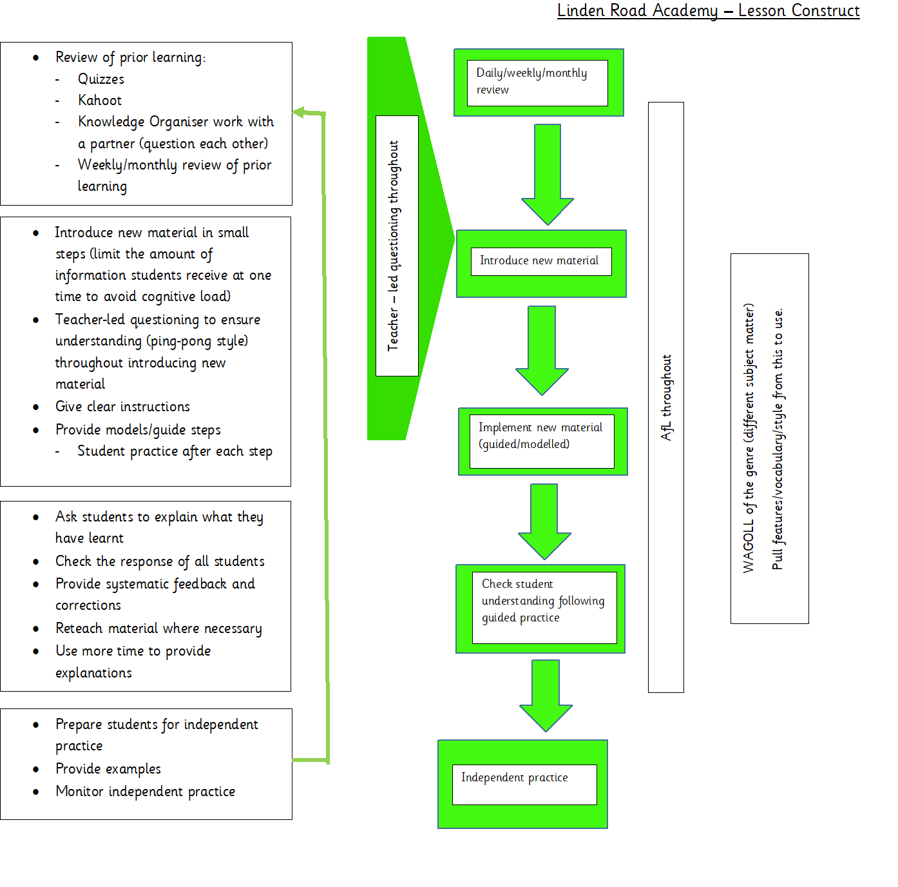
The immersive classroom, outdoor learning and trips should be used to enhance the cultural capital and engagement of our pupils.
This construct does not mean every lesson must look the same – components of lessons can be moved and altered in duration to suit the needs of the children.
Be as creative and innovative as you like!

