e

History Curriculum Intent
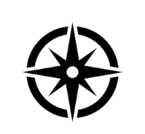
Our History Curriculum aims to enhance our pupils’ historical knowledge and conceptual understanding of developments and changes over time, relating this to the significance and impact of history on the modern world in which we live.
The historical journey begins in EYFS where it is mainly taught through the area of learning: Understanding the World and communication and language. This is where the children will begin to understand and speak confidently about the passing of time from past to present looking at their own personal lives and that of their families. The key skills mentioned below will be built through talk, real experiences, role play and handling artefacts. This will give the children the foundations of historical concepts and skills to build on through the following 2 key stages.
We focus on the development of three Key Skills: Chronological Understanding, Knowledge and Interpretation and Historical Enquiry. Within these, pupils are taught to construct and sequence the past, understand and articulate concepts such as cause and effect, plan and conduct historical enquiries and use appropriate historical terminology.
Our Topics provide a broad and culturally diverse experience for pupils and key themes within topics are revisited sequentially so that pupils can connect their learning, build upon prior knowledge and commit learning into long term memory. Our Key themes are: Location, Main Events, Conflict, Society, Travel and Exploration, Settlement, Culture and Pastimes, Beliefs and Food and Farming.
These themes are visited through the contexts of our History Topics:
EYFS  Taught throughout the year in a range of contexts | Year 1  Heroes | Year 2  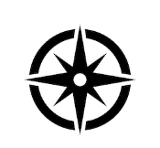  Explorers | Year 3  Invaders | Year 4  Egyptians | Year 5  The Great War | Year 6  World War Two
 |  |  |  |  | Ancient Greek Democracy | Stone Age Evolution

At the end of a topic, pupils answer an assessment question, which gives pupils an opportunity to present their understanding of what they have learnt. Teachers assess the depth of understanding through these answers and use this to inform assessment.
Key knowledge is recapped at the start of every lesson in a Flashback 4 – to ensure that children retain new learning. During Flashback 4 we also revisit History taught in previous years, to sustain knowledge throughout school.
Alongside our historically themed topics, we also run a ‘local history week’ – each class focuses on a different theme of local history within our local area. They become detectives, investigating the past, making comparisons from then to now…. How has Denton changed?
Linden Road Academy History – Big Ideas

Key themes | 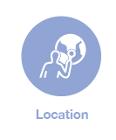 |  |  |  |  |  | 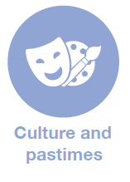 |  | 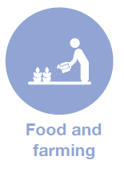

Key Skills | Chronological Understanding | Knowledge and Interpretation  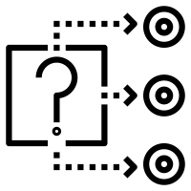 | Historical Enquiry

Our Topics | EYFS | Year 1 | Year 2 | Year 3 | Year 4 | Year 5 | Year 6 | Whole School
 | Taught throughout the year in a range of contexts | Heroes | 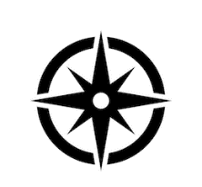  Explorers | Invaders | Ancient Egypt | The Great War  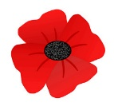  Ancient Greek Democracy | World War Two  Stone Age Evolution | Local History Project

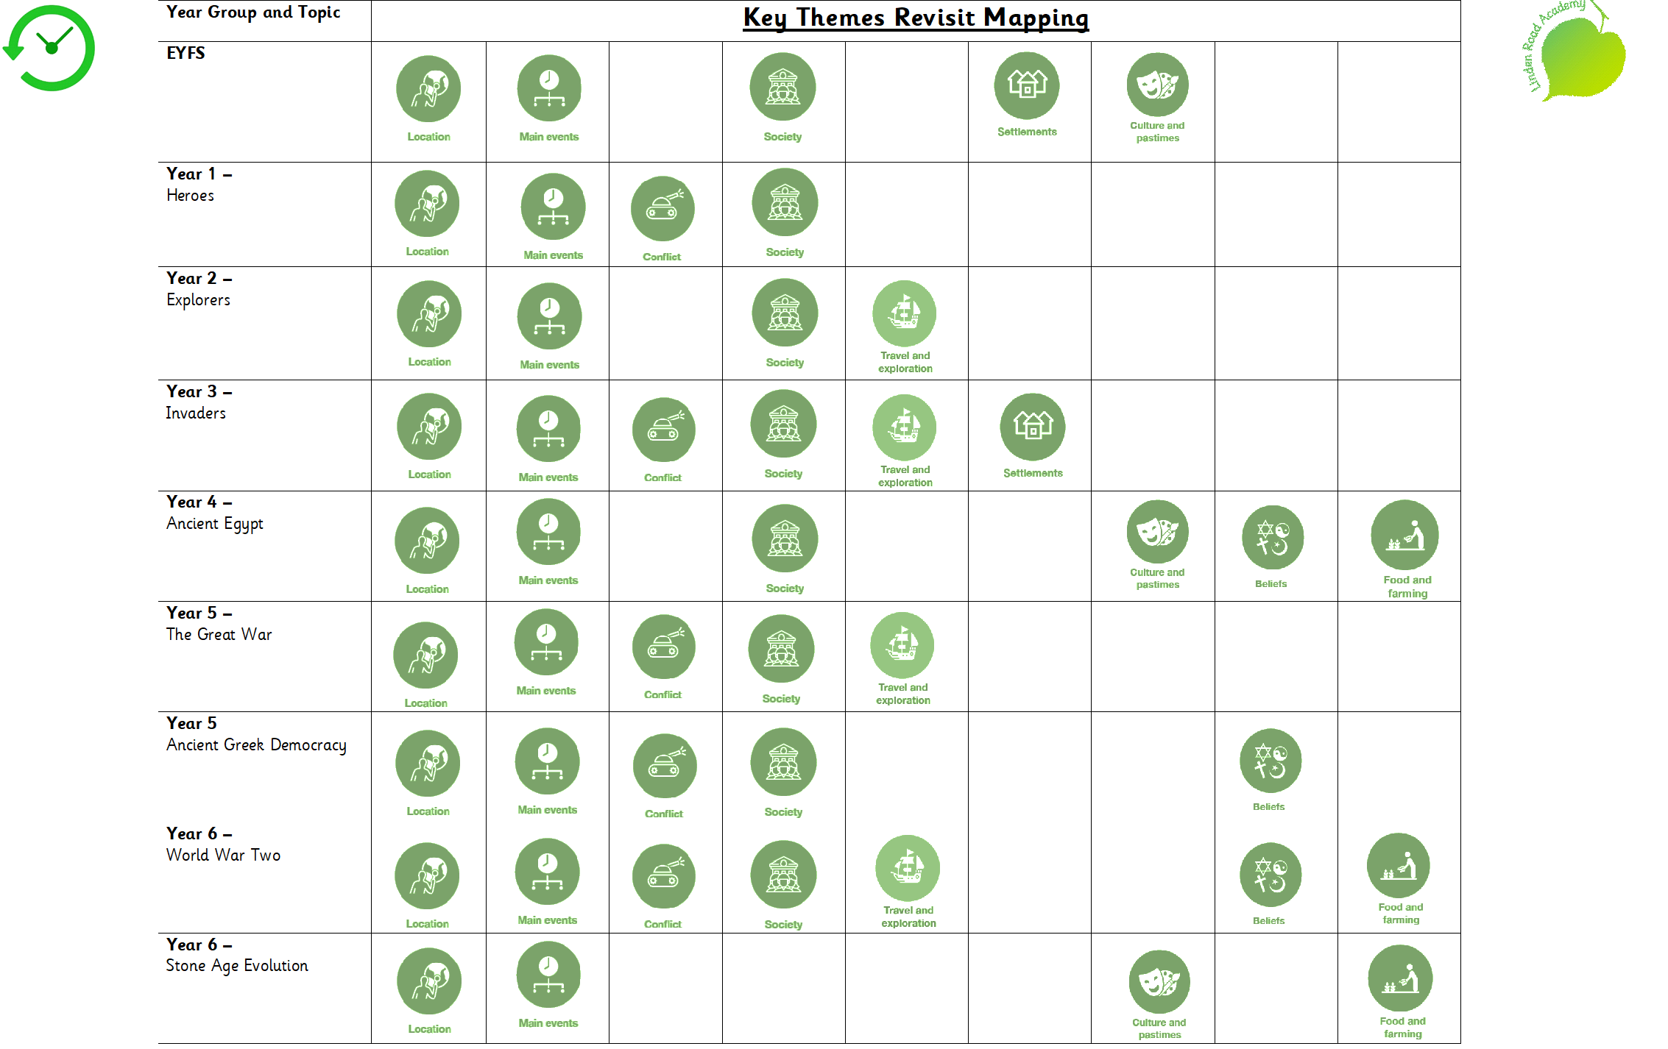

Assessment Question Overview
FS1 | I wonder if you’ve heard this one?  I wonder if dinosaurs lived in zoos?  I wonder why it is cold?  I wonder what is beyond the sky?  I wonder how I will get there?  I wonder where I came from?
FS2 | I wonder if you’ve heard this one?  I wonder if dark is important?  I wonder what makes a hero?  I wonder what’s under my feet?  I wonder if it’s real?  I wonder where we will go?
Y1 | Who changed the world the most and why?
Y2 | Who made the greatest discovery and why?
Y3 | Which invaders had a positive impact on Britain?
Y4 | Which of the achievements of the Ancient Egyptians had the most impact?
Y5 | What was the key factor that led to the triple Entente winning WW1?
Y5 | How has democracy developed since Ancient Greece and should we go further?
Y6 | To what extent was everyone affected by the events of WW2?
Y6 | To what extent was the Stone Age period the greatest evolution of man-kind?

Linden Road Academy History Progression
Topic | EYFS  FS1 I wonder:  -if you’ve heard this one?  -if dinosaurs lived in zoos?  -why it is cold?  -what is beyond the sky?  -how I will get there?  -where I came from?  FS2 I wonder:  -if you’ve heard this one?  -if dark is important?  -what makes a hero?  -if it is real?  -what’s under my feet?  -where we will go? | Year 1  Heroes  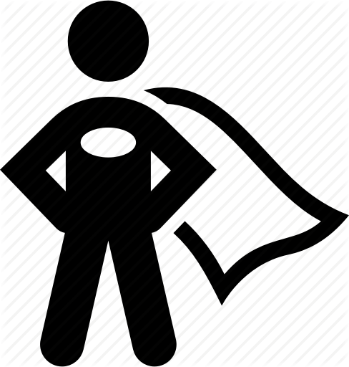 | Year 2  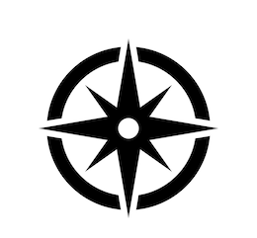  Explorers | Year 3  Invaders | Year 4  Egyptians | Year 5  The Great War  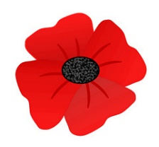  Ancient Greek Democracy  .m k | Year 6  World War Two  Stone Age Evolution
Assessment Question |  | Who has inspired you the most and why? | Who made the greatest discovery and why? | Which invaders had a positive impact on Britain? | Which of the achievements of the Ancient Egyptians had the most impact? | What was the key factor that led to The Triple Entente winning World War One?  How has democracy developed since Ancient Greece? | To what extent was everyone affected by the events of World War Two?  To what extent was the Stone Age period the greatest evolution of man-kind?
National Curriculum | Understanding the World  Past and Present ELG  Children at the expected level of development will:  - Talk about the lives of the people around them and their roles in society;  - Know some similarities and differences between things in the past and now,  drawing on their experiences and what has been read in class;  - Understand the past through settings, characters and events encountered in  books read in class and storytelling  Listening, Attention and Understanding ELG  Children at the expected level of development will:  - Listen attentively and respond to what they hear with relevant questions,  comments and actions when being read to and during whole class discussions  and small group interactions;  - Make comments about what they have heard and ask questions to clarify their  understanding;  Speaking ELG  Children at the expected level of development will:  - Participate in small group, class and one-to-one discussions, offering their own  ideas, using recently introduced vocabulary;  - Offer explanations for why things might happen, making use of recently  introduced vocabulary from stories, non-fiction, rhymes and poems when  appropriate;  - Express their ideas and feelings about their experiences using full sentences,  including use of past, present and future tenses and making use of  conjunctions, with modelling and support from their teacher. | Events beyond living memory that are significant nationally or globally for example:  The lives of significant individuals in the past who have contributed to national and international achievements. Some should be used to compare aspects of life in different periods. | Events beyond living memory that are significant nationally or globally for example:  The lives of significant individuals in the past who have contributed to national and international achievements. Some should be used to compare aspects of life in different periods. | The Roman Empire and its impact on Britain  Britain’s settlement by Anglo-Saxons and Scots  The Viking and Anglo-Saxon struggle for the Kingdom of England to the time of Edward the Confessor  (Within South America)  A non-European society that provides contrasts with British history – Mayan civilization | The achievements of the earliest civilizations – an overview of where and when the first civilizations appeared and a depth study of Ancient Egypt. | A study of an aspect or theme in British history that extends pupils’ chronological knowledge beyond 1066  Within PSHE Democracy  Ancient Greece – a study of Greek life and achievements and their influence on the western world | A study of an aspect or theme in British history that extends pupils’ chronological knowledge beyond 1066  Within ‘Where did it all begin?’  Changes in Britain from the Stone Age to the Iron Age (will be moved to Y6 Next Year)
Chronological Understanding

1. Constructing the past | Begin to make sense of their own life-story and family’s history.  Know some similarities and differences between things in the past and now, drawing on their experiences and what has been read in class; | Briefly describe features of particular themes, events and people from family, local, national and global history. | Explain a range of features covering family, local, national and global history and draw a range of conclusions. | Identify details from local, national  and global history to demonstrate some overall awareness of themes, societies, events and people. | Describe the main context of particular themes, societies, people and events including some explanation. | Provide overviews of the most significant features of different themes, individuals, societies and events covered. | Show a detailed awareness of the themes, events, societies and people covered across the Upper Key Stage 2 topics, e.g. explain different dimensions and characteristics.
2. Sequencing the past | Begin to make sense of their own life-story and family’s history.  Enjoy listening to longer stories and can remember much of what happens.  Know many rhymes, be able to talk about familiar books, and be able to tell a long story.  Understand the past through settings, characters and events encountered in books read in class and storytelling;  Express their ideas and feelings about their experiences using full sentences, including use of past, present and future tenses and making use of conjunctions, with modelling and support from their teacher. | Sequence independently on an annotated timeline a number of objects or events related to particular themes, events, periods, societies and people.  Understand securely and use a wider range of time terms. | Give a valid explanation for their sequence of objects and events on timelines or narratives they have devised.  Use more complex time terms, such as 'BCE'/'AD' and period labels and terms. | Sequence a number of the most significant events, objects, themes, societies, periods and people in Lower Key Stage 2 topics using some dates, period labels and terms. | Sequence accurately the key events, objects, themes, societies, periods and people within and across topics confidently using key dates, period labels and terms. | Sequence with independence the key events, objects, themes, societies and people in Upper Key Stage 2 topics covered using dates, period labels and terms. | Explain independently the sequence of key events, objects, themes, societies and people in topics covered using dates, period labels and terms accurately.
Knowledge and Interpretation

3. Change and development | Begin to make sense of their own life-story and family’s history.  Know some similarities and differences between things in the past and now, drawing on their experiences and what has been read in class; | Identify independently a range of similarities, differences and changes within a specific time period. | Describe independently and accurately similarities, differences and changes both within and across time periods and topics. | Make valid statements about the main similarities, differences and changes occurring within topics. | Explain why certain changes and developments were of particular significance within topics and across time periods. | Compare similarities, differences and changes within and across some topics, e.g. in terms of importance, progress or the type and nature of the change. | Compare independently how typical similarities, differences and changes were.
4. Cause and effect | Understand ‘why’ questions, like: “Why do you think the caterpillar got so fat?”  Understand the past through settings, characters and events encountered in books read in class and storytelling;  Offer explanations for why things might happen, making use of recently introduced vocabulary from stories, non-fiction, rhymes and poems when appropriate; | Identify a few relevant causes and effects for some of the main events covered. | Comment on a few valid causes and effects relating to many of the events covered. | Comment on the importance of causes and effects for some of the key events and developments within topics. | Explain with confidence the significance of particular causes and effects for many of the key events and developments. | Explain the role and significance of different causes and effects of a range of events and developments. | Comment independently on the different types of causes and effects for most of the events covered, including longer- and shorter-term aspects.
5. Significance and interpretations | Understand ‘why’ questions, like: “Why do you think the caterpillar got so fat?”  Show interest in different occupations.  Talk about what they see, using a wide vocabulary.  Talk about the lives of the people around them and their roles in society;  Make comments about what they have heard and ask questions to clarify their understanding; | Identify a range of significant aspects of a theme, society, period or person and offer some comments on why they have selected these aspects. | Provide some valid reasons for selecting an event, development or person as significant. | Explain why some aspects of historical accounts, themes or periods are significant. | Explain independently why a historical topic, event or person was distinctive or significant. | Explain reasons why particular aspects of a historical event, development, society or person were of particular significance. | Compare the significance of events, development and people across topics and time periods.
 | Begin to make sense of their own life-story and family’s history.  Know some similarities and differences between things in the past and now, drawing on their experiences and what has been read in class; |  |  |  | Explain historical situations, events, developments and individuals from more than one viewpoint. | Explain how and why it is possible to have different interpretations of the same event or person. | Understand and explain the nature and reasons for different interpretations in a range of topics.
 | Understand ‘why’ questions, like: “Why do you think the caterpillar got so fat?”  Understand the past through settings, characters and events encountered in books read in class and storytelling;  Offer explanations for why things might happen, making use of recently introduced vocabulary from stories, non-fiction, rhymes and poems when appropriate; |  |  | Comment on a range of possible reasons for differences in a number of accounts.
Historical Enquiry

6. Planning and carrying out a historical enquiry | Understand ‘why’ questions, like: “Why do you think the caterpillar got so fat?”  Make comments about what they have heard and ask questions to clarify their understanding; | Plan questions and produce answers to a few historical enquiries using historical terminology. | Pose independently a series of valid questions for different enquiries and produce effective responses using appropriate vocabulary confidently. | Devise independently a range of historically valid questions for a series of different types of enquiry and answer them with substantiated responses. | Devise independently significant historical enquiries to produce substantiated and focused responses.. | Reach a valid and substantiated conclusion to an independently planned and investigated enquiry with suggestions for development or improvement. | Plan and produce quality responses to a wide range of historical enquiries requiring the use of some complex sources and different forms of communication with detailed ideas on ways to develop or improve responses.
7. Using sources as evidence | Enjoy listening to longer stories and can remember much of what happens.  Explore how things work.  Talk about what they see, using a wide vocabulary.  Understand the past through settings, characters and events encountered in books read in class and storytelling; | Select information independently from several different types of source including written, visual and oral sources and artefacts to answer historical questions. | Critically evaluate the usefulness of sources and parts of sources to answer historical questions. | Recognise possible uses of a range of sources for answering historical enquiries. | Comment on the usefulness and reliability of a range of sources for particular enquiries. | Comment with confidence on the  value of a range of different types of source for enquiries, including extended enquiries. | Evaluate independently a range of sources for historical enquiries considering factors such as purpose, audience, accuracy, reliability and how the source was compiled.

Local History Project
 | EYFS  How have our homes changed? | Year 1  What was our school like? | Year 2  How has Hyde Road changed? | Year 3  What work did women do in Denton in the 19th century?  (Hatting) | Year 4  Was Crown Point always a shopping centre? | Year 5  Who was Albert Hill? (VC) | Year 6  How did Denton contribute to the achievments of the Home front during the world wars?
12. Investigation into Local History | Know some similarities and differences between things in the past and now, drawing on their experiences and what has been read in class;  Make comments about what they have heard and ask questions to clarify their understanding;  Express their ideas and feelings about their experiences using full sentences, including use of past, present and future tenses and making use of conjunctions, with modelling and support from their teacher. | Understand some of the ways we find out about the past, and understand the importance of basing ideas on evidence.  Identify independently a range of similarities, differences and changes within a specific time period. | Identify similarities/differences between periods  Understand some of the ways we find out about the past, and understand the importance of basing ideas on evidence.  Analyse artefacts, ask questions about them and consider how they might find out the answers  Develop the skills of hypothesising, questioning and investigating to study history | Devise independently a range of historically valid questions for a series of different types of enquiry and answer them with substantiated responses.  Comment on the importance of causes and effects for some of the key events and developments within topics.  Recognise possible uses of a range of sources for answering historical enquiries. | Devise independently significant historical enquiries to produce substantiated and focused responses.  Sequence accurately the key events, objects, themes, societies, periods and people within and across topics confidently using key dates, period labels and terms  Explain why certain changes and developments were of particular significance within topics and across time periods.  Explain with confidence the significance of particular causes and effects for many of the key events and developments. | Reach a valid and substantiated conclusion to an independently planned and investigated enquiry with suggestions for development or improvement.  Comment with confidence on the  value of a range of different types of source for enquiries, including extended enquiries.  Explain reasons why particular aspects of a historical person were of particular significance.  Provide overviews of the most significant features of different themes, individuals, societies and events covered. | Plan and produce quality responses to a wide range of historical enquiries requiring the use of some complex sources and different forms of communication with detailed ideas on ways to develop or improve responses.  Regularly address and sometimes devise historically valid questions about change, cause, similarity and difference, and significance  Construct informed responses by selecting and organising relevant historical information  Comment independently on the different types of causes and effects for most of the events covered, including longer- and shorter-term aspects.

