

30th June 2025

Dear Parents/Carers,
September – Uniform Changes

From September we will be changing our PE uniform and school uniform.

PE Kit  Black collar polo shirt – plain (no brands)  Black PE Shorts  Black Leggings  Black Joggers  No fitted shorts (i.e. cycling shorts)  Linden Road jumper/cardigan  (No Hoodies or tracksuits) | School Uniform  White shirt  Black trousers  Black skirt  Tie  Linden Road jumper/cardigan  No black hoodies/tracksuit tops  Plain black shoes  No trainers

You can purchase the black polo shorts from ASDA.

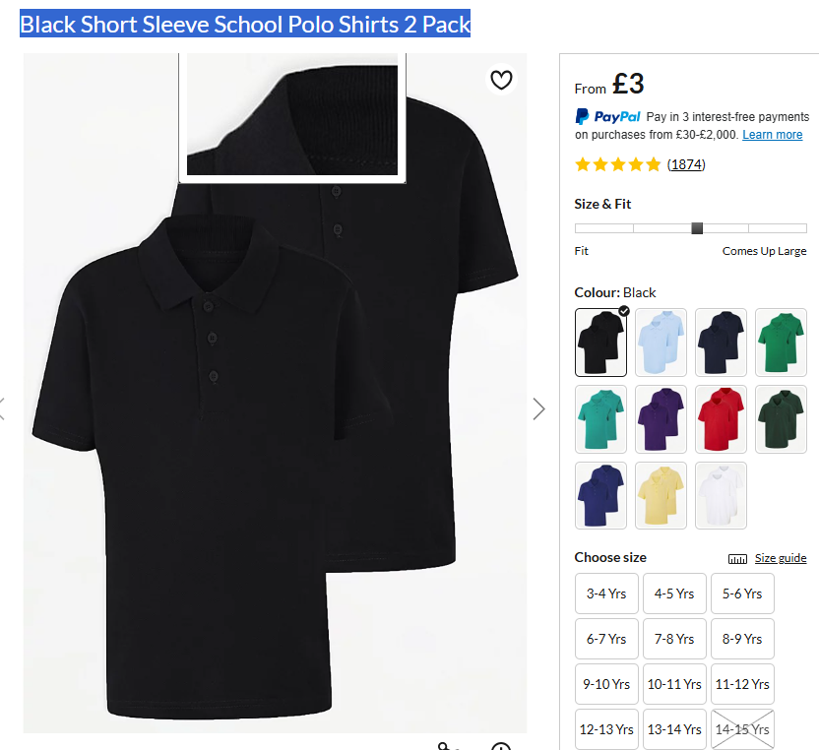

The class teacher will do a uniform check every morning and if you child does not have the correct uniform they will be asked to change into our spares and a text will be sent home.

Yours sincerely,

Mr Greaves,
Principal.

