21st January 2021

Dear Parent/Carer
I’m aware that you are being bombarded with information and I want to make things simpler for you, so I will be sending out a weekly letter with hyperlinks to information for particular year groups or audiences. Hopefully that will ease the pressure that you must already be feeling around supervising your children’s learning at school.
Friday headship
You will probably know by now that Helen Marriott, my co-headteacher, has started as headteacher in her own right at Walthamstow School for Girls. I am, of course, enormously proud of her, but I know I speak for our community when I say how much she will be missed. The governors agreed unanimously that we should approach Rav Bansal, our Deputy Headteacher, to see if he would be interested in the role of headteacher on a Friday. He has been interviewed and has accepted the post. This is really good news for all of us.
ICT Support
I know that some parents are having problems with their ICT hardware at home. We have a company who support our school ICT called Dataspire. However, their contract relates to the computers in our school and those that we lend out to students in need. I am trying to source some more support for parents who don’t have school computers. I will let you know about any progress that I make.

Flu vaccine
Given the closure of schools to most students, Vaccination UK is no longer offering the flu vaccine on school premises. Instead, families are being encouraged to book an appointment at one of Vaccination UK’s community clinics.

To book an appointment, families should call 0208 214 1393 or 0208 214 1394. You can also email newham@vaccinationuk.co.uk. Families will need to provide the child’s full name, date of birth, class, school and vaccine preference (spray or injection). Halal options are now available.
It is not too late for children to get the flu vaccine, so do consider booking an appointment now.
School Closure
Please be aware that school will close for all students at 12.30pm on Tuesday 26th January due to the Year 8 Options Evening

Free School Meals
For parents in receipt of FSM please note vouchers will go directly to your emails and will come from Edenred. You will no longer get a text message to alert you of the vouchers. Vouchers will be released every Tuesday.

Set out below are the timings of our school day
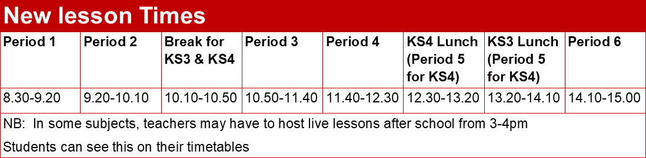

Click here for information about booking computers in local libraries.

Click here for FAQs on remote learning

Click here for notices about children who are coming into school as part of the vulnerable and critical worker cohort

Click here for notices for the parents of Year 11

Click here if you are worried about the mental health of your child.

Yours faithfully

Ian Wilson
Headteacher

