
Introduction

1.1 Little Lever School strives to ‘help every person achieve things they never thought they could’, and recognises that for students to achieve their potential, they must have excellent attendance and punctuality. Little Lever School aspires for all students to have 100% attendance.
Absence can lead to safeguarding concerns. For example, regular attendance is an important protective factor and the best opportunity for needs to be identified and support provided. Research has shown associations between regular absence from school and a number of extrafamilial harms. Regular absence, particularly unexplained absence, can be a red flag for safeguarding issues. Children missing education can act as a vital warning sign to a range of safeguarding issues including neglect, sexual abuse and child sexual and criminal exploitation. It is therefore vital that all students are in school regularly.
Regarding students with anxieties about attending school or mental health concerns, guidance states that ‘schools should set and maintain high expectations for the attendance, engagement and punctuality of pupils who are anxious about attending school. It is important to recognise that, in many instances, attendance at school may serve to help with the underlying issue as much as being away from school might exacerbate it, and a prolonged period of absence may heighten their anxiety about attending in future. (Summary of responsibilities where a mental health issue is affecting attendance, DfE, February 2023)’
Little Lever School aims to support student and parents/carers by:
- Promoting good attendance and reducing absence, including persistent absence.
- Ensuring every student has access to the full-time education to which they are entitled by law.
- Acting early to address patterns of absence.
- Creating a safe and supportive environment where all students can thrive.
Little Lever School will also support parents/carers to perform their duty to ensure their children attend regularly and will promote and support their outstanding punctuality to the school and to lessons.
Improving attendance is everyone’s business. The barriers to accessing education are wide and complex, both within and beyond the school gates, and are often specific to individual students and families. The foundation of securing good attendance is that the school is a calm, orderly, safe and supportive environment, where all students want to be and are keen and ready to learn.
Little Lever School has a senior leader who is responsible for the strategic approach to attendance.
This person is Mr S Cordwell (Assistant Principal) sco@little-lever.bolton.sch.uk
Parents and carers can also contact the following people for more detailed support around attendance:
Attendance Lead and Education Welfare Officer: Ms A Ibrahim aib@little-lever.bolton.sch.uk
Attendance Co-ordinator, Ms L Yoganali and Attendance Administrator, Ms H Vining attendance@little-lever.bolton.sch.uk
You will also be able to discuss attendance with your child’s PREP tutor in the first instance.

Our school website contains further and more detailed information for parents/carers including, but not limited to, other staff to contact in the school about attendance, as well as our extensive strategies and resources regarding the promotion of excellent attendance.

1.2 Trust Vision and Values
Our purpose:
‘To help every person achieve things they never thought they could’ We put students first. They are at the heart of our decision making.
Our Values:
- Be kind
- Work Hard
- Take Responsibility
Our purpose and values help us to continually improve the life chances of children.

2. Scope of the Policy

2.1 This policy meets the requirements of the school attendance guidance from the Department for Education (DfE), and refers to the DfE’s statutory guidance on school attendance parental responsibility measures. These documents are drawn from the following legislation setting out the legal powers and duties that govern school attendance:
- The Education Act 1996
- The Education Act 2002
- The Education and Inspections Act 2006
- The Education (Student Registration) (England) Regulations 2006
- The Equality Act 2010
- The Education (Student Registration) (England) (Amendment) Regulations 2010 • The Education (Student Registration) (England) (Amendment) Regulations 2011
- The Education (Student Registration) (England) (Amendment) Regulations 2013
- The Education (Penalty Notices) (England) (Amendment) Regulations 2013
- The Education (Student Registration) (England) (Amendment) Regulations 2016
- Children missing education: Statutory guidance for local authorities 2016
- Working together to improve school attendance 2024
- Summary table of responsibilities for school attendance 2024
- Mental health issues affecting a pupil's attendance: guidance for schools 2023

This policy also refers to the DfE’s guidance on the school census, which explains the persistent absence threshold. This policy complies with our funding agreement and articles of association.

  - By law, all schools and academies (except those where all students are boarders) are required to keep an attendance register, and all students must be placed on this register.
The law requires the register to be taken twice a day- at the start of the morning session and the once in the afternoon session. Little Lever welcomes students between 8.00am and 8.30am. The exact school start time is 8.30am. Pupils are expected to be in school by this time. Registers will close at 9:00am and arrival after this period will class as a half day absence. (Appendix 1-attendance codes)

  - Lateness and punctuality
A student who arrives late, but before the register has closed, will be marked as late, using the appropriate code (L). This will apply to students arriving between 8:30am and 9:00am. A late correction will be issued at the end of the school day which lasts 10-minutes.
Students arriving after registers have closed at 9am, will be marked as unauthorised absence (U) unless medical evidence has been provided, and will be issued with a 20-minute correction during their lunchtime. Students with a U code will be counted as absent for their AM Mark resulting in 50% attendance of the school day. Parents will be informed each day a student arrives late through the school’s Attend software system.
Where a student’s punctuality is consistently putting their education at risk, parents will be invited for a meeting to discuss what support the school can offer and the guidance in line with the ‘Summary table of responsibilities for school attendance (DfE, 2024). Current guidance states that a fixed penalty notice (FPN) for school attendance can be issued when a child has at least 10 sessions (equivalent to 5 school days) of unauthorized absence within a rolling 10-week period. This includes a student arriving at school after the close of registers at 9:00am.

2.4 Planned medical or dental appointments.
Any absence interrupts the continuity of a student’s learning and should be avoided other than in exceptional circumstances. Applications for other types of absence in term time must be made in advance. Information relating to whether the school can authorise such absence can be found in section 2.7.
Missing registration for a medical or dental appointment is usually counted as an authorised absence (where the appointment could not be scheduled outside of school hours and where we have seen clear evidence); advance notice is required for authorising these absences. Where a student is in school at the time of registration but later leaves, this will not be classed as an absence, as long as they return by 12.30pm.
Parents are encouraged to make medical and dental appointments out of school hours where possible. Where this is not possible, the student should be out of the school for the minimum amount of time necessary.
If a student arrives at school after 9:00am they will be marked as absent for the AM registration period and lose 50% attendance for that school day. If they leave the school before 12:30pm, they will be marked as absent for the PM registration period and lose 50% attendance for that school day. Where evidence is provided, this will be marked as an authorised absence (M), however will still impact a student’s attendance.

2.5 Following up absence
We request that all absences due to illness are reported before 8.30am on each day of absence. This should be done through the school’s main line (01204 333 300) and selecting the option to report your child absent.
The school will follow up all absences and will ensure proper safeguarding action is taken where necessary. The school will always contact parents/carers as soon as possible to alert them that their child has not arrived at school if the absence is unexplained. This is usually a text message followed by a phone call to ensure the student is safe and to clarify arrangements that can be made to ensure the student returns to school as quickly as possible. A member of staff may visit the student’s home to discuss attendance.
To reduce pressure on families and the NHS we do not ordinarily require medical evidence to authorise absence. If a student has attendance below 90% or is absent within the first half term and had an attendance below 90% in the previous academic year, we will require medical evidence to authorise absence.

2.6 Reporting to parents
Parents/carers will receive attendance updates. Attendance is reviewed weekly by the attendance team and where there are concerns, parents/carers will be contacted to discuss what support the school can offer. In addition, students will discuss their current attendance weekly during one of their form sessions.

2.7 Authorised and unauthorised absence
The Principal may not grant any leave of absence to students during term time unless they consider there to be ‘exceptional circumstances’. If you wish to apply for term time leave for exceptional reasons, then a ‘Request for Absence Form’ must be completed, and this must be done well in advance (Appendix 2: Request for Absence Form).
Please note that we cannot authorise holiday requests under any circumstances. We are required under guidance to issue a fixed penalty notice if a child does not attend school due to an unauthorised holiday.
Please refer to the Department for Education working together guidance, reference and linked above, for the latest guidance.

2.8 Legal Sanctions
Parents/carers may be issued with a fixed penalty notice (FPN) for the unauthorised absence of their child from school, where the child is of compulsory school age.
If issued with a penalty notice, parents must pay £80 within 21 days or £160 within 28 days. Failure to pay within 28 days could result in prosecution in court for failure to ensure regular attendance to the school and failure to respond in full to the fixed penalty notice.
A second penalty notice issued to the same parent in respect of the same pupil is charged at a flat rate of £160 if paid within 28 days.
In line with government guidelines, we will have to consider a fine if a pupil misses 10 sessions (half days) of unauthorised absence in a rolling period of 10 school weeks. This threshold can be met with any combination of unauthorised absence. For example, four sessions of absence plus six instances of arriving late. The period of 10 weeks can also span different terms or school years. This also applies to holidays, e.g. children who take 3 days in the beginning of term.
Please note that our policy recognises the government’s definition of both persistently and severely absent students and we reserve the right to instigate legal interventions to help improve attendance when at these thresholds. Students are considered persistently absent when attendance drops below 90% and they are considered severely absent if attendance drops below 50%.
In line with Bolton Local Authority’s Code of Conduct: Issuing Penalty Notices for unauthorised absence from school the issuing of a Penalty Notice is considered appropriate in the following circumstances:
  - Truancy from school, with or without parents’ knowledge (including pupils caught on truancy sweeps)
  - Parentally condoned absences
  - Leave of absence in term time without approval
  - Delayed return from a period of leave of absence which has been approved by the school
  - Unauthorised absence i.e. no reason given for absence
  - Persistent late arrival at school (after the register has closed)
  - Suspended pupil present in a public place during the school hours of the school where the pupil is on roll.
The following outlines the stages of interventions required in government guidance (Working together to improve school attendance, DfE, February 2024) which we follow:
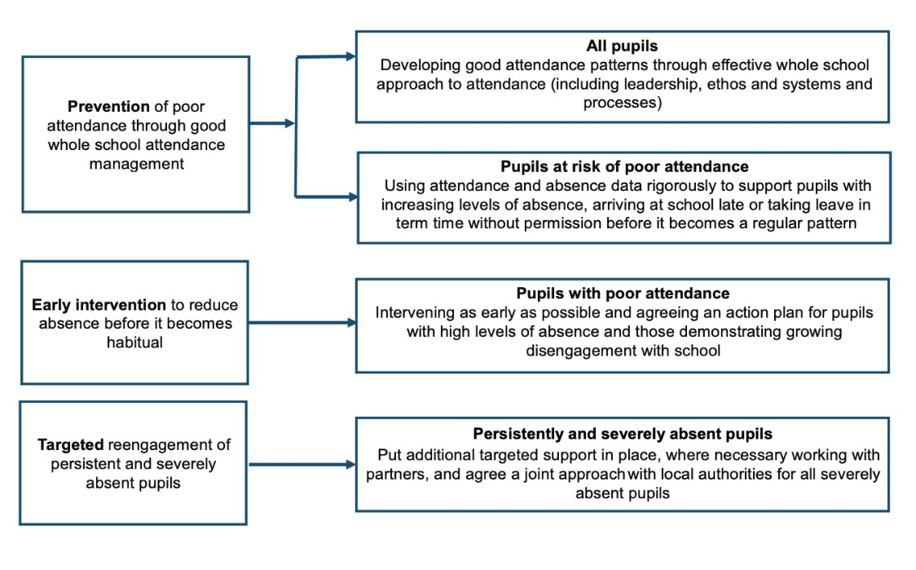
Prior to legal action there will always be support offered first by Little Lever School and all attempts will be made to ensure there is improved attendance before the point of prosecution. This follows government guidance on legal intervention:
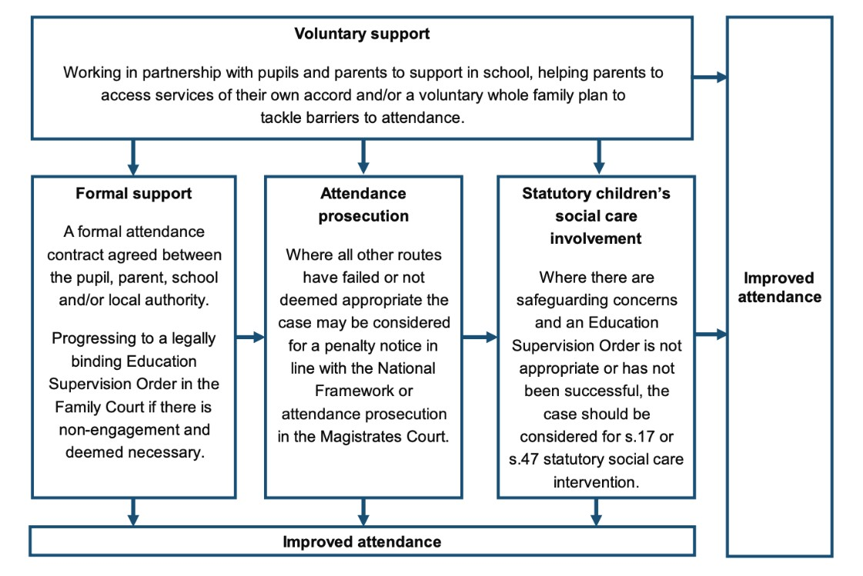
(Working together to improve school attendance, DfE, February 2024)

2.9 Children Missing Education (CME)
All schools, including academies and free schools, must monitor students’ attendance through their daily register. Should a student leave Little Lever School, and the school is not informed by the parents of which new school the student is going to attend, the school will take action to trace the students within 10 school days (not 20 days). This is classed as a missing student.
Little Lever School works closely with local authorities and will escalate the concern to them via the relevant reporting procedures. The school will make reasonable enquiries to establish the whereabouts of a student jointly with the local authority before deleting the student’s name from the register. The school will notify the local authority of when we are about to remove a student’s name from the admission register under any of the fifteen grounds listed in the Education (Pupil Registration) (England) Regulations 2006. For students absent from the school for 20 continuous days and where all attempts from the local authority and the academy have still not established their whereabouts, the student will be removed from the school roll.
If families move away from the area or wish to transfer their child to another school or academy, the Principal must be informed in writing. Students cannot be removed from roll until we have been notified by another school or academy that a place has been offered and accepted.

2.10 Strategies for promoting attendance
In line with guidance Little Lever School sets high expectations for the attendance and punctuality of all pupils and communicate these regularly to pupils and parents through all available channels. In doing so, schools should help parents to understand what is expected of them and why attendance is important to their child’s attainment, wellbeing, and wider development.
At Little Lever School we will visibly demonstrate the benefits of good attendance throughout school life. This may include in displays, assemblies or in registration periods. Where used sensitively and without discrimination, this will also include praising and rewarding strong attendance and importantly, improvements in attendance.
There are a range of strategies to promote good attendance. These include, the 100 Club, the StepUp Challenge, and the Magic 15. Celebrating good and improved attendance forms part of our praise culture and the school will regularly reward students. Where appropriate, we work with the local authority to support students facing barriers to their attendance which may include further support and individualised rewarded targets.
The Step-Up Challenge: The Step-Up Challenge uses Monday Prep Time as an opportunity for tutors to discuss attendance with their form. Within this time the Step-Up Challenge sheets are completed, and students mark off the number of lessons (steps) they have attended the week before making their way to their aspirational target. Where lessons have been missed, students will track their actions to catch-up in this session
The 100 Club: The 100 Club rewards students and incentivises maintaining a 100% attendance within a term even if there were absences before. Weekly rewards are advertised to students in advance with their value increasing throughout the term. The longer a student has a continuance ‘streak’ of attendance, the better their reward.
The Magic 15: Magic 15 rewards students each week for attending every session, every day with 5 achievement points. This list is published for students to see.
The high presence of staff in Little Lever School creates a safe and vibrant environment and allows all students to attend. At Little Lever School there is also a weekly inclusion meeting to discuss the most vulnerable students and to review interventions to overcome barriers to learning, including poor attendance. Further to this there are fortnightly attendance meetings where the Attendance Team and Learning Leaders, the school’s Attendance Champion and Principal will discuss students at risk of falling into the category of a persistent absentee.
Little Lever School reviews the curriculum to ensure it meets the needs of students of all abilities. Our curriculum implementation, levelled support strategies, SEND passports, targeted interventions for students falling behind and use of TAs ensure that students are supported academically. These interventions ensure students can access their learning and therefore be more motivated to attend.

3. Roles and Responsibilities
3.1 Little Lever School believes that attendance is everyone’s responsibility and has adopted a consistent approach to monitoring attendance to intervene and offer support to students and families at the earliest opportunity.

We recognise that attendance is never ‘solved’ and is a continuous process by regularly reviewing attendance and updating messages, strategies and policies.
Parents/carers are responsible for:
- Ensuring their child attends the school each day it is open, dressed in full uniform and with full equipment
- Creating a culture within the home where strong school attendance is seen as essential and expected
- Contacting the school if their child is unable to attend by 8.30am
- Providing their most up to date contact details
- Only requesting leave of absence in exceptional circumstances and well in advance
- Booking any medical appointments outside of the school day, where possible and ensuring where this is unavoidable the pupil returns to school at the earliest possible point
- Proactively engaging with the school with regards to any support that is offered to improve attendance.
Leaders at Little Lever School are responsible for:
- Establishing and promoting a culture whereby students want to attend the school, helping all stakeholders understand the benefits that good attendance brings.
- Ensuring that the school has a clear attendance policy which is published on the school website
- Having a dedicated senior leader with overall responsibility for championing and improving attendance
- Having a link Trustee with oversight of improving attendance
- Guaranteeing that attendance is everyone’s responsibility and keeping the concept of school attendance high profile within the school community
- Having robust daily processes to follow up absence
- Working with parents at an early intervention level so that they are fully aware of the school attendance policy
- Ensuring the attendance policy and procedures are applied and monitored constantly
- Supporting all students, particularly the most vulnerable, to attend the school regularly
- Helping to identify, overcome and remove barriers for good attendance and signpost support where it is needed
- Working with parents/carers in a more formal capacity, where there is lack of engagement and/or where support is not working. This may involve working with the local authority on legal intervention
- Ensuring that students under 90% attendance, classed as persistent absentees, access further support and guidance to rapidly improve attendance
- Intensifying support through statutory children’s social care if there are safeguarding concerns
- Ensuring that school leaders and staff receive training on attendance
- Making certain that school leaders fulfil expectations and statutory duties
- Reviewing the attendance policy annually in accordance with its own internal procedures
- Providing the trust board with timely information so that performance can be scrutinised at the highest level.

4. Little Lever Attendance Team

- Keeping an accurate record of the attendance and sharing daily attendance data with the Department for Education
- To provide support for the Attendance Officers, to hold meetings with parents who have been identified as a serious cause for concern
- To conduct home visits and prepare paperwork for penalty fines
- To develop attendance contracts in conjunction with the Learning Leader
- Implement fast tracking where there is evidence that absences are parentally condoned
- Work together with the school to maintain a comprehensive attendance policy that successfully challenges poor attendance and rewards improvement
- Attend court and give evidence in support of prosecutions where required
- Meet regularly with the school’s senior lead on attendance to continue development of good practice
- Give the Local Authority the name and address of any sick pupils who it is believed with miss 15 consecutive days
- Inform a pupil’s social worker and/or youth offending team worker if there are unexplained absences from school
- Provide all relevant administrative, logistical and support services to ensure both continuity and seamless delivery of its service.

5. Attendance Procedures

5.1 Little Lever School believes that all stakeholders should be clear with regards to what to expect should a student’s attendance fall below our attendance thresholds.
Working together to improve school attendance (DfE, August 2024) makes clear that all parties; including schools, parents, multi-academy trusts and local authorities should place a strong emphasis on school attendance.
All students are expected to attend every session, but where a student’s attendance falls below our thresholds of 96%, or if anomalous patterns of attendance are discovered, our attendance procedures will be instigated according to the Little Lever activation tier shown in the table below:
•
Praise and reward for improvement / maintaining 100%
•
Regular monitoring of attendance to identify possible students of concern early.
•
Early intervention provided by form tutors
•
Attendance dicussed within Prep Time each week by Prep Tutors with praise given to these students
96
%
-
100
%
•
Praise and reward for improvement
•
First concerns of non
-
attendance
•
Learning Leaders identify barriers that may be preventing attendance
•
Attendance mentoring with Learning Leader or member of teaching staff
•
Attendance mentoring with SEND if a student has an identified SEND need
•
Referral to Little Lever Attendance Team when at risk of falling out of this category
•
Student will be discussed at Attendance RAG meetings with supporting actions being put in place
%
90
-
%
95.9
-
Stage 1 Support
•
Intervention by Little Lever Attedance Team
•
Daily monitoring
•
Initial parent/carer phone call to identify barriers that may be preventing attendance and explain that their child is
now class as a persistent absentee. Medical evidence will now be required for further absences to be authorised
•
Initial letter of concern
•
Face to face parental meeting
•
Attendance contract
•
Individualised goals and praise given for improving attendance
UNDER 90%
-
Stage 2 Support
•
Request for an Early Help to completed with parents/carers
•
Discussion of the student at the next Targetted Attendance meeting with the Local Authority's Early Intervention
Service (EIS)
•
nd parent/carer meeting requested
2
•
Fixed penalty warning notice
•
3
rd parent/carer meeting requested and review of the attendance contract
•
EIS informed of intention to proceed with fixed penalty
•
EIS support worker requested
•
4
th parent/carer meeting requested
•
Second fixed penalty
•
5
th parent/carer meeting requested
•
Prosecution considered in consulation with Local Authority
•
Individualised goals and praise given for improving attendance
Under 75%
-
Stage 3 Support

When a student is classed as a persistent absentee in the previous academic year (including students joining in Year 7 where data has been provided by the local primary school) then this student will immediately begin attendance monitoring at Stage 2 support if they have an absence in the first half of the first academic term.
Regular school attendance is essential for your child’s learning, wellbeing, and future opportunities. As a school, we are committed to supporting every child to attend regularly and thrive. We understand that children may sometimes feel unwell, and it can be difficult to decide whether they are too ill for school. Below is important guidance based on NHS advice to help you make informed decisions.
When Should My Child Stay Home?
According to the NHS, children should stay off school if they: [Is my child too ill for school? - NHS]
- Have a high temperature (above 38°C).
- Have vomiting or diarrhoea – they should stay home for 24 hours after the last episode.
- Have chickenpox – stay home until all spots have crusted over (usually 5 days).
- Have measles, scarlet fever, or impetigo – follow NHS advice and treatment timelines.
- Are too unwell to participate in normal activities.
When Can My Child Still Attend?
Children can usually attend school if they:
- Have a mild cough, sore throat, or runny nose, and no high temperature.
- Have cold sores, conjunctivitis, head lice, threadworms, or slapped cheek syndrome, unless they are feeling very unwell.
- Are experiencing mild anxiety or worry – being in school can help ease these feelings.
For a full list of conditions and guidance, please refer to the NHS website: Is my child too ill for school?
Our Commitment to Supporting You
We understand that every child is different, and we are here to help:
- We will work with you to support children with medical conditions or anxiety.
- We can offer pastoral support, access to the school nurse, and referrals to external services if needed.
- We will help your child catch up on missed learning and stay connected with their peers.
Why Attendance Matters
Being in school every day helps children:
- Build friendships and social skills.
- Develop routines and resilience.
- Access the full curriculum and achieve their potential.
Even short absences can add up and impact learning. We ask all families to priorities attendance and communicate with us if your child is unwell or facing challenges.

6. Students with Special Educational Needs and Disabilities (SEND)

We believe that students with SEND needs have the same rights to a full-time education as any other student. Our Attendance Team works closely with our SEND Team to ensure that students with additional needs are supported to reach their academic potential and build regular and consistent routines of attending education
Our policy follows national guideline which clarify that, ‘some pupils face more complex barriers to attendance. This can include pupils who have long term physical or mental health conditions or who have special educational needs and disabilities (SEND). Their right to an education is the same as any other pupil and therefore the attendance ambition for these pupils should be the same as it is for any other pupil, but additional support may need to be provided.
Where individual support of a student is required, we will work with families to ensure that barriers to attendance are removed with an individualised package of support and that our expectations of attendance remain the same for a student with SEND needs; this ensures that no child is disadvantaged and is part of our mission to ensure that ‘every child achieve things they never thought they could.’

7. Students absent due to mental ill health

7.1 Little Lever School is mindful of pupils absent from school due to mental ill health and will provide them with additional support. We also acknowledge many children will experience normal but difficult emotions that make them nervous about attending school, such as worries about friendships, schoolwork, examinations or variable moods. This is commonly called Emotional Based School Avoidance (EBSA).
A Little Lever School support guide for EBSA is available on request for all parents.
In line with government guidance, we believe it is “important to note that these pupils are still expected to attend school regularly” and “may serve to help with the underlying issue”.
Little Lever School will work with pupils, families and medical professionals to provide a graduated response to ensure every student can full access their right to full time education. This will be developed in line with individual need by the Little Lever Attendance team. An example of a graduated response may include the following:
- Parental Meeting
- RAG (Red, Amber, Green) of timetable with student to identify concerns
- Early Help completed with family
- Home visit by Attendance Team
- School visit by student not attending (where appropriate this could be outside of school working hours)
- Virtual school visit for student unable to attend in-person
- CAMHS referral by school if not already completed by pupil’s general practitioner
- Phased curriculum where some or all learning is completed in school but outside of mainstream lessons in alternative areas of school designated for supporting vulnerable students.
- Part-time timetable authorised by the principal and used in exceptional circumstances where all other support has proven unsuccessful. Any part-time timetable will only be issued based on medical evidence, will be time limited, with a view to a return to full-time education.
We strongly believe that in almost all circumstances, students with mental health concerns are best supported in school and that a regular routine of attendance supports improvement. Conversely, we believe that isolation from peers and a lack of routine is shown to have a significant impact on deterioration of a young person’s mental health. As such we offer a wide range of support including: a sensory room; a full-time senior mental health lead; a full time external counselling service; external agency support though an in-school Mental Health in Schools Team (MHIST); access to an external face to face listening service; and ensuring that all staff are trauma and mental health informed.

8. The use of data in attendance

8.1 Monitoring of the attendance and absence data trends on a weekly, half-termly, and yearly basis will be completed by Little Lever School. We also monitor individual pupil attendance, absence and punctuality on a daily and weekly basis. This is to ensure that we spot trends early and take positive intervention fast.
8.2 Little Lever School will also monitor whether there are particular groups of children whose absence may be a cause for concern. Attendance strategies will be informed by this data.
8.3 Pupil level absence data will be collected daily and published at national and local authority level through the DfE’s school absence national statistics. Sharing this data is a legal requirement of the school. Little Lever School will also use this data to compare its attendance and national and local levels to inform our attendance strategy.

9. Home visits and working within the community
We understand that challenges that many families can face, in particular, in the mornings. Our attendance teams will be proactive in the community helping to ensure that students arrive on time every day.
Where parents may have already left during the morning for their job, our Attendance Team can support with ‘morning knocks’ to ensure that students are awake and on their way to school. This will be discussed in meetings with families requesting additional support where there are concerns about attendance or punctuality.
Where students may have an extended period of medical absence, we will also look to visit them regularly at home or hospital. This is to ensure that they still know they are part of the Little Lever School family and so that we can provide practical support such as dropping off work where appropriate.
It is important to note that if a child is absent from school for 3 consecutive days, with or without a notification from the parent or carer, the attendance team will conduct a home visit to provide support and to ensure the school is providing welfare and safeguarding checks for every student on roll.
For students who attend alternative provision, whether that is full-time or part-time, the attendance team will still conduct home visits once-a-week.
We will also complete hope visits where we are unable to confirm a child’s current location. A flow chart below explains how communication will be made when we are unable to confirm a child’s location:
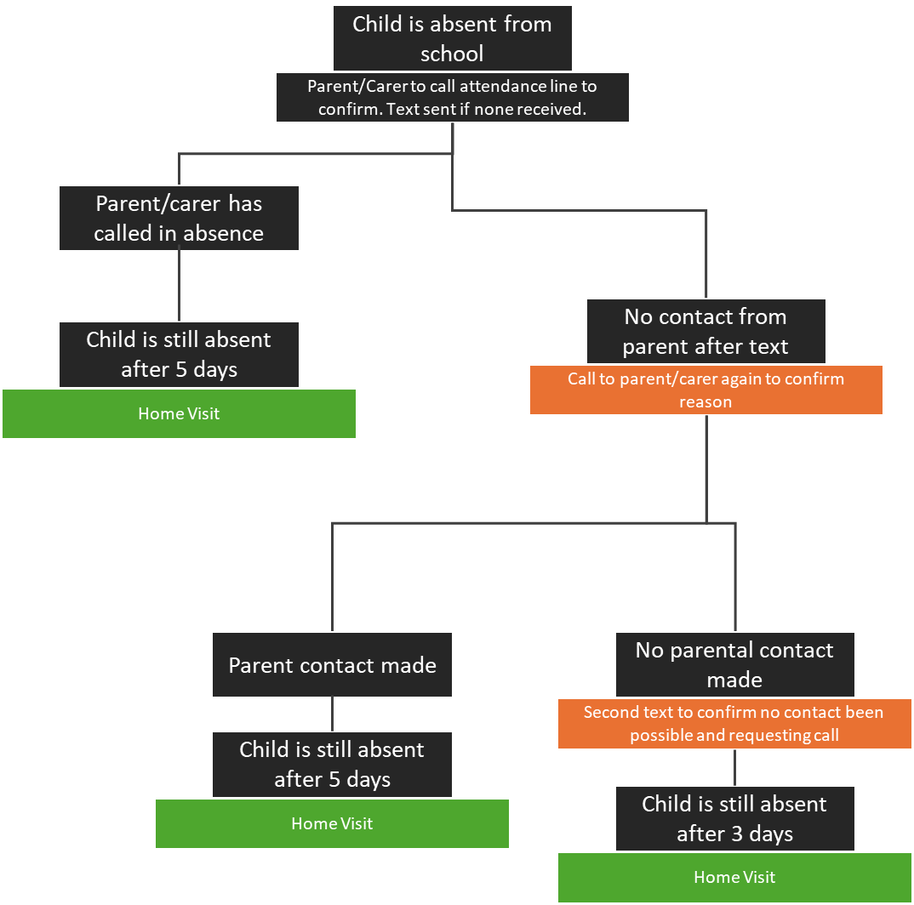
If we are unable to contact families on a home visit, we will leave contact details and confirmation we have visited. We request that parents/carers contact us as soon as possible in this situation. Where we have ongoing concerns about the location of a child, we will liaise with external services and the police to ensure appropriate safeguarding checks are completed.

10. Where to find further information
9.1 Please contact the school directly for further information about this policy or visit the ‘Attendance and Punctuality’ area of the school website. The information provided in section 2 of this policy also signposts further documentation regarding attendance policies and procedures.

Appendix 1: Attendance Codes
The following codes are taken from the DfE’ guidance on academy attendance
Code | Definition | Scenario
 | Attending the school
/ \ | Present at school | Present at the school / = morning session \ = afternoon session. Students must arrive to school before 8.30am.
L | Late arrival before the register is closed | Student arrives late before register has closed. This will be within 30 minutes of it opening
 | Attending a place other than the school
K | Attending education provision arranged by the local authority | The pupil is attending a place, other than the school or any other school at which they are a registered pupil, for educational provision arranged by a local authority
V | Attending an educational visit or trip | Student is on an educational visit/trip organised, or approved, by the school
P | Participating in a sporting activity | Student is participating in a supervised sporting activity approved by the school
W | Attending work experience | The pupil is attending a place for an approved educational activity that is work experience provided under arrangements made by a local authority or the school as part of the pupil’s education.
B | Attending any other approved educational activity | The pupil is attending a place for an approved educational activity that is not a sporting activity or work experience.
D | Dual registered at another school | Student is attending a session at another setting where they are also registered

Code | Definition | Scenario
 | Absent - leave of absence
C1 | Leave of absence for the purpose of participating in a regulated performance or undertaking regulated employment abroad | Student has been granted a leave of absence due to work experience or performances where the school is satisfied it will not have a negative impact on the pupil’s education
M | Leave of absence for the purpose of attending a medical or dental appointment | All appointments should be made outside of school hours. Where this is not possible the student should be out of school for the minimum amount of time necessary
J1 | Leave of absence for the purpose of attending an interview for employment or for admission to another educational institution | Student is required to attend a college interview of interview at another educational establishment
S | Leave of absence for the purpose  of studying for a public examination | Year 11 student on study leave during their public examinations

X | Non-compulsory school age pupil not required to attend school | Where a student is over or under the compulsory school age and is not expected to attend school full time
C2 | Leave of absence for a compulsory school age pupil subject to a part-time timetable | Where under highly exceptional circumstances permission is granted by the Principal for a student to attend school on a part-time timetable
C | Leave of absence for exceptional circumstance | Where a leave of absence is granted in exceptional circumstances. The number of days will be agreed in advance. A need or desire for a holiday or other absence for the purpose of leisure and recreation would not constitute an exceptional circumstance.
T | Parent travelling for occupational purposes | The pupil is a mobile child and their parent(s) is travelling in the course of their trade or business and the pupil is travelling with them.
I | Illness | School has been notified that a student will be absent due to illness
R | Religious observance | Student is taking part in a day of religious observance
E | Excluded | Student has been excluded but no alternative provision has been made
Absent - unable to attend school because of unavoidable cause
Q | Unable to attend the school because of a lack of access arrangements | A student receives support from the Local Authority to make access arrangements for schooling and they have failed to do so
Y1 | Unable to attend due to transport normally provided not being available | The pupil is unable to attend because the school is not within walking distance of their home and the transport to and from the school that is normally provided for the pupil by the school or local authority is not available
Y2 | Unable to attend due to widespread disruption to travel | The pupil is unable to attend the school because of widespread disruption to travel caused by a local, national, or international emergency.
Y3 | Unable to attend due to part of the school premises being closed | Part of the school premises is unavoidably out of use and the pupil is one of those that the school considers cannot practicably be accommodated in those part of the premises that remain in use.
Y4 | Unable to attend due to the whole school site being unexpectedly closed | Where a school was planned to be open for a session, but the school is closed unexpectedly (e.g. due to adverse weather), the attendance register is not taken as usual because there is no school session.
Y5 | Unable to attend as pupil is in criminal justice detention | A pupil is in police detention and cannot attend school.
Y6 | Unable to attend in accordance with public health guidance or law | Where a pupil’s attendance is contrary to advice given by the Secretary of State for Health and Social Care or prohibited by legislations relating to transmission of infection or disease
Y7 | Unable to attend because of any other unavoidable cause | An unavoidable cause, that is not covered by one of the other ‘unable to attend’ codes detailed above, is preventing the pupil from attending the school. The unavoidable cause must be something that affects the pupil, not the parent
 | Absent - unauthorised absence
G | Unauthorised holiday | Student is on a holiday that was not approved by the school. A school cannot grant a leave of absence retrospectively.
N | Reason not provided | Student is absent for an unknown reason (this code should be amended when the reason emerges, or replaced with code O if no reason for absence has been provided after 5 school days)
O | Unauthorised absence | The school is not satisfied with the reasons for the student’s absence
U | Arrival after registration | Student arrived at school after the register closed. The register will close 30 minutes after opening.
 | Administrative codes
Z | Prospective pupil not on admission register | Register is set up but the student has not yet joined the academy
# | Planned school closure | Whole or partial school closure due to halfterm/bank holiday/INSET day

Appendix 2: Request for Absence Form REQUEST FOR STUDENT ABSENCE FROM SCHOOL
Any absence interrupts the continuity of a student’s learning. Government legislation now states that only exceptional circumstances warrant an authorised leave of absence. A leave of absence cannot be granted for a pupil to take part in protest activity during school hours. Please refer to the Department for Education for the latest guidance.
Parents/carers are strongly urged not to take students our of the academy for holidays during term time.
It is expected that this Request for Absence Form is submitted to the school at least 4 weeks in advance of the proposed absence. All factors that need to be considered must be stated on this form. The school has the right to serve a Penalty Notice on parents/carers who insist on taking their children out of the school without authorisation. Penalties require each parent to pay a fine of £80 per child if paid within 21 days or £160 if paid after 21 days but within 28 days. Failure to pay within the specified timescale could result in prosecution in the Magistrates Court for failure to ensure regular school attendance. A second penalty notice issued to the same parent in respect of the same pupil is charged at a flat rate of £160 if paid within 28 days.

Name of child(ren) and Dates of Birth
- Name: __________________________________________________ D.O.B ___________
- Name: __________________________________________________ D.O.B ___________
- Name: __________________________________________________ D.O.B ___________
Address: __________________________________________________________________________
__________________________________________________________________________________
__________________________________________________________________________________
Names of all parents/carers living at this address: ________________________________________
__________________________________________________________________________________

Reason for absence: _________________________________________________________________
__________________________________________________________________________________

I have included all supporting documents for my application including flight details
From (Dates) ___________________ To (Dates) ___________________ Number of days
For medical absence, please attach an appointment card or letter.

Name: _____________________________ Signed: _________________________ Date: ________
PLEASE RETURN TO THE SCHOOL RECEPTION (please turn over)
The education (pupil registration) (England) (Amendment) Regulations 2013:

The education (pupil registration) (England) (Amendment) Regulations 2013 states that Head teachers may not grant any leave of absence during term time unless;
- An application has been made in advance to the Head Teacher by a parent with whom the pupil normally lives with; and
- The proprietor (Head Teacher) or person authorised by the Head Teacher considers that leave of absence should be granted due to the exceptional circumstances relating to the application.
Failure to ensure your child attends regularly is an offence under Section 444 of the Education Act 1996.
If the reasons given for your child’s absence from the school are not satisfactory then the Local Authority may take legal proceedings against you. This may result in:
- A Penalty Notice (£80 per parent per child), failure to pay the Penalty Notice will result in prosecution.
- Prosecution under Section 444 (1) Education Act 1996, where if convicted you may be fined up to £1000
- Prosecution under Section 444 (1a) Education Act 1996, where if convicted you may be fined up to £2,500 and/or 3 months imprisonment.
All applications for leave of absence during term time must be returned to the school well before the period of absence. We have a duty to inform the Local Authority if any pupil has 5 days or more unauthorised absences from school. Should attendance drop below 90%, we will closely monitor attendance on our vulnerable students register.
The local authority will investigate persistent absence and legal proceedings may be considered in accordance with government legislation.
Fixed Penalty Notices (FPNs) are issued per parent, per child. For example:
Two parents taking two children on holiday during term time may receive fines totalling £320 (if paid with 21 days). This will double to £640 if paid after 21 days but before 28 days. If unpaid after 28 days, you may be fined up to £1000.

