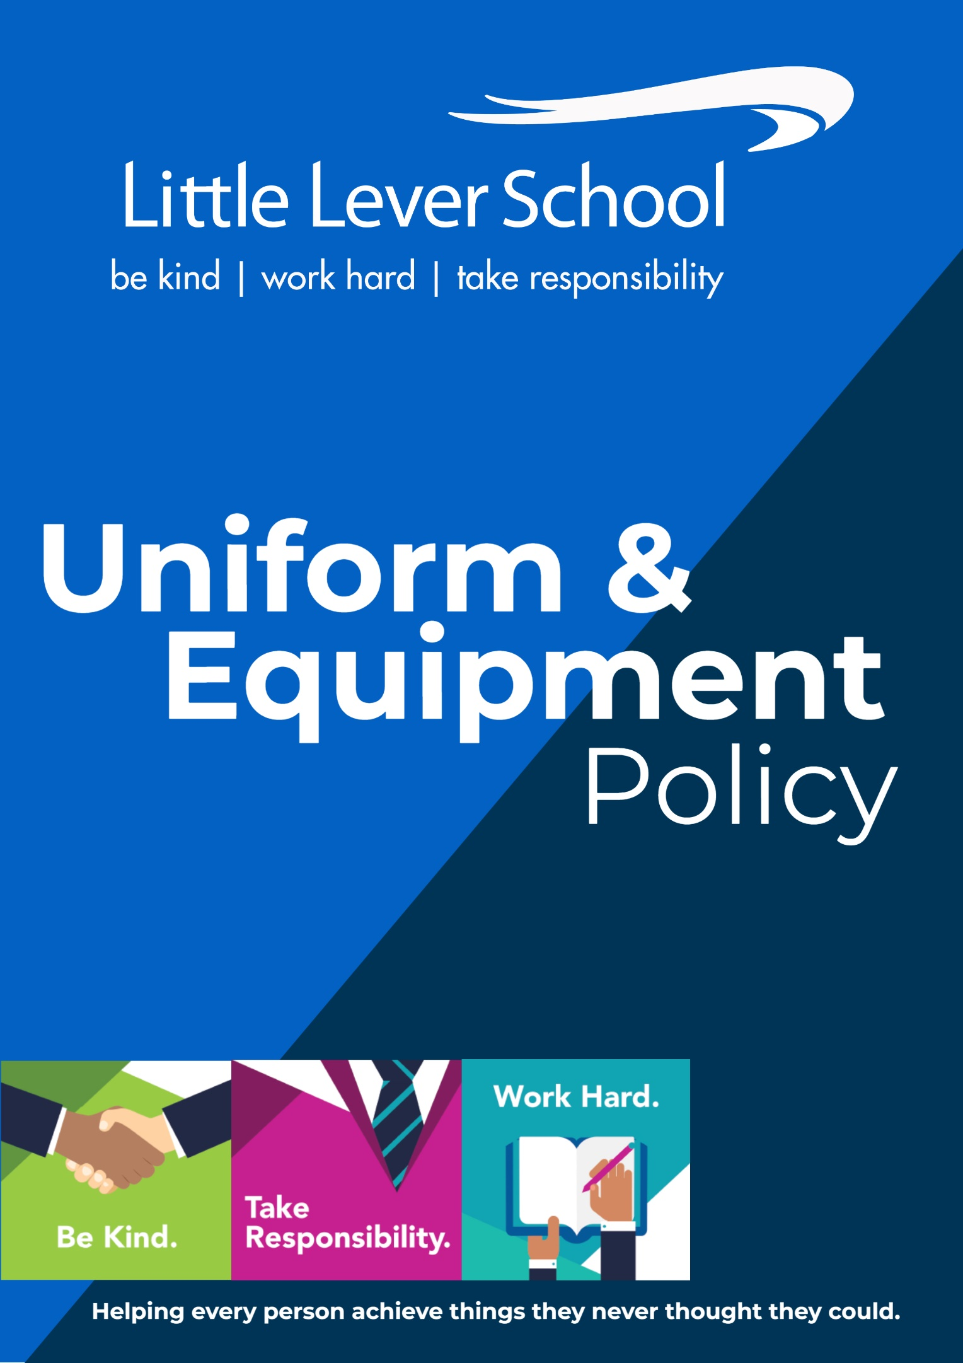
We have a strict uniform policy. This is to ensure students are preparing themselves for the world of work and life beyond their five years at Little Lever. In many jobs, students will have to wear a uniform or specialist equipment. We want to teach our students the value of this. We also want to ensure every student feels part of the Little Lever team. When students wear our blazer, they take on the responsibility to leave the blazer in a better place. This means they represent our community when they wear our blazer, and they must represent our community in the right way.

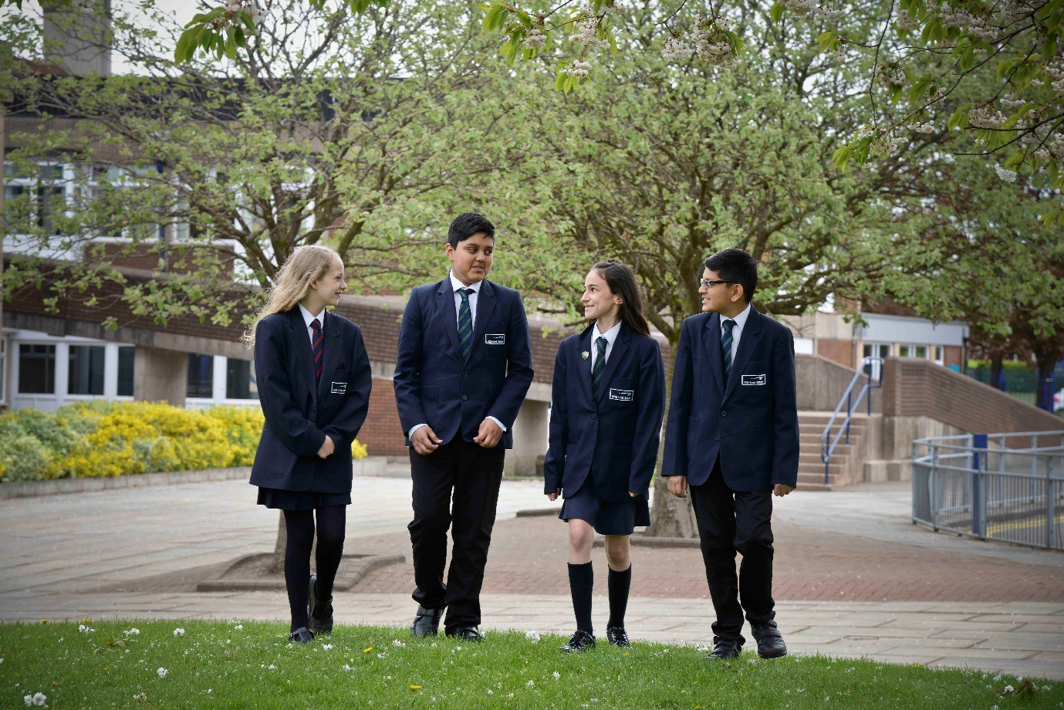

ITEM | SPECIFIC DETAILS AND HOW THEY ARE WORN
Equipment, Pencil Case, Mini Whiteboard, School Bag, Books | The following equipment is provided by the school:  - A3 size Year Group coloured coded wallet in which all equipment is stored.  - A pencil case including pen, purple pen, pencil, ruler, rubber, bookmark.  - Timetable.  - Students must be in possession of their school-issued mini whiteboard and mini-whiteboard pen.  Students must bring their own school bag each day. Bags should not display any inappropriate logos.
Blazer | To be worn at all times unless permission is given to remove it.  Sleeves are to be rolled down.  School-issued reward badges can be worn on lapels. No personal badges are allowed to be worn on blazers.
Trousers | Trousers must be black formal style tailored trousers.  Denim, canvas or chino-style trousers or leggings / ‘jeggings’ are not permitted.
Shirt | White formal shirt. Top button always fastened and shirt tucked in.
Skirt | Navy blue pleated skirt is the only style of skirt that may be worn.  Skirts must not be rolled up. Bobbles and belts are not permitted to be worn to adapt skirts.
Tie | The correct coloured Year Group tie must be worn. The same colour of tie stays with the student throughout their five years at Little Lever School.  Academic Year 2025/26: Year 7 red stripe, Year 8 blue stripe, Year 9 white stripe, Year 10 yellow stripe, Year 11 green stripe.  Ties must be worn at an appropriate length to the waist, displaying a minimum of six stripes below the knot.
School Jumper (optional) | The navy-blue V-neck jumper with the school logo can be worn under the blazer as an additional layer.  Alternatively, a plain navy-blue V-neck jumper with no slogans or badges.  They are not to be worn as a replacement to the blazer.
Plain Black, White or Navy-Blue Socks | Socks must be plain and not worn above knee height.
Plain Black or Navy-Blue Tights | Tights are to be opaque. If students arrive with tights that are laddered or ripped, they must make their way straight to the uniform shop on arrival to school to replace them.
Black Leather Shoes | Traditional, well-constructed, weather-proof, polishable leather or leather-look shoes with a low heel, with no sport logos. Shoes constructed with canvas, suede or fabric materials are not allowed.  Ankle high boots are not allowed.  Trainers – black or otherwise are not permitted.
Hair | Extreme fashion hairstyles (e.g. decorative shaved elements or motifs) and extreme hair colours are not permitted (e.g. hair must be of a natural colour).  If longer than shoulder length, hair must be tied back in situations where it could cause a danger to the individual or others, such as in PE and other practical lessons.
Headwear | Headwear for tying back hair must be plain and in keeping with the school uniform – ribbons, bows, headbands.  Hats of any kind are not part of our school uniform.
False Nails / False Eyelashes | False nails or nail extensions of any description represent a health and safety risk and may not be worn.  Nail varnish must not be worn.  False eyelashes are not permitted.
Make-Up | Any make-up worn by students should be natural and discreet.
Jewellery | Students are permitted to wear a wristwatch.  One pair of small plain gold or silver coloured stud earring can be worn in each ear. Please note all earrings must be removed for PE lessons, plasters or see-through replacements earrings are not allowed to be worn for health and safety reasons.  No other items of jewellery, including bracelets, rings, necklaces or facial / tongue piercings, etc. are permitted under any circumstances.
Coats, Hats, Scarves, Gloves | Weatherproof outdoor coats are only to be worn outside and not when inside the school building.  Coats should be worn over blazers outside the school building. Coats should never be worn instead of blazers.  Coats should not display any inappropriate logos.  In cold or wet weather appropriate hats, scarves and gloves may be worn to and from school, but not inside the school building.  Coats and hoodies must not be worn under school blazers at any time.
Mobile Phones |   Mobile Phones are not allowed in school.  If a student does bring a phone to school, it must be switched off and placed in the bag before crossing the blue line in the morning.  At the end of the school day students must wait to leave the school premises at the blue line before accessing their phone.  If a student’s phone is seen on their person at any point during the school day, the phone will be confiscated, and a 30-minute lunchtime correction will be issued for the following day.
Lost Property | The school cannot accept any responsibility for loss of property.  Parents/carers must ensure all items of clothing are clearly marked with their child’s name and check regularly that the name is still visible.
Confiscated Property | The school cannot take any responsibility for the loss of any property which is confiscated, for example a bracelet being worn by a student or a mobile which a student has been seen using.

PE Uniform
Little Lever School is proud to present our new look PE kit for the academic year 2025/2026! This kit has been designed and chosen by our students.
Our new PE kit is to be phased in and can be seen below. This includes a sports t-shirt, 1/4 zip top (jumper), 1/4 zip rain jacket. These all include the schools’ PE logo and can be purchased from the school’s uniform stockists.
The new PE kit range does not include shorts/skorts with the school logo on. However, it is mandatory for all students to wear plain black shorts or plain black leggings (which must not be sports branded).
PE T-Shirt
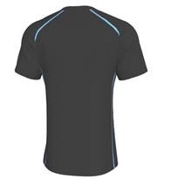
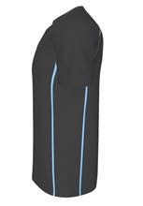
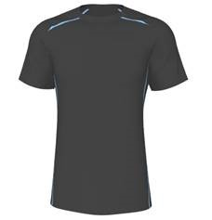

PE ¼ Zip Jacket
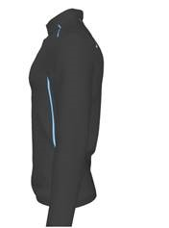
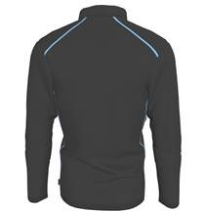
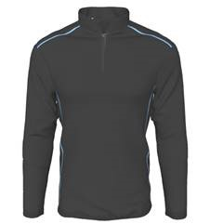

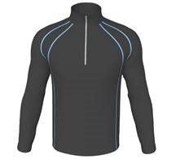
PE Zip Rain Jacket
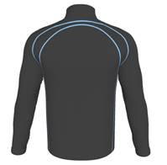
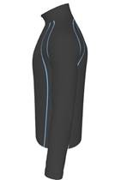

- Shorts plain black with NO school logo or sports branding logos.
- Optional plain black football socks or sports socks. (change of socks must be worn in PE lessons).
- Optional plain black leggings with NO school logo or sports branding
- Optional Plain black track pants with NO school logo or sports branding
- We will no longer be using the reversable rugby jersey, hoodie, leggings with school logo and skort.
For winter use
- Base layers can be worn underneath school kit.
- Optional black track pants or tracksuit top/hoodie with NO school logo or sports branding
Shoes
- Clean sports trainers for indoor use.
- Recommended moulded boots for outdoor use. No metal studs.
As this is a phased introduction, it is not a requirement for students to wear the new PE kit immediately. As your child grows and their kits no longer fit, you will be able to purchase the new designs only. Year 7 starters will also be able to purchase the new design only.
Students will be able to continue wearing our current PE kit for their duration at Little Lever School. Examples are included below.

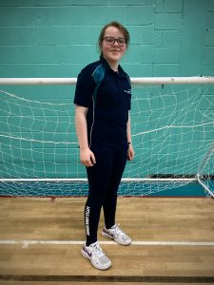


OLD PE UNIFORM
COMPULSORY ITEMS | OPTIONAL ITEMS
Teal and navy polo with logo.  All polo tops must be purchased from school kit providers and must have the Little Lever School logo on it. | Teal and navy hoodie with school logo. Non branded plain navy hoodie/jumper.
Navy shorts, skort or leggings with school logo. | Tracksuit pants with school logo. Non branded plain navy tracksuit pants.
Navy socks with teal turnover with logo or white/black sports socks. Team players must have navy socks with teal turnover for use in school matches. | Base layers for winter use.
Bobble for long hair. | Navy rain/shower jacket with no branding.
Clean trainers with non-marking soles for indoor use. | Plain navy unbranded shorts.
Moulded football boots/blades or suitable outdoor trainers for use on 3g pitch.
No metal studs.

Our Uniform Stockists
- Whittaker’s Schoolwear, Deansgate, Bolton 01204 389485 www.whittakersschoolwear.co.uk
- Smart Clothing, Blackhorse Street, Bolton 01204 392610 www.smartschoolwear.co.uk
- PTS School Wear, 7 New Road, Radcliffe 0161 723 0991 www.pts-schoolwear.co.uk
- Ziggys, Brackley Street, Farnworth 01204 577211
Parents/carers will be required to purchase branded items (blazer, jumper, tie, PE Kit) from a stockist, however all other items can be purchased from supermarkets or other easily accessible shops.
*For families who require support with acquiring school uniforms, please contact school.

