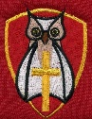
Little Thetford CE Primary School Knowledge Organiser
Year Group: Reception Term: Autumn A Academic Year: 2022.23
Topic: Marvellous Me and My Community
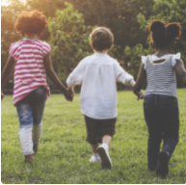
We will support children with settling into the new rules and routines of school and encourage them to make new friends and feel confident in their class. We will teach children about being helpful, kind and thoughtful at home and at school. This project also teaches children how they are unique and special, the importance of friendship and how people in their family, school and local community are important and can help them.
The Learning Journey: What I should already know?

- I may say who is in my family
- I may say where I live
What will I know by the end of this unit?

Key learning: Key skills: I Can..
• Family Community: My family and my home Talk about myself, family, we are all unique.
- Let’s be Friends: Establish rules to be happy, safe, learn good/
bad choices, taking turns, sharing, a good friend
- My emotions Talk about how I am feeling
- People Who Help Me in the school and local community Talk about adults who can help me

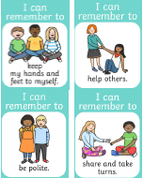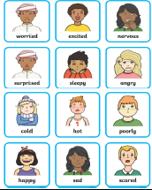

Vocabulary – You need to be able to understand and be able to use these words by the end of this unit
Friend | A person you know well and you like a lot but who is not a member of your family.
Emotion | A feeling you feel, like happy, sad or angry.
Loneliness | Sadness because you have no friends.
Same | Things, that look alike.
Different | Things that are not the same.
Unique | We are all different and one of a kind.
Rules and Routines | These ensure we are all kept happy and safe.
Share | To take turns or give someone something.
Community | A community is made up of a group of people who share or live in the same place.
 | There are different types of communities, such as the family community, the school community and the local community.

Dear Parents/Carers
Please could you go through the vocabulary words and practice them with the children as we will be introducing quizzes to them during this topic.

It is helpful for you to see what topics we are learning about so that you can talk to your child at home. As with all our work in Reception the topic will involve a strong emphasis on practical activities to develop the children's learning. Please do not hesitate to see me if you wish to discuss any aspect of your child’s education. If I am not immediately available, I am happy to arrange a time to see you

Yours sincerely

Mrs Walker, Mrs White and Mrs Martin

