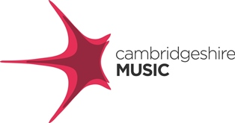
Cambridgeshire Music
36 Mayfield Road
Huntingdon
PE29 1NL

Tel: 01480 373500

How to sign up for Cambridgeshire Music Lessons – brass, strings, piano and woodwind

Lessons for these instruments can be booked via the Cambridgeshire Music website, this is the link
https://www.cambridgeshiremusic.org.uk/pages/discover-music/tuition/

Once on the page you will need to click on “request a lesson” in the top right hand corner under the flute picture, this will take you through to the log in page. If you have not used the website before you will need to create an account.
To do this click on “My Account” in the top right hand corner, where you can register as a “New User Account Registration”. Once you have created an account please add your child’s name to the account. You will receive an email when the account set-up is complete.
To book lessons click on “book a service” by your child’s name and chose Instrument Tuition from the drop down menu.

The price of lessons is £12.50 for an individual 20 minute lesson or £6.25 for a 20 minute group lesson. You can book a longer lesson if working for a higher grade or if you would like time for music theory to be included in the lesson (a 30 minute lesson is £18.75 a session). We aim to provide between 30 and 34 lessons across the school year with lessons booked as blocks (normally 10 or 12 but can be half termly). Lessons not used roll across into the next term. You can arrange to pay in instalments.
If you need an instrument, the cost of hire is £36 per term and can be booked at the same time as requesting lessons by choosing the instrument loan option in the drop down menu.

If you have any questions please contact the business team on cm@cambridgeshire.gov.uk

