Dear Parent and Carers

NHS Test and Trace: COVID-19 Lateral Flow - Home Testing

Tests will come home with students: Monday 22nd March 2021
First test to be done at home: Wednesday 24th March 2021
Following our recent letter, I am writing to thank you for all your efforts and support that has enabled us to reopen Littleport & East Cambs Academy whilst keeping everyone safe.
In collaboration, DfE and DHSC have determined that Lateral Flow Testing (rapid antigen test) is believed to be the most appropriate way of testing Secondary School Students safely to enable them to get back into the classroom and learning as soon as possible.
Along with the other protective measures we are taking, testing allows us to take further measures to help our students to learn in as safe an environment as possible. Up to one in three people who have Covid-19 have the virus without symptoms so could be transmitting the virus unknowingly. Tackling the pandemic requires identifying asymptomatic, infectious individuals. By testing, we will help to reduce the spread in schools. I am therefore strongly encouraging all students to take the tests.
Lateral Flow Device (LFD) tests have been widely and successfully used to detect COVID-19 in asymptomatic individuals. No test is perfect, but the speed and convenience of LFD tests supports detection of the virus in asymptomatic individuals who would not otherwise be tested. They are clinically approved and are crucial in the fight against the virus. As the tests are more sensitive with higher viral loads, there is a risk of returning a negative result when viral loads are low (e.g. in the early stages of infection). This is why Public Health England recommend two LFD tests 3 to 4 days apart, or regular testing, to enhance detection by picking up any cases which were not detected during the first test and to catch any new infections.
If you test positive using a LFD, it is likely that you are infectious at that moment, whereas people testing positive on a polymerase chain reaction (PCR) or lab-processed test could be in the less infectious early or late stages of disease. This means that by using the lateral flow test we can identify people with a high viral load who are the most likely to spread the virus further. A negative LFD result should not be read as a means to relax or ignore social distancing or other virus prevention measures intended to reduce transmission – LFD is an additional tool that contributes to reducing risk.
Home testing
Your child should take the test twice a week, before coming into school the night before. A leaflet giving instructions on how to do the test will be given with the test kit. There is also a useful video to show you how to take the test, follow the link below:
How to take a COVID-19 Lateral Flow Self Test (rapid antigen test) – click the link below to watch the NHS Test and Trace video:
https://www.youtube.com/watch?v=S9XR8RZxKNo&list=PLvaBZskxS7tzQYlVg7lwH5uxAD9UrSzGJ&index=1
STAYING SAFE - Family Members
Encourage your family to also use lateral flow home testing kits. Follow the link to order. https://www.gov.uk/order-coronavirus-rapid-lateral-flow-tests
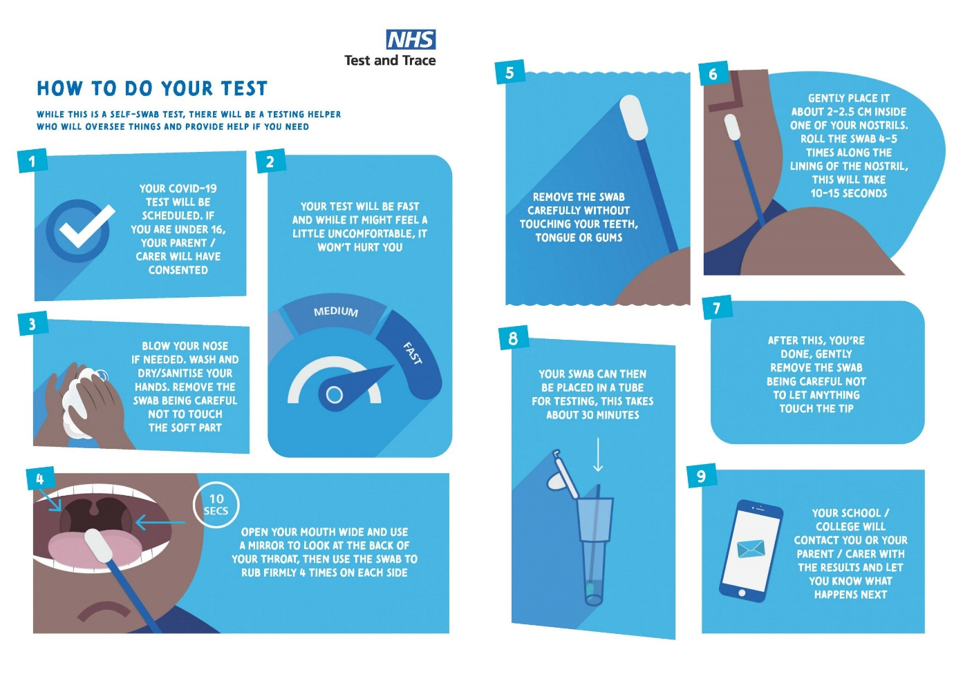
Students will be able to take the tests every week starting from Wednesday 24th March 2021. All students will be required to conduct these tests at home, twice a week on a Wednesday and Sunday evening. Students will be given their LFD test kits (containing 7 tests) during form which we will ask them to store safely in their bag and take home to enable them to start self-testing from home.
How the tests work
Students are asked to conduct the test, twice a week. The LFDs supplied do not require laboratory processing and can provide a quick result in around 30 minutes. Comprehensive guidance on self-testing is contained in the ‘Step-by-Step guide’ leaflet which comes with the test kit.

Reporting result
Once the test has been conducted you will log the test result via the following:
- Online at https://www.gov.uk/report-covid19-result

- IF POSITIVE please also inform the school via email covid@lecacademy.org
(Please put ‘Positive’ in the subject line)

We will assume that all tests are negative/void, unless you inform us otherwise.
Use your smart phone to scan the QR code or enter the code manually (see where to find the code below:
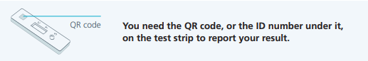
Please ensure you send your test result on the day of your test. You will also receive a text/email notification of a positive or negative result from NHS Test & Trace. Tests are free of charge and will be provided by the school.
Consent / Privacy
Once Students understand the testing process and read a privacy notice (attached), if they choose to participate, they are committing to self-administer the test and provide their results. Schools should ensure that students provide their results (positive, negative or void) to NHS Test and Trace via the self-report gov.uk page. Results should also be shared with school to support local contact tracing.
Students who decline to participate can still attend school if not symptomatic.
People who decline to participate in this testing programme should follow the usual national guidelines on self-isolation and anyone should get tested if they show symptoms.
As you will know, we remain in national lockdown so it is really important that students continue to arrive at school on time and don’t take the opportunity to meet up with friends from other groups either before or after school.
The testing of pupils and the return to school has been one of the most difficult logistical challenges schools have ever faced and I thank you for your support and patience with us as we return your children to school as quickly and as safely as possible.
We will support our students throughout but let us know if you have any questions or concerns with the individual test itself.
Yours faithfully,

Scott Gaskins
Principal, Littleport & East Cambs Academy

