15th January 2021

Dear Parents/Carers

Remote Learning Protocols

Further to the email which outlined our Remote Learning timetables and schedule for learning at home and in school, below outlines our Remote Learning protocols including Teams.

Your child’s education is very important and we want to ensure that during this period of time, students continue to receive a high quality education and they are able to demonstrate the LECA ‘We are INSPIRED’ values at home. Please support us by setting clear expectations for your child working at home. They will be following the Remote Learning timetable and the times for lessons and working from Monday 18th January are outlined below:

Lesson 1: 8:45 – 10:00
Lesson 2: 10:00 – 11:15
Break: 11:15 – 11:45
Lesson 3: 11:45 – 1:00
Lunch: 1:00 – 1:30
Lesson 4: 1:30 – 2:45

All lessons will be set and delivered using Microsoft Teams which will consist of written, recorded and/or live, direct teaching and time given for students to complete tasks and assignment independently.

There will be a gradual increase of lessons using live features. Live features may consist of teaching live using a scheduled lesson, use of audio clips within Teams classrooms to teach and provide feedback, the use of voice-over PowerPoint/YouTube, etc. and the use of approved videos from educational websites such as GCSEPod, Oak National Academy and White Rose Maths.

Students will be set tasks to complete during the lesson which will be set in Class Notebook or Assignments. Tasks will enable teachers to gauge learning and progress and ensure we meet the needs of all students and provide ongoing feedback. Feedback will take various forms, including individual written/recorded feedback, whole-class feedback and/or quizzes marked automatically via digital platforms.
Teachers will be taking registers during scheduled live lessons and student’s attendance is expected; engagement is being monitored in all lessons by students submitting their Assignments on the day of the timetabled lesson. There may circumstances in which students are unable to submit an assignment on the day of the lesson, therefore, assignments will remain open for students to submit work. An email to inform their subject teacher of any delayed submissions would be much appreciated.
Engagement will be tracked on G4S which will be available to view each week to students and parents/carers. Students who have completed the tasks for each lesson or week (subject-dependent) will be awarded an Independent Learner mark and for incomplete work, students will be given a ‘Subject’ – Progress Driven (0 points) mark. When work has been submitted, this mark will be removed from their account. This system of monitoring will enable staff to fully support your child and track that they are engaged and are making progress with their learning.
A system of pastoral support is being provided in which form tutors will make contact with students in their form via email or phone calls home each week. In addition to this, staff members will be checking in with students who have been marked absent on registers or who have not submitted their assignments at the end of lessons.

Teams Guide: Scheduled Live Lessons

- Students will be sent a link by their teacher/subject for joining a Scheduled Live Lesson. The students will find this link in their calendar:

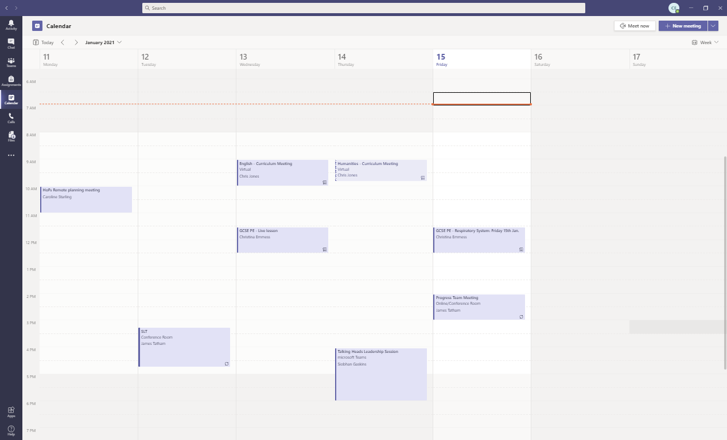

- Students need to click on this link and join the live lesson for the time their lesson starts on their timetable. Students must ensure that their video is turned off throughout the duration of their live lesson. Teachers will not be sharing their video through the lesson and will only be sharing a screen to teach their lesson, i.e. PowerPoint presentation.

- Students will join the ‘lobby’ area and will be accepted into the lesson by the teacher – they will join the lesson muted. The key button students may need to press during the lesson is the speech bubble – this opens the conversation thread which the teacher may use during the lesson to get responses from students, or enables students to ask questions during the lesson.

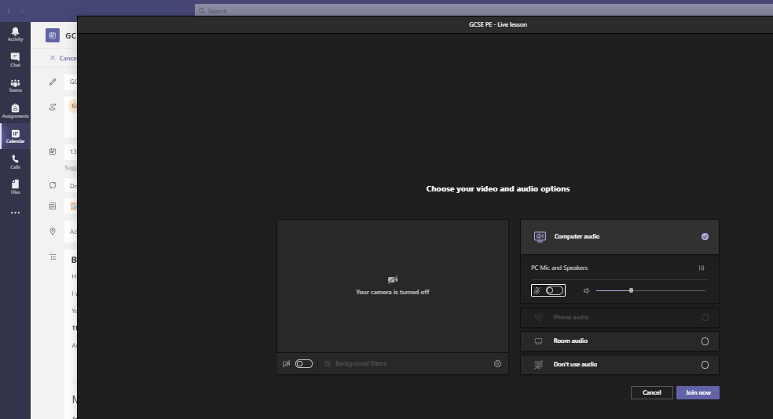

- Behaviour is expected to be outstanding and students are to uphold the high expectations at LECA throughout lessons. Students must use the conversation thread sensibly and ensure it is kept focussed on the work.

- During each schedule live lesson students will be expected to complete an Assignment which may include a task or quiz to assess their progress over the course of the lesson. This is vital for ensuring the following lesson supports students and teachers know how best to support individual students.

As always, if you or your child has any issues please contact their form tutor or class teacher.

Yours sincerely

Christina Emmess
Assistant Principal

