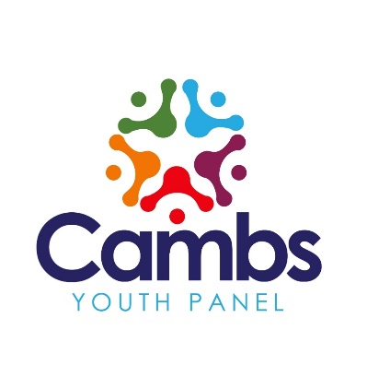
Phil Priestley
Founder and Lead Adult Facilitator
www.cambsyouthpanel.co.uk

Monday 8th March 2021
REF: Cambridge Children’s Hospital competition
Dear Parent,
I’m writing to you on behalf of the Cambs Youth Panel – a group made up of young people aged from 13 – 18 who have been relentlessly supporting young people in our region through the Covid crisis with the distribution of computers and technology since March 2020.
The panel has collaborated with the team behind Cambridge Children’s Network, which is made up of children, young people, families and carers who want to help develop the new Cambridge Children’s Hospital.
This will be the first EVER children’s hospital in the East of England. It will offer a unique ‘whole child’ approach, where mental and physical health are treated together. It will also be a centre for world class research. Members of Cambridge Children’s Network will combine with the project leaders to decide how the hospital looks and the care it provides, before it opens in 2025.
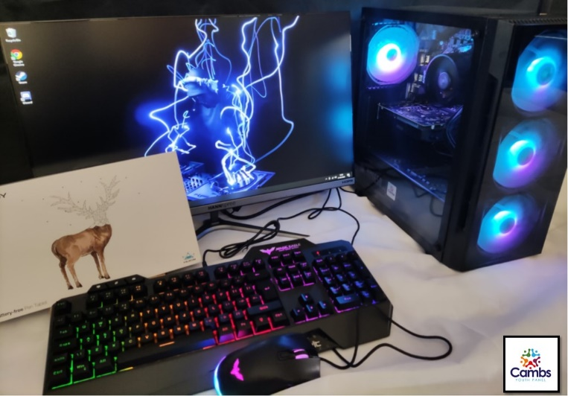
We are incredibly proud to support the Cambridge Children’s Hospital project by offering this competition prize. We are asking your students to develop a logo for Cambridge Children’s Network, giving it a real sense of identity and purpose.
If your son or daughter succeeds in designing the logo chosen by the team, they will win a desktop gaming PC worth more than £800 (pictured).
This computer is equipped with an AMD Ryzen 5 motherboard and 3.6 ghz processor. It has a NVDIA 1050 TI graphics card, 8gb of RAM, a 24 inch super flat widescreen monitor, and comes with a Huion graphics tablet, plus RGB keyboard and mouse. It really is a super prize.
All your son or daughter has to do is visit this link:

Click Here

Our panel member, Molly, has prepared a YouTube video which tells them exactly what they have to do and how they can submit a competition entry for free!
The competition is open to any child aged 11 – 16 years old and closes on the 2nd April 2021. The winner will be announced shortly afterwards once the independent judging panel has decided the winning entry. Runners up prizes (Amazon vouchers) will be awarded.

With kind regards on behalf of the entire Cambs Youth Panel,

Yours faithfully,

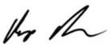
Phil Priestley
Cambs Youth Panel

