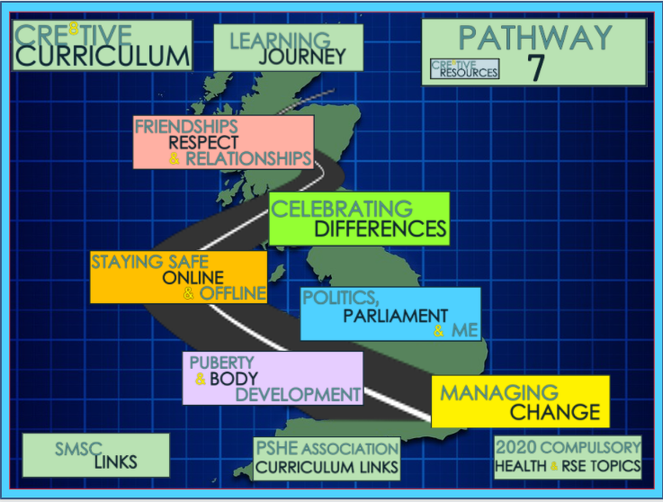
To support our Year 7 Students integrating into LECA smoothly, we begin with Managing Change.
This theme will support students to settle into LECA in their first few weeks, supporting them academically and personally. This is a great topic which will involve:
- Getting to know people
- Community
- Careers & your future
- Sleep and Relaxation
- Transition points in your life and much more!
The second theme is Puberty & Body Development.
This theme will support students to prepare for some of the physical and emotional changes that will begin to occur during puberty. This theme covers areas such as:
- Puberty - Female & Male Focus
- Personal Hygiene
- Growing up and FGM
- Assertive consent
- Self Esteem
Next up, students will cover Politics, Parliament & Me.
This theme will support students to gain an understanding into the UK Parliament, Politics across Britain and support them in becoming knowledgeable, active citizens. During this theme students will cover:
- How the Country is run
- Elections & Campaigning
- Political Debates and much more
The fourth theme that Year 7 will cover is Staying Safe Online & Offline.
This contemporary theme will enable students to recognise the importance of staying safe digitally as well as staying safe offline. Therefore some of the topics include:
- Avoiding gangs
- Staying safe online
- Online gaming
- Drugs Education
The penultimate theme that will be covered is Celebrating Differences.
This theme will delve into the importance of having an appreciation of the multicultural society our students live in. It will encourage students to consider their identity as well as understand challenges that some individuals may face as a result of prejudice and discrimination. Some of the areas covered include:
- Multicultural Britain
- The Equality Act 2010
- Stereotypes in Society
- Islamophobia
Finally, Our Year 7 will cover Friendships, Respect & Relationships.
This theme will promote the importance of positive friendships, respect and relationships to support students in their development as individuals here at LECA and beyond.
Students will cover the following:
- Consent & Boundaries
- Respect and relationships
- What makes a good friend?
- Friendships & Managing them
- Being Positive
- Pressure and Influence
- What does it take to be a man in 2020?

Why have we sequenced the Year 7 curriculum this way?
It is important that we welcome our new students to LECA and enable them to make new friends and build new support networks and the first theme promotes this in a positive and well managed way.
The second theme then supports students to feel confident about puberty and some of the changes they will face. Puberty begins at various ages and stages, however, covering this topic early acts as an inclusive framework for all.
Thirdly we cover Politics, the reason for this being that, by now students should have established friendships and be open to debates and learning about wider issues faced in the UK.
This links in well with the fourth topic in which students consider how to stay safe and how to be aware of their rights as set out by the Government.
Students then move on to Celebrating Differences. At this stage in the curriculum students are mindful of their identities within friendship groups, the Government and issues faced as young people. Therefore, this theme enables students to consider how these differences can be embraced.
Finally, students will cover Friendships, Relationships and Respect. This acts as a brilliant round up theme. By now students would have established friendship groups, most will be exposed to social media or soon be. Students can use this theme to embed diversity, staying safe and Laws surrounding this.

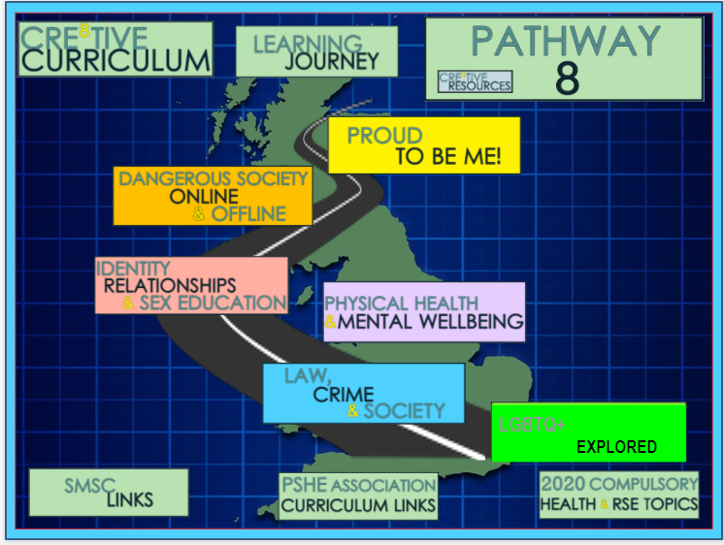
To support our Year 8 Students continuing their PSHE journey at LECA, we begin with the theme LGBTQ+ Explored.
This theme seeks to provide students with an holistic knowledge base of LGBTQ+. This includes personal identity as well as having an awareness of those identifying as LGBTQ+.
Students will cover the following:
- LGBT, What is it?
- Homophobia in School and Society
- Supporting those that are LGBT
- Challenging Homophobia
- Transphobia
The second theme will cover Law, Crime & Society
This theme will educate students on the systems used in the UK in regards to Law, Crime and Society. Students will form an awareness of how to participate positively within society and as such during this theme students will cover:
- Desert Island living
- Desert Island – Building a Community
- Desert Island – Making decisions
- Criminals, Law and Society
- Law making in the UK
- Prisons Reform and Punishment
The third theme is Physical Health & Mental Health
This theme demonstrates crucial elements to support students in being aware of health and wellbeing from a holistic perspective. Students will cover:
- Health and Wellbeing
- What is Mental Health?
- Positive Body Image
- Child Abuse
- Types of Bullying
- Healthy Eating and Cholesterol
- Stress Management
The fourth theme that Year 8 will cover is Dangerous Society Online & Offline
This contemporary theme will enable students to recognise the dangers that can be posed to them within society and how to stay safe from such risks. Therefore some of the topics include:
- County Lines – What is it?
- County Lines – Who is at risk?
- Substance Misuse
- Online Safety – Cyber Bullying
- Grooming Boys and Girls
- Drugs – Alcohol Safety
- Child Exploitation Online Protection (CEOP)

The penultimate theme that will be covered is Identity, Relationships & Sex Education
This theme introduces students to relationship and sex education. Students will ascertain a clear understanding of key areas which in turn will promote them to be confident young people, in charge of their lives. Some of the areas covered include:
- Introduction to Relationship and Sex Education
- Healthy Relationships
- Dealing with Conflict
- Sexual Orientation
- Gender Identity
- Introduction to Contraception
- What is Love?
- Periods and Menstrual Cycle
The final theme that will support students to be informed of the choices they will make during year 9, in terms of their KS4 options is Proud to be me!
This theme will be thought provoking, enabling students to consider their future - a great topic for the end of the academic year with contents such as:
- Employability Skills Practice
- Proud to be Me and Careers
- Career Interests and Job ideas
- Self Esteem and the Media
- Labour Market Information
- Exploring Careers
Why have we sequenced the Year 8 curriculum this way?
A new academic year is a great way to begin with the LGBTQ+ Explored unit. This unit seeks to focus students on their understanding of the LGBTQ+ community and topical issues such as homophobia and transphobia. This was chosen as the first theme at LECA in 2020-21 to further support the individual needs of our students within this year group. This was done with the aim of further building upon our inclusive approach within the school.
The second theme, making links from hate crimes and other criminal related behaviour is Law, Crime and Society. This units builds on the impact of, at times, poor mental health (also covered in unit 1), Laws created to protect ourselves as well as making decisions and their impacts. Students have the opportunity to build their own community, comprising of a diverse range of individuals, representative of our society in the UK.
The third theme, Physical Health and Mental Wellbeing is something that, due to puberty among other key areas of our students lives being particularly prominent at this stage in the academic year, really supports them to gain an understanding of their own physical health and mental wellbeing. It builds on well from the first and second theme which covers self-esteem.
Students then move on to Dangerous Society Online & Offline as it links in closely with crime such as County Lines and the impact that it has on society. At this stage in the curriculum students are mindful of their communities and the real world and issues that many young people face.
Therefore, the penultimate theme is Identity, Relationships & Sex Education. The topics covered here link closely to the above themes and sets them up well for their final theme which is Proud to be me.
This theme focuses on, self esteem, life skills and career aspirations. All key skills to embed, in preparation for a successful academic year in Year 9, as they begin to consider their future GCSE options.

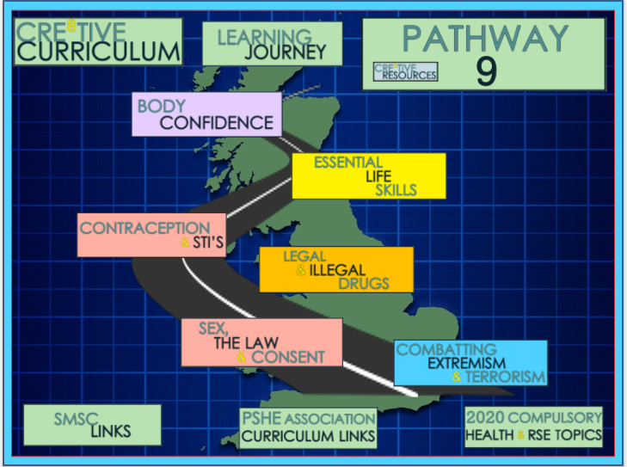

As we welcome Year 9 into the new academic year, we begin their PSHE pathway by covering Combatting Extremism & Terrorism
This theme establishes a knowledge base for students on combatting extremism and terrorism. Students will explore what terrorism is and how radicalisation occurs. Students maturity levels as they enter their last year in Key Stage three acts as a great opportunity to cover the following:
- Conspiracy Theories and Extremist Narratives
- Extremism
- What is Terrorism?
- What are British Values?
- The Radicalisation Process
- Counter Terrorism
- Anti-Semitism
The second theme is Sex, The Law & Consent
This theme educates students on key features of sexual relationships and encounters as well as consent and the Law.
. Students will cover:
- Sexual Consent and the Law
- FGM and the Law
- Delaying sexual activity
- Why have sex?
- Relationship and Partners
- Pleasure and Masturbation
- What are STI’s?
The third theme will cover Legal & Illegal Drugs
This theme delivers students with the required understanding of legal and illegal drugs and their impact. Therefore the content includes:
- Different types of Addictions
- Drugs – Cannabis Products
- Drugs Classifications
- Party Drugs
- Illegal Drugs
- Volatile Substance Abuse
The fourth theme that Year 9 will cover is Contraception & STI's
This theme enables students to explore, in more depth the range of contraception and STI’s. Further to this students will develop an awareness of sexual harassment and stalking. Therefore some of the topics include:
- STI’s
- Contraception Available
- Condom Lesson
- Contraception explored further
- HIV and AIDS
- Sexual Harassment and Stalking
- AIDS Prejudice and Discrimination
The penultimate theme that will be covered is Essential Life Skills
This theme will provide students with key life skills that will promote their resilience as well as giving them the opportunity to consider and plan their futures. Some of the areas covered include:
- From Failure to Success
- First Aid - This will be embedded into the PE curriculum
- Importance of Happiness
- What is Anger?
- Saving and Managing Money
- Employment and Financial Management
- Social Media and Online Stress
Finally, Our Year 9 will cover Body Confidence
This theme is vital in promoting a sense of body confidence and increased self-esteem for students.
Students will cover the following:
- Body Image
- Penis & Testicles
- Vulva & Vagina
- Lifestyle
- Cancer prevention
- Illness
- Grief and Loss
- Emotions & Feelings
- Bullying
Why have we sequenced the Year 9 curriculum this way?
We begin the new academic year with Combatting Extremism & Terrorism as this provides as a great recap for British Values as well as delving into conspiracy theories and terrorism. It is an engaging topic which encourages critical thinking; a key skill required for Year 9 Students.
The second theme, Sex, The Law & Consent is taught next as it applies a clear link with the first theme. Also, students maturity and ability to study topics such as FGM provide some great discussions.
The third theme, Legal & Illegal drugs again builds on from students prior knowledge and enables students to explore the impact of drugs and consider how they can be interconnected with earlier themes, furthering their critical thinking skills.
The fourth theme is then based on Contraception & STI's. Students at this stage in the curriculum are mindful of this theme as it would have been covered in Year 8. Again, this theme links well with previous themes covered earlier in the academic year.
Essential Life Skills is the next theme covered. It begins to see the shift in the curriculum with the focus being on the personal attributes and skills students need to be successful and support them in selecting their GCSE options. This builds on nicely for the final theme which is Body Confidence; the theme that covers key issues for young people such as self esteem changes and lifestyles.

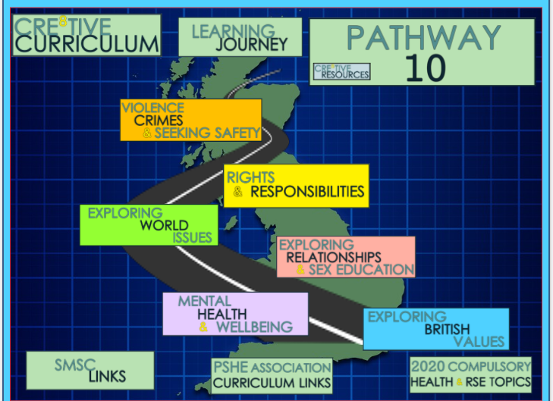

At the start of Year 10 as our students as they enter Key Stage 4, we begin with the theme Exploring British Values
This theme aims to get student to develop their critical thinking skills whilst exploring British Values, Human Rights and elements that threaten the values.
Students will cover the following:
- Critical Thinking and Fake News
- What is a Cult?
- Exploring Britishness and British Values
- LGBT Rights and British Values
- What are Human Rights?
- Exploring Human Rights
Mental Health & Wellbeing is the second theme that will be covered.
This theme supports students in being mindful of how to look after their mental health and wellbeing by covering key issues faced by young people. Students will ascertain a clear understanding of key areas which in turn will promote them to be confident young people, in charge of their lives. Some of the areas covered include:
- Child Abuse CSE
- Screen time and safe use of mobiles
- Common types of Mental Health
- Self-Harm
- Suicide (Thoughts and Feelings)
- Promoting Emotional Wellbeing
Exploring relationships and sex education is the third theme to be covered.
This theme will be thought provoking, enabling students to consider their rights & responsibilities. Students will explore what it takes to feel proud, be confident and ready for their future
Students will cover:
- FGM
- Pornography
- Domestic Abuse & Rape
- Consent
- Sexualisation
- Media
- Social Media – Selfie’s, Likes, Body confidence
- Sexting

The fourth theme that Year 10 will cover is Exploring World Issues
This contemporary theme will enable students to delve into the topics of equality and diversity through current global issues. Therefore students will study:
- International Organisations
- Brexit
- Aid and Supporting other Countries
- Fairtrade
- Peace War and Conflict
- Women’s Rights and Equality
- MeToo and Time Up Movement

Violence, Crimes & Seeking Safety is the final theme.
This theme delivers students with the required understanding of global issues in relation to violence and crimes as well as educating students in how to stay safe. An engaging topic for the start of term with contents such as:
- Honour Based Violence
- Forced Marriages
- Online Gambling
- Social Media Validation
- Keeping Data Safe
- Modern Day Slavery
- Causes of Knife Crime
Why have we sequenced the Year 10 curriculum this way?
As we welcome our Year 10 students into their new academic year, and the beginning of Key Stage 4, we engage them with their first theme, Exploring British Values, which is thought provoking and acts as a fantastic opportunity to build on their critical thinking skills - key to support their KS4 success.
The second theme, Mental Health and Wellbeing links well to the first theme and enables them to consider what their rights are as they continue to develop, whilst becoming active citizens, confident with understanding mental health and what it means to them. It also proves itself to be a brilliant platform for their third theme.
Exploring Relationships & Sex Education is the third theme our Year 10 will study. At this stage students are able to understand how this unit links closely with the second unit. It also encourages students to become mindful of key issues faced in the 21st century.
Next, students will delve into their fourth topic, Exploring World Issues which once again builds on their prior knowledge and themes already covered. This further supports out students to become global citizens. This unit acts as a reflective theme on the topics covered so far. It also acts as a base for encouraging students to think critically about what is happening around them, locally, nationally and globally.
Rights and Responsibilities is the fifth theme covered. This theme will be thought provoking, enabling students to consider their rights & responsibilities, whilst building on their knowledge from previous units. Students will explore what it takes to feel proud, be confident and ready for their future
Moving forward with the curriculum, our Year 10 students will conclude the year by looking at Violence, Crimes and Seeking Safety. This final topics enables students to piece together their knowledge from the previous units and consider the importance of keeping themselves safe.

