Good Morning

At LECA our Pastoral and Wellbeing Team work closely to support each and every one of our young people through various challenges they face both in and out of school as they progress through the years. It has never been more important for school and parents to work collaboratively through this journey. At LECA, we aim to support you as parents and carers by empowering you with the knowledge needed to understand various challenges our young people face including E-Safety, Social Media Platforms, Mental Health and Online Bullying to name a few. The aim is to share knowledge and resources to allow you to be confident in supporting your child to make correct choices.

We have invested in an online platform named ‘National Online Safety’, a multi-award winning provider of online safety, e-learning and resources for all of us to access. At National Online Safety, their mission is to help keep children safe and make the internet a safer place for all. They achieve this by supporting school staff, parents and our young people with the knowledge they need through a range of Online Safety courses for the whole school community.

All of the online safety courses are CPD certified and delivered through a high-quality video format and are easily accessible through their Learning Hub.

With this is mind, today, Friday 9th October 2020, LECA are supporting World Mental Health Day and the ‘Hello Yellow’ Young Minds Campaign and want everyone to wear something yellow.

Looking after our wellbeing has never been more important. By getting involved and following the National Online Safety link below you will be able to start learning and most importantly open up a two-way dialogue with your child that ensures they know they feel supported, listened to and heard.

http://nationalonlinesafety.com/enrol/littleport-and-east-cambs-academy

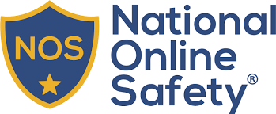

Once you have registered and begin using the online workshop we would welcome any reviews, thoughts and feedback.

