Year 7

Myths and Legends

Remote Learning
Resource Booklet

Key Vocabulary
Aetiological  derived from the Greek αἰτιολογία (aitiología) "giving a reason for" | To explain or give reasons for something in order to make sense of it
Allusion  from French, or from late Latin allusio(n- ), from the verb alludere | An expression or phrase that refers to a well-known story or idea without  naming it explicitly
Anthropomorphism  From  Greek anthrōpomorphos (from anthrōpos ‘human being’ + morphē ‘form’) | A god, animal or object with human characteristics
Archetypal  from Greek arkhetupon ‘something moulded first as a model’ | Typical of a certain person or thing
Epic  From Greek epos meaning ‘word, song.’ | A long poem, typically from ancient tradition, narrating the deeds and adventures of heroic figures
Heroism  comes from the Greek ἥρως (hērōs), "hero" (literally "protector" or "defender | Bravery or courage; to live by the heroic code
Hubris  From ancient Greek. | Excessive pride towards or defiance of the gods, leading to nemesis
Metamorphosis from metamorphoun ‘transform, change shape’. | To undergo a change of some kind
Moral  From moralia, matters relating to customs and mores | A lesson learned as a result of a story or experience
Mortal from Latin mortalis, from mors, mort- ‘death’. | A living human being, often in contrast to a divine being or gods
Myth  From mythos, to report, tale, story | A traditional story that explains, provides a moral, or marks a historical event
Nemesis from nemein ‘give what is due’. | Consequences to actions, usually final or fatal
Psychological  from Renaissance Latin psychologia, the study of the soul | Affecting the mind; related to the  mental or emotional state of  someone
Stereotypical  from Greek stereos "solid") + French type "type" | A fixed idea about a particular type of person or thing
Vengeance  from Latin vindicare ‘vindicate’ | An act of revenge for an injury or wrong carried out.

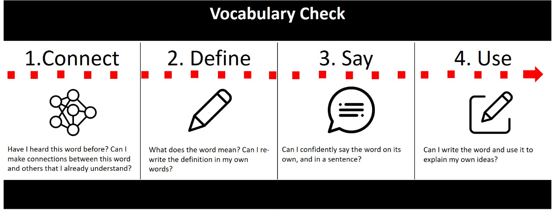

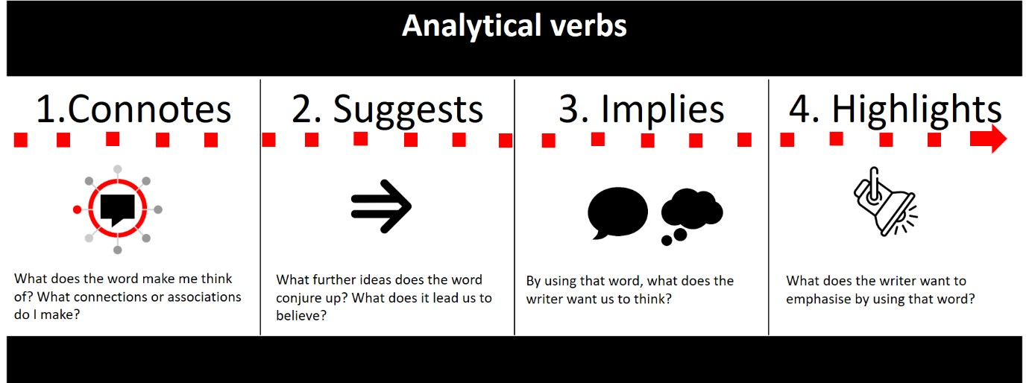

Norse mythology

Norse mythology are a collection of tales from the times of the Vikings, a time when the Scandinavian and Norwegian tribes of Vikings invaded new regions for riches and land, including Anglo-Saxon England, when the Vikings invaded the abbey of Lindisfarne, off the northeast coast of England. Their mythology tales included their own Gods, who were heroes and warriors. Several words originate from the Vikings, including:
- Husband: this came from the word for ‘house’ and ‘bond’ meaning ‘house owner’
- Troll/elf: Norse myths often contained different kinds of monsters
- Thursday/Wednesday: days of the week names after Viking Gods Thor and (W) Odin

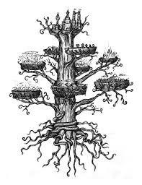
The Vikings believed the universe was organised into nine worlds surrounding the tree of life, Yggdrasil. Yggdrasil (Old Norse Yggdrasil or Askr Yggradils) is the mighty tree whose trunk rises at the geographical centre of the Norse spiritual cosmos. The rest of that cosmos, including the Nine Worlds, is arrayed around it and held together by its branches and roots, which context the various parts of the cosmos to one another. Because of this, the well-being of the cosmos depends on the well-being of Yggdrasil. When the tree trembles, it signals the arrival of Ragnarok, the destruction of the universe. Humans occupied the ‘Middle Earth’, or Midgard. Gods lived above in Asgard, where they had splendid Meadhalls including Valhalla, reserved for great
warriors. Creatures like elves, giants and dwarves occupied the rest of the universe. Like the Greek gods, the Norse gods were anthropomorphic, i.e. behaved like humans.

Neil Gaiman: Norse Mythology, Odin, Thor and Loki

The great Norse myths, which have inspired so much modern fiction are retold here by Neil Gaiman. In this chapter, Gaiman introduces the main players of Norse Mythology: Odin, Thor and Loki.

1 Many gods and goddesses are named in Norse mythology. Most of the stories we have however, concern two gods, Odin and his son, Thor, and Odin’s blood brother, a giant’s son 3 called Loki who lives with the Aesir in Asgard.

Odin
5 The highest and the oldest of all the gods is Odin. Odin knows many secrets. He gave an eye for wisdom. More than that, for knowledge of runes and for power, he sacrificed 7 himself to himself.

He hung from the world-tree, Yggdrasil, hung there for nine nights. His side was pierced by 9 the point of a spear which wounded him gravely. The winds clutched at him, buffeting his body as it hung. Nothing did he eat for nine days or nine nights, nothing did he drink. He 11 was alone there, in pain, the light of his life slowly going out. He was cold, in agony, and on the point of death when his sacrifice bore dark fruit: in the ecstasy of his agony he looked 13 down and the runes were revealed to him. He knew them, and understood them and their power. The rope broke then, and he fell screaming from the tree.

15 Now he understood magic. Now the world was his to control.

Odin has many names. He is the all-father, the lord of the slain, the gallows god. He is the 17 god of cargoes and of prisoners. He is called Grimnir and Third. He has different names in every country (for he is worshipped in different forms and in many tongues, but it is always 19 Odin that they worship).

He travels from place to place in disguise, to see the world as we see it. When he walks 21 among us, he does so as a tall man, wearing a cloak and a hat. He has two ravens, whom he calls Huginn and Muninn, which mean thought and memory. These birds fly back and forth 23 across the world, seeking news and bringing Odin all the knowledge of things. They perch on his shoulders and whisper into his ears. When he sits on his high throne at Hlidskjalf, he 25 observes all things, wherever they may be. Nothing can be hidden from him. He brought war into the world: battles are begun by throwing a spear at the hostile army, dedicating 27 the battle and its deaths to Odin. If you survive in battle, it is with Odin’s grace, and if you fall it is because he has betrayed you. If you fall bravely in war the Valkyries, beautiful 29 battle maidens who collect the souls of the noble dead, will take you and bring you to the hall known as Valhalla. He will be waiting for you in Valhalla, and there you will drink and 31 fight and feast and battle, with Odin as your leader.

Thor
33 Thor, Odin’s son is the thunderer. He is straightforward where his father is cunning, good natured where his father is devious. Huge he is, and red-bearded, and strong, by far the 35 strongest of all the gods. His might is increased by his belt of strength, Megingjord: when he wears it, his strength is doubled. Thor’s weapon is Mjollnir, a remarkable hammer, 37 forged for him by dwarfs. Its story you will learn. Trolls and frost giants and mountain giants
all tremble when they see Mjollnir, for it has killed so many of their brothers and friends. Thor wears iron gloves which help him to grip the hammer’s shaft. Thor’s mother was Jord, the earth goddess. Thor’s sons are Modi, the angry and Magni, the strong. Thor’s daughter is Thrud, the powerful. His wife is Sif, of the golden hair. She had a son, Ullr, before she married Thor, and Thor is Ullr’s step-father. Ullr is a god who hunts with bow and with arrows, and he is the god with skis. Thor is the defender of Asgard and of Midgard. There are many stories about Thor and his adventures. You will hear them.

Loki
Loki is very handsome. He is plausible, convincing, likeable, and far and away the most wily, subtle and shrewd of all the inhabitants of Asgard. It is a pity then, that there is so much darkness in Loki: so much anger, so much envy, so much lust. Loki is the son of Laufey, who was also known as Nal, or needle, because she was so slim and beautiful and sharp. His father was said to be Farbauti, a giant; his name means ‘he who strikes dangerous blows’, and Fabauti was as dangerous as his name.
Loki walks in the sky with shoes that fly, and he can transform his shape so he looks like other people, or change into animal form, but his real weapon is his mind. He is more cunning, subtler, trickier than any god or giant. Not even Odin is as cunning as Loki.

Loki is Odin’s blood brother. The other gods do not know when Loki came to Asgard, or how. He is Thor’s friend and Thor’s betrayer. He is tolerated by the gods, perhaps because his stratagems and plans save them as often as they get them into trouble.

Loki makes the world more interesting but less safe. He is the father of monsters, the author of woes, the sly god.
Loki drinks too much, and he cannot guard his words or thoughts when he drinks. Loki and his children will be there for Ragnarok, the end of everything, and it will not be on the side of the gods or Asgard that they will fight.
Thor

As we re-read Thor’s introductory paragraphs, consider the way in which Nail Gaiman structures the piece of writing to make the character intriguing and interesting.

1  3  5  7  9  11  13  15  17 | Thor  Thor, Odin’s son is the thunderer.  He is straightforward where his father is cunning, good-natured where his father is devious.  Huge he is, and red-bearded, and strong, by far the strongest of all the gods. His might is increased by his belt of strength, Megingjord: when he wears it, his strength is doubled.  Thor’s weapon is Mjollnir, a remarkable hammer, forged for him by dwarfs. Its story you will learn. Trolls and frost giants and mountain giants all tremble when they see Mjollnir, for it has killed so many of their brothers and friends. Thor wears iron gloves which help him to grip the hammer’s shaft.  Thor’s mother was Jord, the earth goddess. Thor’s sons are Modi, the angry and Magni, the strong.  Thor’s daughter is Thrud, the powerful. | Opens with a statement that clearly identifies that the character is the focus and tells us 2 brief bits of information about them.  Now starts to describe his physical appearance. Starts with an adjective, adds another, then comes to an attribute which it then elaborates on for emphasis. Then includes a second sentence telling us more about this particular key attribute by linking it to a physical object or symbol associated with him.  The next paragraph describes a symbol associated with the character. In Thor’s case this is a weapon. It may well not be in your character’s case. Follow the pattern of this paragraph, keeping in the line ‘Its story you will learn’ where it is.  Now go on to write the next two parts. In the first briefly describe your character’s significant family or friends. In the second, briefly describe key
19  21  23 | His wife is Sif, of the golden hair. She had a son, Ullr, before she married Thor, and Thor is Ullr’s stepfather. Ullr is a god who hunts with bow and with arrows, and he is the god with skis.  Thor is the defender of Asgard and of Midgard. There are many stories about Thor and his adventures. You will hear them. | attributes of one of your character’s close friends or family.  This ends with a short declarative sentence which sums up Thor and then entices the reader with information about all the stories that are to come.

The Treasures of the Gods and The Creation of Thor’s Hammer

Loki travelled to Níðavellir, the land of the dwarves, where he found the two dwarf sons of Ivaldi. They agreed to fabricate hair from gold, as fine as Sif's own hair, and with the magical ability to grow on her head. Once completed, they decided to make additional gifts to please and placate the gods. Thor’s hammer was the third gift, preceded by a golden ship that could sail on air, and a golden arm ring.

As we read, consider the way in which Loki manipulates the dwarves, particularly when it looks as though his life is under threat.

1 One day, Loki the trickster found himself in an especially mischievous mood and cut off the gorgeous golden hair of Sif, the wife of Thor. When Thor learned of this, his quick temper was 3 enraged, and he seized Loki and threatened to break every bone in his body. Loki pleaded with the thunder god to let him go down to Svartalfheim, the cavernous home of
5 the dwarves, and see if those master craftspeople could fashion a new head of hair for Sif, this one even more beautiful than the original. Thor allowed this, and off Loki went to 7 Svartalfheim.

There he was able to obtain what he desired. The sons of the dwarf Ivaldi forged not only a
9 new head of hair for Sif, but also two other marvels: Skidbladnir (“Assembled from Thin Pieces of Wood”, the best of all ships, which always has a favorable wind and can be folded 11 up and put into one’s pocket, and Gungnir (“Swaying”, the deadliest of all spears.

Having accomplished his task, Loki was overcome by an urge to remain in the caves of the
13 dwarves and revel in more recklessness. He approached the brothers Brokkr and Sindri
(“Metalworker” and “Spark-sprayer,” respectively) and taunted them, saying that he was sure 15 the brothers could never forge three new creations equal to those the sons of Ivaldi had fashioned. In fact, he even bet his head on their lack of ability. Brokkr and Sindri, however, 17 accepted the wager.

As they worked, a fly (who, of course, was none other than Loki in disguise) stung Sindri’s 19 hand. When the dwarf pulled his creation out of the fire, it was a living boar with golden hair. This was Gullinbursti (“Golden-bristled”), who gave off light in the dark and could run better than any horse, even through water or air.
Sindri then set another piece of gold on the fire as Brokkr worked the bellows. The fly bit Brokkr on the neck, and Sindri drew out a magnificent ring, Draupnir (“Dripper”. From this ring, every ninth night, fall eight new golden rings of equal weight.
23
Sindri then put iron on the hearth, and told Brokkr that, for this next working, they must be especially meticulous, for a mistake would be more costly than with the previous two 25 projects. Loki immediately stung Brokkr’s eyelid, and the blood blocked the dwarf’s eye, preventing him from properly seeing his work. Sindri produced a hammer of unsurpassed 27 quality, which never missed its mark and would boomerang back to its owner after being thrown, but it had one flaw: the handle was short. Sindri lamented that this had almost 29 ruined the piece, which was called Mjollnir (“Lightning”. Nevertheless, sure of the great worth of their three treasures, Sindri and Brokkr made their way to Asgard to claim the 31 wages that were due to them.

33 Loki made it to the halls of the gods before the dwarves and presented the marvels he had acquired. To Thor he gave Sif’s new hair and the hammer Mjollnir. To Odin went the ring 35 Draupnir and the spear Gungnir. And Freyr was the happy recipient of Skidbladnir and Gullinbursti.

37 As grateful as the gods were to receive these gifts – especially Mjollnir, which they foresaw would be of inestimable help in their battles against the giants – they nevertheless concluded 39 that Loki still owed the dwarves his head. When the dwarves approached Loki with knives, the cunning god pointed out that he had promised them his head, but not his neck. Brokkr and Sindri contented themselves with sewing Loki’s mouth shut, and returned to their forge.
Task:
Write Loki’s final speech, before his mouth is sewn up.

We will look at an example together before we write, and use the different techniques used by the writer we have studied to create writing of a high quality.

Consider:
- The purpose of Loki’s speech
- Who he may direct the speech to or directly address
- The excuses he may make for his behaviour
- What he may promise to avoid his punishment

Date:  Exemplar  1  3  5  7  9  11  13  15  17  19  21  23 | Before you put me to death, I beg of you: hear my predicament. I am still Loki, son of Odin, and therefore, I do think I deserve to have my voice heard. It is vital to me that you understand the reasons behind my actions, and that I thought everything I did was for the best. If nothing else  Let me start by reminding you that I only fled as a result of Thor’s threats and cruelty. What started out as a light-hearted joke quickly turned into something more. I feared for my life! Thor’s fury is uncontrollable and terrifying, and I was forced into leaving my home for my own safety. Could you imagine, having to leave everything that’s important to you because of your own brother? He left me with no choice, and I sought refuge with the Dwarves, thinking that they would take care of me. I was wrong.  Originally there to make amends for my errors, I asked the dwarves to make a headscarf that I intended to present as a gift to Sif, my dear sister-in-law, as a way to apologise. However, my good intentions have been re-told as making mischief and trouble, and that simply isn’t the truth. I have been ridiculed, shunned and exiled, and now I am the one in the wrong? Shocked, I feel that this needs further attention.  Whilst some may argue that I am only remorseful now because I know my punishment will be fatal, I would say that my behaviour to date says the very opposite. I appreciate that I joke around, and at times, can be thoughtless when it comes to people’s feelings. However, it is never to upset or offend anyone. I am nothing but loyal to you,  Father. I am nothing but true to you, Father. I am nothing but genuine,  87
Father. Beyond all else, I want you to remember this when you allow 29 these dwarves to take a thread to my mouth and leave me to a lifetime of isolation.

31 There’s nothing more to say at this stage, but all I can ask is for your forgiveness, your kindness, your mercy. Wondering what will become of me, my life is now in your hands.

Reappearing characters in literature

The concept of myths and gods has been used throughout many different religions, countries, cultures and periods of history to explain the different aspects of human behaviour and ideas in society.
What can we recognise from the myths that we have studied, and more recent stories?
Where do the same characters repeatedly appear?
Think about heroes, heroines, villains, monsters, gods and creatures.

Characters in literature: a comparison

In pairs, write two characters that fall into the categories and think about what they have in common. What characteristics do they share?

The Warrior | Women | The Gods
- Commit to the heroic code  - Morally good | - Taunt or tempt male characters  - Fought over like possessions | - Have ultimate control over mortals  - Cause deliberate upset to mortals for their own entertainment

Atalanta | Freyja
The great hero Atalanta had a most royal pedigree: her mother was Clymene of the royal Minyad clan and her father was an Archadian king and the kind of ruler who had no use for female offspring. When his first born by Clymene proved to be a girl, he had the child taken from the palace and exposed on a mountainside to die.  The baby was abandoned in a high cranny on Mount Parthenion where she would soon surely die. Indeed, only half an hour after the palace guard laid her down a bear, attracted by the cries lumbered up to investigate. A maternal instinct drove the bear and instead of eating the infant, she suckled her.  The human baby girl grew to by a sly, wild and swift forest creature. One day she was seen and taken by a group of hunters. They named her Atalanta and taught her the secrets of trapping and killing, of shooting with arrows, spears and slings, coursing, hunting, tracking and all the arts of venery and the chase. She quickly equalled and surpassed their skill, combining as she did human subtlety with the ferocity and speed of the bear that brought her up. | Freyja, (Old Norse for “Lady”), most renowned of the Norse goddesses, who was in charge of love, fertility, battle, and death. Her father was Njörd, the sea god. Pigs were sacred to her, and she rode a boar with golden bristles. A chariot drawn by cats was another of her vehicles. It was Freyja’s privilege to choose onehalf of the heroes slain in battle for her great hall in the Fólkvangar (the god Odin took the other half to Valhalla). She possessed a famous necklace called Brísinga men, which the trickster god Loki stole and Heimdall, the gods’ watchman, recovered. Greedy and lascivious, Freyja was also credited with the evil act of teaching witchcraft to the Aesir (a tribe of gods). Like the Egyptian goddess Isis and the Greek Aphrodite, Freyja traveled through the world seeking a lost husband and weeping tears of gold. She was also known by four nicknames— Mardöll, Hörn, Gefn, and Syr.
- Write two similarities between the characters of Atalanta and Freyja.
- How would you describe their personalities and why?
- Do these female characters fit or rebel against gender stereotypes that we saw before?
- Who is more powerful and how?

Beowulf

Beowulf is the most important work of medieval literature that exists in Britain. It is approximately 1000 years old and written in Old English, a language related to Old German and Norse. More than 3,000 lines long and originally brought to Britain by Danish Viking tribes, the story is set in Scandinavia Beowulf tells the story of the lead protagonist Beowulf, and his battles with a monster named Grendel, with Grendel’s revengeful mother, and with a dragon which was guarding a hoard of treasure. This epic poem, like the Iliad and the Odyssey, would have been sung and recited, not written down until later; and like the Odyssey, there is magic and monsters.
We only have one surviving manuscript copy, that was almost destroyed in a fire in London in the 1700s. You can see the manuscript (and its burn marks) in the British Library today.
Epics focus on a key hero of indescribable strength, feature a feat that others would never be able to complete, and use an omniscient (all-knowing) narrator to create a formal epic poem.

The language used within the epic poem is Old English, a language somewhat recognisable to some of the words we use today. Let’s look at an extract from the text.

[Grendel] slat unwearnum,  bat banlocan, blod edrum dranc,  synsnædum swealh; sona hæfde  unlyfigendes eal gefeormod,  fet ond folma | Grendel tore without hesitation,  bit the bone-locks, drank the blood of the veins,  swallowed sinful bites; soon he had  entirely consumed the unliving one,  down to his feet and hands.

With your working partner, consider the following ideas:

- Which words are similar between Old English and the modern day translation?
- Which words are different and how? Think about if they are completely different, or have been merged with other words, or are unrecognisable.
Kennings

One feature of Old English Poetry is the use of kennings, for example ‘whale-road’ for sea. This is a language technique where an ordinary noun is renamed in a creative way using a compound word (two different words combined with a hyphen).

Examples include:
- Bone-house: the human body
- Wave-floater: ship
- Book-worm: someone who likes to read books
- Ankle-biter: young child
- First-lady: the wife of the president

Create your own kennings for three of the following items:
- Friend
- Shoes
- Book
- Television

In this extract from the epic poem, Beowulf and Grendal the dragon fight.

1 His talon was raised to attack Beowulf What does this
Where he lay on the bed; he was bearing in surprise attack
With open claw when the alert hero’s suggest about
Grendel?
Comeback and armlock forestalled him utterly.
The captain of evil discovered himself
In a handgrip harder than anything He had ever encountered in any man
On the face of the earth. Every bone in his body Quailed and recoiled, but he could not escape. He was desperate to flee to his den and hide With the devil’s litter, for in all his days

He had never been clamped or cornered like this. Then Hygelac’s trusty retainer recalled
His bedtime speech, sprang to his feet
And got a firm hold. Fingers were bursting, Who is winning the
The monster back-tracking, the man overpowering. battle at this stage?
The dread of the land was desperate to escape, How do you know?
20
To take a roundabout road and flee

To his lair in the fens. The latching power
In his fingers weakened; it was the worst trip
The terror-monger had taken to Heorot. 25
And now the timbers trembled and sang,
A hall-session that harrowed every Dane

Inside the stockade: stumbling in fury,
What almost gets
The two contenders crashed through the building. broken in the fray?
30 The hall clattered and hammered, but somehow Survived the onslaught and kept standing:
It was handsomely structured, a sturdy frame
Braced with the best of blacksmith’s work
Inside and out. The story goes
35
That as the pair struggled, mead-benches were smashed

And sprung off the floor, gold fittings and all.
Before then, no Shielding elder would believe
There was any power of person upon earth
40 Capable of wrecking their horn-rigged hall
Unless the burning embrace of a fire
Engulf it in flame. Then an extraordinary
How is Grendal’s wail
Wail arose, and bewildering fear
presented as
45
Came over the Danes. Everyone felt it dramatic?
Who heard that cry as it echoed off the wall,

Date:  50  55  60  65  70  75  80  85 | A God-cursed scream and strain of catastrophe,  The howl of the loss, the lament of the hell-serf  Keening his wound. He was overwhelmed,  Manacled tight by the man who of all men  Was foremost and strongest in the days of this life. But the earl-troop’s leader was not inclined To allow his caller to depart alive:  He did not consider that life of much account  To anyone anywhere. Time and again,  Beowulf’s warriors worked to defend  Their lord’s life, laying about them  As best they could with their ancestral blades.  Stalwart in action, they kept striking out  On every side, seeking to cut  Straight to the soul. When they joined the struggle  There was something that could not have known at the time,  That no blade on earth, no blacksmith’s art Could ever damage their demon opponent.  He had conjured the harm from the cutting edge  Of every weapon. But his going away  Out of this world and the days of his life Would be agony to him, and his alien spirit Would travel far into fiend’s keeping.  Then he who had harrowed the hearts of men  With pain and affliction in former times  And had given offence also to God  Found that his bodily powers failed him.  Hygelac’s kinsman kept him helplessly  Locked in a handgrip. As long as either lived, He was hateful to the other. The monster’s whole body was in pain, a tremendous wound  Appeared on his shoulder. Sinews split  And the bone-lappings burst. Beowulf was granted  The glory of winning; Grendel was driven  Under the fen-banks, fatally hurt,  To his desolate lair. His days were numbered,  The end of his life was coming over him, He knew it for certain; and one bloody clash Had fulfilled the dearest wish of the Danes. | Manacles are iron chains- how does this make us imagine Beowulf’s power?  What do we discover about Grendal? How has Beowulf got around this problem?  Where does Grendal retreat to? How is it described and how does that reflect her retreat?  105

There are six key features of an epic, but we will focus on three of them:
- A key hero of indescribable strength
- Feature a feat that others would never be able to complete
- Use an omniscient (all-knowing) narrator

