Year 8 Gothic Part 2

Home Learning

Resource Pack

Jekyll and Hyde by Robert Louis Stevenson (1886) Extract 1

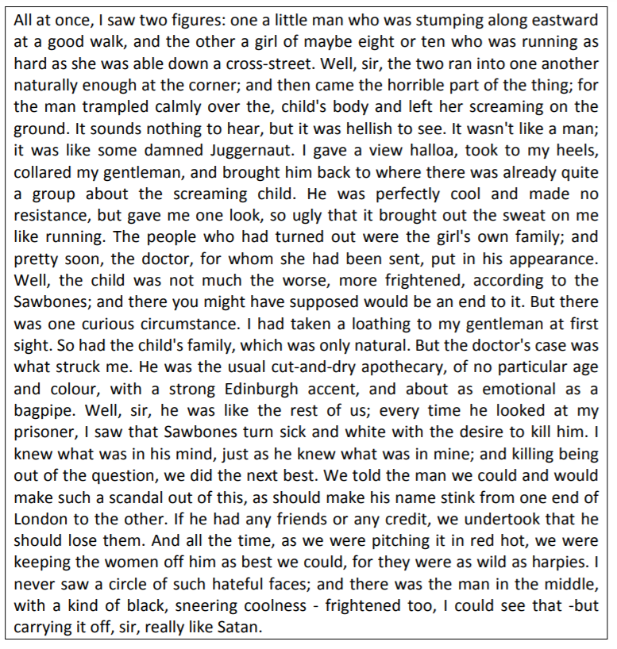

Jekyll and Hyde by Robert Louis Stevenson (1886) Extract 2

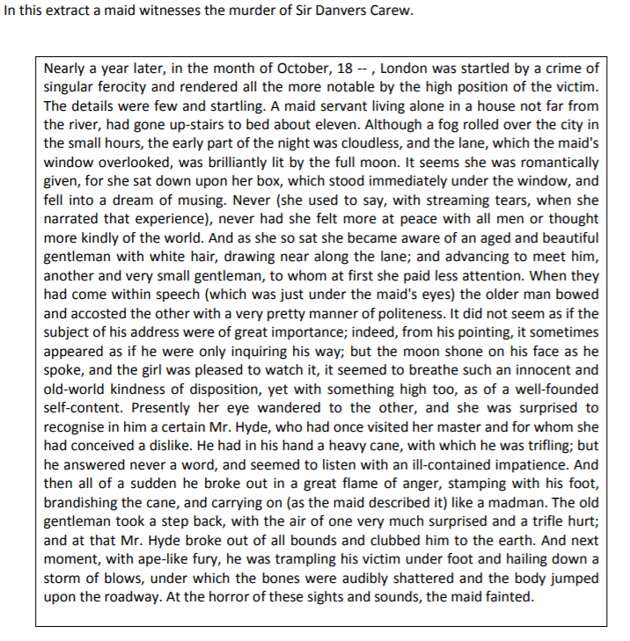

Jekyll and Hyde by Robert Louis Stevenson (1886) Extract 3

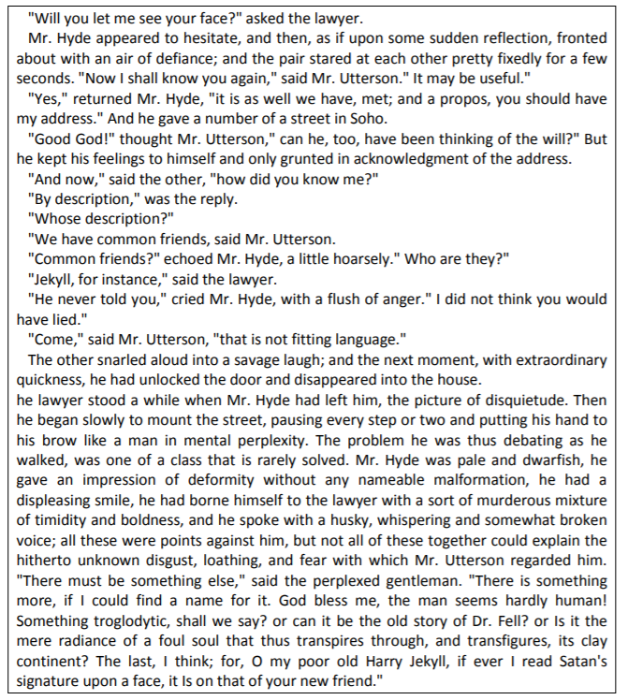

Jekyll and Hyde by Robert Louis Stevenson (1886) Extract 4

In this extract, Utterson and Enfield are on a walk and describe Dr Jekyll’s house.

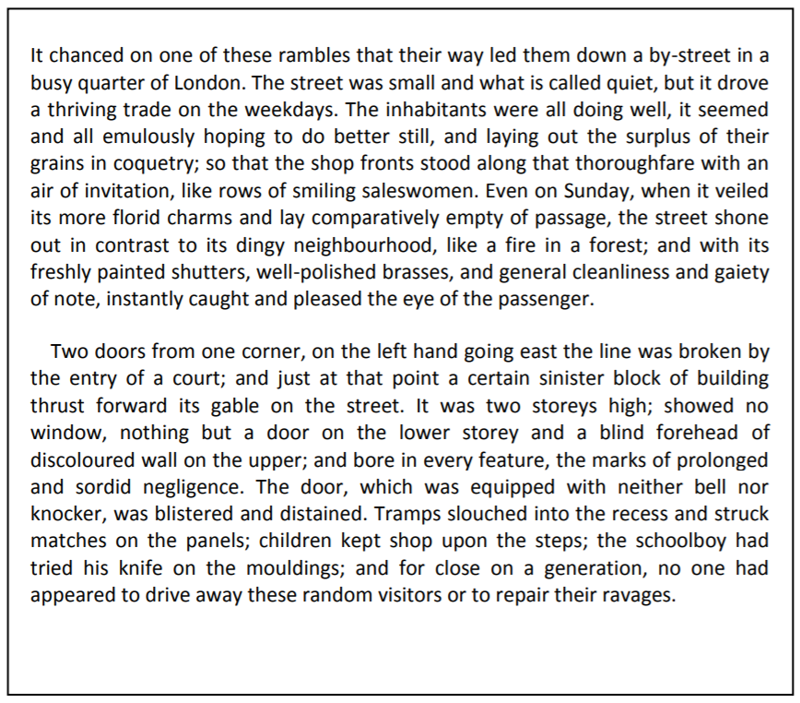

Extract from Jane Eyre by Charlotte Bronte (1847)
I have been married, and the woman to whom I was married lives! You say you never heard of a Mrs. Rochester at the house up yonder, Wood; but I daresay you have many a time inclined your ear to gossip about the mysterious lunatic kept there under watch and ward. Some have whispered to you that she is my bastard half-sister: some, my cast-off mistress. I now inform you that she is my wife, whom I married fifteen years ago, — Bertha Mason by name; sister of this resolute personage, who is now, with his quivering limbs and white cheeks, showing you what a stout heart men may bear. Cheer up, Dick! — never fear me! — I'd almost as soon strike a woman as you. Bertha Mason is mad; and she came of a mad family; idiots and maniacs through three generations! Her mother, the Creole, was both a madwoman and a drunkard! — as I found out after I had wed the daughter: for they were silent on family secrets before. Bertha, like a dutiful child, copied her parent in both points. I had a charming partner — pure, wise, modest: you can fancy I was a happy man. I went through rich scenes! Oh! my experience has been heavenly, if you only knew it! But I owe you no further explanation. Briggs, Wood, Mason, I invite you all to come up to the house and visit Mrs. Poole's patient, and my wife ! You shall see what sort of a being I was cheated into espousing, and judge whether or not I had a right to break the compact, and seek sympathy with something at least human. This girl," he continued, looking at me, "knew no more than you, Wood, of the disgusting secret: she thought all was fair and legal and never dreamt she was going to be entrapped into a feigned union with a defrauded wretch, already bound to a bad, mad, and embruted partner! Come all of you — follow!"
Still holding me fast, he left the church: the three gentlemen came after. At the front door of the hall we found the carriage.
"Take it back to the coach-house, John," said Mr. Rochester coolly; "it will not be wanted to-day."
At our entrance, Mrs. Fairfax, Adele, Sophie, Leah, advanced to meet and greet us.
"To the right-about — every soul!" cried the master; "away with your congratulations! Who wants them? Not I! — they are fifteen years too late!"
He passed on and ascended the stairs, still holding my hand, and still beckoning the gentlemen to follow him, which they did. We mounted the first staircase, passed up the gallery, proceeded to the third storey: the low, black door, opened by Mr. Rochester's master-key, admitted us to the tapestried room, with its great bed and its pictorial cabinet.
"You know this place, Mason," said our guide; "she bit and stabbed you here."
He lifted the hangings from the wall, uncovering the second door: this, too, he opened. In a room without a window, there burnt a fire guarded by a high and strong fender, and a lamp suspended from the ceiling by a chain. Grace Poole bent over the fire, apparently cooking something in a saucepan. In the deep shade, at the farther end of the room, a figure ran backwards and forwards. What it was, whether beast or human being, one could not, at first sight, tell: it grovelled, seemingly, on all fours; it snatched and growled like some strange wild animal: but it was covered with clothing, and a quantity of dark, grizzled hair, wild as a mane, hid its head and face.
"Good-morrow, Mrs. Poole!" said Mr. Rochester. "How are you? and how is your charge to-day?"
"We're tolerable, sir, I thank you," replied Grace, lifting the boiling mess carefully on to the hob: "rather snappish, but not 'rageous."
A fierce cry seemed to give the lie to her favourable report: the clothed hyena rose up, and stood tall on its hind-feet.
"Ah! sir, she sees you!" exclaimed Grace: "you'd better not stay."
"Only a few moments, Grace: you must allow me a few moments."
"Take care then, sir! — for God's sake, take care!"
The maniac bellowed: she parted her shaggy locks from her visage, and gazed wildly at her visitors. I recognised well that purple face, — those bloated features. Mrs. Poole advanced.
"Keep out of the way," said Mr. Rochester, thrusting her aside: "she has no knife now, I suppose, and I'm on my guard."
"One never knows what she has, sir: she is so cunning: it is not in mortal discretion to fathom her craft."
"We had better leave her," whispered Mason.
"Go to the devil!" was his brother-in-law's recommendation.
"'Ware!" cried Grace. The three gentlemen retreated simultaneously. Mr. Rochester flung me behind him: the lunatic sprang and grappled his throat viciously, and laid her teeth to his cheek: they struggled. She was a big woman, in stature almost equalling her husband, and corpulent besides: she showed virile force in the contest — more than once she almost throttled him, athletic as he was. He could have settled her with a well-planted blow; but he would not strike: he would only wrestle. At last he mastered her arms; Grace Poole gave him a cord, and he pinioned them behind her: with more rope, which was at hand, he bound her to a chair. The operation was performed amidst the fiercest yells and the most convulsive plunges. Mr. Rochester then turned to the spectators: he looked at them with a smile both acrid and desolate.
"That is my wife ," said he. "Such is the sole conjugal embrace I am ever to know — such are the endearments which are to solace my leisure hours! And this is what I wished to have" (laying his hand on my shoulder): "this young girl, who stands so grave and quiet at the mouth of hell, looking collectedly at the gambols of a demon, I wanted her just as a change after that fierce ragout. Wood and Briggs, look at the difference! Compare these clear eyes with the red balls yonder — this face with that mask — this form with that bulk; then judge me, priest of the gospel and man of the law, and remember with what judgment ye judge ye shall be judged! Off with you now. I must shut up my prize."
We all withdrew. Mr. Rochester stayed a moment behind us, to give some further order to Grace Poole.

Wide Sargasso Sea by Jean Rhys (1966)

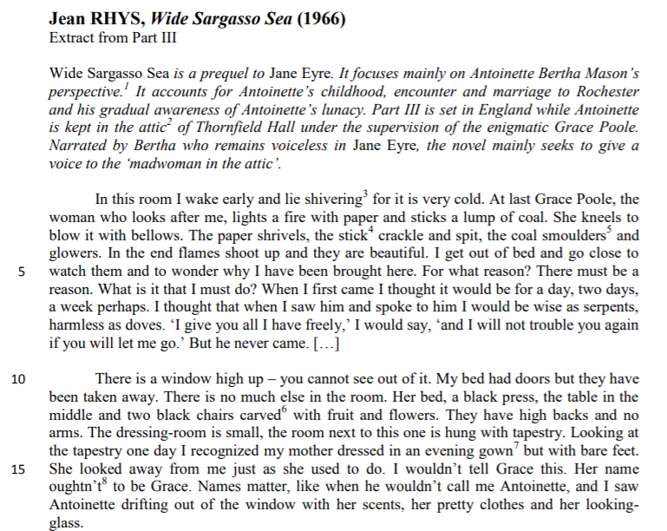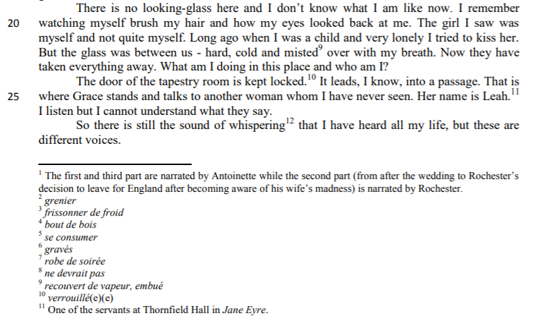

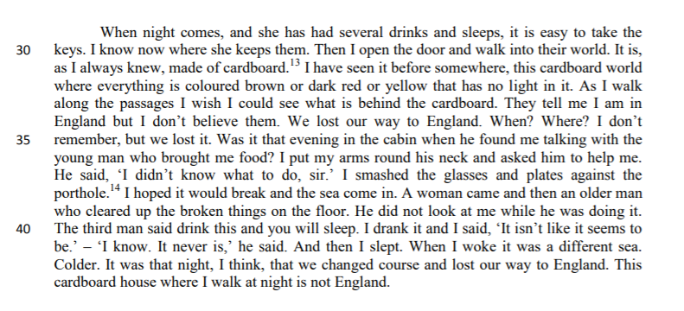

Frankenstein by Mary Shelley (1823)

It was on a dreary night of November that I beheld the accomplishment of my toils. With an anxiety that almost amounted to agony, I collected the instruments of life around me, that I might infuse a spark of being into the lifeless thing that lay at my feet. It was already one in the morning; the rain pattered dismally against the panes, and my candle was nearly burnt out, when, by the glimmer of the half-extinguished light, I saw the dull yellow eye of the creature open; it breathed hard, and a convulsive motion agitated its limbs.

How can I describe my emotions at this catastrophe, or how delineate the wretch whom with such infinite pains and care I had endeavoured to form? His limbs were in proportion, and I had selected his features as beautiful. Beautiful! Great God! His yellow skin scarcely covered the work of muscles and arteries beneath; his hair was of a lustrous black, and flowing; his teeth of a pearly whiteness; but these luxuriances only formed a more horrid contrast with his watery eyes, that seemed almost of the same colour as the dun-white sockets in which they were set, his shrivelled complexion and straight black lips.

The different accidents of life are not so changeable as the feelings of human nature. I had worked hard for nearly two years, for the sole purpose of infusing life into an inanimate body. For this I had deprived myself of rest and health. I had desired it with an ardour that far exceeded moderation; but now that I had finished, the beauty of the dream vanished, and breathless horror and disgust filled my heart. Unable to endure the aspect of the being I had created, I rushed out of the room and continued a long time traversing my bedchamber, unable to compose my mind to sleep. At length lassitude succeeded to the tumult I had before endured, and I threw myself on the bed in my clothes, endeavouring to seek a few moments of forgetfulness. But it was in vain; I slept, indeed, but I was disturbed by the wildest dreams. I thought I saw Elizabeth, in the bloom of health, walking in the streets of Ingolstadt. Delighted and surprised, I embraced her, but as I imprinted the first kiss on her lips, they became livid with the hue of death; her features appeared to change, and I thought that I held the corpse of my dead mother in my arms; a shroud enveloped her form, and I saw the grave-worms crawling in the folds of the flannel. I started from my sleep with horror; a cold dew covered my forehead, my teeth chattered, and every limb became convulsed; when, by the dim and yellow light of the moon, as it forced its way through the window shutters, I beheld the wretch—the miserable monster whom I had created. He held up the curtain of the bed; and his eyes, if eyes they may be called, were fixed on me. His jaws opened, and he muttered some inarticulate sounds, while a grin wrinkled his cheeks. He might have spoken, but I did not hear; one hand was stretched out, seemingly to detain me, but I escaped and rushed downstairs. I took refuge in the courtyard belonging to the house which I inhabited, where I remained during the rest of the night, walking up and down in the greatest agitation, listening attentively, catching and fearing each sound as if it were to announce the approach of the demoniacal corpse to which I had so miserably given life.

Oh! No mortal could support the horror of that countenance. A mummy again endued with animation could not be so hideous as that wretch. I had gazed on him while unfinished; he was ugly then, but when those muscles and joints were rendered capable of motion, it became a thing such as even Dante could not have conceived.

I passed the night wretchedly. Sometimes my pulse beat so quickly and hardly that I felt the palpitation of every artery; at others, I nearly sank to the ground through languor and extreme weakness. Mingled with this horror, I felt the bitterness of disappointment; dreams that had been my food and pleasant rest for so long a space were now become a hell to me; and the change was so rapid, the overthrow so complete!

Morning, dismal and wet, at length dawned and discovered to my sleepless and aching eyes the church of Ingolstadt, its white steeple and clock, which indicated the sixth hour. The porter opened the gates of the court, which had that night been my asylum, and I issued into the streets, pacing them with quick steps, as if I sought to avoid the wretch whom I feared every turning of the street would present to my view. I did not dare return to the apartment which I inhabited, but felt impelled to hurry on, although drenched by the rain which poured from a black and comfortless sky.

I continued walking in this manner for some time, endeavouring by bodily exercise to ease the load that weighed upon my mind. I traversed the streets without any clear conception of where I was or what I was doing. My heart palpitated in the sickness of fear, and I hurried on with irregular steps, not daring to look about me:

New Moon by Stephany Meyer (2006)

Despair momentarily vanished; wonder took its place. Even after a year and a half with him, I still couldn’t believe I deserved such good fortune.
His sister Alice was standing by his side, waiting for me too.
Of course Alice and Edward weren’t really related (in Forks the story was that all the Cullen children were adopted by Dr Carlisle Cullen and his wife, Esmee, both plainly too young to have teenage children), but their skin was precisely the same pale shade, their eyes had the same golden tint, with the same bruise-like shadows beneath them. Her face, like his, was also startlingly beautiful. To someone in the know- someone like me- these similarities marked them out for what they were.
She finally seemed to process my mood. “Okay....later then. Did you like the scrapbook your mom sent you? And the camera from Charlie?”
I sighed. Of course she knew what my presents were. Edward wasn’t the only member of his family with unusual skills. Alice would have “seen” what her parents were planning as soon as they’d decided that themselves.
We reached Edward then, and he held his hand out for mine. I took it eagerly, forgetting for a moment, my glum mood. His skin was as always smooth, hard and, very cold. He gave my finger a gentle squeeze.
“Eighteen isn’t very old,” Alice said. “Don’t women usually wait until their twenty-nine to get upset over their birthday.”
“It’s older than Edward,” I mumbled.
He sighed.
“Technically,” she said, keeping her tone light. “Just by one little year though.” And I supposed... if I could be sure of the future I wanted, sure that I would spend forever with Edward, and Alice and the rest of the Cullens (preferably not as a wrinkled old lady)...then a year or two one direction wouldn’t matter to me so much. But Edward was dead set against any future that changed me. Any future like him- that made me immortal too.
An impasse, he called it.
I couldn’t really see Edward’s point, to be honest. What was great about mortality? Being a vampire didn’t look like such a terrible thing-not the way the Cullen’s did it anyway.
I would never forget the first time I’d gone to his home, the huge white mansion buried deep in the forest behind the river....

Coraline by Neil Gaiman (2002)

Coraline, who has been visiting an alternative reality, discovers that her other parents are not quite what they seem.

Her other parents were waiting for her in the garden, standing side by side. They were smiling.
"Did you have a nice time?" asked her other mother. "It was interesting," said Coraline. The three of them walked back up to Coraline's other house together. Coraline's other mother stroked Coraline's hair with her long white fingers. Coraline shook her head.
"Don't do that," said Coraline.
Her other mother took her hand away.
"So," said her other father. "Do you like it here?"
"I suppose," said Coraline. "It's much more interesting than at home." They went inside.
"I'm glad you like it," said Coraline's other mother. "Because we'd like to think that this is your home. You can stay here for ever and always. If you want to."
"Hmm," said Coraline. She put her hands in her pockets and thought about it. Her fingertips touched the stone that the real Misses Spink and Forcible had given her the day before, the stone with the hole in it. "If you want to stay," said her other father. "There's only one little thing we'll have to do, so you can stay here for ever and always."
They went into the kitchen. On a china plate on the kitchen table were a spool of black cotton and a long silver needle and, beside them, two large black buttons.
"I don't think so," said Coraline. "Oh, but we want you to," said her other mother. "We want you to stay. And it's just a little thing."
"It won't hurt," said her other father.
Coraline knew that when grown-ups told you something wouldn't hurt it almost always did. She shook her head.
Her other mother smiled brightly and the hair on her head drifted like plants under the sea. "We only want what's best for you," she said.
She put her hand on Coraline's shoulder. Coraline backed away.
"I'm going now," said Coraline. She put her hands back in her pockets. Her fingers closed around the stone with the hole in.
Her other mother's hand scuttled off Coraline's shoulder like a frightened spider.
"If that's what you want," she said.
"Yes," said Coraline. "We'll see you soon, though," said her other father. "When you come back."
"Um," said Coraline.
"And then we'll all be together as one big happy family," said her other mother. "For ever and always."
Coraline backed away. She turned and hurried into the drawing room and pulled open the door in the corner. There was no brick wall there now— just darkness; a night-black underground darkness that seemed as if things in it might be moving.
Coraline hesitated. She turned back. Her other mother and her other father were walking towards her, holding hands. They were looking at her with their black-button eyes. Or at least she thought they were looking at her. She couldn't be sure.
Her other mother reached out her free hand and beckoned gently with one white finger. Her pale lips mouthed, "Come back soon," although she said nothing aloud.
Coraline took a deep breath and stepped into the darkness, where strange voices whispered and distant winds howled. She became certain that there was something in the dark behind her: something very old and very slow. Her heart beat so hard and so loudly she was scared it would burst out of her chest. She closed her eyes against the dark.
Eventually she bumped into something, and opened her eyes, startled. She had bumped into an armchair, in her drawing room.
The open doorway behind her was blocked by rough red bricks.
She was home.

The Woman in Black by Susan Hill (1983)

‘The Woman in Black’ was written in 1983, but mimics the style of much older Gothic horror stories from the nineteenth century. The plot concerns a small English town haunted by a mysterious spectre, the titular Woman, and foretells the death of children. Arthur Kipps, a young solicitor, is intrigued by the mystery and stays the night at Eel House, the home of the Woman in Black. In this extract, he details his first night in the house.

During the night the wind rose. As I had lain reading I had become aware of the stronger gusts that blew every so often against the casements. But when I awoke abruptly in the early hours it had increased greatly in force. The house felt like a ship at sea, battered by the gale that came roaring across the open marsh. Windows were rattling everywhere and there was the sound of moaning down all the chimneys of the house and whistling through every nook and cranny.

At first I was alarmed. Then, as I lay still, gathering my wits, I reflected on how long Eel Marsh House had stood here, steady as a lighthouse, quite alone and exposed, bearing the brunt of winter after winter of gales and driving rain and sleet and spray. It was unlikely to blow away tonight. And then, those memories of childhood began to be stirred again and I dwelt nostalgically upon all those nights when I had lain in the warm and snug safety of my bed in the nursery at the top of our family house in Sussex, hearing the wind rage round like a lion, howling at the doors and beating upon the windows but powerless to reach me. I lay back and slipped into that pleasant, trancelike state somewhere between sleeping and waking, recalling the past and all its emotions and impressions vividly, until I felt I was a small boy again.

Then from somewhere, out of that howling darkness, a cry came to my ears, catapulting me back into the present and banishing all tranquillity. I listened hard. Nothing. The tumult of the wind, like a banshee, and the banging and rattling of the window in its old, ill-fitting frame. Then yes, again, a cry, that familiar cry of desperation and anguish, a cry for help from a child somewhere out on the marsh.

There was no child. I knew that. How could there be? Yet how could I lie here and ignore even the crying of some long-dead ghost?

“Rest in peace,” I thought, but this poor one did not, could not.

After a few moments I got up. I would go down into the kitchen and make myself a drink, stir up the fire a little and sit beside it trying, trying to shut out that calling voice for which I could do nothing, and no one had been able to do anything for … how many years?

As I went out onto the landing, Spider the dog following me at once, two things happened together. I had the impression of someone who had just that very second before gone past me on their way from the top of the stairs to one of the other rooms, and, as a tremendous blast of wind hit the house so that it all but seemed to rock at the impact, the lights went out. I had not bothered to pick up my torch from the bedside table and now I stood in the pitch blackness, unsure for a moment of my bearings.

And the person who had gone by, and who was now in this house with me? I had seen no one, felt nothing. There had been no movement, no brush of a sleeve against mine, no disturbance of the air, I had not even heard a footstep. I had simply the absolutely certain sense of someone just having passed close to me and gone away down the corridor. Down the short narrow corridor that led to the nursery whose door had been so firmly locked and then, inexplicably, opened.

For a moment I actually began to conjecture that there was indeed someone—another human being—living here in this house, a person who hid themselves away in that mysterious nursery and came out at night to fetch food and drink and to take the air. Perhaps it was the woman in black? Had Mrs. Drablow harboured some reclusive old sister or retainer, had she left behind her a mad friend that no one had known about? My brain spans all manner of wild, incoherent fantasies as I tried desperately to provide a rational explanation for the presence I had been so aware of. But then they ceased. There was no living occupant of Eel Marsh House other than myself and Samuel Daily’s dog. Whatever was about, whoever I had seen, and heard rocking, and who had passed me by just now, whoever had opened the locked door was not “real.” No. But what was “real”? At that moment I began to doubt my own reality.

