Year 9
Rhetoric
Resource
Booklet

Creative Writing Memoir extract – lesson 1
Extract 1
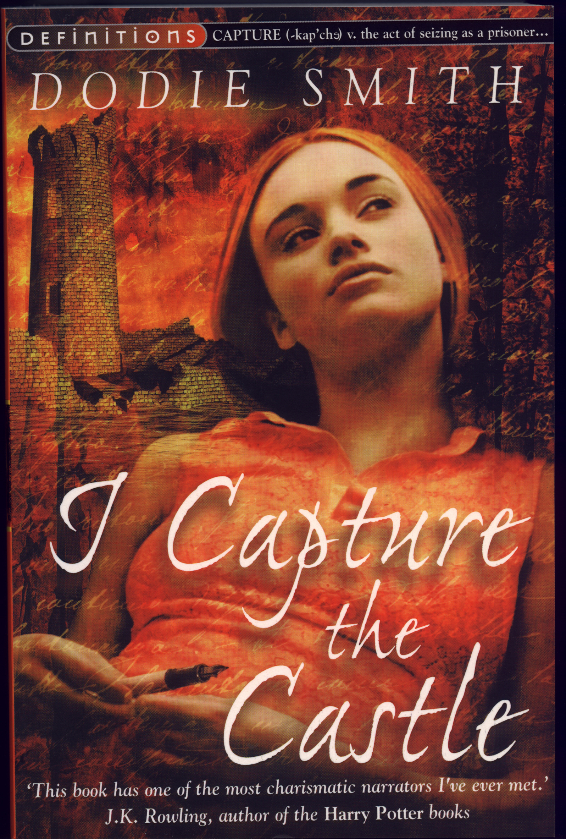
I write this sitting in the kitchen sink.
That is, my feet are in it; the rest of me is on the draining board, which I have padded with our dog's blanket and the tea-cosy.
I can't say that I am really comfortable, and there is a depressing smell of carbolic soap, but this is the only part of the kitchen where there is any daylight yet.
And I have found that sitting in a place where you have never sat before can be inspiring.
I wrote my very best poem while sitting on the hen house.
Though even that isn't a very good poem.
Drips from the roof are plopping into the water-butt by the back door.
The view through the windows above the sink is excessively drear.
Beyond the dank garden in the courtyard are the ruined walls of the edge of the moat.

Creative Writing Memoir extract – lesson 2
Extract 2
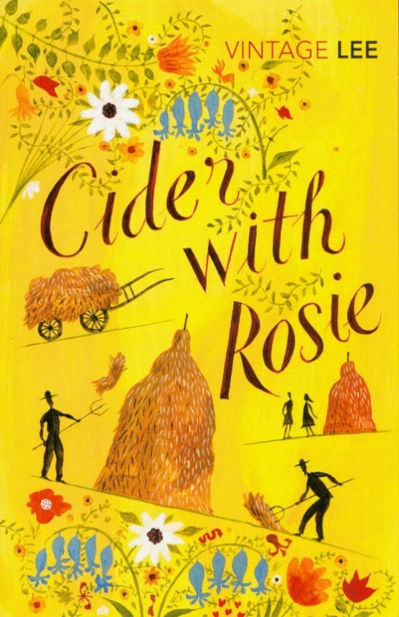
I was set down from the carrier's cart at the age of three; and there with a sense of bewilderment and terror, my life in the village began.
The June grass amongst which I stood was taller than I was, and I wept.
I had never been so close to grass before.
It towered above me and all around me, each blade tattooed with tiger-skins of sunlight.
It was knife-edged, dark, and a wicked green, thick as a forest and alive with grasshoppers that chirped and chatted and leaped through the air like monkeys.
I was lost and didn't know where to move.
A tropic heat oozed up from the ground, rank with sharp odours of roots and nettles.
Snow-clouds of elder-blossom banked in the sky, showering upon me the fumes and flakes of their sweet and giddy suffocation.
High overhead ran frenzied larks, screaming, as though the sky was tearing apart.
For the first time in my life I was out of the sight of humans.
For the first time in my life I was alone in a world whose behaviour I could neither predict nor fathom: a world of birds that squealed, of plants that stank, of insects that sprang about without warning.
I was lost and I did not expect to be found again.
I put back my head and howled, and the sun hit me smartly on the face, like a bully.

Creative Writing Memoir extract – lesson 3

Extract 3
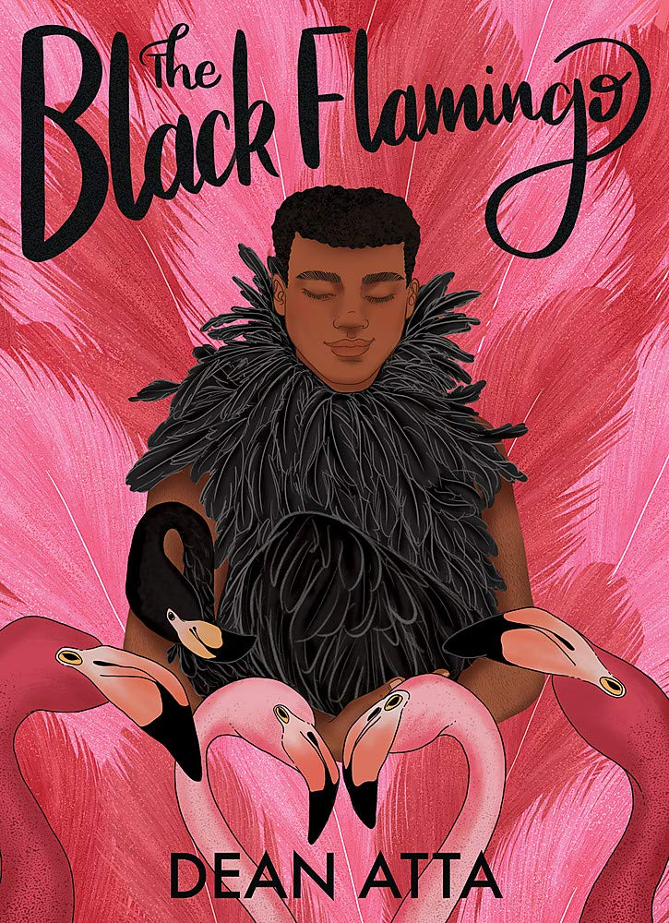
I am eight when my sister Anna is placed into the nest of her white-wicker Moses basket, newly hatched, a chick for me to help Mum raise for the whole of the summer holiday.
Crying for her thumb to suck when I tuck her hands under her tiny torso.
Anna is a living doll, a brown-skinned barbie.
Mum lets me pick out her outfit each morning.

Creating Tension
Extract 1
I got to the counter to pay but suddenly I couldn't find my wallet. It was really annoying because I'd been waiting in the queue for ages and now I couldn't pay. I was holding up all the others. I looked everywhere for my wallet but I couldn't find it. It turned out I had left it at home, so I had to ask my friend to pay for me.

Extract 2
At the counter, having waited for what felt like hours, I reached for my wallet in my jeans pocket.
It was empty.
No wallet. I took off my rucksack and looked inside. Again, no wallet. Just old school books and a few empty crisp packets. My heart rate got faster and louder as I whipped around. Surveying the floor, the counter, anywhere my wallet could be.
Absolutely nothing.

Extract 3
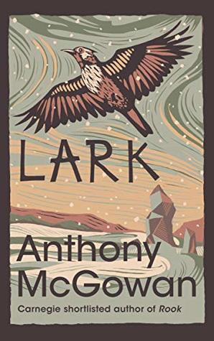
It wasn't supposed to be like this.
It was meant to be a stroll.
A lark.
We decided we'd go for a day up on the moors.
Dad helped us plan it all out.
"I know just the place to go," he said.
We found it on Google Maps and dad printed it out.
But I think time was running out, so the map was faded and blurry.
We had to catch three buses to get there changing at York and then at Thirsk.
I liked the idea of getting three buses.
It made it seem more like an adventure.
But now, I looked around.
It had stopped snowing, but the path had almost vanished.
I saw white fields and stone walls.
The black skeletons of trees climbing out of the frozen earth.
The sky was a sort of pale grey, like a seagull's back.
In fact, the sky was the weirdest thing about it all.
You couldn't see any clouds, or any of the blue in between the clouds.
Just this solid grey nothing like cold porridge, going on forever.
I hit the ground and felt the snow under me, and under the snow, the hardness of the frozen earth.
Then I realised just how much trouble we were in.

Creative Writing lesson 5
Extract 1
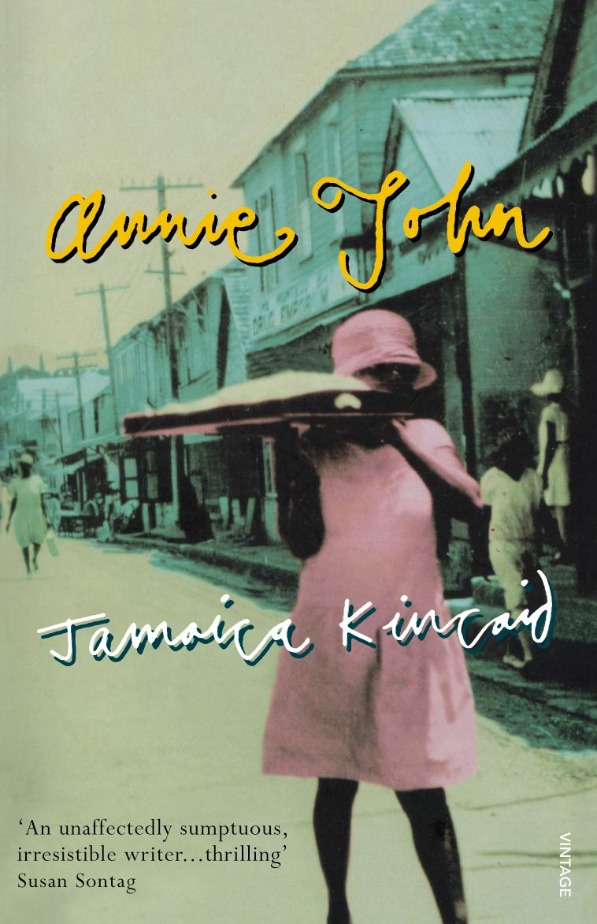
In the year I turned 15, I felt more unhappy than I had ever imagined anyone could be.
It wasn't the unhappiness of wanting a new dress or the unhappiness of wanting to go to the cinema on a Sunday afternoon and not being allowed to do so, or the unhappiness of being unable to solve some mystery in geography or the unhappiness at causing my dearest friends some pain.
My unhappiness was something deep inside me and when I closed my eyes, I could even see it.
It sat somewhere, maybe in my belly, maybe in my heart, I could not exactly tell.
And it took the shape of a small black ball, all wrapped up in cobwebs.
I would look at it and look at it until I had burned the cobwebs away, and then I would see that the ball was no bigger than a thimble, even though it weighed worlds.
If I had been asked, I would not have been able to say exactly how it was that I got that way. It must have come on me like mist.
First I was in just a little mist and could see everything around me though not so clearly then I was completely covered up.
I could not even see my own hand stretched out in front of me.

Mahatma Gandhi “Quit India” Speech

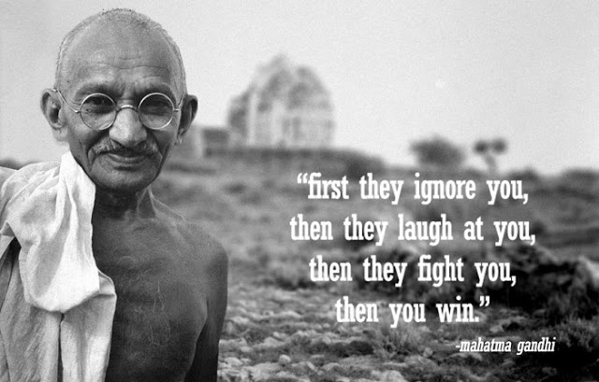

Before you discuss the resolution, let me place before you one or two things, I want you to understand two things very clearly and to consider them from the same point of view from which I am placing them before you. I ask you to consider it from my point of view, because if you approve of it, you will be enjoined to carry out all I say. It will be a great responsibility. There are people who ask me whether I am the same man that I was in 1920, or whether there has been any change in me. You are right in asking that question.
Let me, however, hasten to assure that I am the same Gandhi as I was in 1920. I have not changed in any fundamental respect. I attach the same importance to nonviolence that I did then. If at all, my emphasis on it has grown stronger. There is no real contradiction between the present resolution and my previous writings and utterances.
Occasions like the present do not occur in everybody’s and but rarely in anybody’s life. I want you to know and feel that there is nothing but purest Ahimsa in all that I am saying and doing today. The draft resolution of the Working Committee is based on Ahimsa, the contemplated struggle similarly has its roots in Ahimsa. If, therefore, there is any among you who has lost faith in Ahimsa or is wearied of it, let him not vote for this resolution.
Let me explain my position clearly. God has vouchsafed to me a priceless gift in the weapon of Ahimsa. I and my Ahimsa are on our trail today. If in the present crisis, when the earth is being scorched by the flames of Hims2 and crying for deliverance, I failed to make use of the God given talent, God will not forgive me and I shall be judged unwrongly of the great gift. I must act now. I may not hesitate and merely look on, when Russia and China are threatened.
Ours is not a drive for power, but purely a nonviolent fight for India’s independence. In a violent struggle, a successful general has been often known to effect a military coup and to set up a dictatorship. But under the Congress scheme of things, essentially nonviolent as it is, there can be no room for dictatorship. A non-violent soldier of freedom will covet nothing for himself, he fights only for the freedom of his country. The Congress is unconcerned as to who will rule, when freedom is attained. The power, when it comes, will belong to the people of India, and it will be for them to decide to whom it placed in the entrusted. May be that the reins will be placed in the hands of the Parsis, for instance-as I would love to see happen-or they may be handed to some others whose names are not heard in the Congress today. It will not be for you then to object saying,
“This community is microscopic. That party did not play its due part in the freedom’s struggle; why should it have all the power?” Ever since its inception the Congress has kept itself meticulously free of the communal taint. It has thought always in terms of the whole nation and has acted accordingly... I know how imperfect our Ahimsa is and how far away we are still from the ideal, but in Ahimsa there is no final failure or defeat. I have faith, therefore, that if, in spite of our shortcomings, the big thing does happen, it will be because God wanted to help us by crowning with success our silent, unremitting Sadhana1 for the last twenty-two years.
I believe that in the history of the world, there has not been a more genuinely democratic struggle for freedom than ours. I read Carlyle’s French Resolution while I was in prison, and Pandit Jawaharlal has told me something about the Russian revolution. But it is my conviction that inasmuch as these struggles were fought with the weapon of violence they failed to realize the democratic ideal. In the democracy which I have envisaged, a democracy established by nonviolence, there will be equal freedom for all. Everybody will be his own master. It is to join a struggle for such democracy that I invite you today. Once you realize this you will forget the differences between the Hindus and Muslims, and think of yourselves as Indians only, engaged in the common struggle for independence.
Then, there is the question of your attitude towards the British. I have noticed that there is hatred towards the British among the people. The people say they are disgusted with their behaviour. The people make no distinction between British imperialism and the British people. To them, the two are one This hatred would even make them welcome the Japanese. It is most dangerous. It means that they will exchange one slavery for another. We must get rid of this feeling. Our quarrel is not with the British people, we fight their imperialism. The proposal for the withdrawal of British power did not come out of anger. It came to enable India to play its due part at the present critical juncture It is not a happy position for a big country like India to be merely helping with money and material obtained willy-nilly from her while the United Nations are conducting the war. We cannot evoke the true spirit of sacrifice and velour, so long as we are not free. I know the British Government will not be able to withhold freedom from us, when we have made enough self-sacrifice. We must, therefore, purge ourselves of hatred. Speaking for myself, I can say that I have never felt any hatred. As a matter of fact, I feel myself to be a greater friend of the British now than ever before. One reason is that they are today in distress. My very friendship, therefore, demands that I should try to save them from their mistakes. As I view the situation, they are on the brink of an abyss. It, therefore, becomes my duty to warn them of their danger even though it may, for the time being, anger them to the point of cutting off the friendly hand that is stretched out to help them. People may laugh, nevertheless that is my claim. At a time when I may have to launch the biggest struggle of my life, I may not harbour hatred against anybody.

Michelle Obama’s beautiful letter to her younger self is a must-read for anyone with self-esteem issues

“You’re more than enough, Michelle. You always have been and you always will be.”
Have you ever felt as if you’re blushing and bluffing your way through the working day? Have you doubted your own worth? And has some small secret voice from deep within yourself ever whispered not-so-sweet nothings in your ear? “One day they’re going to find out that you don’t know anything,” it insists, “and that’ll be it for you.”
You’re not alone: ‘impostor syndrome’ affects plenty of us on a daily basis – and it can strike anyone, no matter how successful or famous they are. Even Michelle Obama, easily one of America’s most beloved First Ladies, has now admitted that she used to feel as if she wasn’t… well, not that she wasn’t good enough, but that she wasn’t enough full stop.
As such, the Becoming author has, as a part of CBS News’ Note to Self series, written a letter to her younger self, giving advice to the young woman heading off to college at Princeton. And what she has to say is incredibly powerful.
“Dear Miche,” the letter begins. “There you are, in your jean jacket and braids, a long way from that little apartment on the South Side of Chicago. You’re at one of the finest universities in the world. You’re smiling, and you should be, you worked hard for this. But even now, after you reached your goal, you’re still not quite sure if you belong and can’t get one question out of your mind: ‘Am I good enough?’ There aren’t many kids here who look like you. Some arrived on campus in limousines. One of your classmates is a bona fide movie star, another is rumoured to be a real-life princess. Meanwhile, you got dropped off by your father in the family sedan.”

Obama continues: “Years from now, you’ll learn that your parents had to take out new credit cards to pay your tuition. But Michelle, what you’ll come to realise one day is that you’re only seeing what you lack and not everything that your story has given you. You grew up surrounded by soul and jazz and a deep, anchoring love. Your parents taught you to keep your word and treat people with respect. They encouraged you to develop your own voice and use it. Those lessons are more valuable than anything material. They’ll come in handy in the future, in settings I won’t spoil for you right now.”
Of course, the former First Lady of the United States reflects on her relationship with her now-husband, Barack, as well as the births of their two children.
“You’ll open your heart to someone whose upbringing was nothing and everything like yours, all at the same time,” she says. “He’s driven by a hopeful set of ideals. He’s grounded and kind and absolutely brilliant. And he’s pretty good looking, too. I thought you’d appreciate that. His certainty about his path will feel like a challenge to yours. You’ll learn that even the best relationships take work but that’s okay, that’s normal and it’s what gives your partnership its strength… yet you’ll still struggle to find a balance between your family, your husband’s rising career, and your own sense of self. Be patient. You’ll get there.
“And just when you think you’ve done it, the four of you will be shot out of a cannon into the unknown.”
Obama goes on to reflect on her years in the White House, admitting that “everything you’ve fought for so hard – stability, balance, confidence – will feel like it’s at risk.”
Addressing the countless trolls who have spoken out against her, she adds: “You’ll be attacked by people who’ve never met you and don’t really care to. They’ll try to harm you for their own gain. Don’t stoop to their level, no matter how gratifying it might feel in the moment. Hold tight to those values your parents taught you.”
And, while she admits that her countless fans will make it “easy to think you’re something special”, Obama advises herself to “remember that there are millions of people who grew up like you did and don’t get this kind of spotlight.”
“Reflect the light back on them,” she says. “There are so many people out there like you, Miche. Black girls and minorities of all kinds, working-class kids from big cities and small towns, people who doubt themselves, who are uncertain about whether they belong but have so much to offer the world. Share your story with them, the struggles and the triumphs and everything else. Show them that there’s more beauty inside than they can see right now.”
She concludes her letter by writing: “You’re more than enough, Miche. You always have been and you always will be. And I can’t wait for you to see that.”
Of course, Obama is not the first woman in the spotlight to address her impostor syndrome – and we doubt she will be the last. In 2016, Lupita Nyong’o shared her own self-doubt with Time Out: saying: “What’s it called when you have a disease and it keeps recurring? I go through [acute impostor syndrome] with every role. I think winning an Oscar may in fact have made it worse. Now I’ve achieved this, what am I going to do next? What do I strive for?
“Then I remember that I didn’t get into acting for the accolades, I got into it for the joy of telling stories.”
Emma Watson, similarly, told Rookie: It’s almost like the better I do, the more my feeling of inadequacy actually increases, because I’m just going, ‘Any moment, someone’s going to find out I’m a total fraud, and that I don’t deserve any of what I’ve achieved. I can’t possibly live up to what everyone thinks I am and what everyone’s expectations of me are’.
“It’s weird — sometimes [success] can be incredibly validating, but sometimes it can be incredibly unnerving and throw your balance off a bit, because you’re trying to reconcile how you feel about yourself with how the rest of the world perceives you.”
And even Jodie Foster, in her interview with 60 Minutes, said she thought winning her Oscar for The Accused was “a big fluke”.
“I thought it was a big fluke. The same way when I walked on the campus at Yale, I thought everybody would find out, and then they’d take the Oscar back.”
Speaking about impostor syndrome previously, at a school in London’s Islington, Obama said: “I still have a little [bit of] impostor syndrome, it never goes away, that you’re actually listening to me.
“It doesn’t go away, that feeling that you shouldn’t take me that seriously. What do I know? I share that with you because we all have doubts in our abilities, about our power and what that power is.
“If I’m giving people hope then that is a responsibility, so I have to make sure that I am accountable.”
She added: “”We don’t have any choice but to make sure we elders are giving our young people a reason to hope.”

This is no way to be a man
Barely a week goes by without another young Briton being brutally killed in a knife attack. Acclaimed actor and writer Lennie James, who will star in Fallout, the TV version of Roy Williams's play about teenage violence, has watched in horror as the death toll mounts. Here, in an open letter to the knife carriers, he draws on his own difficult upbringing to make an impassioned plea to the lost generation of young boys who visit random savagery on their victims
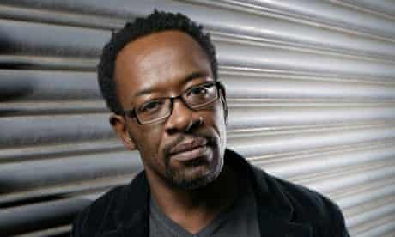
Actor Lennie James talks about knife crime. Photograph: Rex Features
Lennie James

Next month Channel 4 will show Fallout by Roy Williams, the screen version of his critically acclaimed stage play. Beautifully directed by Ian Rickson, Fallout is the enthralling story of the murder of a 16-year-old boy, Kwame, and the consequences that befall the four boys involved in the killing, the two girls connected to it and the police officers investigating the case.
I play one of the police officers, DS Joe Stephens, who is returning for the first time to the estate where he grew up to help in the investigation. He identifies greatly with the victim. Like Joe, Kwame had ambitions outside the confines and dictates of his estate and his background. Joe takes Kwame's death very personally, as if the killers had murdered Joe's younger self. This leads him to pursue the suspects with a zeal that alarms his colleagues, and to bend the rules to breaking point.
First and foremost, as it was on stage, Fallout is a wonderfully written, engrossing and entertaining story about belonging, escape, revenge and love. It is also a story that attempts to make sense of the seemingly senseless killing of a 16-year-old boy, stabbed to death for his trainers.
The issue of knife and gun crime among the young is firmly on the agenda at the moment, and rightly so. Since we premiered Roy's play at the Royal Court Theatre in London in 2003 some 350 teenagers have been shot or stabbed to death by other teenagers or young adults, and that may be a conservative estimate. Twenty-six teenagers were shot or stabbed in London alone in 2007. So far this year more than 100 have been attacked using knives. The number of dead is already at 13 and likely to rise.
Much has been written on the subject of this seeming spike in teen-on-teen violence over the past year or so. Columnists, commentators, politicians, child psychologists, law-makers, police officers, religious and community leaders, bereaved parents, gang members and ex-teenage killers have all expressed their opinions, apportioned blame and offered solutions. I myself was intent on writing a comparison between the war in Iraq and Afghanistan with the so-called 'war on street crime' announced by Boris Johnson, and others before him, and the relative collateral damage and loss of young lives. It was to be an investigation into whether the best response to our young people killing our young people is to declare war on them.
But as I sat down to complete the article, to add some statistics to bolster my argument and to clarify my misgivings as to whether Boris had an exit strategy for his war, I read of the death of Robert Knox. Robert, 18, was allegedly stabbed to death by a 21-year-old who was carrying two knives. So I scrolled up my article to change '13 [dead] and likely to rise' to 14 and likely to... As I did so I wondered how many more times I would have to scroll up and change that number before the article was printed. Would I have to change 16 to 17 and 18 and 19 and so on, and would it still be 'likely to rise'?
Suddenly the article I'd thought would be an interesting and insightful take on the subject became little more than another voice added to the collective hand-wringing and navel-gazing that seems to have characterised the response to this issue. It is all well intentioned and absolutely necessary if we are to find solutions. The problem is that we are so very adept at exploring our own deficiencies but so very slow to improve on them or to learn from them.
Like a huge tanker turning 180 degrees, it takes for ever for our sentiment to be made into decisive action. In the meantime, should the current trend continue, a teenager or two will be stabbed, possibly killed, every week for the rest of this year, like last, by someone no older than themselves.
So instead I have written an open letter to the knife-carriers, to the murderers-in-waiting and their potential victims. I don't know how many of them might be Observer readers, but in this www. world, where this is written may not be where it is read.
Since this article was written, two more teenagers have been killed in London, bringing the total to 16.
· Fallout, part of Disarming Britain, Channel 4's season on gun and knife crime, is to be screened at 10pm on Thursday 3 July

To whom it may concern,
My name is Lennie James. I am a 42-year-old father of three. I grew up in south-west London. I was brought up by a single mother. I was orphaned at 10, lived in a kids' home until I was 15 and was then fostered. I tell you this not to claim any special knowledge of how you've grown, but to explain how I have, and from where I draw my understanding.
I want to talk to you about the knife you're carrying in your belt or pocket or shoe. The one you got from your mum's kitchen or ordered online or robbed out of the camping shop. The knife you tell yourself you carry for protection, because you never know who else has got one.
I want to talk to you about what that knife will do for you. If you carry it, the chances are you will be called on to use it. It is a deadly weapon, so if you use it the chances are you will kill with it. So after you've killed with it, after you've seen how little force it takes for sharpened steel to puncture flesh. After your mates have run away from the boy you've left bleeding. When you're looking for somewhere to dash the blade, and lighter fluid to burn your clothes. When your blood is burning in your veins and your heart is beating out of your chest to where you want to puke or cry, but can't coz you're toughing it out for your boyz. When you are bang smack in the middle of 'Did you see that!' and 'Oh, Jesus Christ!' here's who to blame...
Blame the boy you just left for dead. Blame him for not believing you when you told him you were a bigger man than him. Blame him for not backing down when you made your chest broad, bounced into him and told him about your knife and how you would use it. Blame him for calling you on and making you prove yourself. Tell yourself if he had just freed up his phone or not cut his eyes at you like he did, he wouldn't be choking on his blood and crying for his mum.
Then blame your mum. When the police are banging down her door looking for you, or she hears the whispers behind the 'wall of silence', tell her it's all her fault for being worthless. Cuss her out for having kids when she was nothing but a kid herself, or for picking some drug or some man over you again and again. Even if she only had you and devoted herself to you, even if she is a great mum, blame her anyway. Blame her for not being around more to make sure you took the chances she was out working her fingers to the bone to give you.
When you're done with her, blame the man she picked to make you with. Blame him for being less than half the man he should have been. When he comes to bail you out and starts running you down for the terrible thing you've done, tell him straight: 'I did what I did coz you didn't do what you should have done.' Even if he did right; respected your mother, worked to provide for his family financially and spiritually, taught you right from wrong and drummed it home everyday... Even if he nurtured you as best he could, blame him for the generation of men he comes from.
The one that allowed an adolescent definition of manhood to become so dominant. The one that measures a man by how many babymothers he has wrangling his offspring, or by how 'bad' his reputation is on the streets of whatever couple of square miles he chooses to call his 'ends'.
Damn them for letting you believe that respect is to be found with gun in hand or knife in pocket. Damn them and everyone who feeds the myth of these gangsters, villains, thieves and hustlers. Anyone who makes them heroes while damning hard-working, educated, honest men as weak, sell-outs or pussies.
If you are black, blame white people for the history of indignities they heaped on you and yours. For the humiliation of having to go cap-in-hand or get down on bended knee or having to burn shit down before you are afforded something so basically fundamental as equality. If you are white, blame black folk and Muslims for taking all your excuses. Failing that, blame a class system that keeps you poor and ignorant so the 'uppers' and 'middles' can feel better about themselves.
You have good reason to blame them all. I wouldn't be you growing up now for love nor money. Your generation has so little room to manoeuvre. We had more space to step around the bullshit. We weren't excluded at the rate you lot are. Teachers hadn't given up or lost their authority over us. They still tried to protect and guide us even through our most disruptive years.
The police stopped and searched us, but we fought that right out of their hands - we hoped into extinction. But they want to bring back that abusive practice. They are still hooked on punishment rather than prevention. They seem ignorant to the fact that they are feeding you acceptance of an already prevalent gang mentality. As far as you can see, the police are not protecting and serving you, they are coming at you like just another street gang trying to boss your postcode.
When I was where you are now, generations of state agencies, social services, policy-makers and politicians had not abdicated all responsibility for me. We weren't left to our own devices like you have been. Is it any wonder that you end up expressing yourself in such a violently pathetic way?
We should be ashamed. I am. You have shamed us into a desperate need to do something about ourselves. We have collectively failed you and we should take all the blame that is ours for that... but so should you.
I blame you. I blame you because as a generation you are selfish, self-centred and have little or no empathy for anyone but yourselves. You are politically stunted and socially irresponsible and... you scare us. What scares us most is that you would rather die than learn. Your only salvation may be that still most of you aren't playing it out dirty. The vast majority of young men, even with all that is stacked against them, are finding their way around the crap. The boy you will kill, should you continue to carry that knife, almost certainly had the same collective failures testing him. He probably felt no less abandoned and no less scared. He also, almost certainly, wasn't carrying a knife.
Whatever it seems like, whatever you've read, whatever you tell yourself about protection being your reason, statistics show the life you take will be that of an unarmed person. That is what that knife will do for you. It will make you escalate a situation to where it is needed. It will give you a misguided sense of confidence. It will make you the aggressor. That knife will make you use it. It will bring you nothing worth having. There is no respect there. The street may give you some passing recognition, but any name you think you might make will soon be forgotten.
Your victim will be remembered long after you. Name me one of the boys who killed Stephen Lawrence. Once you've bloodied that knife you may as well be dead because you'll be buried for 10 to 20 years. Banged up for that long, only a fool would look back and think it was worth it. You'll be nothing more than a sad, unwanted, unnecessary statistic.
If you were mine, this is what I would tell you. I would make myself a big enough man to beg. I'd get down on bended knees if I had to. I would beg you to take that knife out of your pocket and leave it at home. I would tell you that I know you are scared and lost and that I know the risks involved in what I'm asking you to do. I know that what we could step around, you have to walk through, and that there is always some fool who isn't going to make it any other way but the wrong way. I'm just begging you not to be that fool.

Be a better man than that. Let the story they tell of you be that you exceeded expectations... that you didn't drown. Don't spend your days looking to be a 'bad-man' - try to be a good one. Our biggest failure is that our actions have left you not knowing how precious you are. We have left you unaware of your worth to us. You are precious to us. Give yourself the chance to grow enough to understand why.
Be safe.
Lennie James

Short bio:
Lennie James was born in Nottingham to Trinidadian parents, and grew up in South London. His mother, Phyllis Mary James, died when he was 12. Lennie and his older brother went into a council children's home. When he was 16 he was fostered with a social worker who had two older children, and they remain very close. Within a year Lennie began writing plays (Storm Damage was broadcast by the BBC in 2000 and won a Royal Television Society (RTS) award in 2001). Lennie received his training at the Guildhall School of Music & Drama from which he graduated in 1988.

We Shall Fight Them On The Beaches
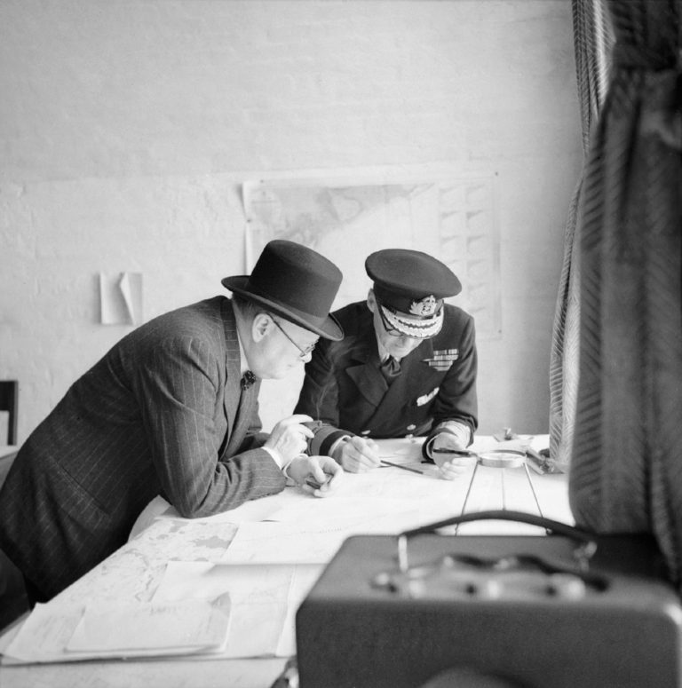

Churchill studies reports of the action that day with Vice Admiral Sir Bertram Ramsay, 28 August 1940, © IWM (H 3508)

4 June 1940
“I have, myself, full confidence that if all do their duty, if nothing is neglected, and if the best arrangements are made, as they are being made, we shall prove ourselves once again able to defend our Island home, to ride out the storm of war, and to outlive the menace of tyranny, if necessary for years, if necessary alone.
At any rate, that is what we are going to try to do. That is the resolve of His Majesty’s Government-every man of them. That is the will of Parliament and the nation.
The British Empire and the French Republic, linked together in their cause and in their need, will defend to the death their native soil, aiding each other like good comrades to the utmost of their strength.
Even though large tracts of Europe and many old and famous States have fallen or may fall into the grip of the Gestapo and all the odious apparatus of Nazi rule, we shall not flag or fail.
We shall go on to the end, we shall fight in France,
we shall fight on the seas and oceans,
we shall fight with growing confidence and growing strength in the air, we shall defend our Island, whatever the cost may be,
we shall fight on the beaches,
we shall fight on the landing grounds,
we shall fight in the fields and in the streets,
we shall fight in the hills;
we shall never surrender, and even if, which I do not for a moment believe, this Island or a large part of it were subjugated and starving, then our Empire beyond the seas, armed and guarded by the British Fleet, would carry on the struggle, until, in God’s good time, the New World, with all its power and might, steps forth to the rescue and the liberation of the old.”
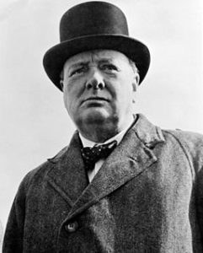
Winston Churchill

