

GCSE REVISION
& EXAMINATION TIMETABLE
2022

If you are not in an exam or a revision session you MUST go to your lessons as usual until Friday 27 May. After this date you will be told which lessons you must attend.

RESULTS DAY: Thursday 25 August 2022

This booklet contains details of the exams and revision sessions over the next two months.

- Please read through it carefully.

- Highlight those exams and revision sessions that you need to attend.

    - Stick this on the fridge / on your bedroom wall / wherever you are likely to see it easily.

- Some of the exams are resits. These are just as important as they can help improve your grade. If you are not sure whether you are doing a resit or not then go and ask your teacher.

- Arrive for your exam 15 minutes before the exam is about to begin. Wait in the Dining Hall.
- You must wear full school uniform for all examinations and revision sessions.
- Please bring pens, pencils etc. to all revision sessions and examinations.
- All mobile phones MUST be turned off.

YOU MUST WRITE WITH A BLACK PEN IN ALL EXAMINATIONS

REVISION TIPS:

- ‘Chunk’ your learning - small sections at a time will make the information easier to absorb.

- Transform information from one format to another. E.g. take written information and turn it into a labelled diagram.

- Use the web sites given by your teachers.

Also: www.bbc.co.uk/schools/gcsebitesize
This is a useful general site covering a wide range of subjects.

- Stick key words around your bedroom.

- Summarise notes in different ways (onto post cards, spider diagrams, flow charts).

- Use highlighter pens to help key information to stick out.

- Get someone at home to test you - answering questions verbally can help you remember the information.

- Try to complete as many past exam questions as possible. If you’ve already done them in class, try to improve your score.

- Remember to have times when you relax - you cannot revise effectively without a break.

- Drink plenty of water and eat healthy snacks. (E.g. bananas, carrot sticks, raisins etc.)

MAKING IT STICK
  - Learn the topic
  - Repeat within 24 hours
  - Repeat for 10 minutes at the end of the week
  - Repeat for 10 minutes 2 weeks later
  - Repeat for 10 minutes 1 month later

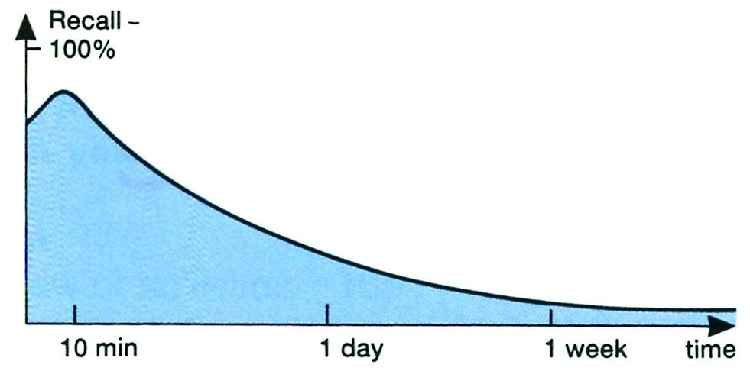
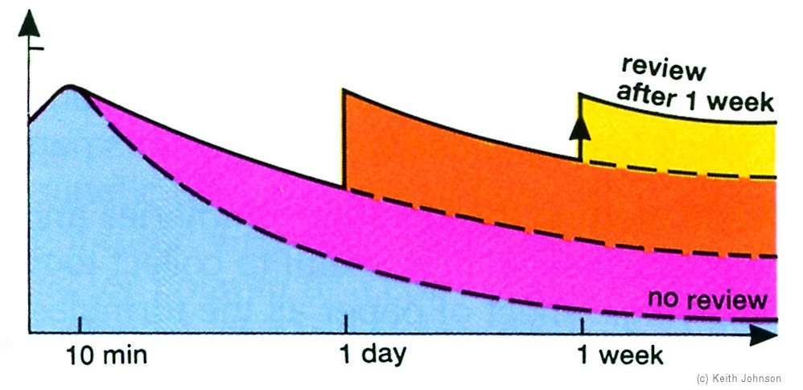

MIND MAPPING: A USEFUL REVISION TOOL

- Use plain paper so lines do not distract the eyes.
- Use landscape paper as our horizontal peripheral vision is better.
- Begin with a central image, while drawing this, your brain is pre-processing relevant information.
- Thick branches radiate from the centre, use a different colour for each, they represent sub topics.
- Branches become thinner towards the edges where fine details are added.
- Single words or phrases can be written along the branches not just at the ends.
- Use pictures, symbols and illustrations.

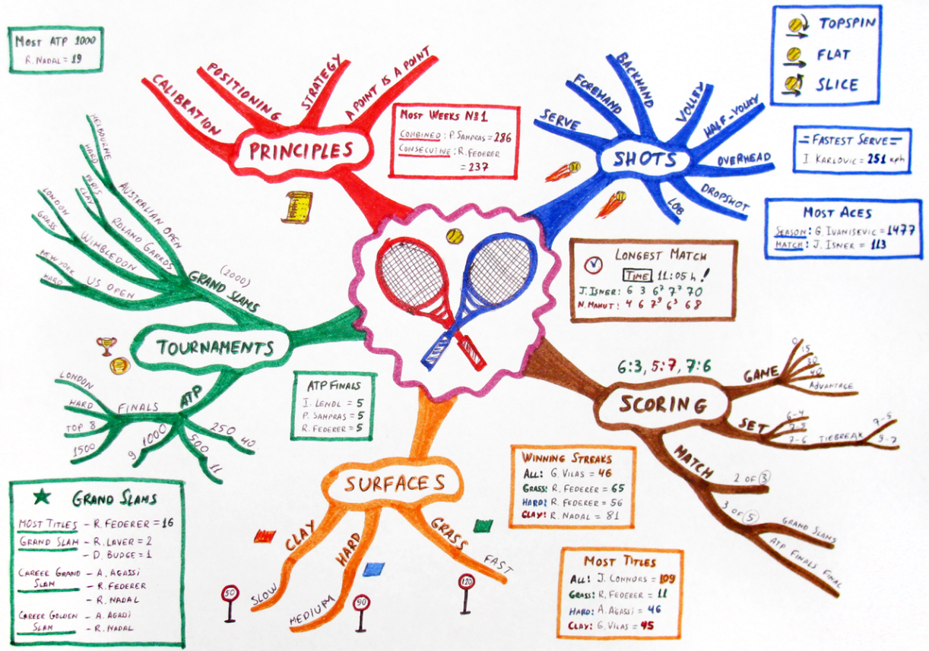

THE IDEAL STUDY HOUR

5 | 20 | 5 |  | 15 |  | 5 | 10
E  X  E  R  S  I  S  E | STUDY  e.g. Mind Map | B  R  E  A  K | REVIEW  previous work  After a day | After a week | After a month | B  R  E  A  K | R  E  V  I  E  W  today’s learning

- A short burst of exercise such as star jumps or running on the spot will get the blood circulating quickly, bringing more oxygen to the brain.

- You need to be very strict with yourself and only allow 5 minutes for each break.

- Having a break is not just about relaxing. Believe it or not you actually learn best during a break.

Amazing Brain Fact:
Your memory is like a muscle. The more you use it the stronger it
gets and the easier it becomes to remember things.

GCSE REVISION & EXAMINATION TIMETABLE 2022

Remember to read this carefully and highlight each
of your exams. If you are not sure whether you are
entered for a particular exam then speak to your
teacher immediately.

If you are not in an exam or a revision session you MUST go to your lessons as usual until Friday 27 May. After this date you will be told which lessons you must attend.

Your teachers will tell you when you have revision sessions.

ALL EXAMINATIONS ARE IN THE SPORTS HALL UNLESS STATED OTHERWISE

Look at the exams you have coming up and fill in the topics you will revise at home to help you make the best use of your time.

DATE | MORNING  All morning examinations begin at 9.30am unless you are told otherwise | AFTERNOON  All afternoon examinations begin at 1.30pm
Tuesday 03 May | French Higher & Foundation Speaking Exams - full details later
Wednesday 04 May | Spanish Higher Speaking Exams - full details later
Friday 06 May | Spanish Foundation Speaking Exams - full details later
Monday  16 May | Religious Studies Exam  Buddhism & Christianity  9.30am – 11.30am | Computer Science Exam  Principles of Computer Science  1.30pm - 3.00pm
What am I going to revise?

Tuesday  17 May | Biology Paper 1 Exam  9.30am – 11.15am (Combined)  9.30am – 10.45am (Separates)
What am I going to revise?

Wednesday  18 May | English Language Paper 1 Exam  9.30am – 11.15am
What am I going to revise?

Thursday  19 May | History Exam  Crime & Punishment  9.30am – 10.45am | Drama Exam  1.30pm – 3.15pm
What am I going to revise?

Friday  20 May | Maths Exam (Non calculator)  9.30am – 11.00am
What am I going to revise?

Monday  23 May | Geography Paper 1 Exam  Natural Hazards, Physical Landscapes (optionality of rivers) and Living world (optionality of hot deserts)  9.30am – 11.00am
What am I going to revise?

Tuesday  24 May | French Listening Exam  9.30am – 10.05am (Foundation)  9.30am – 10.15am (Higher)  French Reading Exam  10.10am – 10.55am (Foundation)  10.20am – 11.20am (Higher) | Sports Studies Exam  Contemporary issues  1.30pm – 2.30pm  GCSE PE Exam  Paper 1  1.30pm - 2.30pm
What am I going to revise?

Wednesday  25 May | English Literature Exam  An Inspector Calls & A Christmas Carol  9.30am – 10.20am
What am I going to revise?

Thursday  26 May | Spanish Listening Exam  9.30am – 10.05am (Foundation)  9.30am – 10.15am (Higher)  Spanish Reading Exam  10.10am – 10.55am (Foundation)  10.20am – 11.20am (Higher)  Construction Exam  9.30am - 10.30am | Religious Studies Exam  1.30pm – 3.15pm
What am I going to revise?

Friday  27 May | Chemistry Paper 1 Exam  9.30am – 11.15am (Combined)  9.30am – 10.45am (Separates) | Computer Science Exam  Application of Computer Thinking  1.30pm – 3.30pm
HALF TERM HOLIDAY

Monday 6 June | Maths and English revision day - details will be sent out later.
Tuesday  7 June  Study leave begins today. You do not need to attend lessons in school. | Maths Exam  Calculator Paper  9.30am – 11.00am | Geography Paper 2 Exam  Urban Issues and Challenges and Resource Management (optionality  of water)  1.30pm – 3.00pm
What am I going to revise?

Wednesday  8 June | English Literature Exam Macbeth & Unseen Poetry  9.30am - 11.15am | Further Maths Exam  Paper 1  1.30pm – 3.15pm
What am I going to revise?

Thursday  9 June | History Exam  Weimar & Nazi Germany  9.30am - 10.50am | Physics Paper 1 Exam  1.30pm – 2.45pm (Combined)  1.30pm – 3.15pm (Separates)
What am I going to revise?

Friday  10 June | English Language Exam  Paper 2  9.30am - 11.15am | PE Exam  Socio-cultural issues  1.30pm – 2.30pm
What am I going to revise?

Monday  13 June | Maths Exam  Calculator  9.30am – 10.00am
What am I going to revise?

Tuesday  14 June | Geography Paper 3 Exam  Pre-release booklet, geographical skills and unseen fieldwork  9.30am – 10.30am
What am I going to revise?

Wednesday  15 June | Biology Paper 2 Exam  9.30am – 11.15am (Combined)  9.30am – 10.45am (Separates) | DT Exam  1.30pm – 2.30pm
What am I going to revise?

Thursday  16 June | History Exam  King Richard, King John  9.30am – 10.25am | French writing Exam  1.30pm – 3.05pm (Foundation)  1.30pm - 2.50pm (Higher)
What am I going to revise?

Friday  17 June | Spanish Writing Exam  9.30am – 10.35am (Foundation)  9.30am – 10.50am (Higher)
What am I going to revise?

Monday  20 June | Chemistry Paper 2 Exam  9.30am – 11.15am (Combined)  9.30am – 10.45am (Separates)
What am I going to revise?

Tuesday  21 June |  | Hospitality & Catering Exam  Paper 1 RESIT STUDENTS  9.30am – 11.00am
What am I going to revise?

Wednesday  22 June | Music Exam  Appraising  9.30am - 11.15am | Further Maths Exam  Paper 2  1.30pm - 3.15pm
What am I going to revise? | Physics! But think about which topics from Paper 2 you want to revise…
Thursday  23 June | Physics Paper 2 Exam  9.30am – 11.15am (Combined)  9.30am – 10.45am (Separates) | Leavers’ Assembly  11.30am

