**YEAR 7**

**Independent learning to be completed during school closure**

**History – How different was life in the Tudor times compared to our modern world?**

During a two week period you would ordinarily have:

3 History lessons. **This is for the fortnight 22/06/20 – 03/07/20**

**Lesson 1 – How bad were jobs in the Tudor times?**

You have already watched one of the episodes in the excellent series ‘Worst Jobs in History’ focusing on Roman and Anglo-Saxon Britain. You are now going to learn about horrid jobs in the Tudor era.

You are going to use *watch the documentary* linked below and whilst you watch you are going to *make notes on each of the jobs* which Tony attempts.

You should include;

* The name of the job
* Who was likely to do this job?
* What actually was the job?
* Were there any good points about this job?

Challenge – Which of these jobs do you think as the worst? You should write a paragraph explaining your choice.

<https://www.youtube.com/watch?v=a6B9euzxXr0>

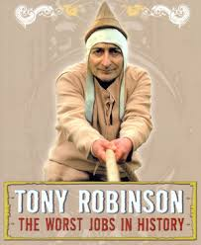

**Lesson 2 – What were Edward and Mary like as monarchs?**

All 3 of Henry VIII’s children became monarch of England. For your next task you are going to research two of his children, his eldest and youngest.

You are going to create two fact files; you may wish to split your page in half for this task, one side for Edward VI and the other for Mary I.

You should include information about their childhood, when they came to the throne, how long they ruled for, their religion and major events in their reign. You can draw pictures if you wish to go along with your notes.

Challenge – Who was the more successful monarch?

You should use the following links to help

<https://kids.britannica.com/kids/article/Edward-VI/476253>

<https://kids.britannica.com/kids/article/Mary-I/476292#:~:text=She%20was%20married%20to%20King,by%20her%20sister%2C%20Elizabeth%20I.>

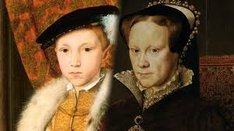

**[](https://longbenton.org.uk/)**

**Lesson 3 – Tudor consolidation**

You have been studying the Tudor period in lots of detail in recent weeks and now you are going to put all your knowledge of Tudor life into a final piece of work.

You can either;

* Write a day in the life of someone living in Hampton court palace. This could be a servant or member of the nobility.
* Produce a traveller’s guide to Tudor England under the reign of Henry telling them everything they’d need to know. Some things to include might be; things to do, things to eat, things to avoid and expectations.
* Write a historical fictional story set in the Tudor era. The plot of the story is entirely your choice but it must include lots of facts about the Tudors.

If you require further information please email:

Miss A Potts, History Teacher

[alp@longbenton.org.uk](mailto:alp@longbenton.org.uk)