Arne Jacobsen- Laminated Plywood Chair

Profile- Arne Jacobsen was a Danish architect and designer remembered for contribution to architectural functionalism and simple but effective chair designs. He was born 11th February 1902 in Copenhagen, and although initially he wanted to be a painter he was persuaded by his father to assume the more secure role of an architect, later from 1924 to 1927 he attended the Royal Danish Academy of Fine Arts and was taught by 2 leading architects and designers. Whilst still a student Jacobsen took part in the Paris Art Deco fair Exposition Internationale des Arts Décoratifs et Industriels Modernes where he won a silver medal for his chair design. It was his interest in Gesamtkunst that took him down the route of product design; it was during the 1950s that his interest in furniture design peaked. A Gesamtkunstwerk is described as a work of art that makes use of all or many art forms or strives to do so. Most of his furniture designs were the result of cooperation with the furniture manufacturer with which he initiated collaboration in 193. He took inspiration for his chair designs from Charles and Ray Eames and Ernesto Rogers and he believed in his idea that the design of every element was equally important from the spoon to the city which resonated well with his own ideas. Two of his successful chair designs the Egg and the Swan were both created for the SAS Royal Hotel which he also designed with during 1956. According to R. Craig Miller Jacobsen’s work "is an important and original contribution both to modernism and to the specific place Denmark and the Scandinavian countries have in the modern movement" and continues "One might in fact argue that much of what the modern movement stands for, would have been lost and simply forgotten if Scandinavian designers and architects like Arne Jacobsen would not have added that humane element to it". Jacobsen is also remembered heavily for his sense and view of the importance of proportion and how proportion ‘makes’ the beautiful Egyptian temples and some of the most admirable buildings of the baroque and renaissance periods, this idea is clearly visible in both his work in furniture and architecture. He collaborated with Fritz Hansen resulting in some famous Danish works such as the Ant, the Series 7, the Grand Prix, the Swan and the Egg.

Laminated plywood chair body
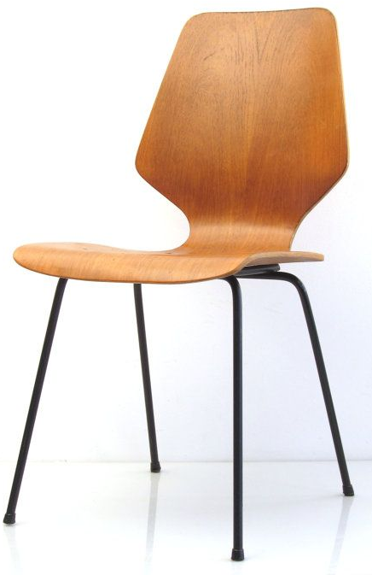
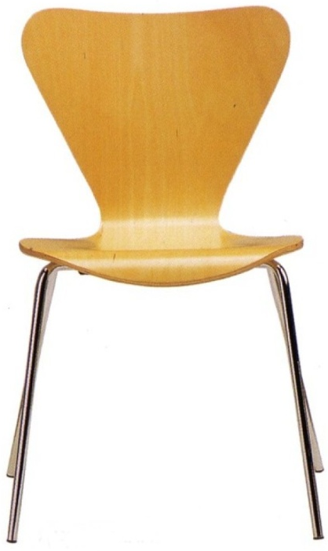
Product- The chair consists of a laminated plywood seat with black rubber coated tubular steel legs. The Model 3107 chair was designed using a new technique in which plywood could be bent in three dimensions. It has been a hugely successful with Fritz Hansen producing over 5 million units since Jacobsen created the design in 1955, the success is especially notable since this design is the most copied chair in the world. Plywood is a combination of 3 (or more) layers or veneers of wood and is both cheap and easily accessible; it has been an important medium for experimentation by modernist designers ever since the 1920s. The layers have been plied together with each grain going crosswise which increases the strength of the material making it suitable for this chair design because it will have to support repeatedly applied loads without weakening. The plies are then glued together using synthetic resin which also adds to the strength of the material. Plywood is constructed using an odd number of plies so that the grain is going in the same direction on both sides of the material. Due to this construction the plywood is less likely to warp or split which increases the ways which it can be used. Currently the chair is available in ten different veneers: maple, beech, ash, cherry, oregon pine, elm, oak, walnut, dark stained oak or full dark stained oak with clear lacquer as well as two finishes: coloured ash or lacquer in all colours. The laminated plywood chair has become a style icon and given that the popularity has not decreased over a period of 6 decades it is now considered as a timeless design. Laminated wood is suitable for the body of the chair, when thin layers of veneer are glued together forming one part, they are called laminates. Complex shapes can be achieved using this material which is one of the reasons why Jacobsen was able to expand his range of chairs into new models with different shaped bodies and additional features such as arm and head rests.
Stained wood such as oak can be used for the veneers to give a pleasing colour.
The frame and chair legs have been chrome plated to improve aesthetics and make them corrosion and scratch resistant. Each leg has a rubber coating covering the end to protect the flooring surfaces that it is used upon and to reduce noise coming from movement. They will also prevent the product from slipping and give it a more stable grip for when the user sits on it.
Can be made into different shapes to add aesthetic appeal

Manufacture- The thin layers of veneer are steam treated first. They are placed in the steam chamber whereby steam is introduced at one end and all of the excess pressure and steam exits at the opposite end. The steam that condenses into water drains out in the central section. As the steam flows through the chamber the veneer absorbs the moisture, they will remain in the chamber for the amount of time needed to attain the desired pliability. They are then removed and it is now possible to bend them into the shape of the chair body using a former. The plywood is then clamped in the former which would be in the shape of the seat; it is then left for several hours where it will cool. The material then takes the shape of the former once the clamps are removed. The layers are then glued together using PVA, cascamite or woodworkers resin and then left in the former until the glue dries/ sets, afterwards it can be removed. The legs are made from chromed steel tubing which is strong, high quality, corrosion resistant and aesthetically pleasing. First the steel tube is cut to size using a guillotine and then it undergoes de-burring to remove any rough or sharp edges caused by the previous cutting. A jig is used to form the curved chair legs once the steel has been heated to red heat to increase malleability. The support rails need to be pinched on each end to flatten part of the tubing so that it can be welded to the 2 sets of chair legs more easily. This piece is also then de-burred and drilled so it can later be attached to the chair body. The 2 parts are then gas welded together to form a permanent and very strong joint with very little flexibility suitable for holding the weight of the user. Chrome plating is a technique whereby an extremely thin layer of chromium is applied to the surface of the steel frame. This process requires nickel to be plated onto the steel before chromium; this provides the smoothness, much of the corrosion resistance and reflectivity. The chromium adds a slightly bluish cast as opposed to the yellowish cast of the nickel; it also protects the nickel against tarnish, minimizes scratching, and contributes to corrosion resistance. Both materials are applied via electroplating. The steel will need to be cleaned and degreased prior to electroplating. A way of doing this could be to use lead anodes with chromium chloride as the main solution. The chair frame is lowered into the chrome plating bath and allowed to reach the same temperature as the solution. An electric current is applied to the solution and after time, chrome is deposited on to the surface of the steel.
Clamps hold the formers together.

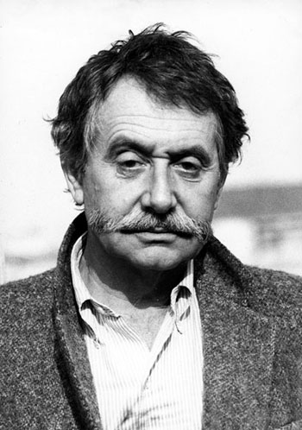
Ettore Sottsass Jr- Carlton room divider
Profile- Ettore Sottsass was an Italian architect and designer of the late 20th century born on the 14th September 1917, he was best known for founding the early 1980s Memphis collective although he also designed some electrical products, glassware and ceramics. Sottsass devoted his life and work to dismantling the past in his various roles as artist, architect, industrial designer, glass maker, publisher, theoretician and ceramicist. The past to him was the rationalist doctrine of his father, Ettore Sottsass Sr, an Italian architect. Although he was fond of his parents, he preferred a different approach. "When I was young, all we ever heard about was functionalism, functionalism, functionalism," he once said. "It’s not enough. Design should also be sensual and exciting." He and his parents moved to Turin in 1929 so that he could study architecture at the best faculty in Italy, this was decided by his father. His architectural career was put on hold as he was called up into the Italian army to fight in World War 2, only to spend most of his time in a Yugoslavian concentration camp. After returning home in 1948, he set up his own architectural and design studio in Milan. In 1956 he and his wife travelled to New York where he was commissioned to create a line of ceramics during this visit, but was also inspired to concentrate on industrial design, rather than architecture, after spending a month working in the studio of the US designer, George Nelson. After travelling back to Italy in 1958, he began working for Olvetti, an Italian manufacturer of office equipment and furniture as a design consultant. The founder Adriano Olvetti hired him to work alongside his son Roberto. It was with this business that Sottsass made his name as a designer and through his use of colour, style and form he managed to bring office equipment into the realm of popular culture. Together with Mario Tchou, they won the prestigious 1959 Compasso d’Oro with the Elea 9003, the first Italian calculator, and revolutionised typewriter design with Olivetti’s first electronic model, the Tekne, in an elegantly angular Sottsass case. He remained a central figure in Italian avant garde throughout the 1960s whilst designing more and more landmark products for Olvetti such as the 1970 bright red Valentine typewriter which was iconic and considered as more of a design statement than an office machine. His furniture was equally influential, notably the mid-1960s "superbox" closets in striped plastic laminate developed for Polotronova. In 1972, Sottsass’ mobile, multi-functional fibreglass furniture unit was the toast of the Italy: The New Domestic Landscape exhibition at MoMA, New York. Around the time of the founding of Memphis Sottsass stated “I didn’t want to do any more consumerist products, because it was clear that the consumerist attitude was quite dangerous”. He felt like the corporate work was stifling his creativity and stylised imagination. As a result, his work from the late 60s to the 70s was defined by experimental collaborations with younger designers and association with the Radical movement (A shift in style amongst the avant garde) culminating in the foundation of Memphis at the turn of the decade.
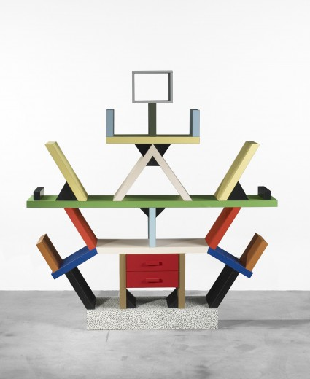
Product- The ‘Carlton ’room divider was among Sottass’ most noted pieces. It was designed in 1981 in Milan and measures 195.5 x 190 x 40 cm of wood and laminated plastic. This design displays many of the trademark characteristics of the design movement which is why Memphis became known almost overnight and why it is so easily recognisable today. Many of their works boast a bright, bold superficial aesthetic and the vivid colours and seemingly random interplay of solids and voids have a heavy avant garde influence that was very popular. The central anthropomorphic design is quite totemic and carries links to Sottsass’ trip around India during the 1960s. Although intended for a luxury market and of fine workmanship, it is made of cheap plastic laminates rather than fine woods, it is also considered to be more of a work of art rather than a functional object. Sottsass often included patterns on his designs, for example the base of ‘Carlton’ displays his Bacterio patterns from 1978. Despite their provocative nature, Sottsass designs are always based on precise relationships between individual parts. Thus, the colours of “Carlton” are carefully matched, and the structure is based on the imaginary form of a rhombus. Traditional wall shelving, with its horizontal and vertical structure, is turned into a multipurpose, dynamic, encompassing object that, like a sculpture, claims the right to stand unrestricted in its own space. Also “Carlton” can be completely dismantled, which is an advantage given its considerable weight because of its size. The Carlton is an icon of Italian 20th Century Design and one of the most outspoken pieces in the Memphis design collection. The Carlton cabinet & room divider is part of the permanent collection of the Metropolitan Museum of Art in New York. “Carlton” is part of the postmodernism design movement and it has all of the typical characteristics of the movement which refers to the manner of playful, ornamented, subversive, and/or heady things. The Memphis designers consciously offered this type of alternative design, and they didn’t care if it was “good” at all, they sought to dismantle the rule “Form follows function” that mid-century modernists lived by. This is why the Carlton room divider is commonly thought of as more of a discussion or display piece than a functioning piece of furniture.
The base of Sottsass’ Carlton room divider displays his pattern Bacterio
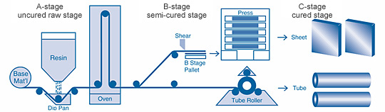
Manufacture- The brightly coloured bookcase looks impractical for storage and more like a design feature or statement. The product is made from modern materials such as melamine formaldehyde laminated MDF which some thought was playful whereas others considered it to be tacky as the materials are unconventional for a piece of furniture. Sottsass has a paradoxical way of working and the materials that he chooses play a key role in the way that the product is conveyed to the viewer. The materials used are cheap but combined with colour and ornamentation such as the totem figure and speckled base the effect is banal and exciting, tacky and luxury. MDF is a relatively cheap, quality board composed of fine wood dust and resin pressed into a board. It is easy to shape and machine which makes it a suitable material for furniture, even more so in this case whereby the MDF will be hidden under a laminate of melamine formaldehyde. This thermosetting polymer is strong, hard, stiff and resistant to some chemicals and stains which indicate that the room divider could have an imposed aspect of functionality although the shape, form and size of the product argue otherwise. The first step is to soak the strips of paper in resin, the bottom layers are kraft paper. In modern manufacturing processes these lower layers are ran through phenolic but the top two layers are impregnated with melamine resin because phenolic resins only produce dark colours whereas melamine will produce a clear surface. The paper for the top layer is transparent and this is run through a vat of melamine resin. The layer beneath this top layer is decorative and is either printed with a colour or pattern that will show through the top translucent layer such as the bright colours or Sottsass’ Bacterio pattern; this is also run through a melamine vat. Decorative plastic laminates can be produced in different grades or thicknesses depending on the desired use. The resin-impregnated sheets are then put into a drying chamber or an oven then they are cut and stacked in layers. The clear layer and the decorative layer are on top of the kraft paper. These layers are then loaded onto a flat hydraulic press to be cured. The press compresses the layers while heating to a high temperature.
Completed melamine formaldehyde laminate

Robin Day- Polypropylene Chair

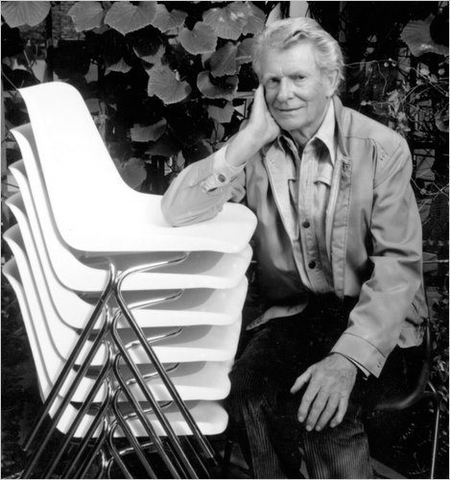
Profile- Robin Day was a British designer with a successful career spanning over 7 decades. He grew up in the furniture making town of High Wycombe in Buckinghamshire, from an early age it was recognised that he was gifted at drawing. He attended the Wycombe School of Art in 1931 where he won a scholarship and study design at the Royal College of Art in 1934, he also went on to produce the best selling chair in the world. His primary aim in terms of design was the marriage between functionalism and technology, and his early work reflected the optimistic, forward-looking mood of the post-war era. He was heavily influenced and also interested by the social context of design and designing things of good quality that most people can afford. The austerity of the war years where materials were limited and everything was in ration lead to Day’s inventive use of new technology and economically sparing use of materials. Day’s ideas were resourceful and he always took a very direct hand on approach to design. He wanted to solve practical problems in the most rigorous, efficient and cost-effective way whereby people from all walks of life could afford to purchase his products. Robin Day took an innovative approach to design and was a firm believer in continual improvement whereby each new design that he created must exceed his previous ideas. (“To produce things which are merely new and not better is really evil”). He also stated that people often think that mere newness is innovation, but it isn’t, this showed his attitude towards design and how he strived to improve on all that he did. The Second World War delayed his career but afterwards he continued by teaching interior design at the Regent Street Polytechnic, where he met Robert Moro, together they formed a partnership in 1946. They produced several exhibitions together but Robin Day continued to present exhibitions individually up until 1960 for some famous clients such as the radio manufacturer EKCO and the industrial giant ICI. During 1948 he met fellow teacher Clive Latimer and they shared success when they won First Prize in the storage section of the International Competition for Low-Cost Furniture Design organised by the Museum of Modern Art in New York. Their winning idea was for a range of multi-purpose storage units manufactured from a tube of pre-formed moulded plywood and it received international acclaim, this brought him to attention of S. Hille and Co, a small London furniture company keen to branch out into modern design. Over the next 20 years he created most of Hille’s designs, all of which were successful although the most iconic design was the polypropylene stacking chair.
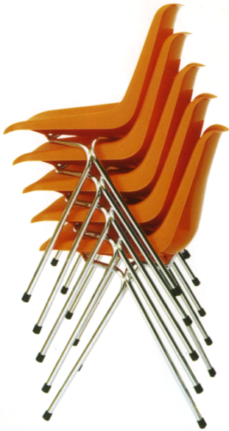
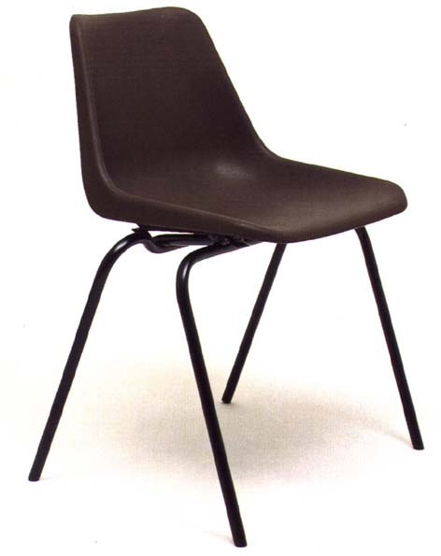
Product- One of his successful designs was the utilitarian Hillestak Chair (1951), a stacking chair with a beech plywood seat and a solid beech frame, was his first mass-produced design. The chair set new standards because it was cheap and lightweight whereas older plywood stackable chairs were expensive and heavy. He went on to improve and build upon this design by creating the polypropylene stacking chair in 1963 for S. Hille & Co. This product was a major breakthrough in furniture design and technology; it was initially created for ease of stacking as this acts as a solution to lack of space. The chair was adapted for airports, concert halls and sports stadiums and is widely used in schools, canteens and in the workplace. The polypropylene chair is still in production today after over 50 years and continues to be as popular as ever due to its ease of storage and ability to be used in a wide variety of places and situations. It is also produced in over 40 countries which contribute to the fact that it is the best selling chair in the world. The brief from Hille for the product was to create a low cost mass-produced stacking chair, affordable by all and to meet virtually every seating requirement. The chair has variations to accommodate a variety of different people of all ages, these have included Series E for children, chairs made in five sizes with lifting holes, and Polo with rows of graduated circular holes making it suitable for outdoor use and increasing its popularity. The Series E chairs are available in standard format and in a flame retardant version. The polymer can have stabilisers added before moulding in order to prevent UV light from damaging the product while in outdoor use. The chosen polymer is lightweight and easy to carry and move, paired with its high impact resistance the material is well suited for this purpose which may be why the product is so popular. The product is made from polypropylene, a thermoplastic polymer that has been injection moulded to form the seat and backrest of the chair. The material is suitable for the purpose of this chair as it has good resistance to fatigue whereby the material will not weaken under the force of repeatedly applied loads or simply people sitting on the chair. Polypropylene is quite a rigid material whilst retaining some degree of flexibility and so the backrest will be able to support the leaning weight of the user at the same time as allowing movement in order to achieve comfort. Another reason for the popularity of the product is because the polymer can be coloured and is available in a wide variety of different options, this means the design appeals to all ages and can be made more interesting in order to fit into a certain colour scheme.
Protect floor surface and reduce noise during movement.
Rubber coatings to prevent the chair from slipping and give it a more stable grip
Easily stackable
Steel frame
Injection moulded polypropylene chair body
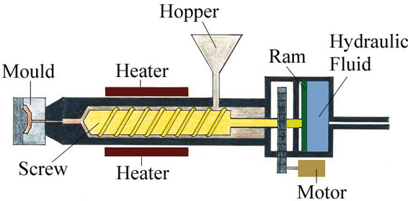
Manufacture- The body of the chair has been injection moulded using the thermoplastic polypropylene. The process involves the polymer granules being poured into a hopper where they are stored until they are needed. The heaters heat up the tube and when the correct temperature has been reached the Archimedean screw powered by the motor begins to turn and this moves the granules along the tube closer to the heaters. This causes the polypropylene granules to soften and when they have liquefied sufficiently the polymer is forced into the mould from the force of the hydraulic ram. The mould halves form the shape of the chair body and the plastic takes shape of the mould, it is here that the polypropylene is left to cool and solidify. After being left to cool, the mould halves are separated and the product is removed via the ejector pins. There is no surface finish required because polypropylene is self finishing and the moulds are produced to a very high standard whereby the finished product will not need any extra work because it has taken the shape and texture of the mould. Some polypropylene chairs today are produced with a grainy texture to improve grip and maximise safety, especially chairs aimed at younger users. The chair legs and frame are made from high quality steel tubing coated in leatherite paint for ultimate durability. The steel offers strength while being lightweight, also it is pliable when heated to ‘red heat’ and able to be formed into the shape of the frame. The frame is gas welded to give a strong permanent joint with no risk of it detaching. The rails connecting from each set of legs is slightly flattened so that it can be attached easier. Firstly the steel tubing is cut into the correct size using a guillotine and then it undergoes filing by hand to remove the burr from the edges that have been cut to improve the safety and quality of the material. To form the tube into the curved shape of the legs a jig is used, the forming takes place after the steel has been heated to red heat where it becomes more pliable. The tubing for the support rails is pinched on each end so that it can be welded to the leg components more easily. This piece is then de-burred to remove sharp edges and improve the quality; it is also drilled at each side so that it can be attached to the underside of the chair body. The 2 components are brought together and gas welded to form a very strong and rigid joint that can absorb the shock of people sitting on the chair and also support their weight. Metric screws are then used to attach the frame to the underneath of the chair body; these can be removed if necessary for uses such as recycling the product or repairing one of the components.

