Google Classroom: A guide for Parents and Carers

If your child needs to be absent from school for a period of time work will be set for them via Google Classroom. This will replicate the learning that is taking places in lessons whilst they are absent. All students should have a google classroom for each of the subjects they are studying.

Below is some guidance on how students can access this work from home.

Step One: Accessing Google Classroom

There are two main ways to access Google Classroom.
- Using a browser on a Windows PC, Apple Mac, or Google Chromebook
- On an iPad using the Classroom app (available on the App Store or a similar Android app available on the Play store)

Step Two: Logging on Using Longbenton E-mail address

- Your child has a Longbenton email account that they will need to use to access their classrooms.
- This email address will be in the following format

examplestudent@longbenton.org.uk

- Students will have set their own passwords for this address in their IT lessons. Students can speak to their IT or form teacher if they do not know their email address
- If your child has forgotten their password, please email the school lhs@longbenton.org.uk with ‘Google Classroom Password Request’ in the subject line

Step Three: Using Google Classroom

- Google Classroom will work in any browser, but Chrome is recommended.
- Access Classroom at https://classroom.google.com (your child will need to sign in using their Longbenton email account).
- Once they have done this, a page should come up that looks like the image below, showing all the subjects your child is studying:

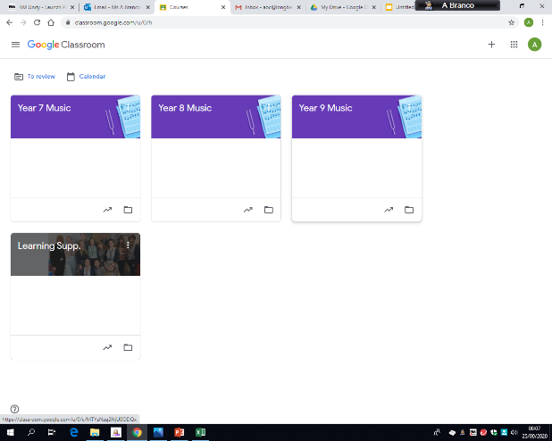

- If they have not already done so, they will need to click the ‘Accept’ button displayed in the bottom right hand corner of each class to gain access to each classroom.

Step Four: Accessing work set on Google Classroom

- Once you click into a class, a page will appear that will look something like this:
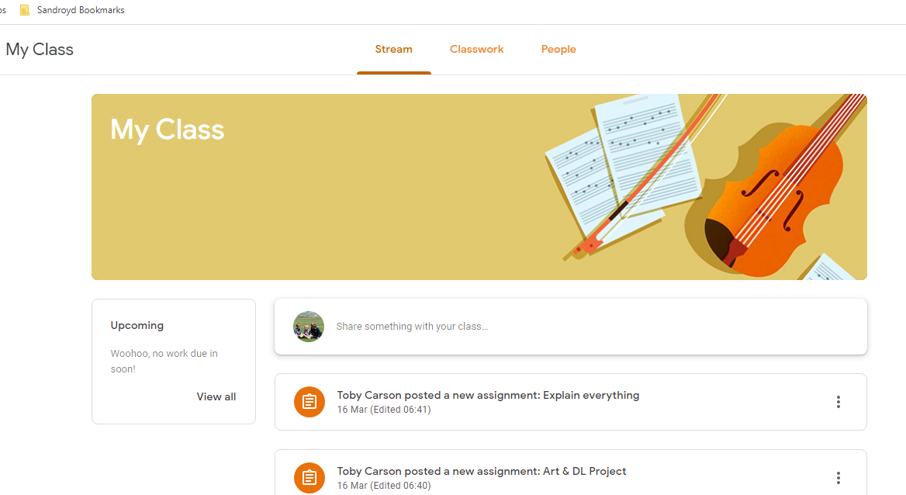

- The ‘Stream’ (shown with the red arrow above) is the first page that appears on every classroom. Here students can discuss work related issues with each other, ask teachers any questions, and will be alerted to anything new.
- Upcoming deadlines are on the left under ‘Upcoming’ (indicated above by a green arrow)
- Next to the ‘Stream’ tab is the ‘Classwork’ tab (shown by the red arrow below). When you click on this, the following page should appear:
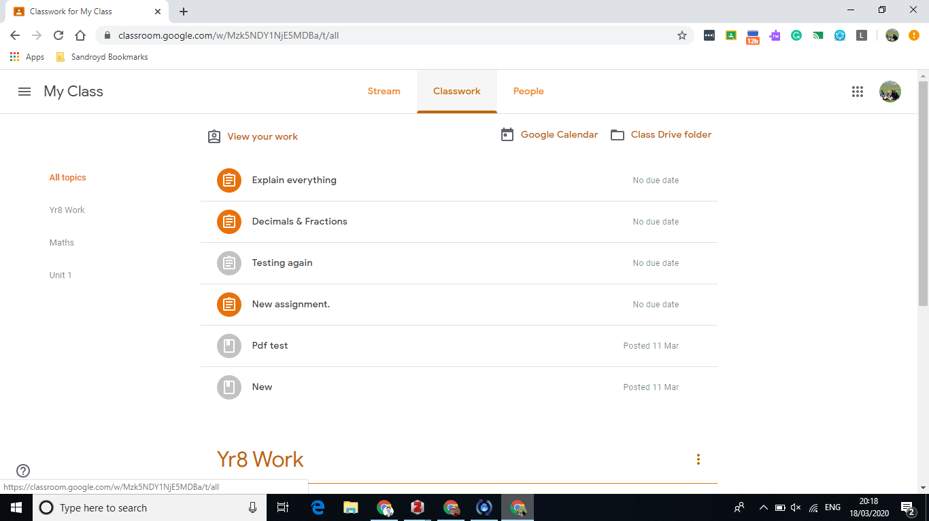

- This tab is where assignments and other resources are available. Click on an assignment for more information.
- The ‘to do’ section is a good way for your child to easily see what work is outstanding.

Step Four: Handing in Work on Google Classroom

- Once you click into an assignment, you may find that your child has been asked to submit a file to complete the assignment.
- Under ‘Add or Create’ you can add a file already in Google Drive, a web link, or a file from the computer (shown below by the red arrow and box).
- Alternatively, you can also create a new file from scratch (shown below by the green arrow and box). This is often preferable as it will not require uploading once completed.

