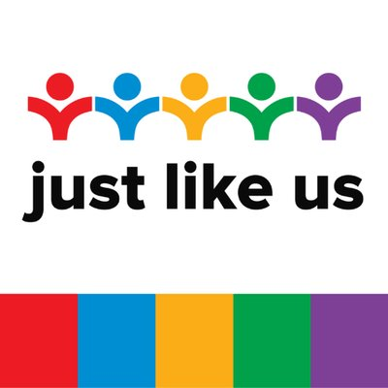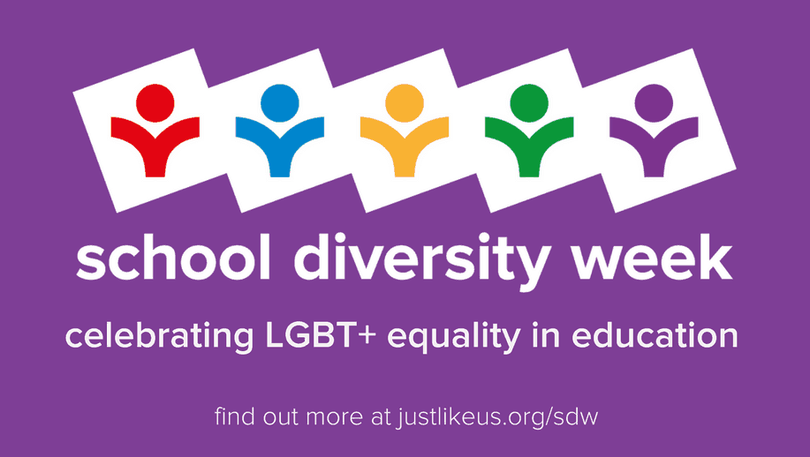

Longbenton Pride: June 2020
Hello to our wonderful Pride members, as well as the rest of our school community, who we warmly welcome to join us for Pride Month 2020.

HAPPY PRIDE MONTH!

This month, we would have been preparing to host School Diversity Week from Monday 22nd to Friday 26th June, with fabulous resources from Just Like Us, a charity who provide support for young people schools across the UK to run their own LGBTQ+ groups, like our very special Longbenton Pride. Though we may not be able to do our usual bake sales and rainbow face painting in school, we have been invited to take part in a range of online activities.

Just Like Us: Masterclasses

Just Like Us are hosting a range of fabulous Masterclasses online, with prominent members of the LGBTQ+ community offering a range of topics and discussion points.

The classes will be broadcasted from the Just Like Us Facebook page- please follow this link for more info, as well as times and dates to get into your diary.

https://www.justlikeus.org/masterclasses

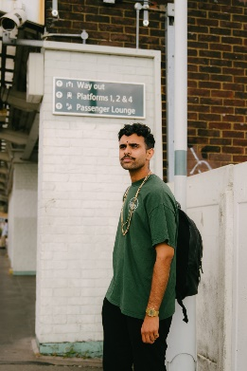
I’m very much looking forward to watching and listening to Sabah Choudery. Last year, we were fortunate enough to take a small group of students to the Stonewall Children and Young People’s Conference, where Sabah was a guest speaker and was wonderful. Check out the work they do at their website below and do try to watch their masterclass about gender diversity. You’ll learn all about “different gender identities, why they matter and Sabah will tell their own story”.

http://sabahchoudrey.com/

Just Like Us: Daily Photo Challenge

Another activity to take part in, is the Daily Photo Challenge. You can send your photos to Just Like Us through their social media pages BUT we’d also love for you to save your photos to add to Miss McK’s Display.

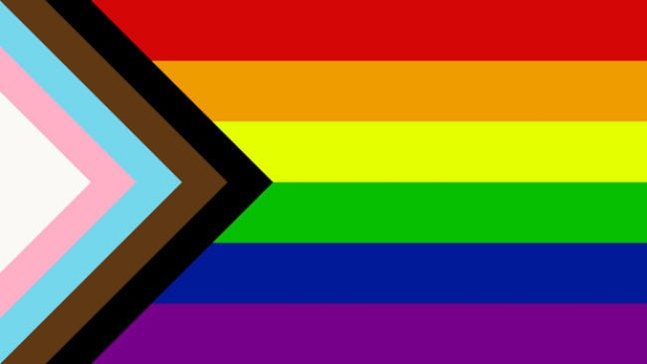
Monday to Thursday is about the Progress Flag, created in 2018 to update the existing rainbow pride flag. It incorporates the trans flag with the white, pink and light blue. The brown and black stripes represent LGBTQ+ people of colour. These groups “face disproportionate levels of discrimination, face unique challenges and have histories that other members of the LGBT+ communities don’t. The flag draws attention to these and encourages us to fight for the equal rights of everyone under the LGBT+ umbrella.”

Friday is the Rainbow Clothes Campaign- wear any of the colours or all of them!

Monday 22nd June Progress Flag Red, orange and yellow
Tuesday 23rd June Progress Flag Green, blue, purple
Wednesday 24th June Progress Flag White, pink, light blue
Thursday 25th June Progress Flag Brown, black
Friday 26th June Rainbow Clothes Campaign- all of them!

All of the info you need is here:

https://www.justlikeus.org/daily-photo-challenge

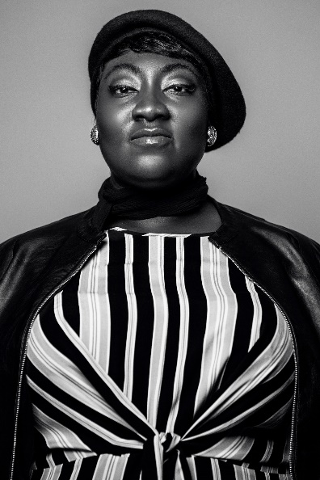
Black Lives Matter: Lady Phyll

Lady Phyll is also running a crucial Masterclass about activism and the importance of diversity, which is particularly important following recent events. Please make time to engage with this talk. https://www.justlikeus.org/masterclasses

In the linked article below, she explains the importance of educating ourselves.

https://www.vogue.co.uk/arts-and-lifestyle/article/uk-black-pride

Pride in London: You Me Us We Campaign

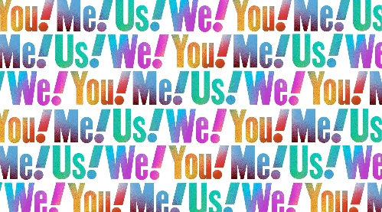

Though this year’s Pride Festivals can’t take place, there is still a lot going on to celebrate and support LGBTQ+ people and to raise awareness. Pride in London’s ‘You Me Us We’ campaign is focussing on allies.

Allies are people who support the LGBTQ+ community and are incredibly important- an ally can be anyone who supports the community, either from outside (straight allies), or within the community itself.

Follow the link to pledge your act of allyship- there are some great suggestions of things we can all do. You don’t have to give your full name or leave contact information, but your pledge and act of allyship counts and is important.

https://prideinlondon.org/about-us/campaigns/you-me-us-we/

Proud to be Longbenton Pride

As part of our own Pride Month celebrations this year, Mrs Hutchins asked staff and students from the Longbenton Pride Group to write an article about what our group means to them and why they feel it’s important.

Miss McKenna

Miss McKenna joined Mrs Hutchins this year to host Longbenton Pride and her knowledge has been incredibly valuable to our students. This is her article about joining us.

“My interest in LGBTQIA+ issues predominantly arose during my English Literature MA degree when I analysed texts through a queer lens. I am intrigued by the transgressive but also problematic representation of LGBTQIA+ people in literature and television. My degree highlighted the important and progressive mark queer people and allies leave on our political and social landscape, which I feel should be celebrated.
I joined Longbenton High School as an English teacher in September 2019. During my interview, I expressed an interest in joining Longbenton Pride - a Friday lunchtime club for LGBTQIA+ students and allies. Subsequently, I joined Mrs Hutchins to run Longbenton Pride and I was immediately welcomed into the club by staff and students. Every Friday, we discuss LGBTQIA+ topics exploring both injustices and celebrations within the community. We also have a Longbenton Pride display in CM03 which is an amalgamation of Mrs Hutchins’ display from CM15, my own additions and the students’ contributions. It has sparked numerous progressive discussions with pupils outside of the club, which I believe is a step in the right direction. I am excited to see more of our students’ creative work to include in our display which will hopefully spark further open-mindedness and acceptance around school.
I wanted to be a part of Longbenton Pride for a number of reasons: to create a safe space for LGBTQI+ students and allies to express their thoughts, feelings and emotions, to examine significant issues surrounding the LGBTQIA+ community and to inspire them to be who they truly are without judgement, shame or prejudice. I also hope to highlight and examine the prevalent debates and discussions surrounding the LGBTQI+ community. Hopefully, this will convey the importance of kindness, compassion and progressive discussions within our school and beyond.
Finally, to the Longbenton Pride students - you continuously amaze me and I am grateful for your unwavering spirit in the face of adversity, creative debates and humorous resilience. I would like you to always remember that you should not change who you are to fit society’s prescribed constructs – you are enough.
I am so excited to see you all again when school reopens.
Stay safe, stay positive and celebrate your uniqueness.”

Mrs Armstrong

Mrs Armstrong was part of the staff team for the Stonewall Children and Young People Conference 2019, following which she also joined Mrs Hutchins this year to support Longbenton Pride. Her strength and guidance has meant so much to us.
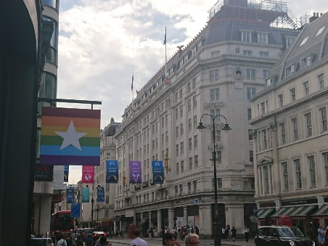
“I joined LHS in May of last year and I was thrilled to hear about Longbenton Pride. I was later offered the opportunity to attend a Stonewall conference in London with Mrs Hutchins and some Year 10 students who had been part of the club for some time. This was a very interesting experience and it helped me develop both personally and professionally. It was also great to see the students learning and interacting with like-minded individuals whom they may not have otherwise met.
The statistics for people in the LGBTQ+ community experiencing discrimination, poor mental health and suicidal intention are very alarming. I believe it is essential that all young people feel supported and valued. This is exactly what the pride club provides as well as a safe and comfortable space in which students can be themselves without judgement. There is a real sense of belonging and community. Individuals who do not identify as LGBTQ+ also attend the club and are known as allies. They provide support to others and offer a great example of the unity we need to see in society so that everyone is accepted and treated with respect. One ally recently said that he viewed the club as somewhere he could be himself and that the other members were like a second family to him.
This academic year we have seen an increase in numbers of both student members and staff. I feel honoured to be part of the staff team which now includes Mrs Hutchins and Miss McKenna and me. I hope to see the club continue to grow.”
Gabe Porter, Head Boy, Year 11

As a founding member of the group, Gabe has been an inspiration to us all and we hope he will continue to support our group, even after his time at Longbenton.

“Longbenton High School has undergone a complete overhaul in the past decade - from a brand new build, to a change in name, Longbenton is a fresh-faced school. A notable addition for me is the founding of our LGBT club, Longbenton Pride.
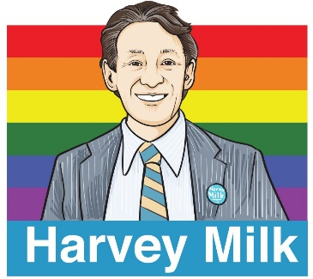
Our club came from humble beginnings - initially, we were a small group of like-minded students and a few staff, under the moniker of the 'Harvey Milk Society', after the first gay appointed official in California.
Chloe Harrowell, who helped found the club when she was in Year 10, admits that she had concerns in the beginning. "I think setting it up was hard because we didn't know how the school would respond. Once we had the club, it was so small but we were so excited because after four years of being at the school we had finally gotten a space that would be a place of understanding and care as everyone in the club could start to share their experiences. That's why we had originally named it after Harvey Milk; we wanted to start something incredible simply by creating happiness and exhibiting equality- just like he did."
Eventually, our club began to expand and we had a Programme of Events, with a talk from Dr Katie Ward about Trans People, as well as a theatre trip to see Northern Stage is Curious, in which a group of queer entertainers could showcase their talents in dance, singing and comedy. This was fundamental in understanding that our lives will continue outside of being LGBT students - we can also be LGBT creators, scientists, teachers. Our queerness will not limit us, but instead open doors.
In a bid to open our club up even more, Longbenton Pride became involved in School Diversity Week 2019. We raised money through a 'Rainbow Bake Sale' and a face-painting event (which we'd done on a smaller scale the previous year). We also conducted assemblies to whole year groups to explain our club and our aims and created a curriculum for PSD lessons centering on LGBT themes.
Also in 2019, students and staff went on a trip to London to participate in the Stonewall Children and Young People Conference. Staff were given a talks on how to support their LGBT school community, whilst students partook in ice breaker activities with other schools. There was a Q&A panel with several members of the LGBT community, including a gay head teacher, which helped staff to understand how to help aid queer students and helped students understand how LGBT staff may feel. There was also a panel of students, which was optional to join; whilst none of our students participated specifically, we found it fundamental to hear the experiences of other queer pupils.
In the beginning of the new school year, our club completely opened up to the rest of the student body. We rebranded as Longbenton Pride and doubled our numbers - we hope to continue this in future years and make Longbenton High School a completely safe and friendly space for all diverse students.”

Ethan Walker, Year 8

Ethan joined us this year and wrote this incredibly heart- warming article, which is the perfect end to this bumper newsletter, celebrating Pride Month 2020, School Diversity Week and Longbenton Pride.

“Being a LGBTQ+ Ally
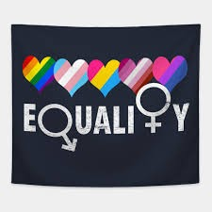
By Ethan Walker

Being a member of the LGBT+ group at Longbenton High School is a good thing to be, for it is a good example of people coming together and accepting who they are. I am proud of being an Ally of the LGBT+ community. Whilst I do not identify as LGBT, I am an ally of it, a supporter. Though I am straight and cis-gender, I still get called ‘gay’ on social media and in public but regardless of what others think, as long as people in the LGBT+ community are happy, than I will be as well.

I originally started going to the club because I saw it as a chance to chill and support people, while also being myself (*insert random personality trait here*). Also, I want to show my uncle, who is gay, that I support him and that we are all here to accept him for who he is. Furthermore, I believe that being different should not be held against a person because I am aware that there are high rates of suicide in the LGBT+ community, because people laugh at them and make them feel unwanted.

And this is why people like me (Allies) are here to help, however we can.

Since joining Longbenton Pride, I feel like I have joined a community of people who I didn’t really know, from all different year groups across school, and yet have become like close cousins, like a second family. This has made me feel happy because I feel like I'm a part of something that could help a lot of people feel accepted in the role we play in life.

I like to remember this quote: “Always smile because you are never fully dressed without one” -Allister (Hazbin Hotel)”

