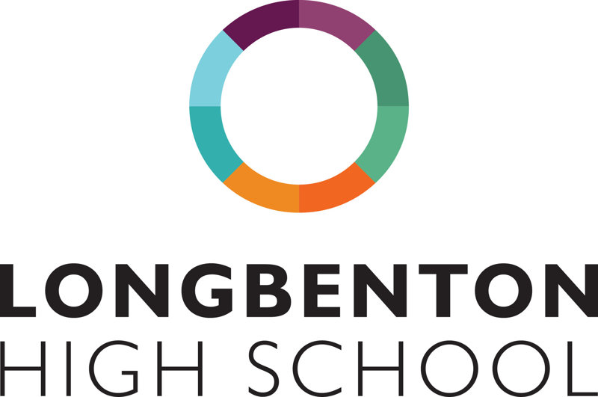
Frequently asked Questions
School Bromcom ID is 14794
How do I get a MCAS account?
Parents can access the Parent Login screen in two ways:
- From within the web browser type www.mychildatschool.com, this will open the Parent Login screen.
- From the MyChildAtSchool mobile phone app, this will open the Parent Login screen.
Follow the steps at the link below to set up your account. Scroll down the page to the heading How to Self Sign Up for parents and it will guide you through step by step.
Our school ID if you are asked for it is: 14794
https://docs.bromcom.com/knowledge-base/how-to-use-self-sign-up-for-parent-mcas-account/
How do I top up break/lunch money on MCAS?
Guidance on making payments can be accessed via these links:
Making payments on the MCAS app. Making payments on the MCAS website.
I can’t see all my children in the app?
If you have more than one child at the same school, once logged into MCAS for one child, click on your child’s name in the top left hand corner to switch between the accounts for your children. If your other child/ren’s names are not listed, please text the school via MCAS or LHS@longbenton.org.uk and we will link your children manually for you.
I don’t get any notifications in the app?
Not every device activates notifications when the App is set up.
To check, go to;
Settings>Notifications>MyChildatSchool….Make sure ‘allow notifications’ is on and that a sound has been applied and the ‘sound’ is switched on.
I have forgotten my password
At the login screen there is a ‘Forgotten details’ button. This will send you an email link to change password. Please note this must be the email address we have on record for you.
My child has free school meals, how do they pay at the tills?
A child who is in receipt of free school meals will have their account topped up with the daily allowance every morning. The current daily allowance is £2.60. This can be spent at break, lunch or both. The quickest and easiest method of payment for students is facial biometric recognition. This way students can access funds parents have topped up in MCAS or their free school daily allowance (£2.60). Parents need to complete the google form XXXXXXXXXXXXXXX for the start of term (please see MCAS FAQ for further information). Students in receipt of free school meals can also top up their MCAS account if they wish.
Biometric Facial Recognition
- Why are you using biometric recognition?
Biometric recognition converts physical characteristics into a unique digital signature that can be used to quickly and securely locate your child’s cashless catering account. This helps speed up service and eliminates the requirement to remember a free school meals code or carry another means of payment, such as a card that can be lost or stolen.

- How does it work?
When the child looks at the camera, the software reads key features and compares this against the database of registered users. When it finds a match it automatically opens their cashless catering account, allowing the operator to complete the sale. It takes seconds.

- What happens when my child leaves the school?
All data will be deleted and will not be stored.

- I don’t wish to give permission for my child to participate with biometric recognition. Can my child still purchase school meals?
Yes, but they will have to use a debit card or remember a PIN number to access MCAS.

- What if I change my mind?
If you initially opt in for your child to use biometric recognition but later change your mind, contact the school and we will remove the permission from the system, which will automatically remove any biometric data associated with your child and provide your child with an alternative method of authentication.

- Can this biometric data be used by any other agency?
No, the software turns your child’s physical characteristics into an encrypted string of characters known as a template (using AES 256; no fingerprint image is stored). Even if someone were to gain access to the data and break the encryption, this template does not contain enough information to reverse engineer into useable data.
The full online parent guide is available here: https://docs.bromcom.com/knowledge-base/mcas-parent-guide/
If you need any further help, please can contact the school either by the MCAS app or emailing the school directly at LHS@Longbenton.org.uk

