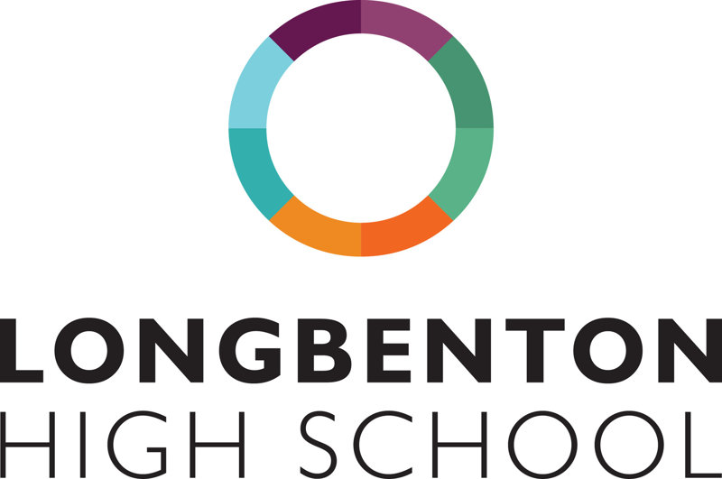
Dear Parent/Carer
Welcome to our electronic communication and payment system, My Child At School (MCAS). MCAS enables you to receive information from school securely, quickly and reliably.
We are encouraging all parents/carers to log on to MCAS regularly to access live attendance and engagement information about your child, access reports and make payments for breakfast and lunch money (we will be launching payment for clubs, trips and other purchases in the near future).
As a reminder, My Child At School is an online portal providing access to information from school via any modern web browser (e.g. Edge, Firefox, Chrome, Safari etc.) as well as a free app (for android or ios) which can be enabled with Push Notifications to ensure you receive timely information.
Accessing MCAS allows you to:
- see your child’s timetable for the current week
- update your child’s medical information, personal information and your own contact details
- top-up your child’s lunch account securely, quickly and easily, as well as monitor their spending
- access Assessment Reports
- access live lesson attendance information
- access information regarding positive and negative behaviour
NB Coming soon payment for trips, clubs and other purchases
We can:
- share more information regarding your child/ren
- save money on admin time, texts, printing and paper
You can access MCAS via an App or a web browser. If you are able to use the App, this allows the school to reduce costs by sending messages via the app rather than text message (text messages will continue to be sent in an emergency situation e.g. school closure). Please ensure that notifications for the MCAS App are switched on in your phone settings.
Data Collection Form
You can update your personal contact details, and some details about your child via MCAS. This will replace the annual data collection form school usually sends to you.
To review and update details within MCAS, click on the Data Collection Form. There is a tab for reviewing and updating student details and a separate tab for updating personal details (you as a user). Any changes you request will be received by the school for review and confirmation in our system.

Accessing MCAS
You can download the App from your App store by searching for MyChildAtSchool. You can log on to the web browser here. The email address used to set up the MCAS account must be the same email address held on our records.
To log on to your account you will need the School ID (14794), your username and password. Your username will be your surname followed by a number and your password will be one you created when you registered your account. If you have forgotten your username or password, please follow the forgotten login details link in the App or website.
Topping up MCAS
Guidance on making payments can be accessed via these links:
Making payments on the MCAS app. Making payments on the MCAS website.
Multiple Children
If you have more than one child at the same school, once logged into MCAS for one child, click on your child’s name in the top left hand corner to switch between the accounts for your children. If your other child/ren’s names are not listed, please text the school via MCAS or LHS@longbenton.org.uk and we will link your children manually for you.
How children pay for catering services at school
The quickest and easiest method of payment for students is facial biometric recognition. This way students can access funds parents have topped up in MCAS or their free school daily allowance (£2.60). Parents need to complete the google form XXXXXXXXXXXXXXX for the start of term (please see MCAS FAQ for further information). Students can also pay by debit card, but we do not accept cash payments. Please do not worry if you are having difficulty topping up your MCAS account before the beginning of term, we allow students to go ‘overspent’ on their MCAS account in the first instance, allowing any issues to be resolved.
I hope this has helped to resolve any queries you may have, but please contact the school with any concerns or issues you have. You can contact the school via the MCAS app or email the school at LHS@longbenton.org.uk.
Yours faithfully
K Holbrook
Kelly Holbrook

