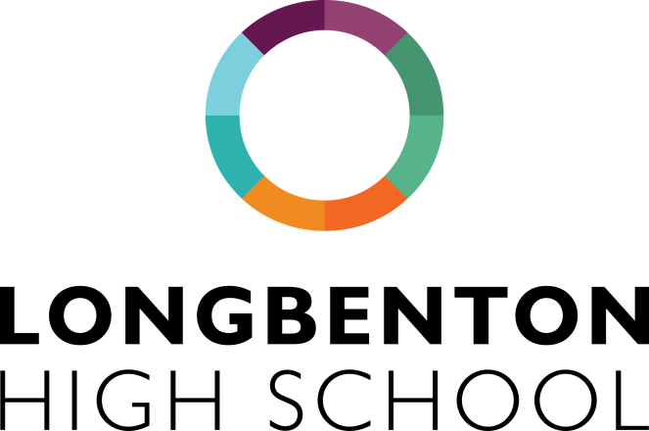

Relationship and Sex Education Curriculum Content

Year 7

Topic | Objectives
Families | - To know different types of families that exist in the UK.  - To understand the changing nature of family life.  - To appreciate and show tolerance towards different forms of families.  - To understand different types of conflict that occur within families.  - To discuss and explore ways to reduce conflict.
Respectful Relationships | - To identify characteristics of healthy and unhealthy relationships within friendships.  - To identify what is bullying.  - To recognise the effects of bullying.  - To know how to seek support when experiencing bullying.  - To know and identify different forms of abuse.  - To recognise abusive behaviours.  - To know where to seek support relating to issues of abuse.
Online Media | - To know what is meant by e-safety.  - To improve understanding on how to stay safe online.  - To explore the impact of viewing harmful images and videos online.  - To know how to report harmful incidents online.
Intimate Sexual Relationships and Health | - To know different views, laws and rights on gender.  - To know and understand what it means to identify as heterosexual, bisexual, gay and asexual.  - To appreciate different viewpoints on sexuality and gender.  - To know the Law on sexuality in the UK.  - To know the emotional changes relating to puberty.  - To know the physical changes that occur during puberty.
Being Safe | - To understand what is meant by consent.  - To explore boundaries within friendships and relationships.  - To know what is meant by online consent.

Year 8

Topic | Objectives
Families | - To know the laws and legal rights of a married couple.  - To explore the different types of marriage and the changing legal and social attitudes towards different types of marriage.  - To know the difference between forced and arranged marriages.
Respectful Relationships | - To understand and recognise peer on peer abuse.  - To reflect on the importance of boundaries within friendships.  - To understand the dangers of peer pressure.  - To know where and how to receive support relating to issues of abusive relationships from peers.
Online Media | - To know the online risks of sharing and receiving material.  - To know the laws relating to online safety.  - To know the risks that are posed online.  - To know how to report harmful incidents online.
Intimate Sexual Relationships and Health | - The laws relation to LGB Rights.  - The laws relating to Gender Rights and Equality.  - To understand what is meant by Gender Transitioning.  - To understand the effects on LGBTQ discrimination.
Being Safe | - To understand what is meant by coercion.  - To know the consequences of coercing another person.  - To explore boundaries within friendships and relationships.

Year 9

Topic | Objectives
Families | - To recap and review healthy family relationships and their importance.
Respectful Relationships | - To know the effects and harm caused by stereotypes (sex, gender, religion, sexuality, race and disability)  - To know the Laws on prejudice and discrimination.  - To understand and reflect on the effects of bullying and how to recognise common features of bullying.  - To know what constitutes as abuse in various different types of relationships.
Online Media | - To recognise individual responsibility when commenting on social media platforms.  - To understand the laws and consequences of online abuse.
Intimate Sexual Relationships and Health | - To know the scientific facts of reproduction.  - To be aware of the different methods of contraception, what contraception is and purpose.
Being Safe | - To be aware of online responsibility in relation to online abuse, sharing and possessing images.  - To identify risky behaviours.

Year 10

Topic | Objectives
Families | - To review and recap on the different types of families and the laws on marriage and divorce.
Respectful Relationships | - To identify features of healthy relationships.  - To know and understand what Protected Characteristics are and the Equality Act 2010.
Online Media | - To review online safety and to understand how to control privacy settings.  - To understand the dangers associated with data sharing.
Intimate Sexual Relationships and Health | - To know what coercive control is in a relationship.  - How to recognise and check for consent.  - Explore how to manage sexual pressure set by society and peers.  - To explore in depth the meaning of LGBTQ and how these definition and identities have changed over time.
Being Safe | - To know the Laws on the age of consent.  - To know the different sexually transmitted diseases, the short and long term health effects of STIs.  - To know where to receive an STI test and what takes place during an STI test.

Year 11

Topic | Objectives
Respectful Relationships | - To explore the qualities of healthy relationships such as trust.
Online Media | - To know and understand the dangers on online grooming.  - To understand the effects and pressure created by online media.
Intimate Sexual Relationships and Health | - To know what is meant by reproductive health and explore what effects reproductive health.  - To know what are the different pregnancy choices.  - To learn the effects of hormonal contraception.  - To review sexual health and how to take care of sexual health.
Being Safe | - To know the Laws and consequences of abusive relationships.  - To understand what is meant by sexual harassment and violence.  - To know what Female Genital Mutilation (FGM) is and raise awareness and understanding of the issue.  - To understand what is meant by Honour based violence.

