Learner Guide to Microsoft Teams Assignments

Section 1
How to use Teams on a Desktop or a Laptop
- How to log on
- How to upload an assignment
- How to access and respond to feedback given to you by your teacher

Section 2
How to use Teams on a tablet or mobile phone
- How to log on
- How to upload an assignment
- How to upload a picture of work you have completed as an assignment

Desktop/Laptop Guide

Firstly, browse to longdendalehighschool.org.uk using your web browser (Google Chrome is highly recommended), from the homepage scroll down halfway to ‘email system’. Your email will be the year you leave followed by your first name, fullstop(.) and last name plus ‘@lhs.aspireplus.org.uk’. For example, Bob Smith in Y9 would use the email ‘23bob.smith@lhs.aspireplus.org.uk’.
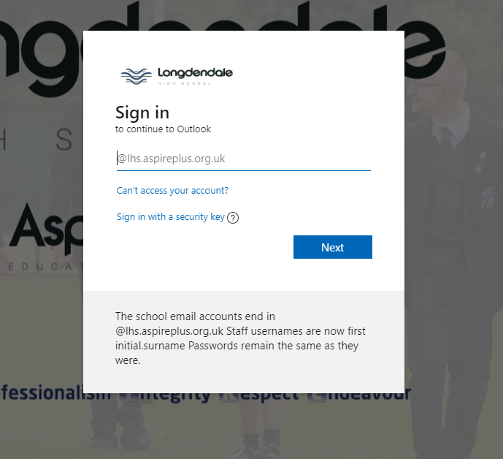
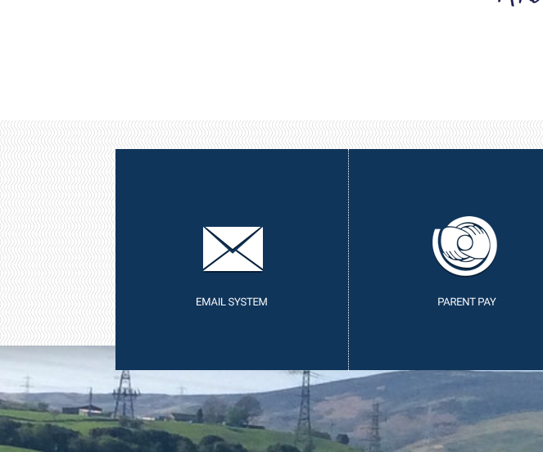

Once logged into your emails click on the 9 white dots at the top left of the page, from the pop up menu choose ‘Teams’.
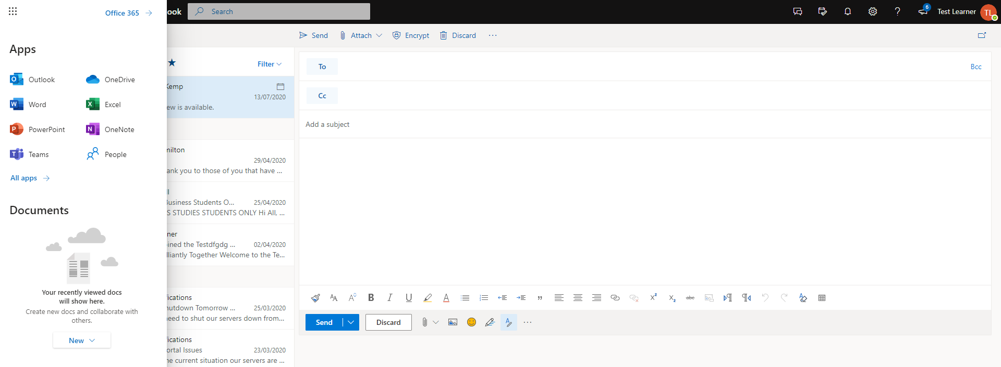

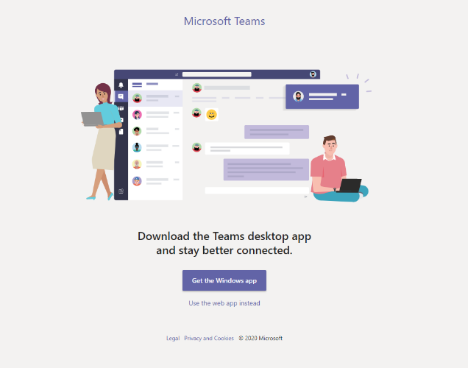
You may be prompted to download the Microsoft Teams app, the app does not have to be downloaded but does offer better performance.

To continue using Teams from within your web browser select ‘Use the web app instead.
To download the Teams app on your Windows computer select ‘Get the Windows app’.
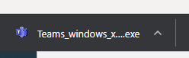
Once the file has finished downloading double click to install the application.
The Teams application will automatically open once the installation is complete.

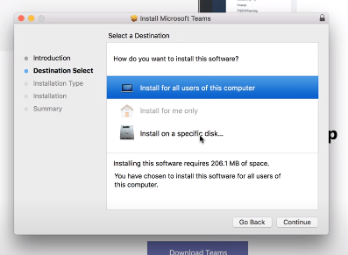
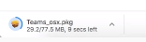
To download the Teams app on your Apple Mac computer select ‘Get the Teams app’. Once the file has finished downloading double click the .pkg file to start the installation of the application.
Continue through the installation, selecting the options for your computer, it is recommend to keep the default options in the installation. When prompted for your login to install software put in your mac computer login not your learner email. Once installed the Teams app will show in your applications folder or Launchpad.

Once Teams has loaded click on ‘assignments’. This page will display all of your allocated classes. Click on a class to view your assignments.
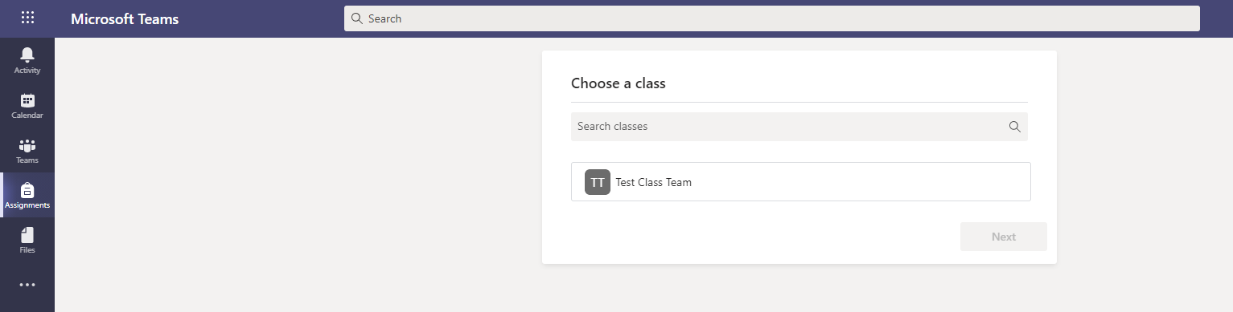
You will also receive a notification in the activity feed when new assignments are set and when your teacher has provided feedback.
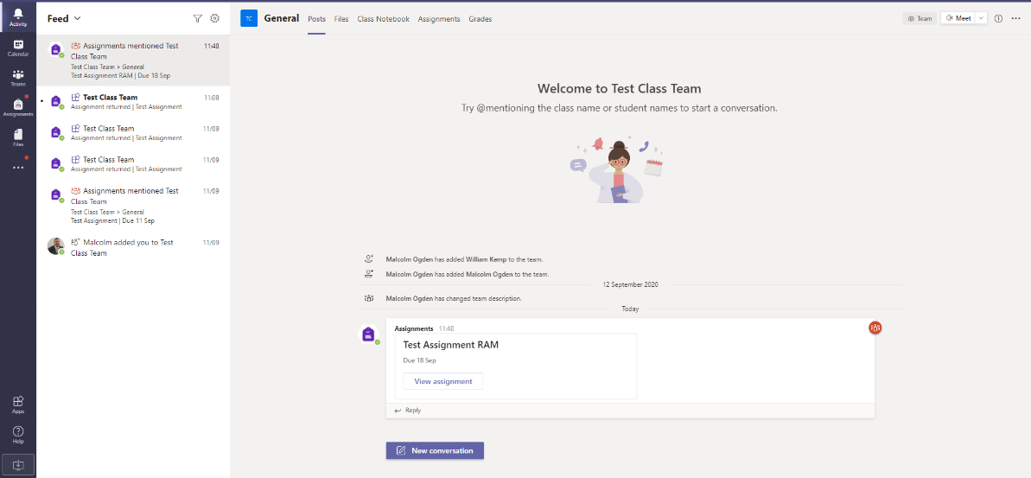

Click on the assignment you are wanting to complete.
From the example assignment set you will see I have been assigned a resource file; this is an un-editable file to use as a reference to complete your work. The teacher may also add links to online resource such as news articles.
An answers sheet has already been created for me, this is where I will fill in the questions set by the teacher.
Work can also be submitted using your own created document by selecting ‘Add work’, this would be used for example to upload a picture of artwork, or when a teacher has not assigned an answers/work sheet.
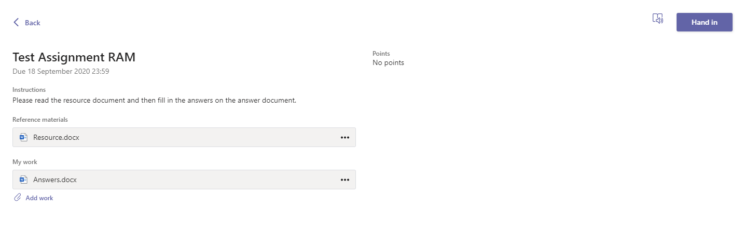
To fill in the answers document click on the attached ‘my work’ file, this will then open the document in Word Online within your browser, offline Microsoft Office suite is not necessary as every learner has access to office online. In the below Image you can see me filling in my answers to the set questions, once I am happy with my answers I will select ‘close’ from the top right; this will then save the document.
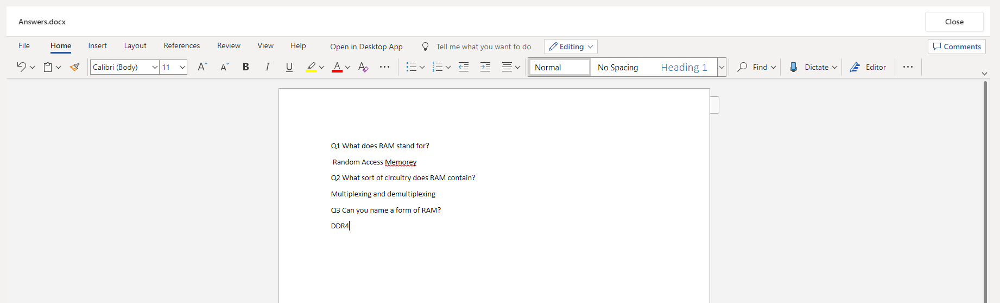

Now I have filled in my document and uploaded any additional work and I am happy with it I can now click on ‘hand in’ to submit to the teacher. Once succesfully handed in you will see an animation on the right side of the window.
From the activity feed, once my work has been marked by the teacher I will receive an alert that my assignment has been marked. The teacher has requested me to hand in my assignment again once completing the feedback they have sent. Double click on the answers sheet to edit your work, and save the document by selecting ‘close’. I can now re-submit my work by clicking ‘hand in again’; an animation will follow again once successfully submitted.
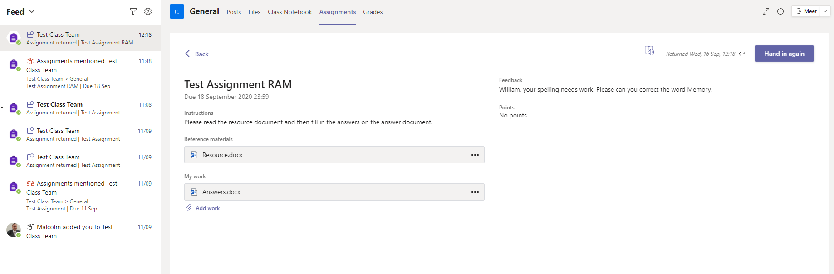
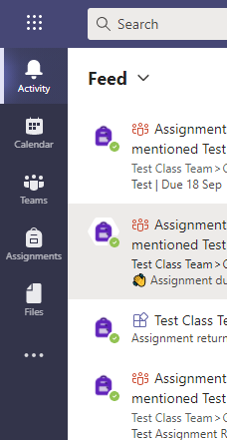

I can see all of my completed assignments by going to ‘Assignments’ from the left navigating bar then selecting the relevant class.
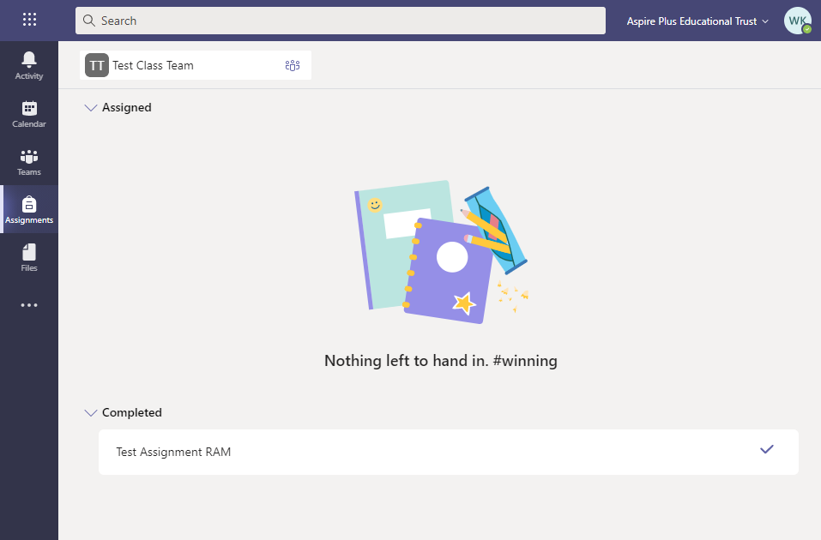
To view the grades rewarded for each assignment select ‘teams’ then the relevant class and select ‘grades’. In this example, the teacher did not allocate any points to the task.
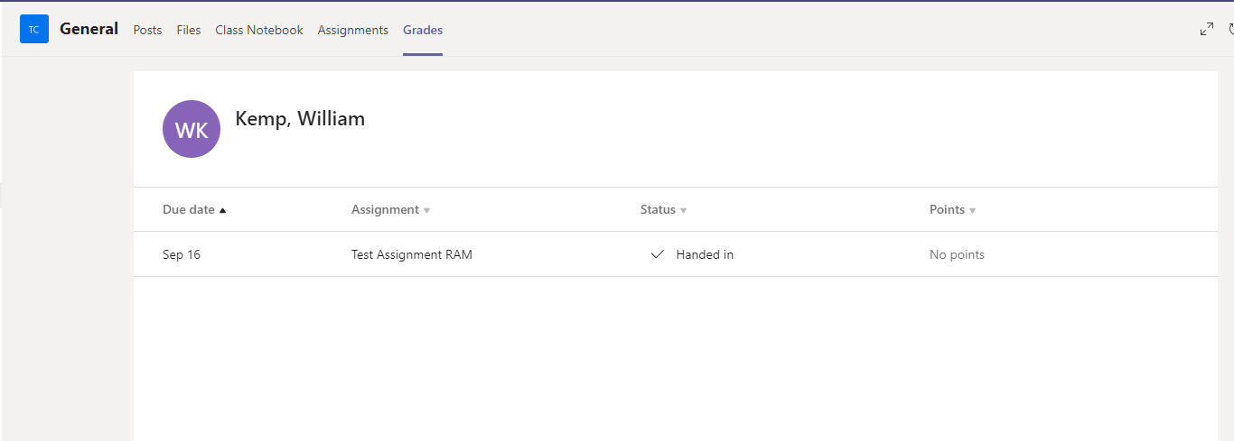

Mobile Guide
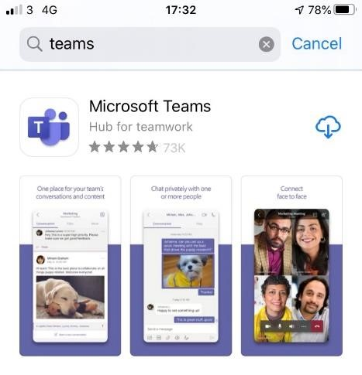
To access Teams Assignment through your mobile device you will need to download the free app ‘Microsoft Teams’. This app is available through the App store for Apple users and Google Play store for Android users.

To sign in, your email will be the year you leave followed by your first name, fullstop(.) and last name plus ‘@lhs.aspireplus.org.uk’. For example, Bob Smith in Y9 would use the email ‘23bob.smith@lhs.aspireplus.org.uk’. Your password is the same one you use for your email or school computer.
Be sure to allow notifications to be alerted of new assignments, important messages or feedback from your teacher.

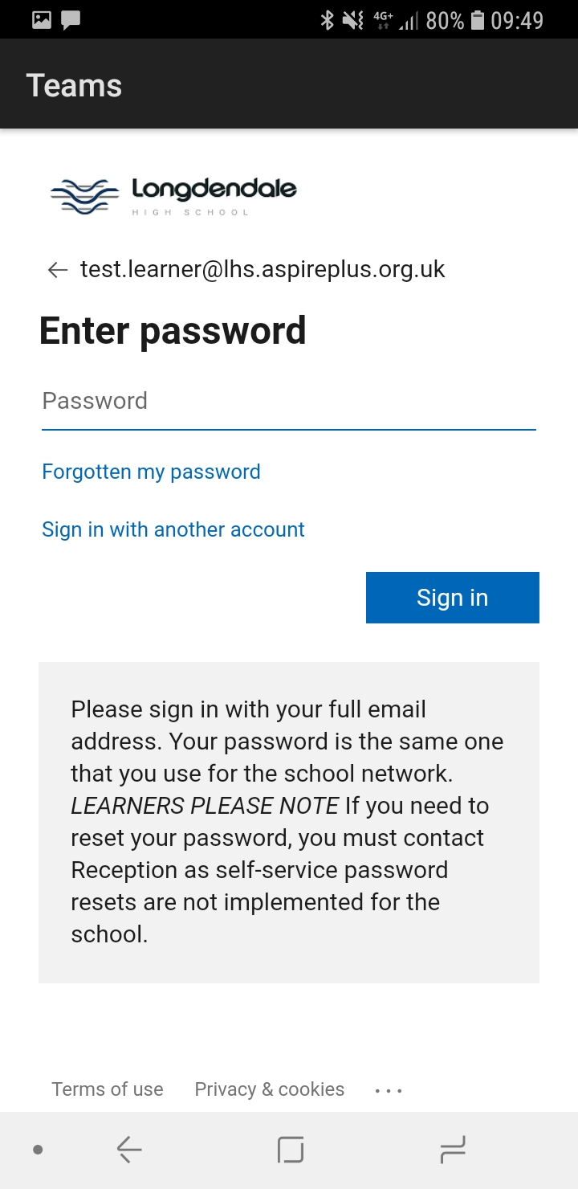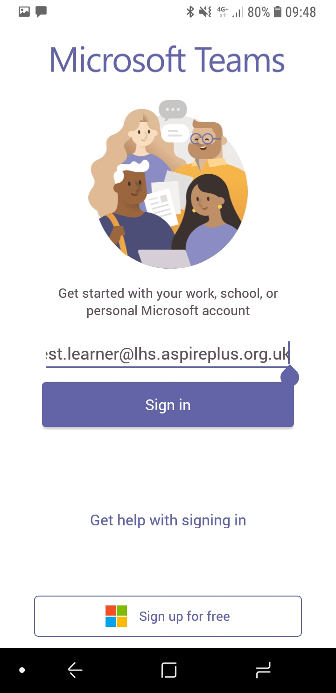

To upload a document, follow the guide in the desktop/laptop guide as submitting a document from a phone or tablet is the same process. However if you have piece of written work that you need to upload, you can use your tablet or phone to take a picture of your work.

Alerts of new assignments set will appear in the activity feed or can be viewed from the assignments tab and choosing the relevant class.
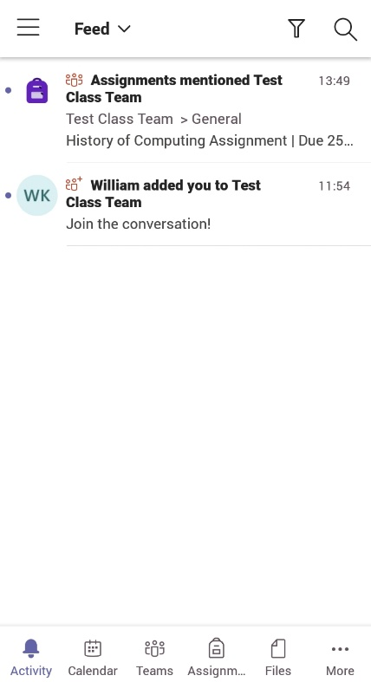
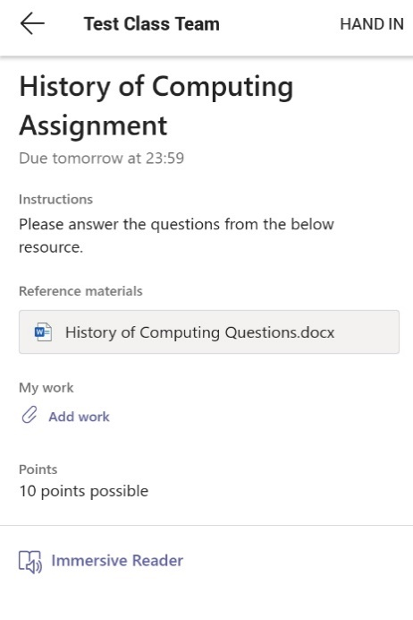

There are a few options for uploading your work from the ‘Add work’ button:
- Create a new file:
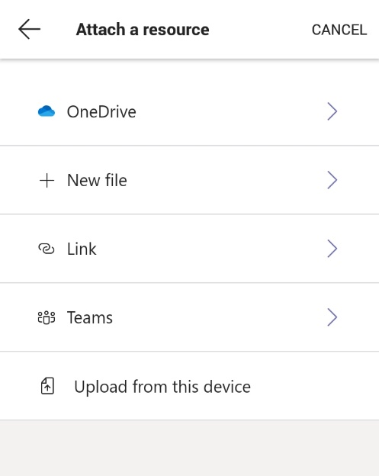

To create a new file Microsoft office will need to be downloaded onto your device (for all learners the license is free). To be directed to the app store to download the app click on the word icon in the bottom right. Sign in using your school email to activate the free license.
- Attach a photo of written work:
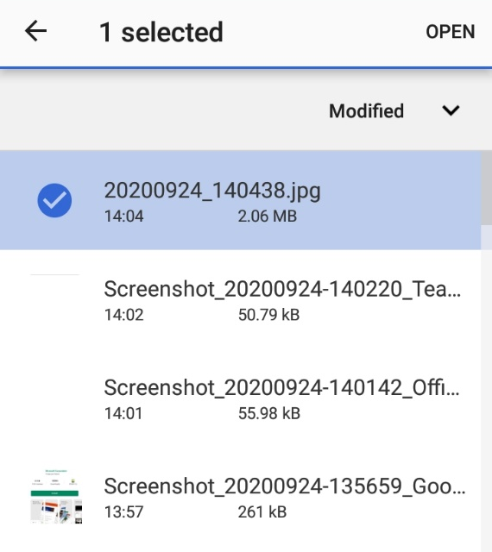

Take a photo of written work using your devices camera app. Select ‘Upload from this device’ and select your image from your device then ‘open’.
- Teacher has provided an answers sheet
If your teacher has provided an answers sheet this can be edited by selecting the document and editing this using the Microsoft office app.
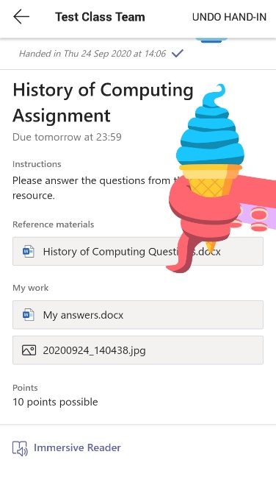

The assignment is now submitted to the teacher. When assignment has successfully submitted an animation will appear on your screen.
In this example I have chosen to submit a word document containing my answers and a photo of written answers.

An alert will appear in the activity feed once the teacher has marked and provided feedback for your work. All completed assignments can be seen from the assignments tab.
