Health and Safety Handbook

Contents
1. Health and Safety Policy Statement 10
2. Regulation References 11
3. Responsibilities 11
4. Safety Guidelines 12
a. Safe Use of Mobile Phones 12
b. Drugs and Alcohol 12
c. Smoking 12
d. Slips, Trips and Falls 12
e. Working from Height 13
i. Step Ladders 14
Many accidents occur due to step ladders being poorly maintained or misused. 14
f. Safe Stacking 14
5. Manual Handling 14
6. Personal Protective Equipment - PPE Clothing 15
7. Fire Precautions 15
a. MEANS OF ESCAPE 16
b. The Fire Triangle… 16
c. Types of Fire Extinguishers 17
8. Control of Substances Hazardous to Health 18
a. CARE OF SKIN 18
b. SAVE YOUR SKIN 18
9. Infection Control & Blood-borne Viruses 19
10. Safety Signs 19
11. Accidents and Incidents 21
a. Emergencies: 21
b. Where instant action is needed: 21
c. First Aid Box Locations: 21
d. Defibrillator is located: 21
e. Medical Information 21
f. Illness 21
g. Medication 21
12. Teachers’ responsibilities 21
a. Epilepsy 22
13. Staff Responsibilities 22
14. Individuals suffering from Epilepsy have an additional duty to: 22
15. Diabetes 22
a. Teachers’ responsibilities: 22
b. Furthermore, diabetic person’s responsibilities include: - 22
16. New and Expectant Mothers 23
17. Safety in PE 23
18. Method Statements 24
19. Other Health and Safety Arrangements 24
a. Off-site visits and residential holidays 24
b. Break and lunch time supervision. 24
c. Car park area. 24
d. Security of premises. 24
e. Lone Working 24
f. Key Holder Safety during Call Outs 24
g. Critical Incidents 24
h. Risk Assessments 25
20. Summary 26
21. ACKNOWLEDGEMENT 26

This Handbook belongs to:
Role:
Issue date:
Issued by: | Mark Garside  Headteacher

Health and Safety Policy Statement
In accordance with its duty under section 2(3) of the Health and Safety at Work etc. Act 1974, and in fulfilling its obligations to employees and members of the public who may be affected by its activities, Longmoor Community Primary School have produced the following statement of policy in respect of Health and Safety:
It is our aim to achieve a working environment that is free of work-related accidents and ill health and to this end we will pursue continuing improvements from year to year.
Longmoor Community Primary School recognises its Health and Safety duties under the Health and Safety at Work etc. Act 1974 and the Management of Health and Safety at Work Regulations 1999, and all concomitant legislation, to ensure, so far as is reasonably practicable, the health and welfare at work of all employees.
Particular attention will be paid to duties required, namely:
- Provision and maintenance of safe plant and systems of work.
- Safe and healthy use, handling and storage of articles and substances.
- Provision of necessary information, instruction, training and supervision.
We undertake to discharge our statutory duties by:
- Identifying hazards in the workplace, assessing the risks related to them, and implementing appropriate preventative and protective measures.
- Providing and maintaining safe plant and work equipment.
- Establishing and enforcing safe methods of work.
- Recruiting and appointing personnel who have the skills, abilities and competence commensurate with their role and level of responsibility.
- Ensuring that tasks given to employees are consistent with their skills, knowledge and ability to perform.
- Ensuring that technical competence is maintained through the provision of refresher training as appropriate.
- Promoting awareness of Health and Safety and of good practice through the effective communication or relevant information.
- Furnishing sufficient resources needed to meet these objectives to maintain a safe working environment.
A successful Health and Safety programme is dependent on the participation and co-operation of all employees. All employees are aware that they have a legal duty to:
- Exercise reasonable care for the Health and Safety of themselves and others who may be affected by their acts or omissions at work.
- Co-operate with and assist the employer in meeting statutory obligations.
- Not intentionally or recklessly interfere or misuse anything provided in the interests of health, safety and welfare.
Our Health and Safety Policy will be reviewed annually as a minimum, to monitor its effectiveness and to ensure that it reflects changing needs and circumstances. The Policy will be subject to additional review to reflect changes to legislative requirements, changes to key personnel in the school and advancement in technologies which affect the school’s activities.
Copies of this Health and Safety Policy Statement will be displayed in the workplace. The full School Health and Safety Policy will be available for all employees to read.
All Employees will be expected to comply with this Health and Safety Policy.
Signed: | 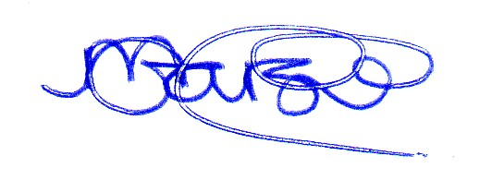 | Role: | Headteacher
Name: | Mark Garside | Date: | 18th September 2023

Regulation References
- The Health and Safety at Work Act 1974.
- Construction (Design & Management) Regulations 2015 (CDM).
- The Provision and Use of Works Equipment Regulations (PUWER) 1998.
- The Lifting Operation and Lifting Equipment Regulations (LOLER) 1998.
- The Manual Handling Operation Regulations 1992.
- Personal Protective Equipment (P.P.E.) at Work Regulations 1992.
- Control of Substances Hazardous to Health (C.O.S.H.H.) Regulations 2002.
- Electricity at Work Regulations 1989.
- Control of Asbestos at Work Regulations updated 2012.
- The Health and Safety (First Aid) Regulation 1981.
- Management of Health and at Work Safety Regulations 1999.
- Confined Space Regulations 1997.
- Display Screen Equipment Regulations 1992.
- Health & Safety (Consultation with Employees) Regulations 1996.
- The Health & Safety (Safety Signs & Signals) Regulations 1996.
- Control of Noise at Work Regulations 2005.
- The Control of Vibration at Work Regulations 2005.
- Reporting of Injuries, Diseases, or Dangerous Occurrence Regulations (RIDDOR) 2013.
- The Workplace (Health, Safety & Welfare) Regulations 1992.
- Working at Height Regulations 2005 (amended 2007).
- Regulatory Reform (Fire Safety) Order 2005.
- Control of Asbestos Regulations 2012.

Responsibilities
The Health and Safety at Work Act 1974 gives everyone responsibilities.
Schools must provide a safe place of work, safe equipment and the instruction and training to enable you to carry out your work safely.
Employees you have legal duties too.
They include:
- Taking reasonable care for your own health and safety and that of others who may be affected by what you do or do not do.
- The safety of pupils in classrooms, laboratories and workshops is the responsibility of class teachers. This responsibility cannot be delegated to a student teacher. If, for any reason, a teacher considers he/she cannot accept this responsibility he/she should discuss the matter with the Head before allowing practical work to take place.
- Co-operating with your school on health and safety.
- Correctly using work items provided by the school, including personal protective equipment, in accordance with training or instruction.
- Not interfering with or misusing anything provided for your health, safety, or welfare.
- The following safety rules have been implemented to ensure your safety and the safety of your school colleagues.
Do
- Wear Personal Protective Equipment when appropriate
- Report any accident or injury to the lead first aider- they will provide 1st aid and communicate to a member of SLT any defects in plant or equipment. Any hazards in the school must be reported the same way.
- Keep your workplace clean and tidy
- Understand and comply with all safety signs and instructions
- Drive carefully by observing speed limits & traffic signs
- Use the eating, drinking & toilet facilities provided
Do not
- Report for work under the influence of drink or drugs
- Indulge in horseplay
- Alter or adapt safety equipment unless authorised and trained to do so
- Use plant or equipment for which you have not been authorised and trained
- Bring any equipment or substances in to school without prior permission from the SLT.

Safety Guidelines

Safe Use of Mobile Phones
Mobile telephones should be turned off whilst working with children. Please see a member of the leadership group should you require your mobile to be on during special circumstances.
Staff should not give out their personal mobile phone details to children or parents.
Staff should always take mobile phones with them when they are involved in a trip or off-site visit (this includes swimming). A copy of mobile telephone numbers of all staff accompanying children on a school trip or off-site visit should be included on the trip pro-forma which should be left in the school office.
Mobile phones may also be required for communicating between members of staff when classes are split or in special circumstances.
The HSE advises that employees should be instructed not to use mobile phones whilst carrying out any task or duty where safety is important and the use of the phone might interfere with concentration such as: working at height, working from a ladder

Drugs and Alcohol
Alcohol and drug misuse has an effect on an individual’s health and wellbeing and can cause a wide range of social problems, affecting family, friends and colleagues.
We have made it our policy and a condition of employment at school that, if it is suspected that anyone is intoxicated by drink, or are under the influence of un-prescribed drugs, they will not be permitted into school.

Smoking
Since 2007 it has been illegal to smoke at places of work.
It is also illegal to smoke in school vehicles, this includes; cars and mini buses etc. This includes E- Cigarettes.
Always ensure that:
- You only smoke off the school grounds

Slips, Trips and Falls
Slips and trips account for about a third of all reported major injuries - just fewer than 90% of which involve fractures of arms, wrists and ankles.
They are the most common hazard faced at work, with nearly 1000 workers a month suffering serious injury (a broken bone or head injury) following a slip or trip.
What can I do to prevent slips and trips?
What can you do to make a difference?
- Your actions could make the difference between someone getting injured or not.
- Seen a spillage? Instead of thinking it is someone else's problem, why not clear it up?
A useful checklist to help improve safety for you and your colleagues at Longmoor Community Primary School.
- Use your initiative
- Suggest ways of preventing contamination (water, oils, cardboard, waste etc.) from getting onto the floor
- Monitor everything you put in place
- Make sure the floor is clean and dry
- Clear up spillages immediately
- Dispose of waste materials
- Remove any obstructions
- Avoid trailing cables
- Store goods safely
- Keep workstations clear of obstacles
- Make sure flooring materials are level and secure (site manager)
- Identify and mark slopes and changes of levels (site manager)
- Ensure you have adequate lighting
- Wear suitable footwear
- Think about visitors to your workplace, what do they need to know? Do you need to do more to protect them?
Cleaning floors can prevent accidents - but unless it is done with care, it can also introduce new risks.

Working from Height
It is not possible to provide a comprehensive list of ‘Working at Height’ situations.
Definition of ‘at height’ is, if a person could be injured falling, even if it is at or below ground level. ‘Work’ includes moving around at a place of work (except by a staircase in a permanent workplace) but not travel to or from a place of work.
The Site Manager will use only completed working platforms – with guard rails, toe boards, etc.
Do not interfere with, alter or move any scaffolding or ladder access equipment that is on school premises
All ladders must be tied or footed regardless of the duration of work. Only trained persons may erect or alter scaffolds.
Teachers, staff, volunteers and trainees are not permitted to use anything other than a two step ladder. Any other requirements the site manager must be informed. It is unacceptable to use chairs, tables etc. to gain access to height. Suitable footwear must be worn when using a step ladder i.e. not high heel shoes.
Displays
When erecting a display, all staff must take extra care. Please seek assistance from the site manager if you require additional help or equipment.
List of Risks
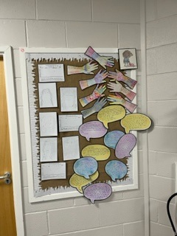
- Falls from heights, slips, trips
- Lack of handrails
- Falling objects
- Accessibility
SAFETY GUIDELINES
Considerations that should be given to minimise the risk: -
- The ability to reach the place of work safely.
- That any scaffold / platform provided is erected by a competent person and current safety tag is visible.
- Sufficient signage is on display.
- Advice is sought when appropriate
- When working from ladders, ensure the equipment is in good working order. The ladder should be secured to prevent slipping down / sideways.
- Never over reach or over stretch yourself to gain access.
- Never operate any lifting equipment i.e. hoists, unless you have been authorised and trained to use the equipment specified.

Step Ladders
Before use, check the condition of:
- Treads.
- Stiles.
- Hinge arrangement.
- Restraining rope between legs.
- Floor / surface condition.
Damaged step ladders are to be taken out of use and either destroyed or returned to the supplier.
Working from step ladders:
- Firm level base.
- Type of operation – should a mobile platform be used instead.
- Work no further than two thirds up step ladders (hand hold required).
- Boards not to be placed between treads on steps to provide working platform.
Where work is to be done at height:
- Identify the remaining work for which ladders can still be used. Restrict this to short duration, light duty work based on a suitable assessment of the risks.

Many accidents occur due to step ladders being poorly maintained or misused.

Safe Stacking
Many accidents occur when materials have to be taken from shelving, particularly when this is done by hand.
Care taken when material is stacked initially can help prevent many of these accidents.
SAFE STACKS SAVE INJURIES
- When handling dangerous materials, wear protective clothing i.e. gloves.
- Only stack material in authorised areas, never near doorways, access routes or on fire routes.
- Stack on a level firm surface.
- When handling materials by hand, check weight, if in doubt ASK.
DO NOT ATTEMPT TO LIFT MORE THAN YOU FEEL ABLE

Manual Handling
One third of all injuries received at work are the result of bad lifting and carrying techniques. Many of these injuries result in permanent damage to the back, but if care is taken these injuries could be avoided.
- Size up the load and if necessary, make a trial lift of a few inches.
- Do not attempt to lift alone, any load that is too heavy, too large, or awkward.
- Ensure that there are no obstructions in the direction you will be going.
- Take up position, feet at shoulder breadth apart; one foot slightly forward pointing in the direction you will be going.
- Bend the knees – back muscles should be relaxed.
- Get a secure grip of the load.
- Lift, keeping the back straight, arms close to body, with leg muscles providing the power.
- Step off in the direction that advanced foot is pointing, load held close to body.
- Do not carry a load that obscures the vision.
- When lifting to a height from the floor, do it in two stages.
Remember- get down to the load, bend your knees not your back and lift using your legs

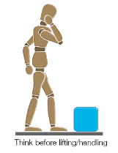 | 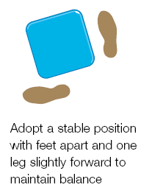 | 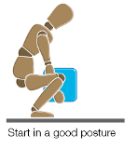 | 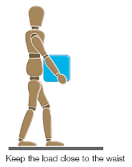
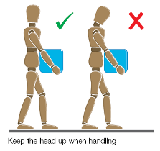 |  | 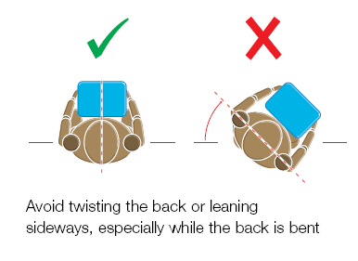

Personal Protective Equipment - PPE Clothing
Suitable and sensible clothing will be provided when required and can provide effective protection against a wide range of hazards.
Main Points
- Wear safety shoes/boots that provide protection to your toes and to the soles of your feet.
- Wear suitable gloves where there is any risk to your hands.
- Wear hi-visibility clothing/vests – be seen.
- Keep clothing reasonably clean to protect against dermatitis, fire, etc.
Avoid loose clothing – especially loose ends that can get caught in machinery, etc.

Fire Precautions
Fire prevention is much better than firefighting. You should therefore be aware of the fire risks, particularly with those associated with your own work.
a. Ensure that you know what to do in the case of fire.
b. Ensure you know your escape routes.
c. Keep fire doors clear and unobstructed.
d. Do not obstruct access to fire extinguishers; learn how they operate – read the labels or ask.
e. Do not hang clothing over or near heating equipment.
f. Do not let paper or other rubbish accumulate.
g. Do not smoke in unauthorised areas i.e. the school grounds.
h. Use proper containers for flammable liquids, not open tins, or buckets.
i Handle flammable liquids at a safe distance from possible sources of ignition.
j. Switch off from the mains any electrical equipment when not in use.
k. Only bring substances and equipment into school with prior permission from the Headteacher
l. Ensure you assemble in the appropriate assembly point and follow procedures for checking all children are present.
Remember, if there is a fire and you have left the school, and fail to sign out or inform others, someone maybe risking their life searching for you. If there is a signing in and out procedure, you must adhere to it at all times.
Longmoor Community Primary School regularly undertakes fire drills, including full evacuation of the building. These will take place during each term (3 times each year).

MEANS OF ESCAPE
Regular inspections should be made of means of escape, to ensure that they are kept free from obstruction. If it is found that they are even partially blocked, for example, by furniture or rubbish, immediate action must be taken to clear the obstruction.
Inspections should also include a visual check that all fire safety signs e.g. direction of escape routes, are in place and clearly visible. Immediate action should be taken to replace or rectify any sign which is not clearly visible. Primary, Secondary and, where practicable, tertiary routes will be displayed on the inside of every classroom door.

The Fire Triangle…
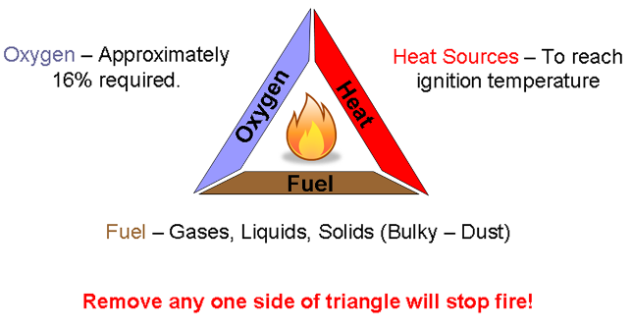

Types of Fire Extinguishers
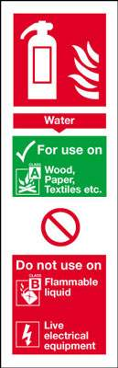 | 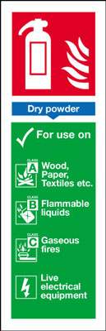 | 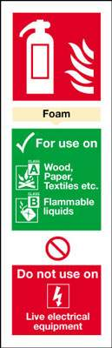 | 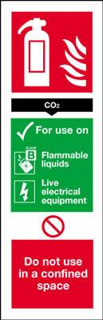
Please note that although CO₂ is nonconductive, electrical equipment involved in a fire should always be isolated whenever possible before the extinguisher is used. Because of extreme cold (especially the discharge horn), only the squeeze grip control and carrying handle should be held during use.

 | Control of Substances Hazardous to Health  Whilst working in school it is possible that you will come into contact with materials or substances which could cause health problems if sensible precautions are not taken.  CARE OF SKIN
The Employment Medical Advisory Service in conjunction with the Health and Safety Executive has issued information on skin care as this is the most common occupational health problem.
The following advice may help prevent you becoming affected:

SAVE YOUR SKIN
Occupational contact dermatitis is a rash caused by substances used at work. It can look like some common rashes not connected with work. Some people are more likely to get it than others but it is not catching. It most commonly affects the hands, forearms and legs although when it is caused by dust, mist, or fumes, you may also get it on the face, neck, or chest.
SOME COMMON CAUSES ARE:
- Pitch, tar, bitumen, brick, stone, cement, plaster, dust, paints, varnishes, lacquers, stains, certain epoxy resins, certain woods, acrylic and formaldehyde resins chromates (in primer paints, cement) organic solvents, petrol, white spirit, thinners, acids, and alkalis to name but a few.
- Some substances take weeks, months, or even years to cause dermatitis. This is because the skin becomes allergic to them. This type of dermatitis may also cause swelling of the eyes and lips.
- Always read and follow the C.O.S.H.H ‘safe use’ advice supplied with the product and always wear the recommended P.P.E.
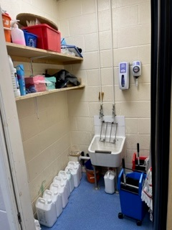

Infection Control & Blood-borne Viruses
Under the Health and Safety at Work Act 1974 and the Management of Health and Safety at Work Regulations 1999, we have a legal duty to protect the health of our employees and anyone else who may be affected by our work, or who may be on our premises at any time. We will consult all our employees on the risks identified and the measures needed to prevent or control these risks. We will also ensure all employees are familiar with our safety policy.
Specific legislation on hazards that arise from working with biological agents such as BBVs is contained in the Control of Substances Hazardous to Health Regulations 2002. Under COSHH we have a legal duty to assess the risk of infection for employees and others affected by your work. When the risk is known, you need to take suitable precautions to protect their health. We will also provide all our employees with adequate information, instruction and training on any risks to their health which they may face at work.
All staff are advised to ensure their vaccinations i.e. Hepatitis etc are all up to date. If you require any further information, please contact a member of SLT.
GUIDANCE
- Wash your hands before and after treating wounds. This helps protect both the patient and first aiders.
- Rubber or disposable gloves should be worn when dealing with bleeding wounds and body fluids.
- The gloves should be kept separate for first aid use only.
- Cotton wool, lint and micropore tape and plasters are available for the dressing of wounds.
- Plastic bags must be used for the disposal of badly soiled cotton wool etc. For most injuries, soiled dressings can be wrapped in paper towels and taken to the bin by a member of staff. Children with cuts, bleeding noses etc., should not be sent into school with another child.
- All soiled dressings, after first aid treatment, should be placed in a “Disposan” unit.
- If the “Disposan” unit is needed in the classroom, only staff should move it.
- Following a biting incident by a child, please report this immediately to the lead first aider or a member of SLT.

Safety Signs

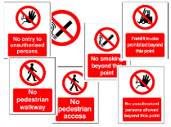 | Prohibition Signs - a sign prohibiting behaviour likely to increase or cause danger (e.g. 'no smoking');
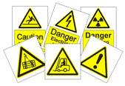 | Hazard Signs - a sign giving warning of a hazard or danger (e.g. 'danger electricity');
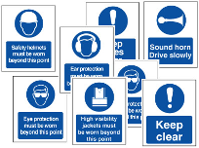 | Mandatory Signs - a sign prescribing specific behaviour (e.g. 'ear protection must be worn');
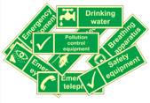 | Safety Signs - escape or first-aid sign - a sign giving information on emergency exits, first-aid, or rescue facilities (e.g. 'emergency exit/escape route'
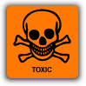 | Chemical Signs – a sign which gives warning of a hazard associated with a chemical or substance.

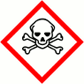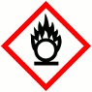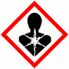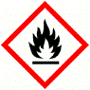
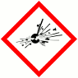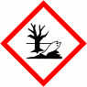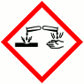

Accidents and Incidents
In the event of a child injury during break, PE or lesson time please ensure the incident is reported by a first aider. Forms are available for minor and non-minor incidents (Riddor etc). A member of the leadership team should be consulted if necessary. In the event of any head injury, a head bump letter/incident report should also be completed and sent home with the child as well as a phone call to parent/guardian at the time of the incident. Incident reports are available from Donna Coburn. If you are in any doubt as to the seriousness of any injury, ensure a member of the leadership group is consulted. A significant number of staff receive regular first aid training to enable them to deal with minor injuries. The first aid lead is Julie Jones.
In the event of any staff accident please notify a member of the leadership group.

Emergencies:
If a serious accident happens, prompt action may save a life or at least reduce the suffering of a child or one of your colleagues. You can help by making sure that first aid assistance is called promptly. Familiarise yourself with the staff members who are trained first aiders.

Where instant action is needed:
- Do not move the injured person unless their position is life threatening.
- Get someone to call the emergency services, stay with the injured person, keep them warm and ensure that they can breathe freely.
- If there is serious bleeding, apply pressure near the wound, but do not touch the wound itself.
- Do not allow the injured person to eat or drink.
- In the case of electric shock do not touch the injured person until the power is switched off.

First Aid Box Locations:
- First Aid equipment is available in each year group.
- First Aid boxes will be located in the main corridors of the school during 23/24 Academic Year.

Defibrillator is located:
- On the Administration Corridor, between the School Business Manager’s Officer and the Learning Mentor’s Office.
Always report All Accidents, Incidents and Near Misses. It is important that they are reported so that they can be investigated and measures put in place to stop them from happening again.

Medical Information
A list of children with specific medical conditions is available via Medical Tracker for relevant class teachers who require it. It is updated on a regular basis to ensure accuracy of information.

Illness
Children who become unwell during the course of the day should be monitored by class teachers. If it is felt that they need to go home a member of the Leadership Team should be consulted. Children who leave school during the school day should be signed out of school by means of the signing out register kept in the main office.
An up-to-date list of contagious illnesses, with details for recognition and quarantine time-scales, is kept in the Main School Office for all staff to refer to. All cases should be reported to a member of the Leadership team.

Medication
Medication may be administered by trained staff if a request has been issued in writing giving the school necessary authorisation.

Teachers’ responsibilities
The head teacher will ensure that:
- Medicines brought into the school are suitably labelled with the name of the pupil; name of drug; dosage; frequency of administration.
- A record card is completed for each pupil receiving medication. The card should include the following information:
- The medicines required by the pupil
- Details of dosage and times for administration
- The types of medicines being carried
- Appropriate risk assessment undertaken
- The staff involved in administration or supervision of medication
- Staff do not compel a pupil to take medication
- In an emergency, students have prompt access to their medicine through a recognised procedure
- All staff are familiar with the emergency procedure
- These procedures are followed when on school outings.
Staff who participate in the administering of medication to students will comply with the school’s policy.
Medication is stored out of children’s reach located in locked cupboards.
All medication, including inhalers, should be returned to parents prior to all holiday periods.
If a nominated staff member is not comfortable administering a medication he/she may refer to the Leadership team.

Epilepsy
Epilepsy is defined as having repeated seizures, although not all epileptic sufferers have seizures. There are different types of seizures, some end in seconds and others go on for minutes. People affected might lose awareness of what is happening or where they are during a seizure and they may lose consciousness altogether. Each person’s experience of epilepsy is unique.

Staff Responsibilities
- Co-operate with the school in relation to health and safety arrangements
- Follow any training, guidance and instruction
- Report any accident or incident.

Individuals suffering from Epilepsy have an additional duty to:
- Alert the school if his/her epilepsy is having an adverse effect on his/her tasks
- Inform the school if the condition could increase the risk of an accident
- Notify the school and DVLA if receiving treatment or tablets. Notification to the DVLA is a legal requirement
- Follow any training, guidance and instruction provided by the school.

Diabetes
For each affected member of staff with diabetes, the level of treatment will vary greatly from individual to individual and within each individual from day to day. It may therefore be necessary to seek specialist help.
Staff suffering from diabetes may have a warning card (medic – alert) or bracelet, sugar lumps, tablets or an insulin syringe (which may look like a pen) among their possessions.

Teachers’ responsibilities:
- To co-operate with the school in relation to health and safety arrangements
- Follow any training, guidance and instruction
- Report any accident or incident.

Furthermore, diabetic person’s responsibilities include: -
- Alerting the school if their condition is having an adverse effect to their ability to work or increase the likelihood of an accident
- Notifying the employer and the DVLA if:
- Receiving treatment with insulin where the job entails driving any vehicle or
- Receiving any type of medication for diabetes where the job entails driving Group 2 vehicles (bus, coach or lorry)
If the condition is managed by diet or non-insulin medication (or both) there is no obligation to inform the DVLA provided the employee is free from certain diabetes related complications, listed on the DVLA website, or has not been advised to do so by their GP, specialist or optician.
- Co-operation with the school arrangements for health & safety
- Following any training, guidance and instruction provided by the school.

New and Expectant Mothers
We are committed to protecting the health and safety of all new and expectant mothers. The phrase “new or expectant mother” means a worker/student who is pregnant, who has given birth within the previous six months or who is breastfeeding. “Given birth” is defined in the regulations as delivered a living child or, after 24 weeks of pregnancy, delivered a stillborn child.
Staff will: -
- Report their pregnancy as soon as it is confirmed
- Follow advice and information given by the school in relation to safe working practices
- Report any hazardous situation so that arrangements for the appropriate remedial action can be taken
- Co-operate with management arrangements for health and safety

Safety in PE
During any PE activity, the teacher or responsible person has a duty of care to the whole class and should ensure that planning and implementation of the PE activities includes, recognition of safety as an important element - it should not be necessary to stand by one piece of equipment during a PE lesson.
Firm control should be maintained at all times.
- All students must be wearing appropriate dress and should not have anything in their mouths during physical education lessons.
- Equipment should be checked for stability and good repair before activities commence.
- All movement of equipment must be supervised and safe practices observed.
- In gymnastics, it is important that an indirect teaching approach is adopted as this caters for the needs and abilities of all pupils.
PE Teachers will:
- Ensure they comply with this policy and follow the associated procedures/safe systems
- Ensure that the teaching staff wear appropriate clothing and footwear, for the activities undertaken and then environment in which the activity is taking place
- Ensure adequate supervision during classes, proportionate with the age, and ability of the individual students, the activity undertaken, location travel distance and weather conditions
- Weekly visual inspections are to be undertaken and any faulty equipment, removed and reported to head of department
In case of an accident in a PE lesson:
- Stay with casualty - if in doubt do not move him/her
- Send a child or another adult to inform a member of the Senior Leadership Team or another teacher.
- If the casualty requires further treatment parents should be informed and any necessary arrangements made.
- Complete an incident form.

Method Statements
A work method statement, sometimes called a "safe system of work,” is a document that details the way a work task or process is to be completed. The method statement should outline the hazards involved and include a step-by-step guide on how to do the job safely. The method statement must also detail which control measures have been introduced to ensure the safety of anyone who is affected by the task or process.
Method Statements are requested by organisations of all sizes and in all industries. The reason they do this is so they can comply with Health and Safety legislation which requires them to make suitable and sufficient enquiries as to the competence of any organisation they contract to carry out work.

Other Health and Safety Arrangements

Off-Site Visits and Residential Holidays
Staff taking part in visits, journeys and holiday excursions should ensure they have the necessary knowledge, experience and skills required so that they will be aware of and have made arrangements to deal with all risks involved. Insurance schemes are fully implemented. Parental consent is obtained before taking any children off the school site. Vehicles used to transport children are fitted with seatbelts. Children are given appropriate supervision and instruction in the use of these. A separate policy for educational trips and visits exists. This also includes a risk assessment pro-forma.

Break and Lunch Time Supervision.
At break and lunch times, children are supervised by a minimum of one member of staff per year group positioned strategically.

Car Park Area.
Parent vehicles and taxis, other than those authorised by the school, are required to park outside of the school grounds at all times.

Security of premises.
During school hours all staff are responsible for the monitoring of visitors/strangers on the school premises. If an unattended visitor is found on the premises they must be offered assistance. If suspicions are raised, inform a member of the Leadership Team immediately.

Lone Working
All staff should avoid lone working wherever possible by arranging for a colleague to also be on site. Where lone working is unavoidable staff should ensure that all outside doors are locked and curtains/blinds are closed when it is dark.
Fire doors must be unlocked when staff are working on the premises, e.g. out of school hours.
Anyone lone working should ensure they have access to a personal mobile phone.
When two or more people work late they should try to leave the building together.
Cars should be parked as close to the access doors as possible.
Where possible staff should let someone know if they will not be home at their usual time and what time they can be expected.
Provide information on their whereabouts during working hours to the school management team/Site Manager.
Report all incidents relating to lone working using schools reporting procedure.

Key Holder Safety during Call Outs
Key holders on call out should be mindful of their own safety.
Before leaving the key holder should ensure that the school is secure and the alarm re-set.
If any member of staff is onsite and concerned about their own safety or damage to the school due to the presence of other people on or around the site they should telephone the police.

Critical Incidents
The school has contingency measures in place for dealing with critical incidents. See Longmoor Community Primary School Emergency Plan for further details.

Risk Assessments
A risk assessment is nothing more than a careful examination of what in your work, could cause harm to people so that you can assess whether you have taken enough precautions or should do more to prevent them.”
The purpose and function of risk assessments may be expressed as the following:
To identify operations, tasks, and processes which may foreseeably cause harm to employees or others, including members of the public (hazard);
To identify the potential of the hazard being realised, and the potential consequences which might then occur (risk)?
To enable a risk assessment to be developed which will assist in eliminating or reducing the exposure of the population to the risk.
When an evaluation of the risk has been considered, the principles of prevention, control, and protection should be applied. The hierarchy of control is as follows:
- Avoid the risk if possible.
- Combat risk at source.
- Change the method of work to suite the individual.
- Make use of technological developments.
- Incorporate control measures into the procedures within an overall planned structure to reduce risks.
- Give precedence to controls which cover the whole workforce or activity.
- Provide information and training to employees and self-employed persons.
- Confirm that the control measures indicated by the risk assessment have been put into place and are effective.
Definitions that must be understood:
A “Hazard” is defined as something with the potential to cause harm. This includes injury and ill health, loss of production and damage to plant, goods, property or the environment.
“Risk” is the likelihood that the harm from a particular hazard is realised and the severity of its consequences.
To complete risk assessments efficiently an element of forethought and planning should be utilised.
The HSE recommend that we use a five step method:
- STEP 1 Look for the hazards.
- STEP 2 Decide who may be harmed and how.
- STEP 3 Evaluate the risk arising from the hazard.
- STEP 4 Record the findings of the assessment.
- STEP 5 Review the assessment from time to time and amend it if necessary.
A suitable and sufficient risk assessment should identify all the hazards associated with that activity and be carried out by a competent person and record the significant findings and be communicated to those persons likely to be exposed to the risk.
All staff must:
- Co-operate with management arrangements in respect of workplace risk assessments
- Follow any training, information, guidance and instruction given to the school
- Comply with any control measures laid within risk assessments
- Report any hazards or defects to the school management team immediately
- Make full and proper use of any PPE provide

Summary
As a School we expect that you will agree and abide by the advice and basic precautions outlined in this booklet.
We all know, however, that conditions can change rapidly, suddenly creating new dangers to guard against. For this reason you are asked to ‘THINK SAFETY’ and recognise that accident prevention concerns everyone. Your concern will mean better safety, better conditions, improved productivity, and the continued prosperity of yourself, your fellow colleagues, and your School.
You can prevent accidents happening!
For further Health & Safety information, please refer to the school Health & Safety Policy.
Additional information can be found on the Health & Safety Executives Website: www.hse.gov.uk

ACKNOWLEDGEMENT
This is to acknowledge that I have received my copy of:
1. The Health and Safety Handbook
2. The Health and Safety policy
I have read and will abide by all the rules and regulations in the Handbook and Policy, together with any additional safety rules and regulations relating to my job.
Signed:
Name:
Job Detail:
Date:
This is to acknowledge that I have delivered the Health and Safety Handbook and the Health and Safety policy to the person who has signed the above receipt and that I have given an orientation as to the contents of the Handbook to that person.
Signed: | 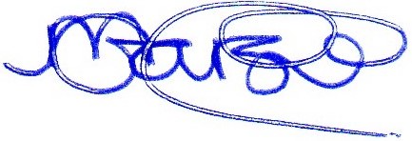
Name: | Mark Garside
Job Detail: | Headteacher
Date: | 11th October 2023

