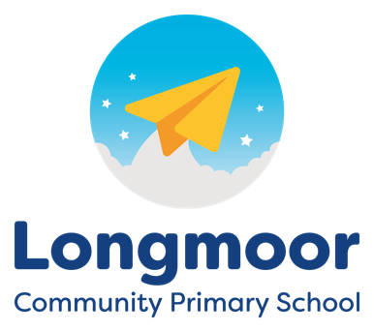

**Nursery Staff**

Mrs. Gough, Mrs. Callaghan, Mrs. Mannion, Mrs. Saunders, Mrs. Whelan

**Key Person Focus**

Transition, story, news, music, maths, mark-making, RE/PSHE

Nursery

Learning Block 6 (12)

**Themes & Focus**

Changing Me

Special Places

Noah's Ark

Transition

Safari animals

Camping

Sports

**Home Links**

- Trip to Knowsley safari Park - 25th June (with an adult from home)

- Practise writing your child's first name at home

- Teddy Bears' Picnic Stay & Play - 10th July

- Various Reception transition dates for parents/carers

**Daily Enhancements**

Monday – motor skills

Tuesday – gardening

Wednesday – food preparation

Thursday – dance

Friday - yoga

**Personal, Social & Emotional Development**

Preparing for transition (resilience)

Sharing and taking turns

Understanding feelings

Respecting differences

Strengthening friendships

**Expressive Art and Design**

Daily singing/circle games

Role play opportunities based on Noah's Ark

Colour mixing

Carnival of the Animals

**Physical Development**

Sports Day (3rd July)

Daily sensory circuit

Parachute/circle games

Fine motor skills

Early mark-making

Dance lessons (Thursday)

Yoga

**Understanding the World**

Visiting Knowsley Safari Park

Camping Day

Noah's Ark story

Weather (rainbows)

**Communication & Language**

Using words to solve problems

Weekly sharing of news

Listening & taking turns

Initiating conversations

New vocabulary

Listening games

Resolving conflicts

**Literacy**

Daily story time (in Key Person groups)

Sound discrimination games

Mark-making

Recognising names

Nursery Rhymes

Traditional Tales

SignAlong sign language

Phonics (for those moving up to Reception)

**Mathematics**

Days of the week / seasons

Colours

Recognising and making simple patterns

Counting to 5

1:1 correspondence

Subitising

Simple 2D shapes

Weight/Measure